Lecture (8)

Characteristic of higher fungi .
- It includes only .Two phyla – Ascomycota and Basidiomycota
- Thallus in both consists of sepatate hyphae that form extensive mycelia,
Septa have pores that allow migration of cytoplasm, organelles and nuclei .
3-Asexual reproduction by conidia bearing on conidiophores
4-In sexual cycle, plasmogamy is separated from karyogamy – produces dikaryotic phase.
5-Sexual reproduction produces spores after meiosis – ascospores or basidiospores (1n)
6- Evidence from DNA sequences suggests that Ascomycota and Basidiomycota are sister groups but to date no indication of ancestors.

Phylum : Acomycota
Its members are commonly known as the sac fungi this name comes from forming sexual spore (ascospore). They are the largest phylum of Fungi, with over 64,000 species. Among the Ascomycota are some famous fungi: Saccharomyces cerevisiae,(baker yeast) the yeast of commerce and foundation of the baking and brewing industries, Penicillium chrysogenum, producer of penicillin, Morchella esculentum, the edible morel, and Neurospora crassa, using as a model in genetic studies. There are also some in famous Ascomycota, a few of the worst being: Aspergillus flavus, producer of aflatoxin, the fungal contaminant of nuts and stored grain that is both a toxin and known natural carcinogen, Candida albicans, cause of thrush, diaper rash and vaginitis and some species cause powdery mildew on plants like - Erysiphae sp. is caused powdery mildew on grasses and cucumberaceae plants
.
Characteristics of Ascomycota
1-Somatic phase :Most have either unicellular like yeast or filamentous growth forms Hyphae have perforated septa.
2-Almost all ascomycetes are terrestrial or parasitic. However, a few have adapted to marine or freshwater environments.
3-The cell walls of the hyphae are variably composed of chitin and β-glucans, just as in Basidiomycota.
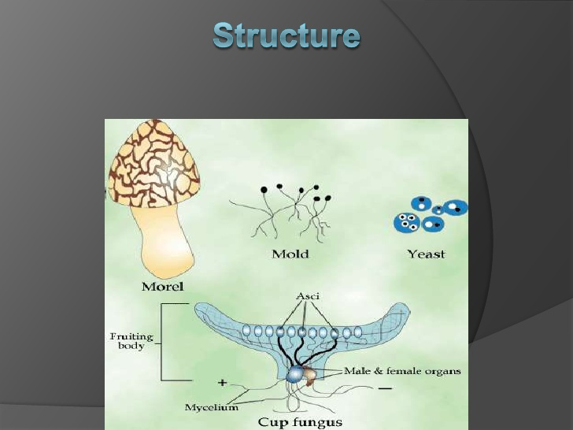
5-Includes yeast, cup fungi, truffles, powdery mildew, & morels(true mushrooms).
6- Sexual reproduction by forming ascospores produce inside sacs are called asci(singular :ascus) ,Most asci are cylindrical, or globose each ascus has 8 ascospores .

7- Most produce multicellular fruiting body – the ascocarp in which the asci and ascospores are formed . Asci usually develop on an inner surface of the ascocarp , a layer called the hymenium or hymenial layer .
Ascocarp – specialized hyphae formed by parent fungi during sexual reproduction
Hymenium layer :- the spore-bearing layer of the fruiting body of certain fungi, containing asci or basidia.
8-Characterisitics of asci and ascocarp important in classification of Ascomycota
9-Asexual reproduction – production of conidia (a unicellular spore produced asexually by a fungus
10-Many of the Deuteromycota thought to be asexual or anamorphs of Ascomycota.
Deuteromycota :- members of this group lack a sexual stage, they are often referred to as imperfect fungi
11-Previous hypotheses that the Ascomycota evolved from red algae (similarities in
morphology of sexual structures) and Mucorales
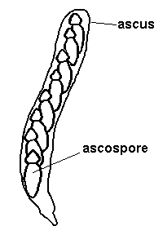
Life cycle of Ascomycota

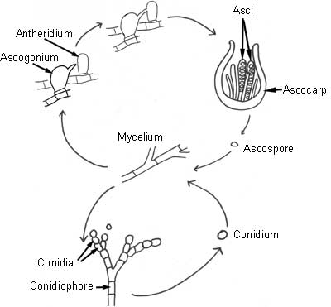
In asexual reproduction, spores are formed as the result of mitosis (nuclear division in which the number of chromosomes in the daughter nuclei is the same as it was in the parent nucleus). The resulting mitospores (aso called conidia) are released in large numbers, and allow the ascomycete to disperse over a wide area.
Sexual reproduction involves the formation of an ascus (plural; asci) by the fusion of two hyphae of different mating types. The ascus is shaped like a bag, and acts like a bag in that it contains the spores. These spores are called ascospores and are formed by the fusion of two nuclei (karyogamy) to form a diploid nucleus. This diploid nucleus divides by meiosis (nuclear division with reduction in the number of chromosomes) to give four spores, which then divide by mitosis to give eight haploid ascospores.
These ascospores have thick cell walls, and have the ability to persist in the environment for a long time. The structure of the ascus varies within the group except yeasts tend to have single asci (naked asci) not forming ascocarp , others have their asci formed within a fruiting body called an ascocarp. These occur in several different forms:
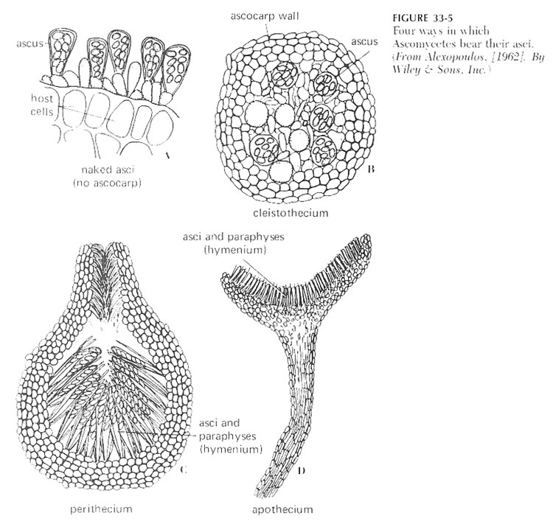

Use of ascocarps in the classification of fungi belonging to the Ascomycota:

1. Hemiascomycetes (includes yeasts)
- In this case the asci are NOT ENCLOSED in an ascocarp.
- Asci are naked

2. Plectomycetes
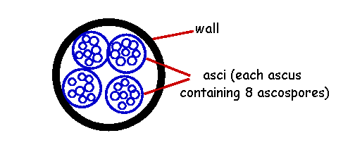
- Fungi belonging to this group form CLEISTOTHECIA.
- These are round, completely closed ascocarps, possessing no natural opening.
- The asci are arranged irregularly within them.
- When mature the cleistothecia burst open to release their asci and ascospores.

3-Pyrenomycetes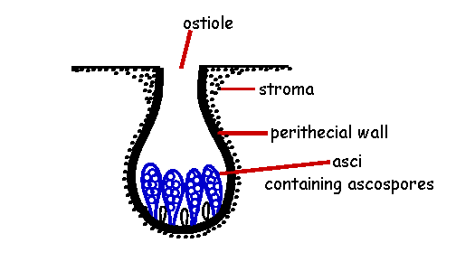
- Fungi belonging to this group form PERITHECIA.
- Perithecia are spherical or flask-shaped ascocarps.
- They open via a neck-like OSTIOLE with a terminal pore through which the ascospores are liberated.
- The asci are arranged in an orderly layer at the base of the cavity.

4. Loculoascomycetes
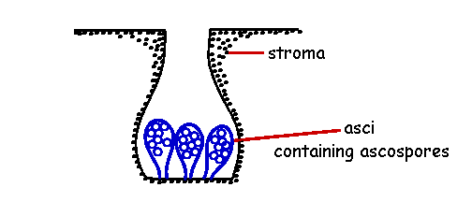
- Fungi belonging to this group form ASCOSTROMATA (or PSEUDOTHECIA).
- Ascostromata resemble perithecia but in the former there is no wall surrounding the central region of the ascocarp - only a cavity within the mass of hyphal tissue (STROMA) in which the asci are located. Ascocarp with asci formed in cavity (locule) within stromatic tissue

5. Discomycetes
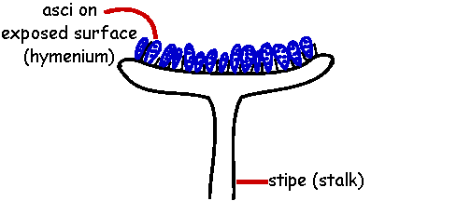
- Fungi belonging to this group form APOTHECIA.
- An apothecium is an OPEN- or CUP-SHAPED ascocarp.
- The asci are arranged on the exposed surface (HYMENIUM).

Examples of Ascomycota
Aspergillus
- Anamorphic genus – close to 100 species
- 11 different teleomorphic genera produce Aspergillus conidia on conidiophores, including Eurotium, Emericella
- Common fungi found in air, soil, water
- Grow on a variety of substrates, in humid climates found growing on clothing, shoes, etc.
- Important as contaminants of stored grain, species produce aflatoxin
- Produce characteristic conidiophore
- Conidia produced by phialides – flask shaped conidiogenous cells
- Have a characterisitic foot cell

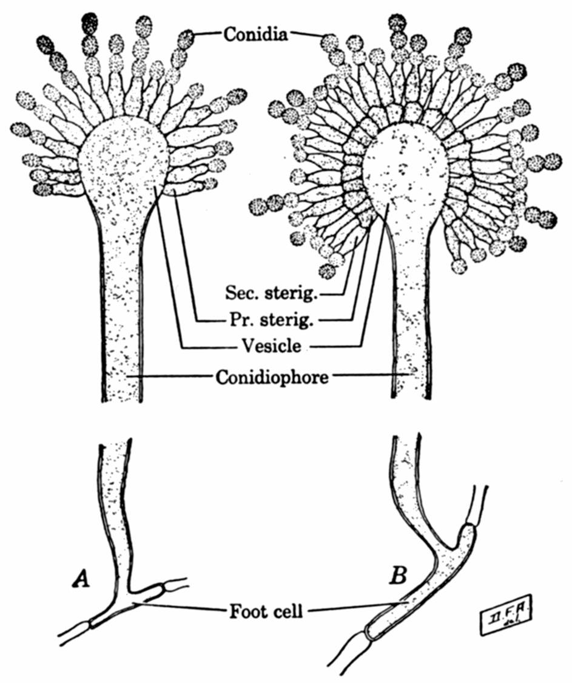
Penicillium spp.
- Over 95 species connected to 3 teleomorphic (sexual reproduction) genera – Talaromyces, Eupenicillium, Carpentales
- Very common in soil, conidia found in air, water, soil
- Food spoilage – on citrus fruits, jelly, cheeses
- Produce penicillin and other chemicals industrially
- P. roqfertii, P. camembertii used to make cheeses
- Asexual conidiophore – not swollen at tip, no foot cell
- Phialides arranged in a brushlike manner
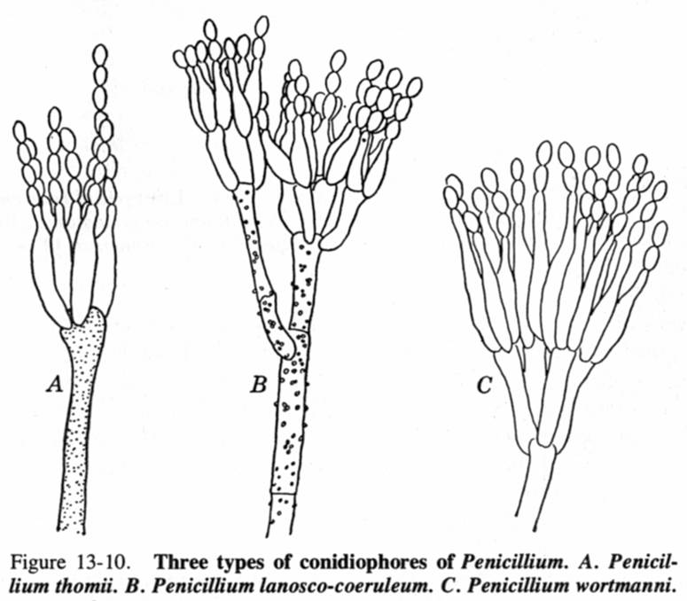

Powdery mildews
Ascocarp do not form opening so can be termed cleistothecia, but are more like perithecia without an opening
- Produce colorless hyphae on surface of plant host
- Produce haustoria that penetrate epidermal cells of host to feed or absorb nutrients from the host (plant).
- Asexual reproduction : Hyphae produce chains of conidia during growing season (spring and summer) on surface of plant leaf – giving the powdery, white appearance and sexual reproduction by ascospores produce inside ascocarp cleistothecium
- Cleistothecium are closed, have characteristic appendages extending from them

Truffles
- Truffles produce hypogeous ascocarp
- Ascocarp are highly modified
- Hymenium has great deal of infolding
- Ascospores not forcibly ejected
- Ascomata broken open by animals or by weathering
- Some species emit strong odor so that small animals, insects can detect them underground, dig up and eat them, dispersing spores
- Geopora, Tuber

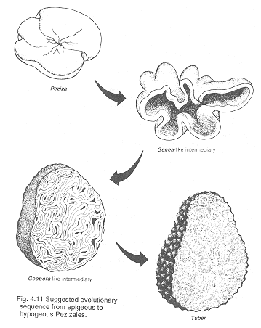
Yeasts
- Many species associated with flowers, fruits where high concentrations of sugar are present
- Many are facultative anaerobes – aerobic respiration or ethanol fermentation
- Widely used in brewing (beer, wine) and baking industries
- Some used as human & animal food, source of vitamins
- Also include some human pathogens – Candida albicans – normal flora
- Thallus is typically unicellular, in some species there may be a limited mycelium (filamentous yeasts)
- Asexual reproduction – budding and fission
- Commonly occurs as budding – unequal cell division where a daughter cell grows larger until it separates from mother cell

Sexual reproduction
- Haploid-diploid life cycle as in Saccharomyces cerevisiae (baker’s and brewer’s yeast)

