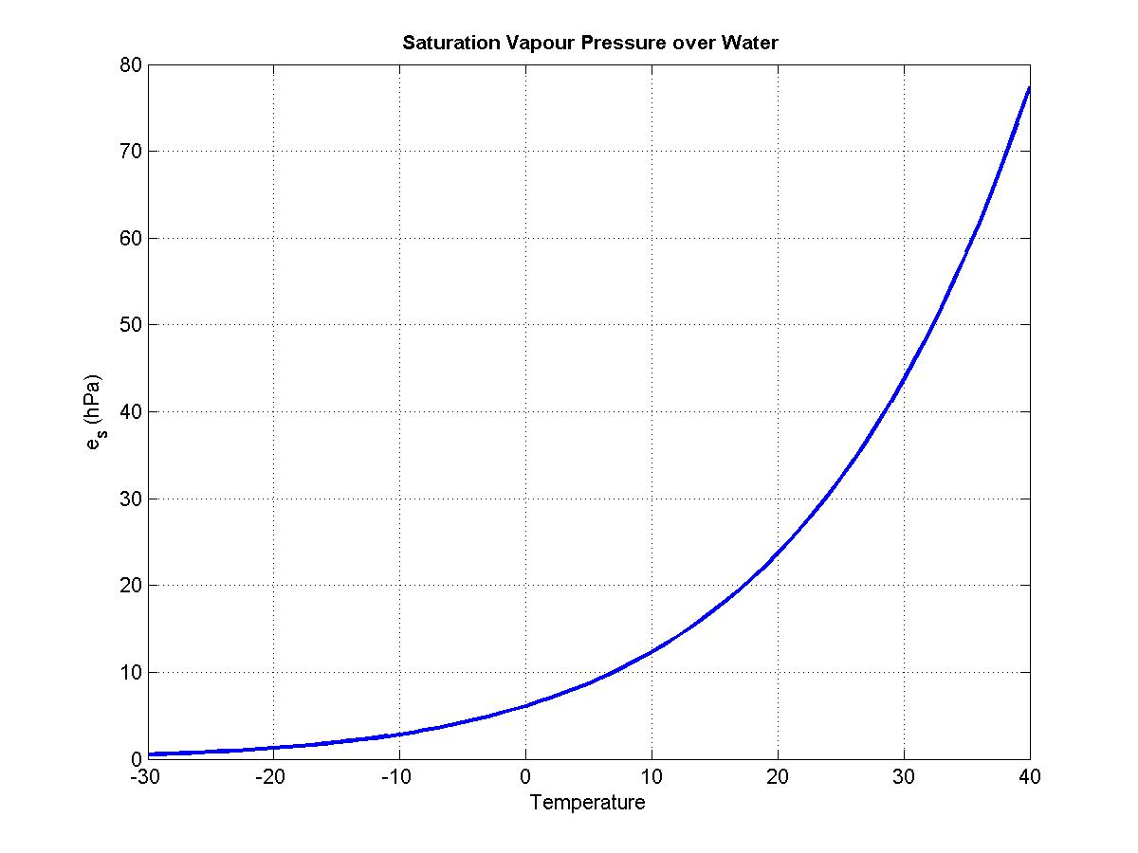

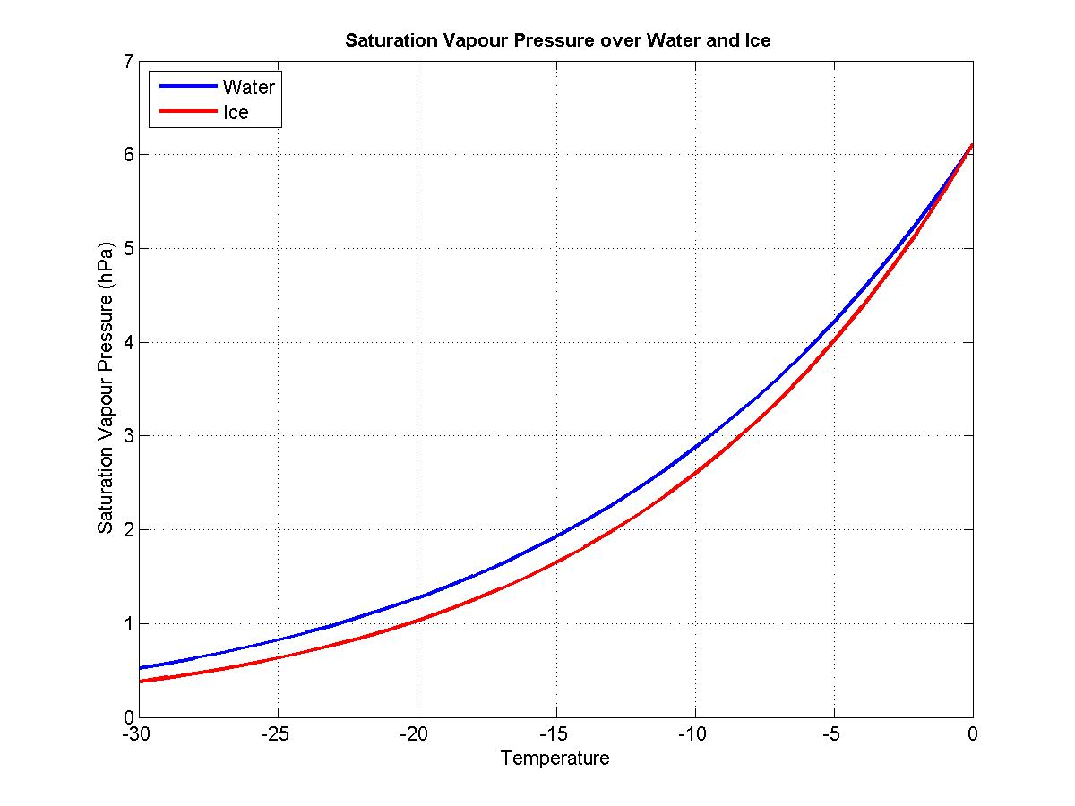

Surface air  temperature (oC) | Surface mixing  ratio (kg/kg) | LCL (m)
20 | 0.005 | 2000
 | 0.007 | 1400
 | 0.010 | 800
25 | 0.005 | 2650
 | 0.007 | 2050
 | 0.010 | 1450

