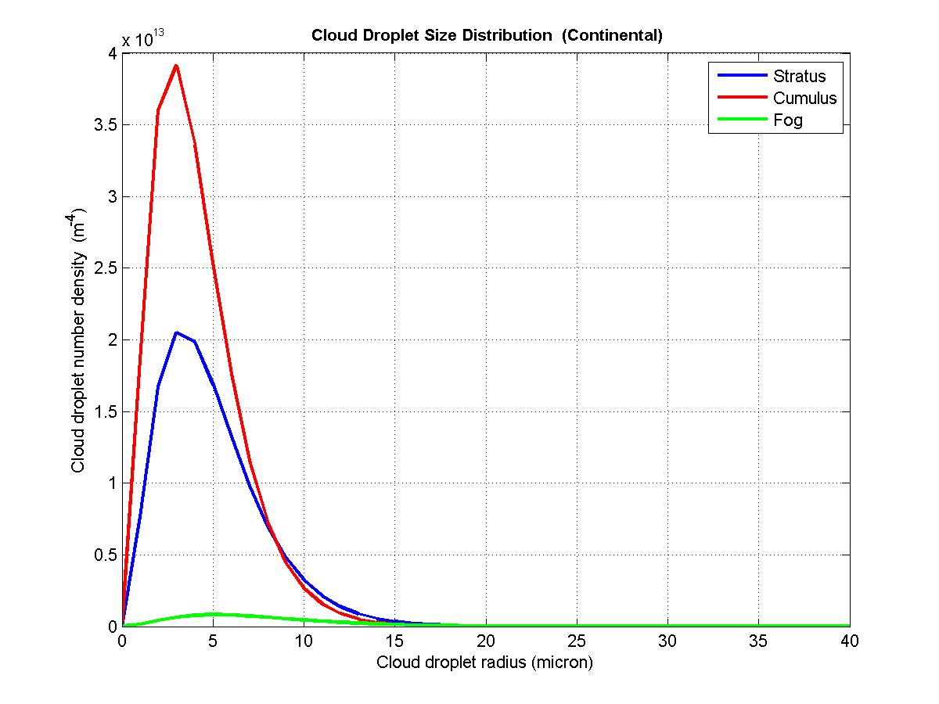

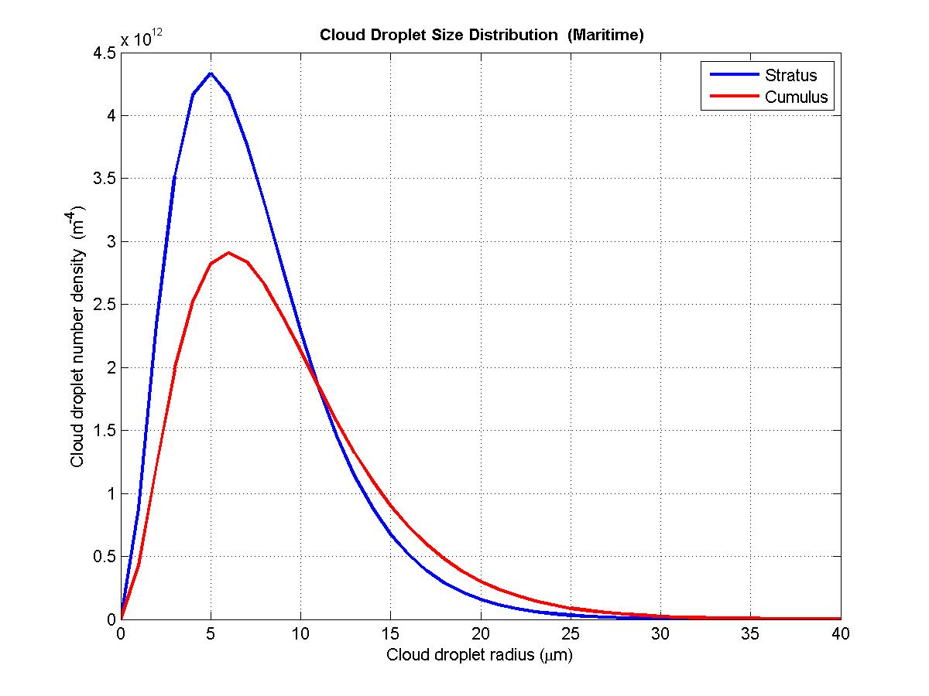
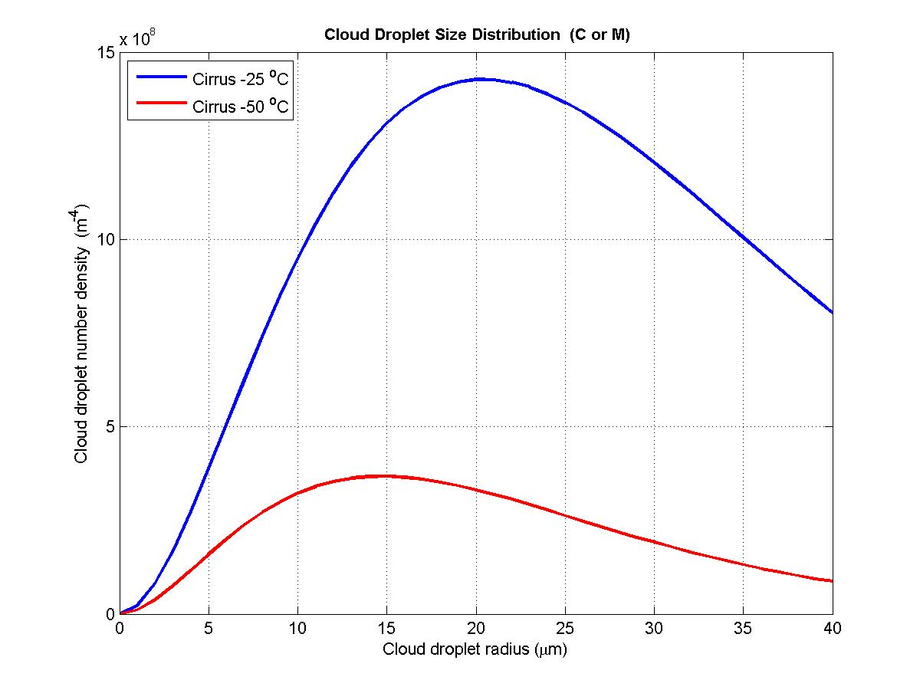

Cloud Type | Area (cm²/m³) | distance (mm)
Continental Stratus | 1025.1 | 0.98
Continental cumulus | 1139.81 | 0.84
Continental fog | 144.96 | 2.51
Maritime stratus | 721.76 | 1.44
Maritime cumulus | 870.7 | 1.54
C or M cirrus -25 C | 16.9 | 12.94
C or M cirrus -50 C | 1.63 | 22.84

