Lab :2

The animal cell
Cell: It is the basic unit of structure & function in an organism.

Cell theory: Every living organism is composed of cell and every cell in an organism produced by another cell.

The main parts of cell (cell structure) :

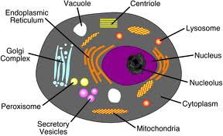

Living &non-living component in cell
- Living component
1-Cell membrane : surrounds the part of a cell together ,it controls the movement of material into and out of a cell.
2- Cytoplasm : is protoplasm inside the (cell membrane ). It makes
up most of the mass of many cells, different cell materials are
produced in the cytoplasm.
Function : produces variety of cell materials.

3- Nucleus : It controls cell activities, it is often in or near the center of a cell material .That nucleus is separated from the cytoplasm by a thin membrane is called (nuclear membrane).
Function : Controls cell activities.

4- Mitochondria : Are rod- shaped in the cytoplasm .
Function : Release energy & it is called (power house of cell) 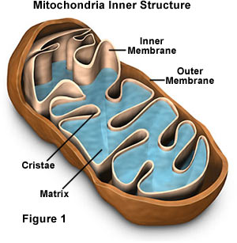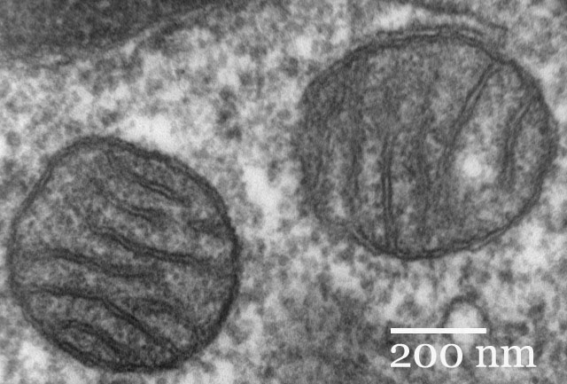
5- Ribosomes : Are tiny- particles, so small . They can see only with an electron microscope.
Function : Parts of cells where proteins are made.
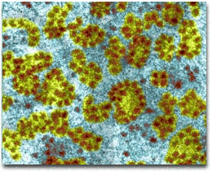
6- Endoplasmic reticulum : Structures like tubes in the cytoplasm of the cell.
Function : Moves materials within cells.
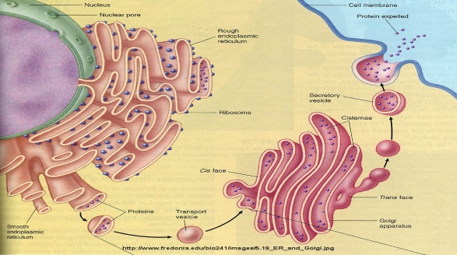
7-Lysosome:round organelles surrounded by a membrane and containing digestive enzymes.
B- Non Living component
Vacuoles : is a liquid- filled sphere surrounded by a membrane.
Function : stores water &dissolved materials.
Note: You can see these types of structures in Amoeba or Paramecium

- Organisms are divided according to number of cells:
1- Unicellular Organisms: some Organisms are single cells are called unicellular e.x. : Bacteria , Amoeba , Euglena .

2- Multicellular Organisms: some Organisms have many cells are called multicellular e.x. : Animal tissue & Plant tissue .

We can divide the organisms to:
1-Eukaryotic
2-Prokaryotic
 | Eukaryotic | Prokaryotic
1-nucleus | present | absent
2-number of  chromosomes | More than one | one
3-number of cells | multicellular | unicellular
4-nucleous membrane | present | absent
5-mitochondria | present | absent
6-ribosomes | larger | smaller
7-ex: | Animal, plant | Bacteria

