Lab :1

The microscope

- Compound microscope
- Dissecting microscope
- Scanning electron microscope
- Transmission electron microscope

The Compound Microscope
A microscop: It is a tool that is used to study things that can not be seen with the naked eye.
Microscope parts
1- Eye piece (ocular lens) : contains the magnifying lens you look through, and may be provide with pointer to point on indicated parts from the body we need to exam.
2- Body tube : It holds the eye piece.
3- Arm : Supports the body tube & it holds the microscope.
4- Revolving nose piece : Holds high & low power objectives ; can be rotated to change magnification .
5- Objective lens : we can divided it to :
a) Low power objective (L.P.) :- Provides the least magnification, usually it power is (4.5 X) and (10 X).
b) High power objective (H.P.) :- Provides the most magnification, usually it power is (40 X).
c) Immersion oil :- magnification usually (100 X), it is used only with oil drop.
6- Coarse adjustment : moves the body up & down for focus, it is used with (L.P.) objective.
7- Fine adjustment : used to sharpen the image, moves the body tube slightly , it is used with (H.P.) objective.
8- Condenser:- It condense the light.
9- Stage:- Supports the microscope slide.
10- Stage clips:- Holds the microscope slide in place.
11- Diaphragm :- Regulates the amount light which enter the body.
12- Mirror :- Reflects the light upward through the diaphragm to the objective & the eye piece.
13- Base :- Supports the microscope.

How to keep your microscope
(Use of the microscope)

- Always carry the microscope with both hands , holds the arm with one hands & place the other hand under the base.
- Place the microscope on the table gently with the arm towards you and the stage facing a light source.
- Turn on the light from the swich.
- Look through the eye piece & adjust the diaphragm so that the greatest amount of light comes through the opening in the stage. The circle of light is called the field of view.
- Turn the revolving nose piece so that the low power objective lens clicks in to place.
- Always focus first with the coarse adjustment & the low power objective lens.
- Turn the revolving nosepiece until the high power objective (H.P.) clicks into place. Use only the Fine adjustment knob with this lens.
- Use only special lens paper to clean lenses.
- Before putting the microscope away, always turn the low power into place over the stage.
- Be sure that the distance between the low power & the stage is about two or three centimeters.
- Turner off the switch.

The partical part

How to see your field:
- Gently scrape the inside of your mouth with the flat side of a toothpick .
- Place the sampil in the middle of slide.
- Stain the sampil with methylene blue or iodine.
- Hold a cover slip at a 45 degree angle to the slide and lower the cover slip onto the sampil.
- Place the slide on the microscope stage.Use the stage clips to hold the slide in place.
- Use the mirror or light to send light upward through the slide.
- View the microscope from the slide and the low power objective with the coarse adjustment knob until it is closed to the cover slip.
- Look through the eye piece until you can see the cell,then focus with the fine adjustment knob.

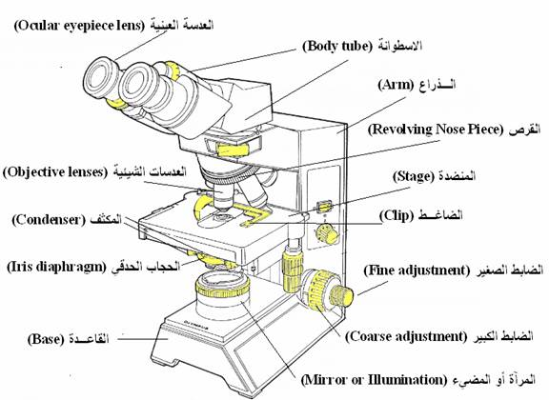
The compound microscop

Total Magnification:
To figure the total magnification of an image that you are viewing through the microscope is really quite simple. To get the total magnification take the power of the objective (4X, 10X, 40x) and multiply by the power of the eyepiece, usually 10X.
