4: Thunderstorms
No other weather encountered by a pilot can be as violent or threatening as a thunderstorm. Thunderstorms produce many hazards to the aviation community; it is important that pilots understand their nature and how to deal with them.
To produce a thunderstorm, there are several ingredients which must be in place.
These include:
• An unstable air mass
• Moisture in the low levels
• Daytime heating, upper level cooling
• For severe thunderstorms, wind shear.

The Life Cycle of a Thunderstorm
The thunderstorm, which may cover an area ranging from 5 miles in diameter to, in the extreme case, as much as 50 miles, usually consists of two or more cells in different stages of their life cycle.
The stages of life of individual cells are:
- Cumulus Stage :
The cumulus stage is marked by updrafts only.
These updrafts can reach values of up to 3,000 feet per minute and cause the cloud to build rapidly upwards, carrying super cooled water droplets well above the freezing level. Near the end of this stage, the cloud may well have a base more than 5 miles across and a vertical extent in excess of 20,000 feet. The average life of this stage is about 20 minutes.
(b) Mature Stage
The appearance of precipitation beneath the base of the cell and the development of the downdraft mark the transition to this stage. The downdraft is caused by water drops Which have become too heavy for the updraft to support and now begin to fall.
At the same time, the drops begin to evaporate as they draw in dry air from the edge of the cloud, and then fall through the drier air beneath the base of the cloud. This evaporation causes the air to cool and become denser, resulting in a downwash of accelerating cold air. Typical downdraft speeds can reach values of 2,500 feet per minute.

(c) Dissipating Stage
The dissipating stage of a cell is marked by the presence of downdrafts only. With no additional flow of moisture into the cloud from an updraft, the rain gradually tapers off and the downdrafts weaken. The cell may dissipate completely in 15 to 30 minutes, leaving clear skies or patchy cloud layers. At this stage the anvil, which is formed almost exclusively of ice crystals, often detaches and drifts off downwind.
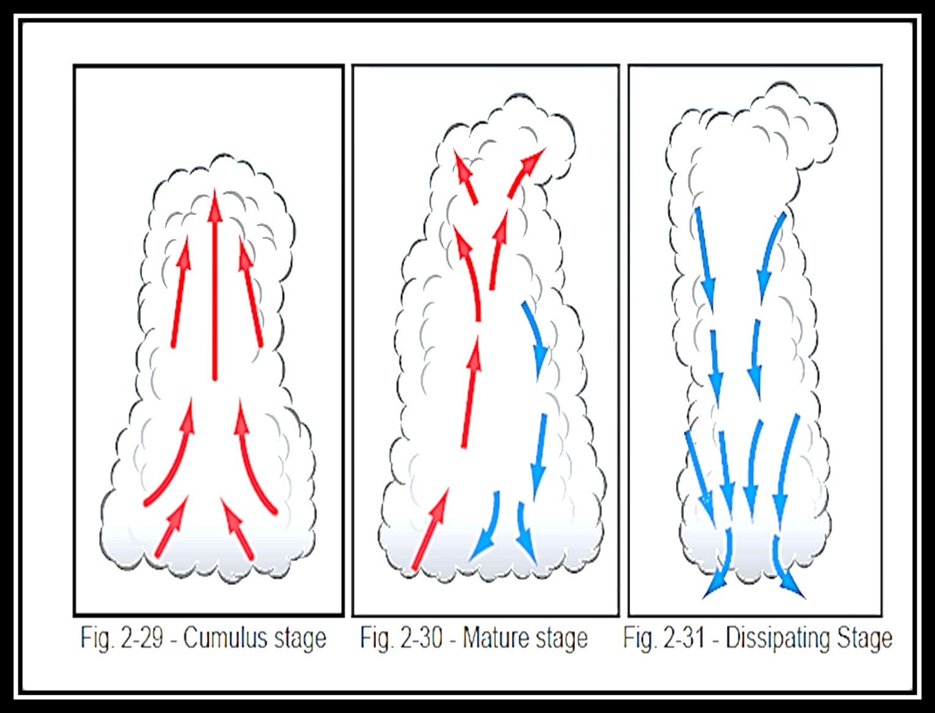
Types of Thunderstorms
(a) Air Mass Thunderstorms
These thunderstorms form within a warm, moist air mass and are non-frontal in nature. They are usually a product of diurnal heating, tend to be isolated, reach maximum strength in the late afternoon, are seldom(نادر) violent ((عنيف, and usually dissipate quickly after the setting of the sun.
There is also: a second form of air mass thunderstorm that is created by cold advection. In this case, cold air moves across warm land or water and becomes unstable. Of these two, it is the movement of cold air over warm water that results in the most frequent occurrence of this type of thunderstorm. Since the heating is constant, these thunderstorms can form at any time of day or night.
(b )Frontal Thunderstorms
These thunderstorms form either as the result of a frontal surface lifting an unstable air mass or a stable air mass becoming unstable, as a result of the lifting. Frontal thunderstorms can be found along cold fronts and warm fronts.
These thunderstorms tend to be numerous ((متعددة in the area, often form in lines, are frequently embedded in other cloud layers, and tend to be active during the afternoon and well into the evening. Cold frontal thunderstorms are normally more severe than warm frontal thunderstorms.
(c) Squall Line Thunderstorms:
A squall line (or line squall) is a line of thunderstorms. Squall lines can be several hundred miles long and have lower bases and higher tops than the average thunderstorm. Violent combinations of strong winds, hail, rain and lightning make them an extreme hazard not only to aircraft in the air, but also to those parked uncovered on the ground. Squall line thunderstorms are most often found 50 to 300 miles ahead of a fast-moving cold front but can also be found in accompanying low pressure troughs, in areas of convergence, along mountain ranges and even along sea breeze fronts.
(d) Orographic Thunderstorms
Orographic thunderstorms occur when moist, unstable air is forced up a mountain slope. These are common in the foothills of the Rocky Mountains where, on a typical summer day, they form due to a combination of upslope flow and daytime heating. When they get high enough, the prevailing west-southwest flow aloft carries them eastwards. If conditions are favorable, they can persist for several hours, otherwise they dissipate fairly rapidly. Typically, they will begin to develop in mid-morning and can continue to form well into the afternoon. In such situations, these storms frequently produce copious amounts of hail.
(e )Nocturnal Thunderstorms
Nocturnal (نشط ليلاً) thunderstorms are those that develop during or persist all night. Usually, they are associated with an upper level weather feature moving through the area, are generally isolated, and tend to produce considerable lightning.
Severe Thunderstorms
The discussion of the life cycle of a thunderstorm does not fit the case of those that seem to last for extended periods of time and are most prolific in producing tornadoes and large hail. A particular type of severe thunderstorm is known as a “Super cell”. The Super cell storm typically begins as a multi-cellular thunderstorm. However, because the upper winds increase strongly with height, the cell begins to tilt. This causes the descending precipitation to fall through only a portion of the cell, allowing the updraft to persist.
The environment in and around a thunderstorm can be the most hazardous encountered by an aircraft. In addition to the usual risks such as severe turbulence, severe clear icing, large hail, heavy precipitation, low visibility and electrical discharges within and near the cell, there are other hazards that occur in the surrounding environment.

