Lecture 3 advance immunology
By Dr Alia Alubadi
Note:
1- CD3 is a protein complex (T cell co-receptor ) composed of four distinct chains. In mammals, the complex contains a CD3γ chain, a CD3δ chain, and two CD3ε chains (CD3-gamma, -delta, and -epsilon), that activating both the cytotoxic T cell (CD8+ naive T cells) and T helper cells (CD4+ naive T cells).
2-The ζ-chain (zeta-chain) associate with the T-cell receptor (TCR) to generate an activation signal in T lymphocytes. The zeta chain plays an important role in coupling antigen recognition to several intracellular signal-transduction pathways.
Low expression of the antigen results in impaired immune response.
The TCR, ζ-chain, and CD3 molecules together constitute the TCR complex.
3- CD4 (cluster of differentiation 4) is a glycoprotein found on the surface of immune cells such as T helper cells, monocytes, macrophages, and dendritic cellsencoded by the CD4 gene, this gene is expressed not only in T lymphocytes, but also in B cells, macrophages, granulocytes, as well as in various regions of the brain.
CD4+ T helper cells are called helper cells because one of their main roles is to send signals to other types of immune cells, including CD8 killer cells, which then destroy the infectious particle. CD4 receptor is a member of the immunoglobulin superfamily, has four immunoglobulin domains (D1 to D4) that are exposed on the extracellular surface of the cell:
D1 and D3 resemble immunoglobulin variable (IgV) domains.
D2 and D4 resemble immunoglobulin constant (IgC) domains.
CD4 interacts with the β2-domain of MHC class II molecules through its D1 domain.
The short cytoplasmic/intracellular tail (C) of CD4 contains a special sequence of amino acids that allow it to recruit and interact with the tyrosine kinase Lck. When the TCR and CD4 bind to distinct regions of an antigen-presenting MHCII molecule, tyrosine kinase Lck bound to the cytoplasmic tail of CD4 tyrosine-phosphorylates immunoreceptor tyrosine activation motifs (ITAM) on the cytoplasmic domains of CD3 to amplify the signal generated by the TCR. Many functions have been assigned to the cytoplasmic tail of CD4 including anti-viral regulation (down/upregulation of CD4), T-cell maturation, activation and differentiation, and Lck signal transmission.
4- CD8 (cluster of differentiation 8) is a marker for cytotoxic T cell population, it is a transmembrane glycoprotein that serves as a co-receptor for the T-cell receptor (TCR), which plays a role in T cell signaling and aiding with cytotoxic T cell antigen interactions, through binds to a major histocompatibility complex MHC class I protein.
The most common form of CD8 is composed of a CD8-α and CD8-β chain( each encoded by a different gene, in humans located on chromosome 2), both members of the immunoglobulin superfamily with an immunoglobulin variable (IgV)-like extracellular domain connected to the membrane by a thin stalk, and an intracellular tail.
The CD8 co-receptor is predominantly expressed on the surface of cytotoxic T cells, but can also be found on natural killer cells, cortical thymocytes, and dendritic cells.
The extracellular IgV-like domain of CD8-α interacts with main recognition site the α3 portion (because it’s flexible loop) of the Class I MHC molecule, also the CD8 co-receptor plays a role in T cell signaling. The cytoplasmic tails of the CD8 co-receptor interact with Lck (lymphocyte-specific protein tyrosine kinase). Once the T cell receptor binds its specific antigen Lck phosphorylates the cytoplasmic CD3 and ζ-chains of the TCR complex which initiates a cascade of phosphorylation eventually leading to activation of transcription factors which affect the expression of certain genes.
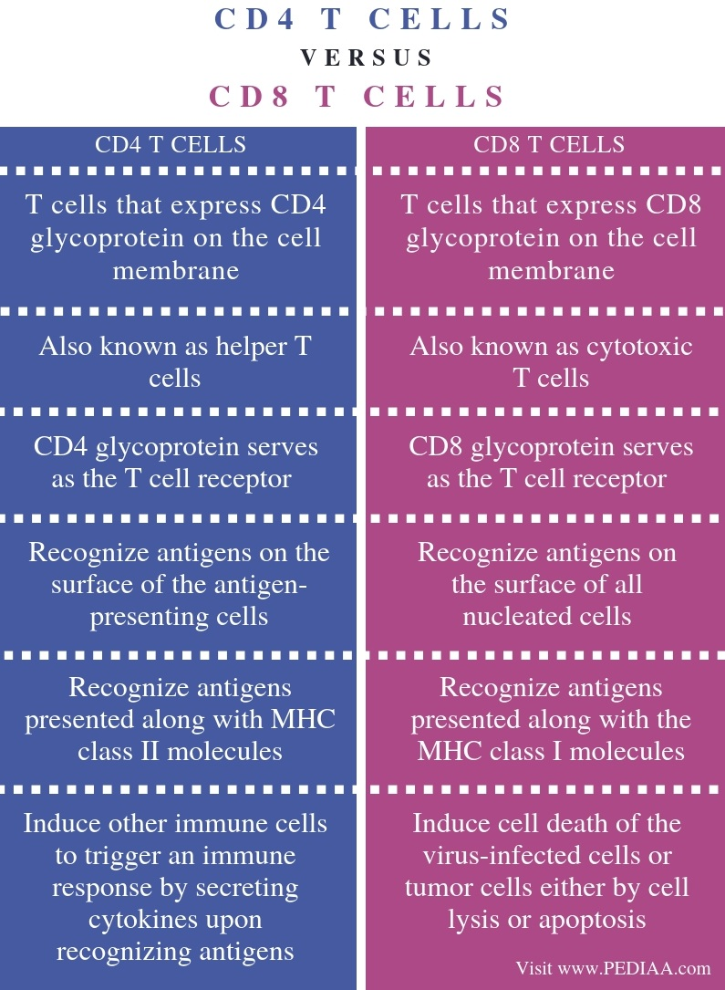

Note: Lck (or lymphocyte-specific protein tyrosine kinase) is a protein (a member of the Src family of non-receptor tyrosine kinases are cytosolic enzymes that can transfer the phosphate group from ATP to a tyrosine residue of a protein (phosphorylation)) phosphoprotein expressed in a variety of lymphoid and non-lymphoid cell lineages, Lck is most commonly found in T cells, associates with the cytoplasmic tails of the CD4 and CD8 co-receptors on T helper cells and cytotoxic T cells. Lck is a tyrosine kinase, which phosphorylates tyrosine residues of certain proteins involved in the intracellular signalling pathways of these lymphocytes.

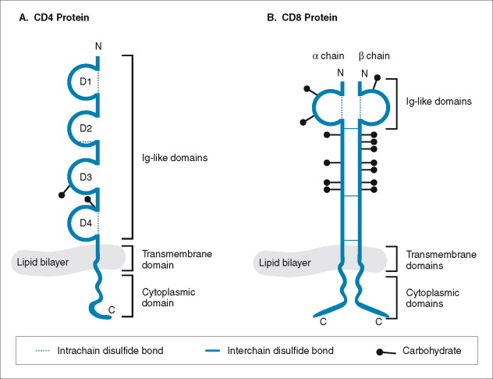
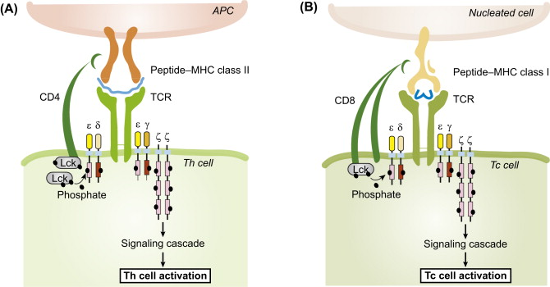

MHC molecules, antigen presentation
The major histocompatibility complex (MHC) is a collection of genes coding for MHC molecules. In humans, the MHC genes are also referred to as human leukocyte antigen (HLA) genes, these were polymorphic genes (with the highest number of allelic variations) which encode proteins with the greatest diversity in the human population. Thus, most individuals of the 0identical function.
There are two classes of MHC molecules involved in adaptive immunity, MHC I and MHC II. MHC I molecules are found on all nucleated cells; they present normal self-antigens as well as abnormal or nonself pathogens to the effector T cells involved in cellular immunity. In contrast, MHC II molecules are only found on macrophages, dendritic cells, and B cells; they present abnormal or nonself pathogen antigens for the initial activation of T cells.
T cells recognize antigens in a very different way from B cells or antibodies. They cannot see the antigen in its native form, only its fragments as antigen after a partial degradation and processing by cells that express them are called antigen-presenting cells (APC). Thus, the main task of the MHC molecules on the surface of an antigen presenting cell to present peptides derived from various proteins to T cells.
On the cell surface, a vast number- even millions of MHC molecules can be present at the same time, each MHC molecule binds only one peptide, but the MHC molecules on a cell surface together are able to present many different peptides from all kinds of proteins at the same time.

Under normal circumstances, only self-protein derived peptides are presented on MHC molecules. However, in case of an infection microbial peptides, while in case of cancer tumour cell-derived specific peptide fragments from altered proteins are also present among the normal self-peptides. T cells, by checking the tens of thousands of different peptides bound to MHC molecules on the surface of the antigen-presenting cell try to find a few specific MHC-peptide complexes, which activates them.

Most mammalian species express three different MHC I and three different MHC II molecules. Since these are polymorphic and genetically encoded, a total of somewhere between 3 and 6 (depending on the differences between the inherited genes) alleles will be expressed on cells. These are polymorphic in the peptide-binding groove region of MHC molecules to present different peptides of a defined antigen.

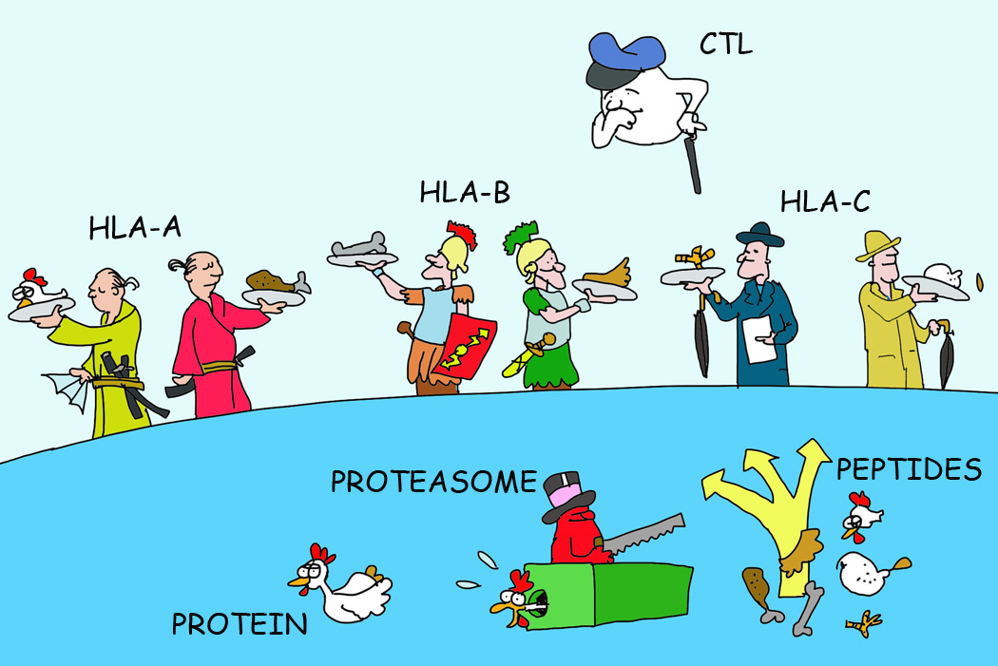

MHC Genes and Functions:
It is a collection of genes within a long stretch of DNA on chromosome 6, which codes for 3 classes of molecules
- Class I MHC genes: encode glycoproteins expressed on the surface of nearly all nucleated cells; the major function of the class I gene product is presentation of peptide antigens to TC cells.
- Class II MHC genes encode glycoproteins expressed primarily on APCs, where they present processed antigenic peptides to TH cells.
- Class III MHC genes encode, various secreted proteins that have immune functions, including components of the complement system and molecules involved in inflammation (e.g. TNF, Heat Shock proteins).

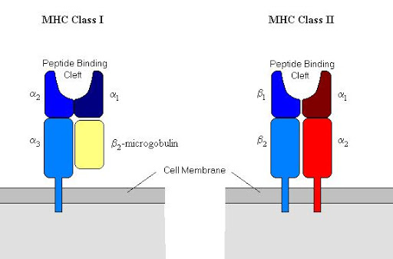
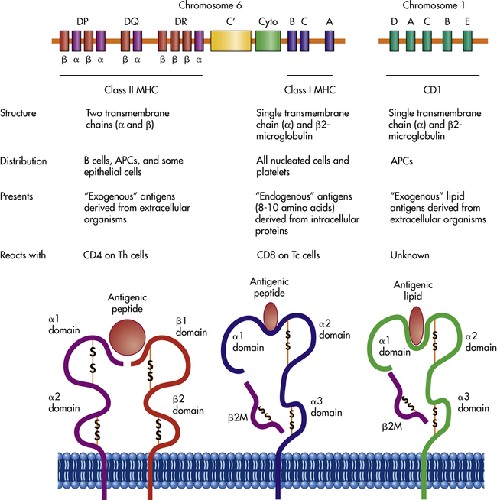
MHC I and MHC II
Both types of MHC molecules are transmembrane glycoproteins that assemble as dimers in the cytoplasmic membrane of cells, but their structures are quite different.
MHC I molecules are composed of a longer α protein chain coupled with a smaller β2 microglobulin protein, and only the α chain spans the cytoplasmic membrane. The α chain of the MHC I molecule folds into three separate domains: α1, α2 and α3.

MHC II molecules are composed of two protein chains (an α and a β chain) that are approximately similar in length. Both chains of the MHC II molecule possess portions that span the plasma membrane, and each chain folds into two separate domains: α1 and α2, and β1, and β2.
For MHC I, the antigen-binding cleft is formed by the α1 and α2 domains, whereas for MHC II, the cleft is formed by the α1 and β1 domains.
Thus cytotoxic T cells and helper T cells recognize antigens presented by different type of MHC molecules and peptides of different origin, extracellular (exogenous) peptides presented by MHCII molecules to CD4+helper T cells, while endogenous proteins or intracellular bacteria, viruses or the abnormal proteins of tumour cells presented by MHCI molecules to CD8+ cytotoxic T cells.

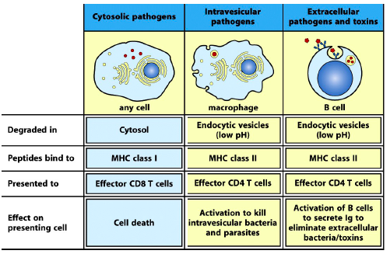
MHC I, MHC II molecules are synthesized in the endoplasmic reticulum.
Antigen presentation
Endogenous pathway shows viral antigens that enter the host cells by the intracellular route. Once internalized, the viral antigens are degraded into peptides by proteasomes. Thereafter, the processed antigenic peptides are transported via the transporter associated with antigen presentation (TAPs) to the endoplasmic reticulum (ER) where they are loaded onto MHC-I molecules for presentation at the cell surface to CD8+ T-cells.
1- MHC class I molecules are assembled in the endoplasmic reticulum (ER) and consist of two types of the chain – a polymorphic heavy chain and a chain called β2-microglobulin. The heavy chain is stabilised by the chaperone calnexin, prior to association with the β2-microglobulin.
Note: Without peptides, these molecules are stabilised by chaperone proteins (such as calreticulin and Tapsin etc), Tapasin interacts with the transport protein TAP (transporter associated with antigen presentation) which translocates peptides from the cytoplasm into the ER.
2- The generated peptides( usually 8-10 amino acids) are delivered into the endoplasmic reticulum (ER) by a transporter protein complex, where they can bind to the freshly synthesized MHC molecules that are „held open” by chaperons and the bind to the peptidebinding groove of MHCI molecules.
3- Once an appropriate peptide has been bound to MHC I in the ER and the chaperons are dissociated, a conformational change occurs and the MHC molecule becomes „closed”, unable to exchange the bound peptide. The significance of this process is to prevent the binding of extracellular peptides to MHC I molecules.
4- The MHC I molecules leave the endoplasmic reticulum and pass through the Golgi-apparatus; finally, they appear on the cell surface.
When T cells recognize peptides of foreign or harmful cell proteins in complex with MHC I molecules, they kill the target cell to prevent further spreading of an infection or the development of a tumour.
MHC I is expressed on the surface of all nucleated cells, so any cell becomes infected, following antigen presentation, they become a target for cytotoxic effector T cells.

The self-antigen epitopes bind within the MHC I antigen-binding cleft and are then presented on the cell surface. Immune cells, such as NK cells, recognize these self-antigens and do not target the cell for destruction.
In contrast to T cells, it is not the MHC I bound peptides that NK cells recognize, it is rather the lack of MHC I molecules, which unleash their activation. This can be effective in killing off those cells, which try avoiding recognition by the adaptive immune system. For example, certain virus-infected cells express only a very limited number of MHC molecule, thus they become „invisible” to cytotoxic T cells. However, NK cells detect the lack of MHC I and destroy the abnormal cells.

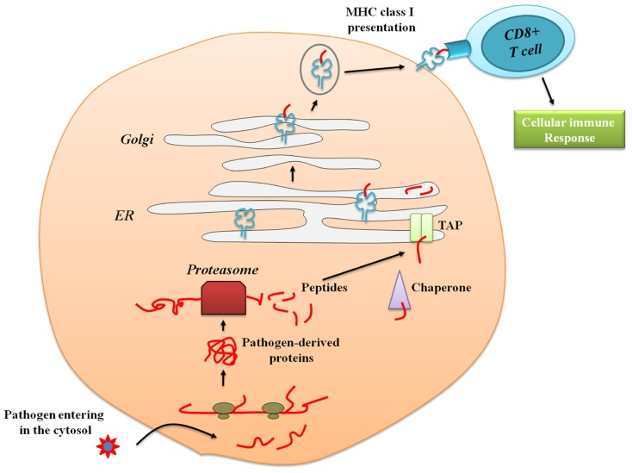
Note: Chaperones are proteins that assist others to fold properly during or after synthesis, to refold after partial denaturation, and to translocate to the cellular locales at which they reside and function. Chaperones are also involved in the regulation of their own genes and in the presentation of proteins destined for degradation by proteases. Some chaperones are themselves proteases.
The MHC II molecules are expressed by the professional antigen-presenting cells such as dendritic cells, macrophages and B cells. These cells are able to engulf extracellular antigens (exogenous) and to present them on MHC II molecules to CD4+ helper T cells. MHCII molecules (unlike MHCI) are specialized to display antigens derived from the extracellular space.
1- Following phagocytosis or endocytosis, exogenous antigens get into the endosome.
2- Later the endosome fuses with lysosomes to become endolysosomes containing proteolytic enzymes.
3- Peptides generated here from exogenous proteins or from microbes by proteolysis form a complex with MHCII molecules.
4- The associate of newly synthesized class II α and β chains in the endoplasmic reticulum (ER) with invariant chain (Ii) to form a complex that itself is incapable of binding peptides, which prevents binding of endogenous peptides into the peptide-binding pocket of MHCII.
5- Transport of the complex through the Golgi-apparatus occurs in this „blocked‟ state.
6- In the endolysosome, proteolytic enzymes degrade the invariant chain, making the binding site available for peptides derived from extracellular antigens.
- Usually 10-20 amino acids long peptides bind best to MHCII molecules, then digest invariant chain, leaving a residual class II-associated invariant chain peptide (CLIP) in the peptide-binding groove of the MHC class II. Later, the CLIP is exchanged for an antigenic peptide derived from a protein degraded in the endosomal pathway.
8- After peptide-binding the MHCII-peptide complex appears on the cell surface to present antigens to CD4+ helper T cells.

In return, activated helper T cells are able to influence the immunological functions of antigen-presenting cells in several ways:
• Activated effector T-helper cells facilitate the activation and subsequent antibody production of the antigen-presenting B cells, thus they support the humoral immune response.
• In case of antigen-presenting macrophages, the effector T-helper cells further activate them, increasing their efficiency in killing phagocytosed bacteria “settling in” in their endosomes.
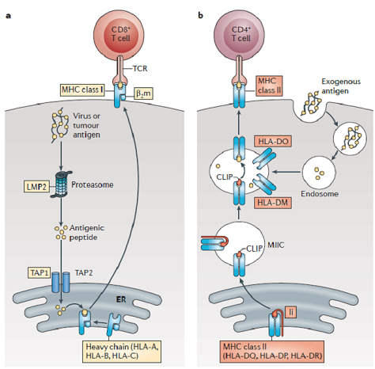

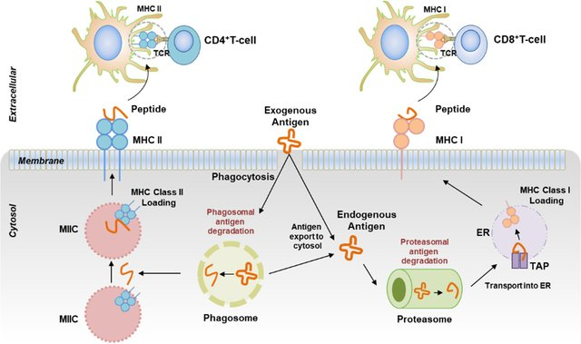

Taken together, activated CD4+ helper T cells increase the activation and facilitate the function of the antigen-presenting cells, while activated CD8+ cytotoxic T cells induce death of the antigen-presenting cells.
Naïve T cells are activated in the secondary lymphoid organs.
T cells that have not met their specific antigen can be most efficiently activated by dendritic cells. These professional antigen-presenting cells in addition to the MHC molecules express those cell surface molecules, which provide effective stimulation for naïve T cells.
Activated naïve T cells proliferate and differentiate into effector T cells, which later will be able to carry out the above-mentioned functions of cytotoxic and helper effector T cells.
Cross-presentation is the process by which exogenous antigens captured by phagocytic antigen-presenting cells are processed and presented onto MHC-I molecules to CD8 T cells (cytotoxic T cells).
Cross-presentation is of particular importance and only few dendertic cells can perform this type of presentation, because it permits the presentation of exogenous antigens, which are normally presented by MHC II on the surface of dendritic cells, to also be presented through the MHC I pathway. The MHC I pathway is normally used to present endogenous antigens that have infected a particular cell. However, cross presenting cells are able to utilize the MHC I pathway in order to remain uninfected, while still triggering an adaptive immune response of activated cytotoxic CD8+ T cells against infected peripheral tissue cells.And this type of presentation induce by Th cells through IL-2 secretion which react with its receptors on denderitic cells, which encourage this type of presentation.
This process is necessary for immunity against most tumors and viruses that do not readily infect antigen-presenting cells, but rather intracellular tumors and viruses that infect peripheral tissue cells.Cross presentation is also required for the induction of cytotoxic immunity by vaccination with protein antigens, for example, tumour vaccination.
NS. | Characteristics | MHC-I molecule | MHC -II molecule
1. | Distribution | Present on almost all nucleated cells including platelets. | Have a restricted tissue distribution and are chiefly found on macrophages, dendritic cells, B cells, and other antigen-presenting cells only.
2. | Encoding genes | MHC class I proteins are encoded by the HLA-A, HLA-B, and HLA-C genes. | MHC Class II proteins are encoded by the genes of the HLA-D region.
3. | Nature of antigen presented | Antigens presented by MHC class I molecules are of endogenous origin. | Antigens presented by MHC class II molecules are derived from extracellular proteins.
4. | Antigen | Cytosolic proteins; they sample peptides generated within the cell or those that may enter cytosol from phagosomes. | Class II molecules sample peptides outside the cell such as lysosomal proteins mostly internalized from extracellular environment.
5. | Enzymes involved in peptide generation | Cytosolic proteasome | Endosomal and lysosomal proteases
6. | Peptide loading of MHC | Endoplasmic reticulum | Specialized vesicular compartment
7. | Peptide-loading complex | Includes the ER transporter associated with antigen processing (TAP1/2), tapasin, the oxidoreductase ERp57, and the chaperone protein calreticulin. | Chaperones in ER; invariant chain in ER, Golgi and MHC Class II compartment/Class II vesicle
8. | Recognizing co-receptor | They are recognized by CD8 co-receptors through the MHC Class I β2 subunit. | They are recognized by CD4 co-receptors through β1 and β2 subunits.
9. | Receptor T cell | Present antigens to CD8+ T cells. | Present antigens to CD4+ T cells.
10. | Structure | MHC class I molecules consist of one membrane-spanning α chain produced by MHC genes, and one β chain produced by the β2-microglobulin gene. | MHC class II molecules consist of two membrane-spanning chains, α and β both produced by MHC genes.
11. | Building amino acids | Possess 8-10 amino acids. | Possess 10-20 amino acids.
12. | Peptide binding domains | α1 and α2 are peptide binding domains. | α1 and β1 are peptide binding domains.
13. | Invariant chain | Has no invariant chain. | Has an invariant chain.
14. | Functional effect | Presence of abundant antigens target cell for destruction. | Presences of foreign antigens induce antibody production.
15. | Detection Method | Serology | Serology and mixed lymphocyte reaction
Antigen-Presenting Cells (APCs)
All nucleated cells in the body have mechanisms for processing and presenting antigens in association with MHC molecules. This signals the immune system, indicating whether the cell is normal and healthy or infected with an intracellular pathogen. However, only macrophages, dendritic cells, and B cells have the ability to present antigens specifically for the purpose of activating T cells; for this reason, these types of cells are sometimes referred to as antigen-presenting cells (APCs), all APCs play a similar role in adaptive immunity, there are some important differences to consider. Macrophages and dendritic cells are phagocytes that ingest and kill pathogens that penetrate the first-line barriers (i.e., skin and mucous membranes). B cells, on the other hand, do not function as phagocytes but play a primary role in the production and secretion of antibodies. In addition, whereas macrophages and dendritic cells recognize pathogens through nonspecific receptor interactions (e.g., PAMPs, toll-like receptors, and receptors for opsonizing complement or antibody), B cells interact with foreign pathogens or their free antigens using antigen-specific immunoglobulin as receptors (monomeric IgD and IgM). When the immunoglobulin receptors bind to an antigen, the B cell internalizes the antigen by endocytosis before processing and presentting the antigen to T cells.
