Lecture 2 of Advanced Immunology
By Dr Alia Alubadi
To Recognizing nonself through
- Via pattern recognition receptors:
- Via somatically generated receptors:
2. Somatically generated receptors
Bone marrow-derived and thymus-derived lymphocytes (B cells and T cells, respectively) generate distinct receptors during development. Each lymphocyte randomly generates a unique receptor through the rearrangement and rejoining of a relatively small number of genes into a merged gene encoding the receptor, are generated randomly prior to any contact with self or nonself; therefore, each individual can generate enormous numbers of B and T cells, each with a unique receptor. A subsequent process, in which the receptors are uniquely vetted by each individual, results in the retention of a set of receptors that is individualized to that particular self and his or her nonself environment.
In addition, the initial responses of the cells of the adaptive immune system could depress responses during subsequent encounters with the same threat or stimulus due to the basis for immunologic memory, one of the hallmarks distinguishing the adaptive from the innate immune system.
The specialized receptors of B cells and T cells of the adaptive immune system are regenerated anew in the lymphocytes of each individual through random somatic chromosomal rearrangements and mutations which lead to a vast array of receptors specific for precise molecular details found in unique epitopes that may be encountered in the future.
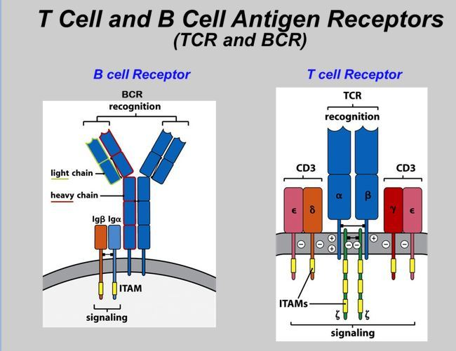

- B cell receptors: (BCRs) is a transmembrane protein on the surface of a B cell, which is composed of two light chains and two heavy chains, which are normally linked to Ig-α and Ig-β(CD79) signaling molecules which have cytoplasmic tails of lg-α and Ig-β (CD79) bearing an immunoreceptor tyrosine-based activation motif (ITAM), initiate an intracellular signalling cascade that may lead to B-cell activation which secrete immunoglobulins that have the same epitope-binding specificity as their BCR.

Note; immunoreceptor tyrosine-based activation motif (ITAM) is a highly conserved region in the cytoplasmic domain of signaling chains of adapter proteins and receptors and is a critical mediator of intracellular signals. ITAM signaling is required for the differentiation and function of B and T cells in adaptive immunity and regulates the function of innate immune cells, including natural killer cells, and myeloid cells such as macrophages, neutrophils, and dendritic cells.

- The T cell receptors TCR (structurally similar to immunoglobulin molecules) is a protein complex found on the surface composed of two different chains consists of an alpha (α) chain and a beta (β) chain , and it associated with ( expressed as part of a complex with) CD3 complex (of transmembrane surface molecules)which facilitating cell signaling and also minority of T cells express an alternate receptor consists of gamma and delta (γ/δ) chains, insteade (α&β chains). An additional accessory molecule (CD4 or CDS) is also present to serve as a type of coreceptor for the TCR.

Note: 1- CD3 is a protein complex (T cell co-receptor ) composed of four distinct chains. In mammals, the complex contains a CD3γ chain, a CD3δ chain, and two CD3ε chains (CD3-gamma, -delta, and -epsilon), that activating both the cytotoxic T cell (CD8+ naive T cells) and T helper cells (CD4+ naive T cells).

2-The ζ-chain (zeta-chain) associate with the T-cell receptor (TCR) to generate an activation signal in T lymphocytes. The zeta chain plays an important role in coupling antigen recognition to several intracellular signal-transduction pathways.
Low expression of the antigen results in impaired immune response.

The TCR, ζ-chain, and CD3 molecules together constitute the TCR complex.

3- CD4 (cluster of differentiation 4) is a glycoprotein found on the surface of immune cells such as T helper cells, monocytes, macrophages, and dendritic cells, encoded by the CD4 gene.
CD4+ T helper cells are called helper cells because one of their main roles is to send signals to other types of immune cells, including CD8 killer cells, which then destroy the infectious particle. If CD4 cells become depleted, for example in untreated HIV infection, or following immune suppression prior to a transplant, the body is left vulnerable to a wide range of infections that it would otherwise have been able to fight.
CD4 receptor is a member of the immunoglobulin superfamily, has four immunoglobulin domains (D1 to D4) that are exposed on the extracellular surface of the cell:
D1 and D3 resemble immunoglobulin variable (IgV) domains.
D2 and D4 resemble immunoglobulin constant (IgC) domains.
CD4 interacts with the β2-domain of MHC class II molecules through its D1 domain.
The short cytoplasmic/intracellular tail (C) of CD4 contains a special sequence of amino acids that allow it to recruit and interact with the tyrosine kinase Lck.

4- CD8 (cluster of differentiation 8) is a marker for cytotoxic T cell population, it is a transmembrane glycoprotein that serves as a co-receptor for the T-cell receptor (TCR), which plays a role in T cell signaling and aiding with cytotoxic T cell antigen interactions, through binds to a major histocompatibility complex MHC class I protein.
The most common form of CD8 is composed of a CD8-α and CD8-β chain( each encoded by a different gene, in humans located on chromosome 2), both members of the immunoglobulin superfamily with an immunoglobulin variable (IgV)-like extracellular domain connected to the membrane by a thin stalk, and an intracellular tail.
The CD8 co-receptor is predominantly expressed on the surface of cytotoxic T cells, but can also be found on natural killer cells, cortical thymocytes, and dendritic cells.
The extracellular IgV-like domain of CD8-α interacts with main recognition site the α3 portion (because its flexible loop) of the Class I MHC molecule, also the CD8 co-receptor plays a role in T cell signaling. The cytoplasmic tails of the CD8 co-receptor interact with Lck (lymphocyte-specific protein tyrosine kinase). Once the T cell receptor binds its specific antigen Lck phosphorylates the cytoplasmic CD3 and ζ-chains of the TCR complex which initiates a cascade of phosphorylation eventually leading to activation of transcription factors which affect the expression of certain genes.
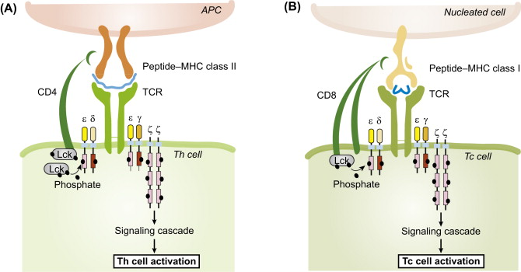
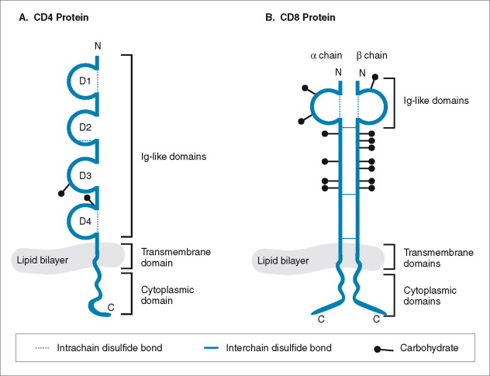
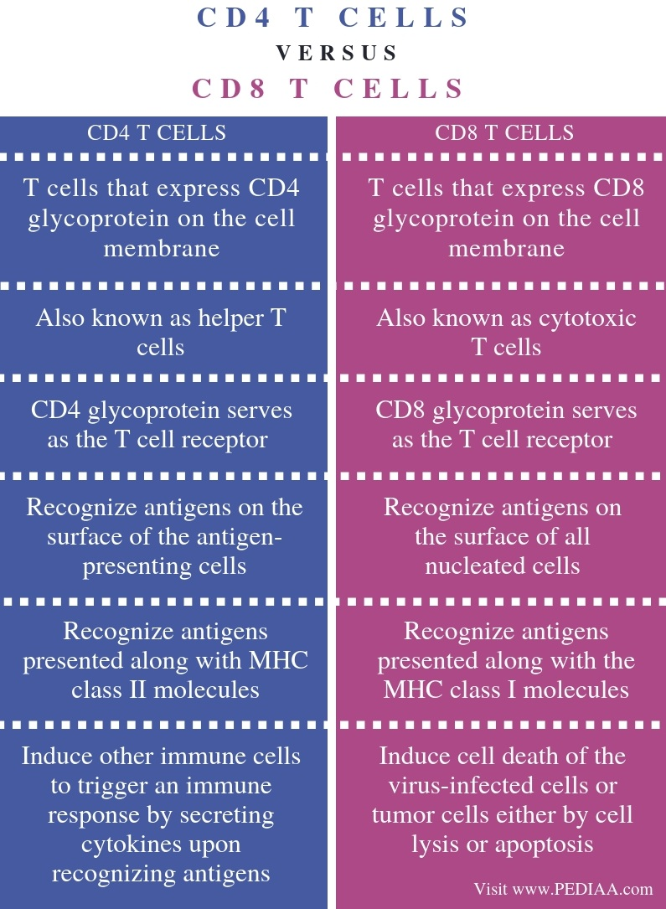

T cells that is responsible for recognizing fragments of antigen as peptides bound to major histocompatibility complex (MHC) molecules.
When the TCR engages with antigenic peptide and MHC (peptide/MHC), the T lymphocyte is activated through signal transduction, that is, a series of biochemical events mediated by associated enzymes, co-receptors, specialized adaptor molecules, and activated or released transcription factors. Based on the initial receptor triggering mechanism, the TCR belongs to the family of Non-catalytic tyrosine-phosphorylated receptors (NTRs).
Each chain consists of a variable region at its amino terminus and a constant region at its carboxy terminus. The variable regions of the chains are determined by the rearrangement of the DNA encoding them and the production of an mRNA transcript, including both the variable and constant regions. Splicing of the mRNA that is then translated into the polypeptide chains unites the variable and constant regions.

DNA chromosomal rearrangement is responsible for a significant portion of epitope-specific diversity among T and B cell receptors. Rearangment occurs at both the DNA and RNA levels by the deletion of nucleotides, followed by reannealing, to bring together gene segments that were previously separated

V(D)J recombination is the mechanism of somatic recombination that occurs only in developing lymphocytes during the early stages of T and B cell maturation. It results in the highly diverse of antibodies/immunoglobulins and T cell receptors (TCRs) found in B cells and T cells, respectively.
V(D)J recombination in mammals occurs in the primary lymphoid organs (bone marrow for B cells and thymus for T cells) and in a nearly random fashion rearranges variable (V), joining (J), and in some cases, diversity (D) gene segments.
Human antibody molecules are composed of heavy and light chains, each of which contains both constant (C) and variable (V) regions, genetically encoded on three loci:
1- The immunoglobulin heavy locus on chromosome 14, containing the gene segments for the immunoglobulin heavy chain.
2- The immunoglobulin kappa (κ) locus on chromosome 2, containing the gene segments for part of the immunoglobulin light chain.
3- The immunoglobulin lambda (λ) locus on chromosome 22, containing the gene segments for the remainder of the immunoglobulin light chain,
The heavy chain region contains 2 constant (Cμ and Cδ) gene segments and 44 Variable (V) gene segments, plus 27 Diversity (D) gene segments and 6 Joining (J) gene segments, while the light chain region contains multiple copies of three different types of gene segments consist of constant gene segments with numerous V and J gene segments but do not have D gene segments.
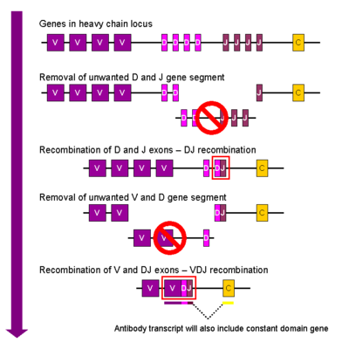

DNA rearrangement causes one copy of each type of gene segment to go in any given lymphocyte, generating an enormous antibody repertoire.
The T cell receptor genes are similar to immunoglobulin genes in that they too contain multiple V, D, and J gene segments in their beta chains (and V and J gene segments in their alpha chains) that are rearranged during the development of the lymphocyte to provide that cell with a unique antigen receptor. The T cell receptor in this sense is the topological equivalent to an antigen-binding fragment of the antibody, both being part of the immunoglobulin superfamily.
An autoimmune response is prevented by eliminating cells that self-react. This occurs in the thymus by testing the cell against an array of self-antigens expressed through the function of the autoimmune regulator (AIRE).

Note; AIRE is a transcription factor expressed in the medulla (inner part) of the thymus. It is part of the mechanism which eliminates self-reactive T cells that would cause autoimmune disease. It exposes T cells to normal, healthy proteins from all parts of the body, and T cells that react to those proteins are destroyed.

Through the action of AIRE, medullary thymic epithelial cells (mTEC) express major proteins from elsewhere in the body (so called "tissue-restricted antigens" - TRA) and T cells that respond to those proteins are eliminated through cell death (apoptosis). Thus AIRE drives negative selection of self-recognizing T cells. When AIRE is defective, T cells that recognize antigens normally produced by the body can exit the thymus and enter circulation. This can result in a variety of autoimmune diseases.

A cell persists if it creates a successful product that does not self-react, otherwise, it is pruned via apoptosis.
D-to-J recombination occurs first in the β-chain of the TCR. This process can involve either the joining of the Dβ1 gene segment to one of six Jβ1 segments or the joining of the Dβ2 gene segment to one of six Jβ2 segments.

DJ recombination is followed (as above) with Vβ-to-DβJβ rearrangements. All gene segments between the Vβ-Dβ-Jβ gene segments in the newly formed complex are deleted and the primary transcript is synthesized that incorporates the constant domain gene (Vβ-Dβ-Jβ-Cβ). mRNA transcription splices out any intervening sequence and allows translation of the full length protein for the TCR β-chain.
The rearrangement of the alpha (α) chain of the TCR follows β chain rearrangement, and resembles V-to-J rearrangement described for Ig light chains. The assembly of the β- and α- chains results in formation of the αβ-TCR that is expressed on a majority of T cells.
The process of V(D)J recombination is mediated by VDJ recombinase, which is a diverse collection of enzymes, several enzymes are known to be involved in the process and include recombination activating genes 1 and 2 (RAG), terminal deoxynucleotidyl transferase (TdT), and Artemis nuclease, a member of the ubiquitous non-homologous end joining (NHEJ) pathway for DNA repair, DNA-dependent protein kinase (DNA-PK), and DNA polymerases λ and μ.
The process ultimately results in novel amino acid sequences in the antigen-binding regions of immunoglobulins and TCRs that allow for the recognition of antigens from nearly all pathogens including bacteria, viruses, parasites, and worms as well as "altered self cells" as seen in cancer. The recognition can also be allergic in nature (e.g. to pollen or other allergens) or may match host tissues and lead to autoimmunity.

The differences between immunoglobulins and T cell Receptors:
1. Ig is found on the membrane and can be secreted, T cell receptors are only on the membrane.
2. Ig can bind to free antigen. TCR requires antigen presentation cells (APC) before it can bind.
3. Ig has two Ag binding sites (bivalent). TCR only has one antigen-binding site (monovalent)
4. Ig can bind to protein, carbohydrates, lipids, nucleic acid Ag. TCR can only bind to peptide Ag in MHC binding region.

Immune Tolerance
the state of unresponsive of the immune system to the antigen (autoantigens) known as immune tolerance (self-tolerance) if self-tolerance fails response to self-antigen lead to autoimmunity that means immune system attack and damage on molecules, cells, tissues, organs.
Self-tolerance achieved by various mechanisms
- First step; Central tolerance refers to the primary central lymphoid organ (bone marrow and thymus) where are lymphocytes were developed and express their antigens receptors, bone marrow and thymus also provide the growth factors and other molecular signals for lymphocytes maturation, this mechanism comprise of eliminate most auto reactive T &B cells during the early maturation or development.
Note; The role of AIRE in the thymus is to induce the expression of many proteins that are not typically expressed in thymic cells, such as proteins characteristic of the lungs. In this way, developing T cells are exposed to many peptide-MHC complexes, not just those normally expressed by thymic cells, thereby preventing autoimmunity once T cells leave the thymus.
- Second step; Peripheral tolerance refer to peripheral or secondary lymphoid organs, which include spleen, lymph nodes and the component of the mucosal immune system, the job of these organs is to capture and concentrate pathogens (foreign antigen), the second job of peripheral lymphoid organs is prevents auto reactive mature lymphocyte from attacking self-antigens, by peripheral clonal deletion T-cells when self-antigen appear in human body DC present these protein on its surface, when no infection there is no danger signals so cannot or very low express co-stimulatory molecules, now DCs present these self-antigens to naive T cells and these T cell receives first signal for its activation but co stimulation molecule is absent on DCs, which lead to apoptosis of T cells that lead to toleration.
- Anergy is a third processes that induce tolerance, modifying the immune system to prevent self-destruction (the others being clonal deletion and immunoregulation).
Anergy is defined as the lack of responsiveness to an antigen despite the presence of antigen-specific lymphocytes. Investigators hypothesized that if anergy is a credible process to explain tolerance to self, anergic cells would persist but would fail to respond to antigenic stimulation.
There are three types of selection
- Non selection because no interaction and cause cell death. TCR recognition of MHC complexes. When a TCR binds an antigen-MHC complex displayed by a sick or infected cell, the T cell can induce cell death called apoptosis (top).
- Positive selection due to moderate interaction and lead to survival all. T cells in the thymus that bind moderately to MHC complexes receive survival signals (middle). Further, this positive selection process also determines if a T cell will become a CD8+ T cell or a CD4+ T cell.
- Negative selection (clonal deletion) due to very strong interaction, because these cells carrying receptors that bind to self-antigens with high affinity and cause to cell death. T cells whose TCRs bind too strongly to MHC complexes, and will likely be self-reactive, are killed in the process of negative selection (bottom).

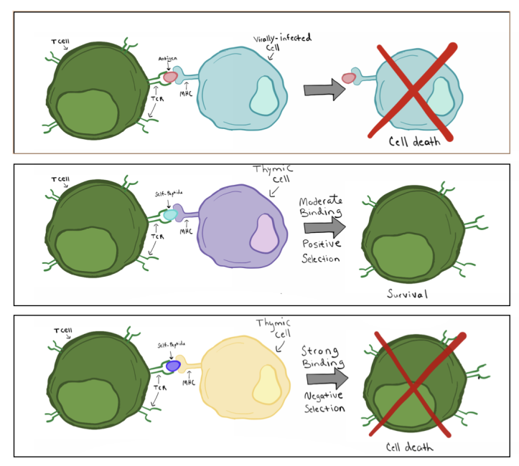

ثة أنواع من الاختيار
1- عدم الانتقاء لعدم وجود تفاعل ويسبب موت الخلايا. اعتراف TCR لمجمعات MHC. عندما يرتبط TCR بمركب مستضد-معقد التوافق النسيجي الكبير المعروض بواسطة خلية مريضة أو مصابة ، يمكن للخلية التائية أن تحفز موت الخلية الذي يسمى موت الخلايا المبرمج (أعلى)
2- الانتقاء الإيجابي بسبب تفاعل معتدل ويؤدي إلى بقاء الجميع. تستقبل الخلايا التائية الموجودة في الغدة الصعترية والتي ترتبط بشكل معتدل بمجمعات معقد التوافق النسيجي الكبير إشارات البقاء (في الوسط). علاوة على ذلك ، تحدد عملية الاختيار الإيجابي هذه أيضًا ما إذا كانت الخلية التائية ستصبح خلية CD8 + T أو خلية CD4 + T.
3-الانتقاء السلبي بسبب التفاعل القوي جدا ويسبب موت الخلايا. تُقتل الخلايا التائية التي ترتبط TCRs بشدة بمجمعات معقد التوافق النسيجي الكبير ، ومن المحتمل أن تكون ذاتية التفاعل ، في عملية الاختيار السلبي (أسفل).

