Lecture 1 of Advanced Immunologyتحتاج الى اعادة قراءة لحذف المتكرر
By Dr Alia Alubadi
The term immunogenicity (immunogenicity, induce &immunogenic) refers to the ability of a substance to induce cellular and humoral immune response, while antigenicity (antigenicity, attach&antigen) is the ability to be specifically recognized by the antibodies generated as a result of the immune response to the given substance.
The immune system comprises both innate and adaptive immune responses. Innate immunity occurs naturally because of genetic factors or physiology; it is not induced by infection or vaccination but works to reduce the workload for the adaptive immune response. Both the innate and adaptive levels of the immune response involve secreted proteins, receptor-mediated signaling, and intricate cell-to-cell communication.
To Recognizing nonself through
- Via pattern recognition receptors:
- Via somatically generated receptors:

- Via pattern recognition receptors:
Physical and Chemical Barriers
1- The skin functions as a barrier, the skin by desiccation (drying out) and by the skin’s acidity and beneficial microorganisms that coexist on the skin compete with invading pathogens, preventing infection.
2- Tears and mucus secretions that trap and rinse away pathogens, and cilia in the nasal passages and respiratory tract that push the mucus with the pathogens out of the body.
3- The low pH of the stomach (which inhibits the growth of pathogens),
4- Blood proteins that bind and disrupt bacterial cell membranes, and the process of urination (which flushes pathogens from the urinary tract).
Some pathogens have evolved specific mechanisms that allow them to overcome physical and chemical barriers. When pathogens do enter the body, the innate immune system responds with inflammation, pathogen engulfment, and secretion of immune factors and proteins.
5- Pathogen Recognition and Preformed receptors
An infection may be intracellular or extracellular, depending on the pathogen. All viruses are (intracellularly), whereas bacteria and other parasites may replicate intracellularly or extracellularly, depending on the species, pathogen detect the specific pathogen-associated molecular patterns (PAMPs) on the pathogen’s surface by immune system cells receptors that recognize these PAMPs via complementary pattern recognition receptors (PRRs).
PAMPs are carbohydrate, polypeptide, and nucleic acid “signatures” that are expressed by viruses, bacteria, and parasites but which differ from molecules on host cells.
Toll-like receptors (TLRs) are a type of Pattern Recognition Receptors (PRRs) are proteins molecules, that play a key role in the innate immune system, capable of recognizing molecules frequently found in pathogens (the so-called Pathogen-Associated Molecular Patterns—PAMPs), or molecules released by damaged cells (the Damage-Associated Molecular Patterns—DAMPs). They are single-pass membrane-spanning receptors usually expressed on macrophages and dendritic cells, that recognize microbes which activate immune cell responses. The TLRs include TLR1, TLR2, TLR3, TLR4, TLR5, TLR6, TLR7, TLR8, TLR9, TLR10, TLR11, TLR12, and TLR13.
TLRs mediate the generation of defensive responses that include transcriptional activation, synthesis, and secretion of cytokines to promote inflammation, and the attraction of macrophages, neutrophils, natural killer (NK) cells, and dendritic cells to the site of infection.
MHC I molecules are proteins on the surfaces of all nucleated cells, thus they are scarce on red blood cells and platelets which are non-nucleated. The function of MHC I molecules is to display fragments of proteins from the infectious agents within the cell to T-cells; healthy cells will be ignored, while “non-self” or foreign proteins will be attacked by the immune system.
An infected cell by some viruses(or a tumor cell) produce proteins that interfere with MHC I processing and/or trafficking to the cell surface, varies from virus to virus and results from active inhibitors being produced by the viruses, which NK cells detect as “unhealthy” or “abnormal” while searching for cellular MHC I molecules, and its cytoplasm secretes granules comprised of perforin, a destructive protein that creates a pore in the target cell. Granzymes are released along with the perforin in the immunological synapse.
A granzyme is a protease that digests cellular proteins and induces the target cell to undergo programmed cell death, or apoptosis. Phagocytic cells then digest the cell debris left behind. NK cells are constantly patrolling the body and are an effective mechanism for controlling potential infections and preventing cancer progression.
MHC II molecules are found mainly on cells containing antigens (“non-self proteins”) and on lymphocytes. MHC II molecules interact with helper T-cells to trigger the appropriate immune response, which may include the inflammatory response.
6- Natural Killer Cells
Lymphocytes are leukocytes that are histologically identifiable by their large, darkly staining nuclei; with very little cytoplasm. Infected cells are identified and destroyed by natural killer (NK) cells, lymphocytes that can kill cells infected with viruses or tumour cells.
NK cells identify intracellular infections, especially from viruses, by the altered expression of major histocompatibility class (MHC) I molecules on the surface of infected cells.
Natural killer (NK) cells bear killer activation receptors (KARs) that detect stress-related molecules, MICA and MICB, and killer inhibition receptors (KIRs) that detect MHC class I molecules on nucleated cells in the body.
7- Complement receptors: The complement system is a complex set of soluble molecules that generate various reactions that attract immune cells to the site of infection and lead to destruction of microbes. Cell-surface bound complement receptors on phagocytic cells and B cells recognize these bound complement fragments and facilitate the binding, ingestion, and internal degradation of the tagged microbes.
8- Fc receptor is a protein found on the surface of certain cells – including, among others, B lymphocytes, follicular dendritic cells, natural killer cells, macrophages, neutrophils, eosinophils, basophils, human platelets, and mast cells – that contribute to the protective functions of the immune system. They allow these cells to bind to antibodies that are attached to the surface of microbes or microbe infected cells, helping these cells to identify and eliminate microbial pathogens.
Their activity stimulates phagocytic or cytotoxic cells to destroy microbes, or infected cells by antibody-mediated phagocytosis or antibody-dependent cell-mediated cytotoxicity.
The common classes of Fc-receptors, those that bind IgG, are called Fc-gamma receptors (FcγR), those that bind IgA are called Fc-alpha receptors (FcαR) and those that bind IgE are called Fc-epsilon receptors (FcεR).
Cytokine Release Affect
The binding of PRRs with PAMPs triggers the release of cytokines, which signal that a pathogen is present and needs to be destroyed along with any infected cells.
A cytokine is a chemical messenger that regulates cell differentiation (form and function), proliferation (production), and gene expression to affect immune responses. At least 40 types of cytokines exist in humans that differ in terms of the cell type that produces them, the cell type that responds to them, and the changes they produce.
1- Interleukins are involved in bridging the innate and adaptive immune responses. Interleukins are a group of cytokines (secreted proteins and signal molecules) that were first seen to be expressed by white blood cells (leukocytes).
2- Interferons are a group of signaling proteins made and released by host cells in response to the presence of several viruses.
One of the functions of interferon is to inhibit viral replication. They also have other important functions, such as tumour surveillance. Interferons work by signalling neighbouring uninfected cells to destroy RNA and reduce protein synthesis, signalling neighbouring infected cells to undergo apoptosis (programmed cell death), and activating immune cells.
In response to interferons, uninfected cells alter their gene expression, which increases the cells’ resistance to infection. One effect of interferon-induced gene expression is a sharply reduced cellular protein synthesis. Virally infected cells produce more viruses by synthesizing large quantities of viral proteins. Thus, by reducing protein synthesis, a cell becomes resistant to viral infection.
The adaptive much longer than the innate response; and more specific to pathogens and has memory. There are two types of adaptive responses: the cell-mediated immune response, which is carried out by T cells, and the humoral immune response, which is controlled by activated B cells and antibodies.
Unlike NK cells of the innate immune system, B cells (B lymphocytes) are gives rise to antibodies, whereas T cells (T lymphocytes) are a key component in the cell-mediated response—the specific immune response that utilizes T cells to neutralize cells that have been infected with viruses and certain bacteria. There are three types of T cells: cytotoxic, helper, and suppressor T cells. Cytotoxic T cells destroy virus-infected cells in the cell-mediated immune response, and helper T cells play a part in activating both the antibody and the cell-mediated immune responses. Suppressor T cells deactivate T cells and B cells when needed, and thus prevent the immune response from becoming too intense.
An antigen-presenting cell (APC) is an immune cell that detects, engulfs, and informs the adaptive immune response about an infection, and digest it to form many different fragments of the antigen, then be transported to the surface of the APC, where they will serve as an indicator to other immune cells. Dendritic cells are immune cells that process antigen material; they are present in the skin (Langerhans cells) and the lining of the nose, lungs, stomach, and intestines. Sometimes a dendritic cell presents on the surface of other cells to induce an immune response, thus functioning as an antigen-presenting cell. Macrophages also function as APCs. Before activation and differentiation, B cells can also function as APCs.
After phagocytosis by APCs, the phagocytic vesicle fuses with an intracellular lysosome forming phagolysosome. Within the phagolysosome, the components are broken down into fragments; the fragments are then loaded onto MHC class I or MHC class II molecules and are transported to the cell surface for antigen presentation.
Note that T lymphocytes cannot properly respond to the antigen unless it is processed and embedded in an MHC II molecule. APCs express MHC on their surfaces, and when combined with a foreign antigen, these complexes
T and B Lymphocytes
Lymphocytes in human circulating blood are approximately 80 to 90 percent T cells, and 10 to 20 percent B cells.
T cells encompass a heterogeneous population of cells with extremely diverse functions. Some T cells respond to APCs of the innate immune system, and indirectly induce immune responses by releasing cytokines. Other T cells stimulate B cells to prepare their own response. Another population of T cells detects APC signals and directly kills the infected cells. Other T cells are involved in suppressing inappropriate immune reactions to harmless or “self” antigens.
T and B cells exhibit a common theme of recognition/binding of specific antigens via a complementary receptor, followed by activation and self-amplification/maturation to specifically bind to the particular antigen of the infecting pathogen.
T and B lymphocytes are also similar in that each cell only expresses one type of antigen receptor, when they recognize small components of antigens, called epitopes “antigenic determinants” , presented by APCs, In the absence of information from APCs, T and B cells remain inactive, or naïve, and are unable to prepare an immune response. The requirement for information from the APCs of innate immunity to trigger B cell or T cell activation illustrates the essential nature of the innate immune response to the functioning of the entire immune system.
Naïve T cells can express CD4 or CD8, on their surface, which regulate how a T cell will interact with and respond to an APC. Naïve CD4+ cells bind APCs via their antigen-embedded MHC II molecules and are stimulated to become helper
T (TH) lymphocytes, cells that go on to stimulate B cells (or cytotoxic T cells) directly or secrete cytokines to inform more and various target cells about the pathogenic threat. In contrast, CD8+ cells engage antigen-embedded MHC I molecules on APCs and are stimulated to become cytotoxic T lymphocytes (CTLs), which directly kill infected cells by apoptosis and emit cytokines to amplify the immune response. A single T cell will express thousands of identical copies of one specific TCR variant on its cell surface. The specificity of the adaptive immune system occurs because it synthesizes millions of different T cell populations, each expressing a TCR that differs in its variable domain. This TCR diversity is achieved by the mutation and recombination of genes that encode these receptors in stem cell precursors of T cells. The binding between an antigen-displaying MHC molecule and a complementary TCR “match” indicates that the adaptive immune system needs to activate and produce that specific T cell because its structure is appropriate to recognize and destroy the invading pathogen.
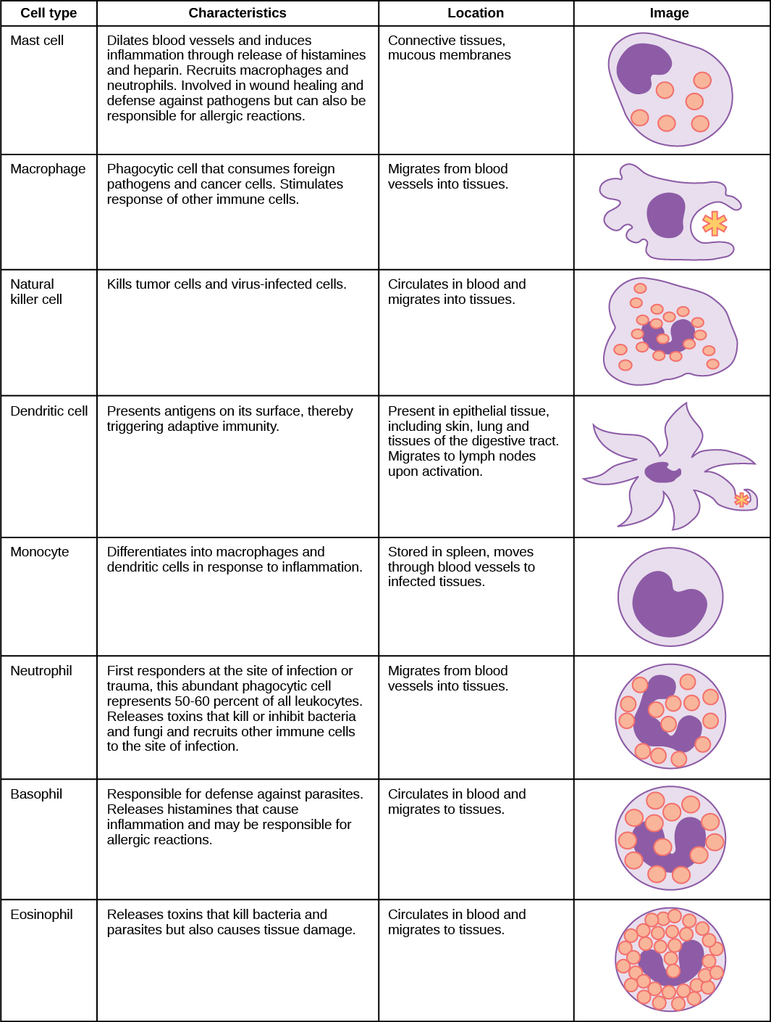

signal a “non-self” invader. 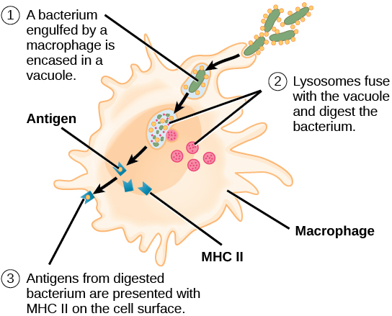
Immunologic memory
Immunologic memory. The innate immune system reacts to a given stimulus with a consistent intensity, regardless of how many times it has been exposed to that stimulus.
The adaptive immune system can adapt and modify its response after each exposure to a given stimulus.

