Parasitology lecture 2 Biotechnology 3ed stage by Dr Alia Alubadi
Specimens are selected for laboratory diagnosis:
a) Blood – in those parasitic infections where the parasite itself in any stage of its development circulates in the bloodstream, the examination of blood film forms one of the main procedures for specific diagnosis. For example, in malaria, the parasites are found inside the red blood cells.
b) Stool – examination of the stool forms an important part in the diagnosis of intestinal parasitic infections and also for those helminthic parasites. In protozoan infections, either trophozoites or cystic forms may be detected; Example, Amoebiasis, Giardiasis, etc.
In the case of helminthic infections, the adult worms, their eggs, or larvae are found in the stool.
c) Urine – when the parasite localizes in the urinary tract, the examination of the urine will be of help in establishing the parasitological diagnosis. For example in urinary Schistosomiasis, eggs of Schistosoma haematobium are found in the urine.
d) Sputum – examination of the sputum is useful in the following:
• In cases where the habitat of the parasite is in the respiratory tract, as in Paragonimiasis, the eggs of Paragonimus westermani are found.
• In amoebic abscess of lung or in the case of amoebic liver abscess bursting into the lungs, the trophozoites of E. histolytica are detected in the sputum.
e) Biopsy material - varies with different parasitic infections. For example spleen punctures in cases of kala-azar, muscle biopsy in cases of Cysticercosis,
f) Urethral or vaginal discharge – for Trichomonas vaginalis.
Prevention and control
Preventive measures designed to break the transmission cycle are crucial to successful parasitic eradication. Such measures include:
- Reduction of the source of infection- the parasite is attacked within the host, thereby preventing the dissemination of the infecting agent. Therefore, a prompt diagnosis and treatment of parasitic diseases is an important component in the prevention of dissemination.
- Sanitary control of drinking water and food.
- Proper waste disposal – through establishing safe sewage systems, use of screened latrines, and treatment of night soil.
- The use of insecticides and other chemicals used to control the vector population.
- Protective clothing that would prevent vectors from resting in the surface of the body and inoculate pathogens during their blood meal.
- Good personal hygiene.
- Avoidance of unprotected sexual practices.
Parasitology Classification
Parasites of medical significance are divided into two main categories that include single-celled parasites (protozoa) and multicellular metazoa (helminths and arthropods).
(1) PROTOZOA
Protozoa (singular, unicellular, protozoan), may be distinguished from other eukaryotic protists by their ability to move at some stage of their life cycle and by their lack of cell wall.
Protozoa reproduce sexually and asexually
- Asexually: Fission (mitosis), Budding, Schizogony
- Sexually: Conjugation, Gamete formation
 Definitive Host harbors the sexually reproducing stage of parasite
 Intermediate Host harbors asexually reproducing stages of the parasite’s life cycle
❑ Movement:
- A single or multiple flagella
- Cilia, Balantidium
- Pseudopodia, Enramoeba
- No obvious means of locomotion,
Morphology of protozoa
Protozoa are predominantly microscopic, they are within a mass of protoplasm, consisting of a true membrane –bound nucleus and cytoplasm.
The nucleus contains clumped or dispersed chromatin and central nucleolus or karyosome, which are useful structures to distinguish protozoan species from one another based on the shape, size and distribution of these structures.
Classification of protozoa
Protozoa of medical importance are classified based on their morphology and locomotive system as described below:
1-Sarcodina - Entamoeba histolytica
2-Flagellates - Giarda lamblia, Trichomonas vaginalis, Trypanosoma spp, Leishmania spp
3-Cliliophora - Balantidium coli
4-Coccidian - Cryptosporidium parvum, Toxoplasma gondii, Plasmodium species
Protozoan pathogens can also be grouped according to the location in the body where they most frequently cause disease.
1- Sarcodina (Amoebas)
Unicellular microorganisms with a relatively simple life cycle which can be divided into two stages:
• Trophozoite – actively motile feeding stage.
• Cyst – a protective stage for parasite, resistant to exist outside of the host, infective stage.
Their reproduction is through binary fission, e.g. splitting of the trophozoite or through the development of numerous trophozoites with in the mature multinucleated cyst.
Motility by pseudopodia (“false foot”).
1-Entamoeba histolytica
Morphological features
(a) Trophozoites
Viable trophozoites about 10-60μm in diameter.
Motility is rapid, progressive, and unidirectional, through pseudopods.
Nucleus: chromatin arranged on the nuclear membrane and the presence of a small, compact, centrally located karyosome.
Cytoplasm: described as finely granular with few ingested bacteria or debris in vacuoles.
(b) Cyst
Cysts range from 10-20μm. The immature cyst has inclusions namely; glycogen mass and chromatoidal bars. As the cyst matures, the glycogen completely disappears; the chromotiodials may also be absent in the mature cyst.
Life cycle
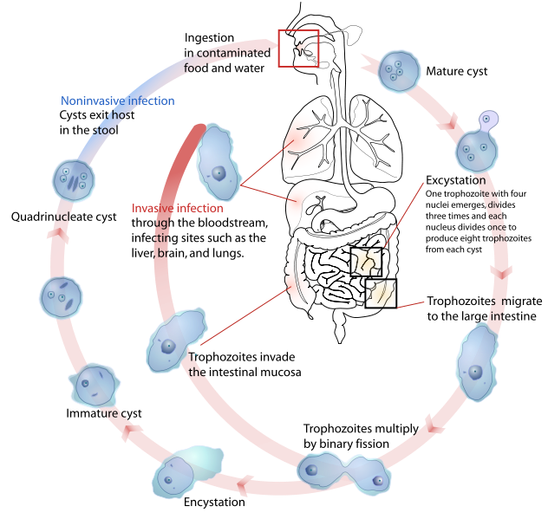
It is usually transmitted by the faecal-oral route by contamination, by anal-oral contact or by contact with dirty objects. Infection is spread by ingesting mature quadric nucleate infective cyst, contaminated food or drink and also by hand to mouth contact, the cyst wall is resistant to gastric juice. In terminal ileum (with alkaline pH), excystation takes place, rophozoites being actively motile invade the tissues and ultimately lodge in the submucous layer of the large bowel, multiply by binary fission. Trophozoites are responsible for producing lesions in amoebiasis, while extra intestinal lesions occur by invasion of blood vessel.
Pathogenesis
Most infections are asymptomatic and the disease is diagnosed as amoebic dysentery (primary amoebiasis) or amoebic liver abscess (secondary amoebiasis).
Trophozoites divide and produce extensive local necrosis in the large intestine. Invasion into the deeper mucosa with extension into the peritoneal cavity may occur. This can lead to secondary involvement of other organs, primarily the liver but also the lungs, brain, and heart. Extraintestinal amebiasis is associated with trophozoites. Amoebas multiply rapidly in an anaerobic environment, because the trophozites are killed by ambient oxygen concentration.
Clinical features
Amoebic dysentery (primary amoebiasis) causes diarrhoea, flatulence, and cramping. More severe disease is characterised by bloody stools. Systemic (secondary amoebiasis or extraintestinal amebiasis) signs of infection (fever, leukocytosis, rigors). The liver is primarily involved, because trophozoites in the blood are removed from the blood by the portal veins. The right lobe is most commonly involved, thus pain over the liver with hepatomegaly and elevation of the diaphragm is observed.
Laboratory diagnosis
- In intestinal amoebiasis:
• Examination of a fresh dysenteric fecal specimen or rectal scraping for
- trophozoite stage. (Motile amoebae containing red cells are diagnostic of amoebic dysentery) while Cyst stage indicate infection with either a pathogenic E.histolytica or non-pathogenic E.dispar.) Extraintestinal amoebiasis
• By scanning procedures for liver and other organs.
• Specific serologic tests, can confirm the diagnosis.

Prevention
Prevention depends on better personal hygiene and sanitary disposal of human excreta. Avoid eating raw vegetables grown by sewerage irrigation and night soil.
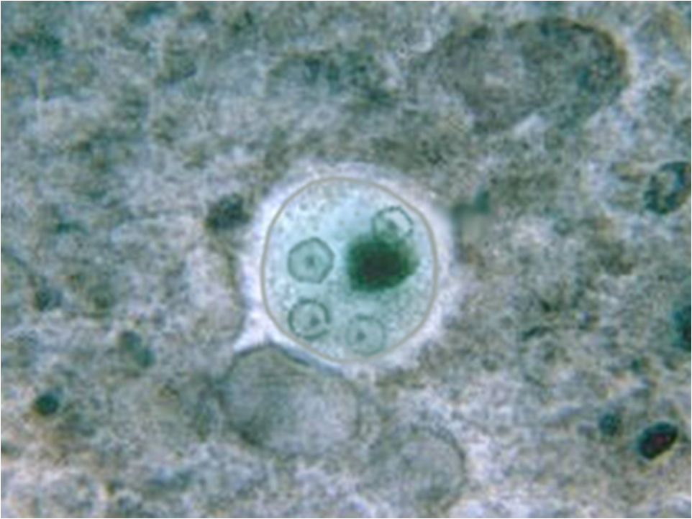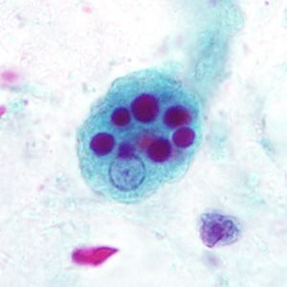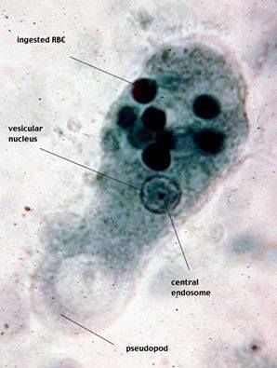
Other amebae inhabiting the alimentary canal
Most of these amoebae are commensal organisms that can parasitize the human gastrointestinal tract, and infection are acquired by ingestion of contaminated food or water with cyst-bearing faeces, the life cycle stages include; trophozoite, cyst. Prevention like E. histolytica
Entamoeba gingivalis
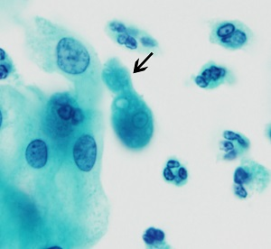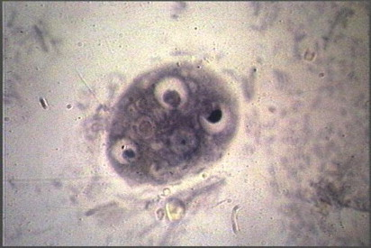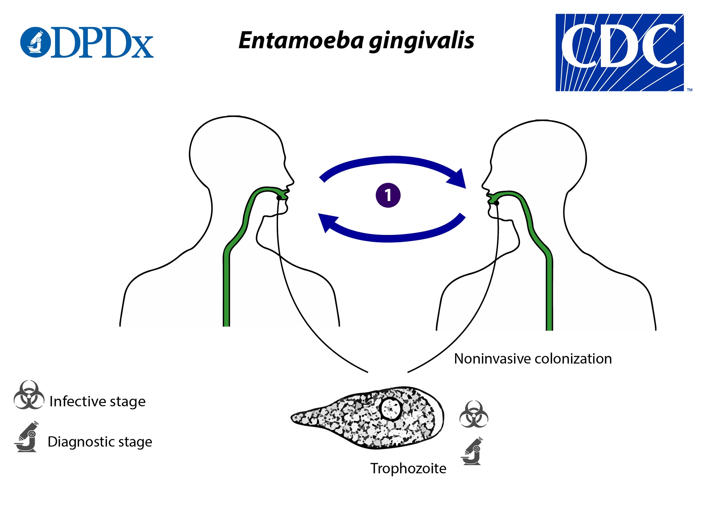
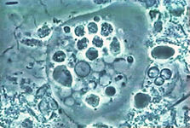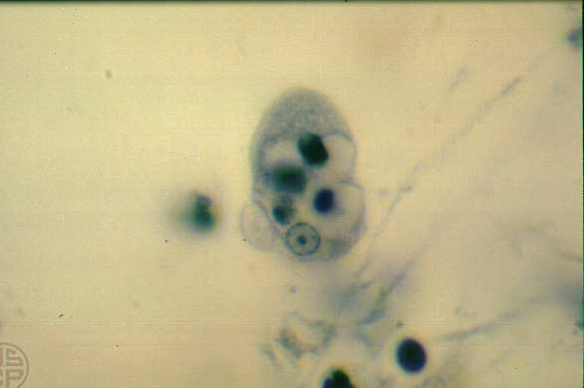
Entamoeba gingivalis is a non-pathogenic ameba that inhabits the human oral cavity and occasionally other sites, only the trophozoite stage presents. Trophozoite in the smear of tartar material from around teeth (iron hematoxylin stain, oil immersion). This trophozoite shows a prominent nucleus containing a punctate karyosome and fine, evenly distributed peripheral chromatin. The densely staining round bodies within food vacuoles in the cytoplasm are degenerating leukocytes. The nucleus of this species closely resembles the nucleus of E. histolytica, but the source of the organism from the mouth and the presence of ingested leukocytes differentiate it from E. histolytica. E. gingivalis has no cyst stage.
Entamoeba hartmanni
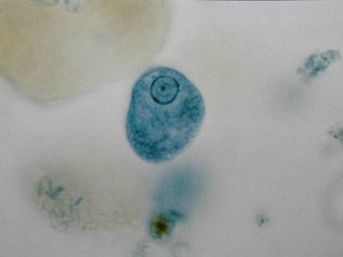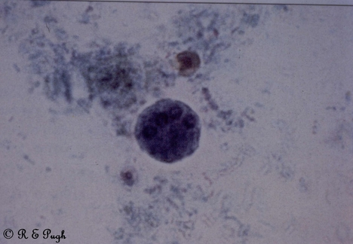
Entamoeba coli
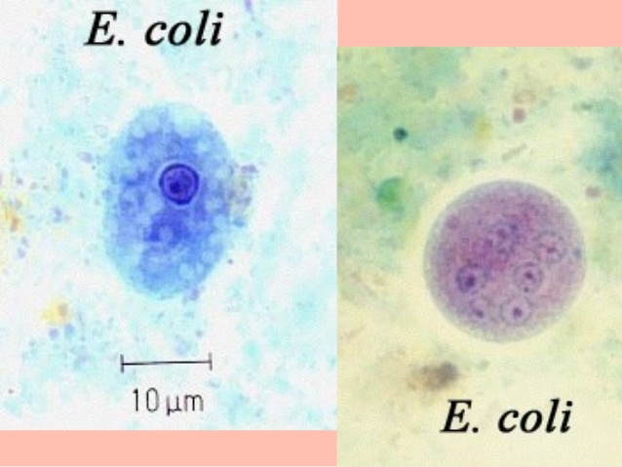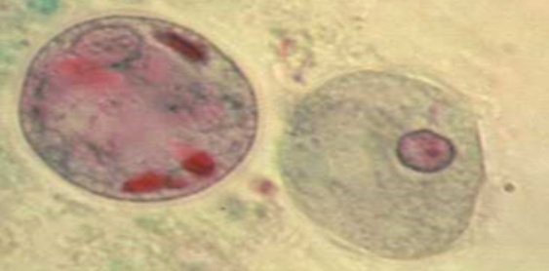
Endolimax nana:
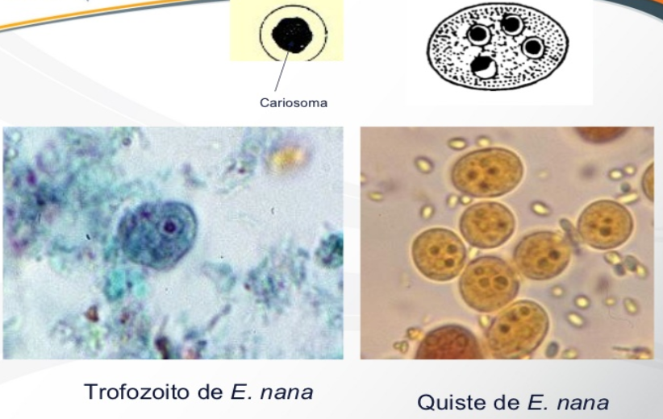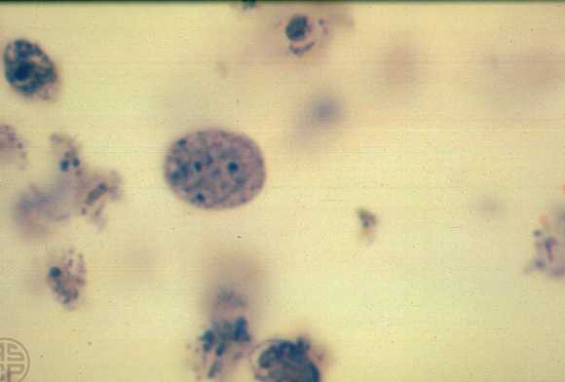
Iodamoeba buetschlii:
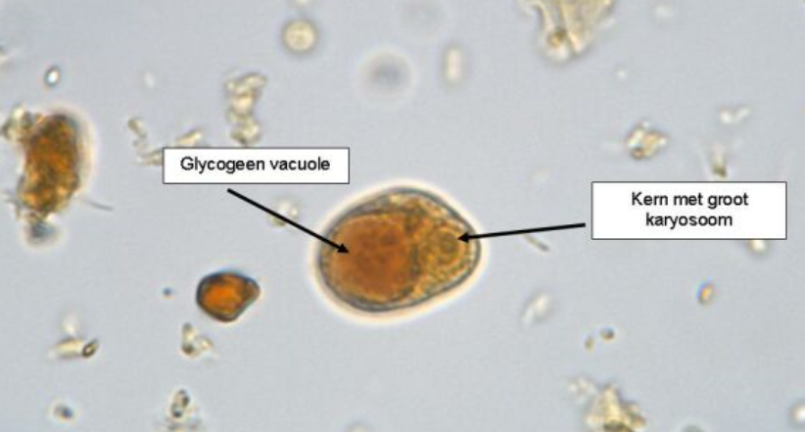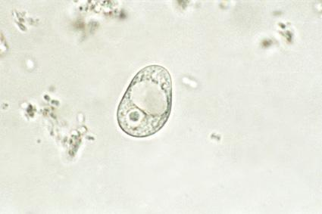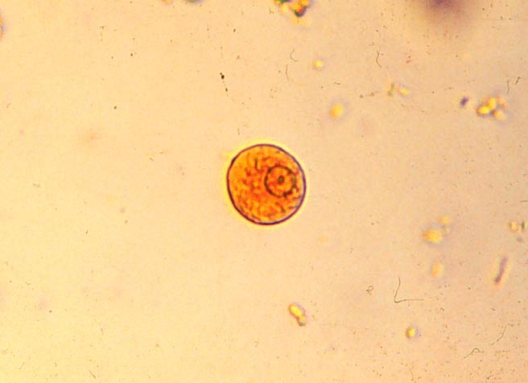

Characteristics | E. histolytica, E. dispar and E. moshkovskiib | Entamoeba hartmanni | Entamoeba coli | Endolimax nana | Iodamoeba buetschlii
Trophozoites (size, nucleus, and movement) | 15-20 μm; 1 nucleus; actively motile cytoplasmic protrusions, quickly finger shaped pseudopodium | 8-10 μm; 1 nucleus; nonsuccessive | 20-25 μm; 1 nucleus; slow movement, short and blunt pseudopodium | 7-9 μm; 1 nucleus, blunt and hyaline pseudoodium, slow movements | 9-14 μm; 1 nucleus, slow movement, nonsuccessive, hyaline pseudopodium
Cysts (size, nucleus) | 12-15 μm; mature cyst has 4 nuclei, immature cyst has 1 or 2 nuclei | 6-8 μm; mature cyst has 4 nuclei; immature cyst has 1 or 2 nuclei; 2 nucleated cysts very common | 15-25 μm; mature cyst has 8 nuclei, rarely 16 or more nuclei | 6-8 μm; 4 nuclei | 10-12 μm; 1 nucleus
Appearance of trophozoites | Stained trophozoites fine, uniform granules of peripheral chromatin, and small central karyosome in nucleus; ingested RBC (E. dispar and E. moshkovskii are similar to E.histolytica trophozoites, sometimes ingested RBCs) | Nuclear structure similar to E. histolytica; ingested bacteria; cytoplasm finely granular | Nuclear with irregular cluster of peripheral chromatin; large, irregular, eccentric karyosome | Nucleus with large karyosome; no peripheral chromatin | Large central karyosom, granular cytoplasm
Appearance of cysts | Uniform size in having both karyosome and peripheral chromatin, typical nuclear structure, chromatodial bars with squared or rounded ends | Typical nuclear structure, chromatodial bars with rounded or squared ends | Typical nuclear structure, sliver-shaped or irregular chromatoidals | Chromatin, 4 nuclei with large karyosomes and no peripheral chromatin | Large karyosome, eccentric refractile granules (basket nucleus), large compact glycogen, no peripheral chromatin
Pathogenicity | Pathogen (E. dispar and E. moshkovskii are nonpathogens) | Nonpathogen | Nonpathogen | Nonpathogen | Nonpathogen

Naegleria fowleri

Trophozoite has a single nucleus containing a large karyosome. The nuclei lack peripheral chromatin. is a heat-loving (thermophilic), free-living ameba, commonly found around the world in warm fresh water (like lakes, rivers, and hot springs) and soil, it can infect humans by entering the nose during water-related activities, travels to the brain and causes a severe brain infection called primary amebic meningoencephalitis, which is usually fatal. The only infective stage of the ameba is the trophozoite, the trophozoites replicate by binary division.

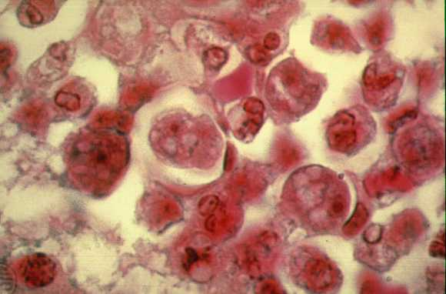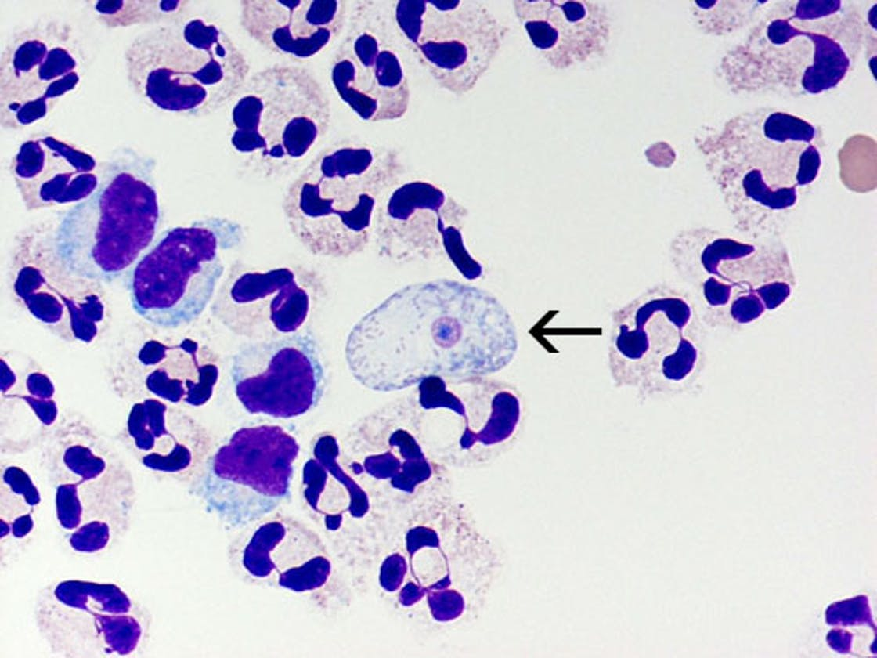

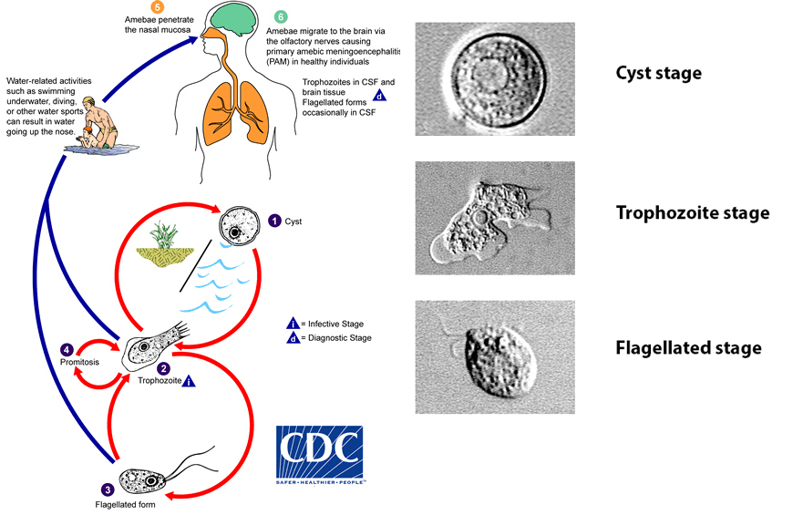

Dientamoeba fragilis the organism was an amoeba with a binucleate structure, which was described as fragile and disintegrating quickly outside the body. Thus, the name Dientamoeba fragilis was proposed, but recently they described as a flagellate protozoan parasite of the human gastrointestinal closely related to the trichomonads found in human stool specimens, D. fragilis is almost always found solely as a trophozoite. However, the rare presence of putative cyst and precyst forms in clinical specimens has been reported; their transmission potential is being investigated. Other aspects of the transmission and pathogenicity of D. fragilis also are poorly understood. Trophozoites are found in the lumen of the large intestine, where they multiply via binary fission, and are shed in the stool, only the trophozoite stage of D. fragilis had been detected. Both asymptomatic and symptomatic infection (e.g., with various nonspecific gastrointestinal symptoms) have been reported.

