Medical Parasitology Lecture 3
By Dr. Alia Alubadi
The stage in the life cycle at which the parasite is able to initiate an infection to its host is referred to as an infective stage. It is in contrast to the diagnostic stage, i.e. the stage at which the parasite leaves the host, e.g. through excretion together with the stool, urine, or sputum.
A (Intestinal flagellates) Giardia lamblia
Phylum: Protozoa Class: flagellatae
Disease: Giardiasis
Habitat: in the upper part of small intestinal (duodenum).
Host: final host ----------> human especially children . Intermediate host--------> No.
Infective stage: mature cyst with 4 nuclei).
Mode of infection: orally by ingestion mature cyst with contaminated food & water.
Diagnostic sample: stool.
Diagnostic stage: trophozoite &cyst stage.
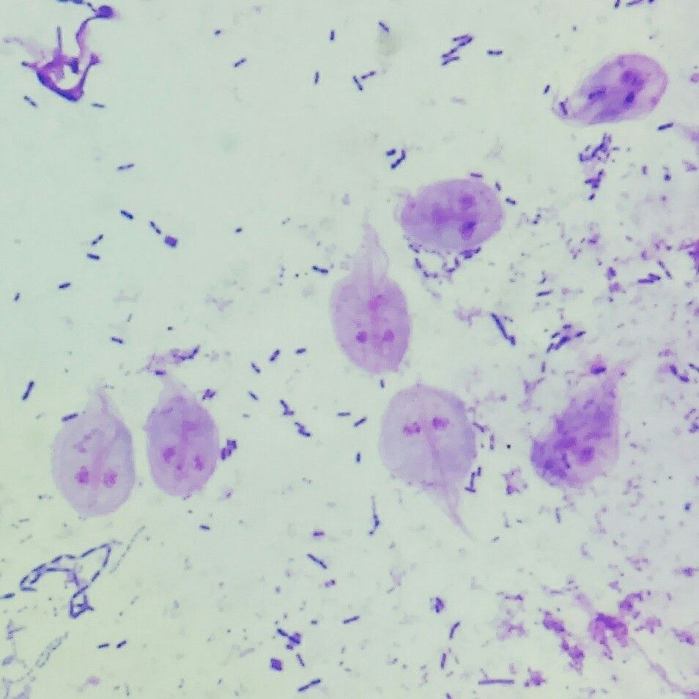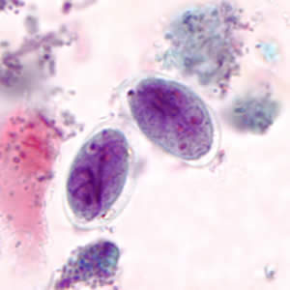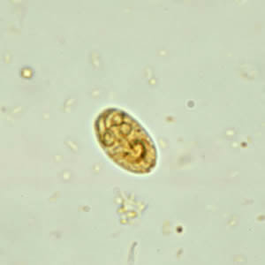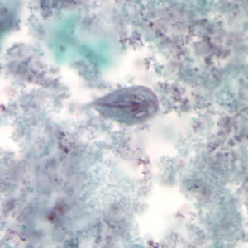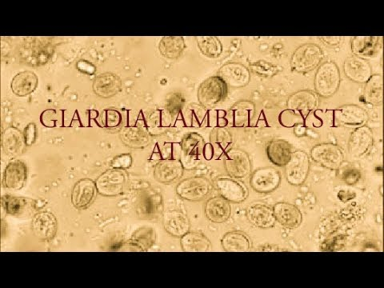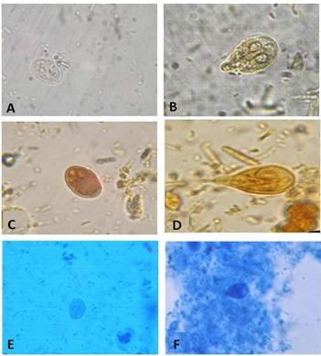
Morphology: have two stages.
- Trophozoite: bilaterally symmetrical, pear shape (rounded anteriorly & tapering posteriorly), have 2 oval sucking (adhesive) discs at the anterior part of ventral flattened surface. 4-have 2 nuclei each with large central karyosome, have 2 longitudinal axostyles & 2 median bodies (deeply staining boxes), have 8 flagella (4pairs), movement rapid , jerky, twisting motion (falling leaf movement), found only in diarrheic stool (in acute stage).
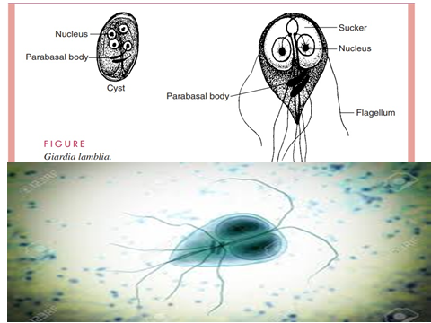
- Cyst: Mostly oval shape, Size 10-12 mµ with 2 layers, Have defined double wall, Have 2-4 nuclei at anterior end, Axostyle & parabasal body & ather structure may be seen, - Found in formed stool & in liquid stool in large number.
Life cycle cyst forming in the intestine of infected host -------> become mature & pass out with feces --------> ingested by new host with contaminated food & water -------> excystation occurs in the small intestine --------> trophozoite multiply by simple fission -------> formation of cysts.
Symptoms (clinical signs): trophozoite of giardia lamblia adhere to intestinal wall by their adhesive sucking discs & cause malabsorption & dehydration that lead into repeated diarrhea with watery, greenish & fatty stool.
B (Genital flagellates) Trichomonas vaginales
Phylum: Protozoa Class: flagellatae
Disease: Trichomonasis
Habitat: Vagina of female &urethra of male .
Host: final host ----------> human. Intermediate host--------> No.
Infective stage: Trophozoite.
Mode of infection: directly by sexual contact (the male carrier the disease from infected female to healthy female).
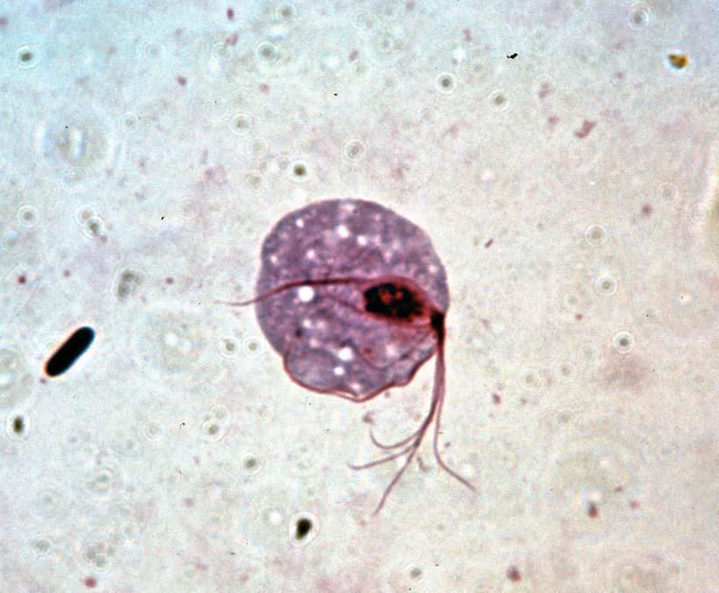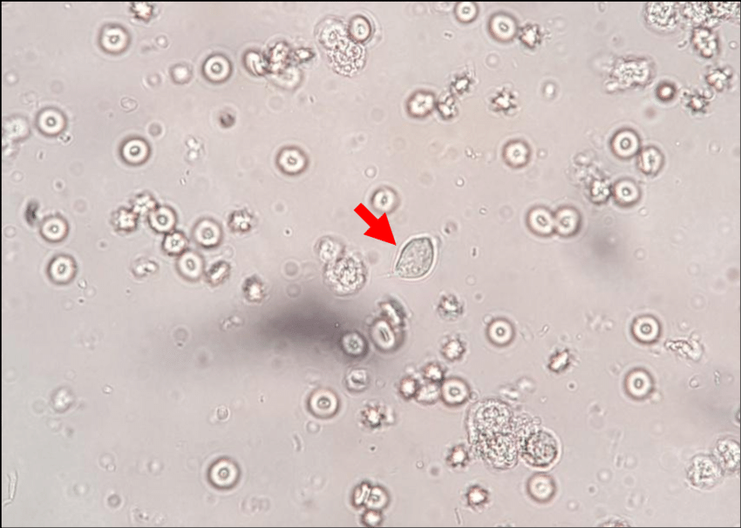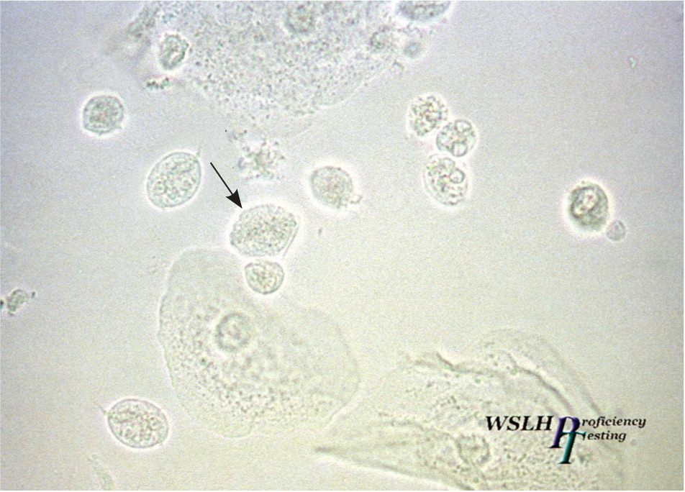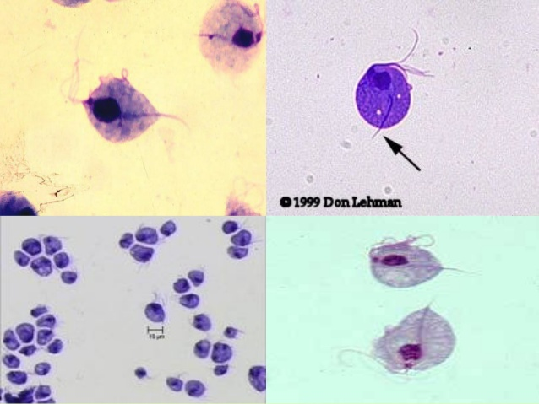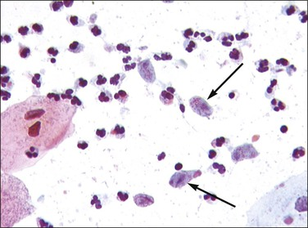
Diagnostic sample: In female: vaginal swab or urine in male: Urethra discharge or urine.
Morphology: have only trophozoite & have no cyst stage.
Trophozoite , Oval or Pear shape, Size 15-30 um, Have 4 equal anterior flagella & 1 posterior flagellum, Have 1 large oval nucleus with equal distributed of chromatin, Have longitudinal axostyle, Have short undulating membrane, Rotating movement a gliding motion.
Life cycle:
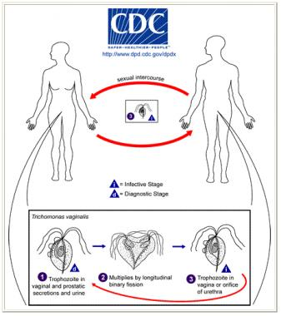
Trophozoite multiply in vagina of infected female or in urethra of infected male ----> transmitted directly during sexual contact between male & female.
Symptoms (clinical signs): In female vaginitis (vaginal inflammation ) which lead to yellowish frothy vaginal discharge. In male: asymptomatic, may cause urethritis & urethral discharge. Laboratory Diagnosis: In female vaginal discharge, vaginal swab or urine ---------> direct smear with saline -------> search for trophozoite. Or stain by Giemsa stain -------> search for trophozoite. In male urethral discharge or urine in normal saline or stain by Giemsa.
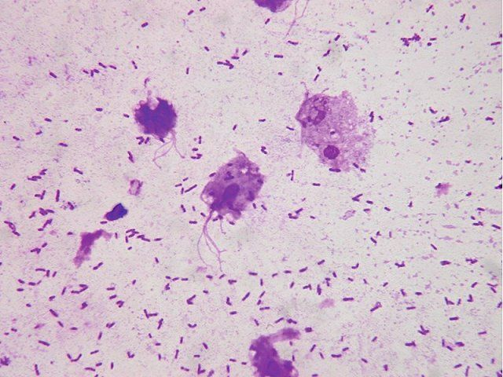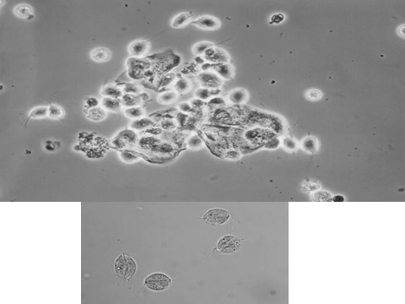
Diagnostic stage: trophozoite.

C- Blood & tissue flagellates Parasitic flagellates that inhabit in blood &tissue of human including:
- Genus: Leishmania.
- Genus: Trypanosoma.
Leishmania spp. and Trypanosoma spp. have digenetic life cycles, involving vertebrate hosts (man and reservoir animals) and invertebrate hosts (arthropods: vectors).There are 4 parasitic stages (or forms) this phenomena known as polymorphism:Amastigote & Trypomastigote occur in vertebrate hosts Promastigote & Epimastigote occur in invertebrate hosts.
Amastigote; the term is used mainly to describe an intracellular phase in the life-cycle of trypanosomes that replicates. It is also called the leishmanial stage, is a round protist cell that does not have visible external flagella.
Trypomastigote: the morphological form in the lifecycle of trypanosomatids in which the characteristic morphological form is a flagellum arises from a posteriorly located kinetoplast and emerges from the side of the body, with an undulating membrane running along the length of the body.
Promastigote: that is characterized by a single anterior flagellum and no undulating membrane.
Epimastigote: a stage in unicellular life-cycle, typically trypanosomes, where the flagellum is anterior of the nucleus, and attached the cell body by a short undulating membrane.
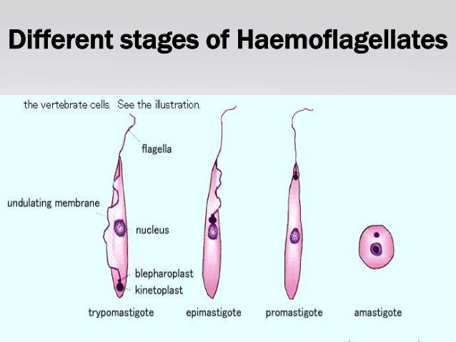
- Genus: Leishmania
Amastigote forms are seen in human infections and are seen mainly in the cells of reticuloendothelial system located in liver, spleen, bone marrow, and peripheral blood.
Ther are 3 species of Leishmania that can infected man these are:
- Leishmania tropica, in blood &skin tissue.
2-Leishmania donovani, : blood & skin tissue. Monocyte of reticulo-endothelial system(viscera) Ex: spleen , liver , lymph node, bone marrow .
3-Leishmania brazilensis , blood &tissue of mucous membranes of nose, throat, ear , mouth.
Pathogenicity
Leishmania donovani causes a visceral disease called Kala-azar. It is a parasite of the reticuloendothelial (RE) system and affects the organs containing the reticuloendothelial system like the bone marrow, liver and spleen. There is hepatosplenomegaly. The patient gets an intermittent fever. There is associated with anaemia, cachexia, loss of weight. There is dry skin, brittle hair and pigmentation of the skin. There may also be diarrhoea, dysentery. Oedema is seen due to hypoalbuminemia.
Leishmania tropica causes Oriental sore (cutaneous leishmaniasis) On the skin which becomes dry there may appear solitary or multiple ulcerating papules. Healing occurs with scarification. Post-kala-azar dermal leishmaniasis
Leishmania brazilensis- Espundia (muco cutaneous leishmaniasis)
Disease:
1-Leishmania tropica: Causes cutaneous lieshmaniasis (oriental sore or Bagdad boil).
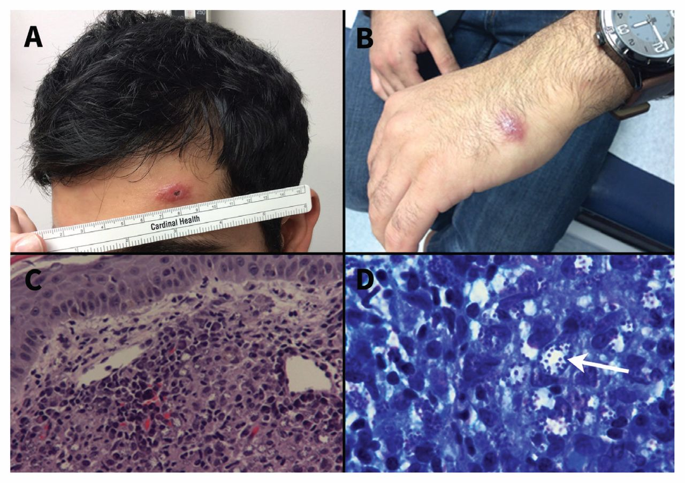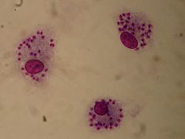
2-Leishmania donovani : Causes visceral lieshmaniasis (Kala azar or black fever).
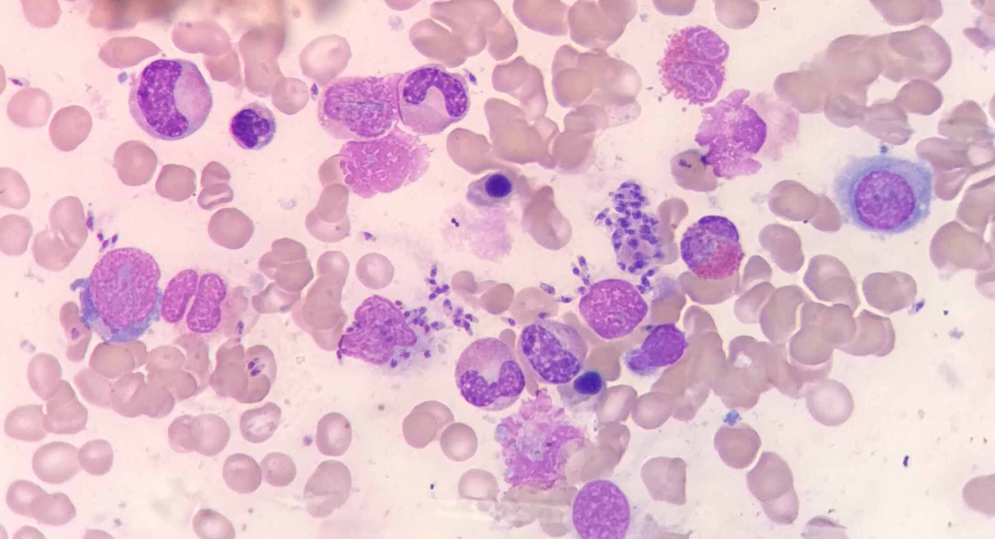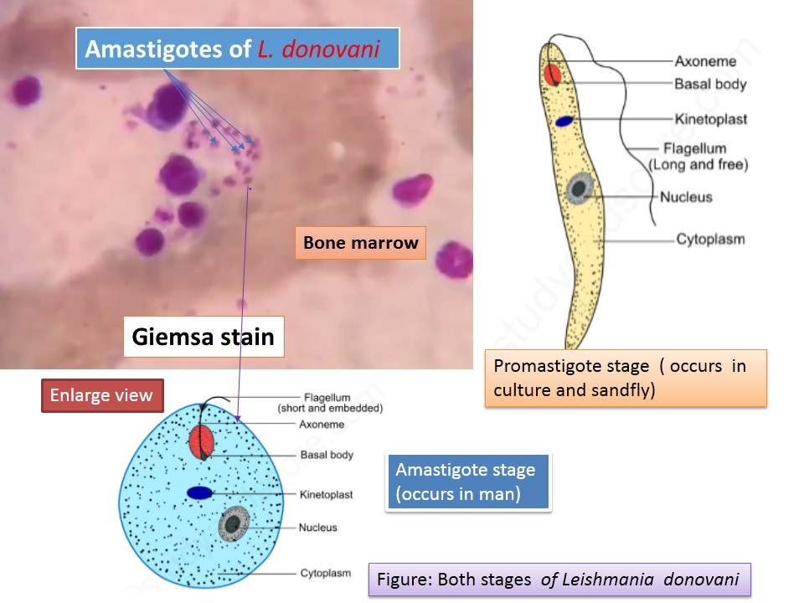
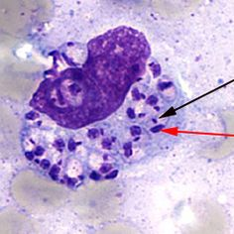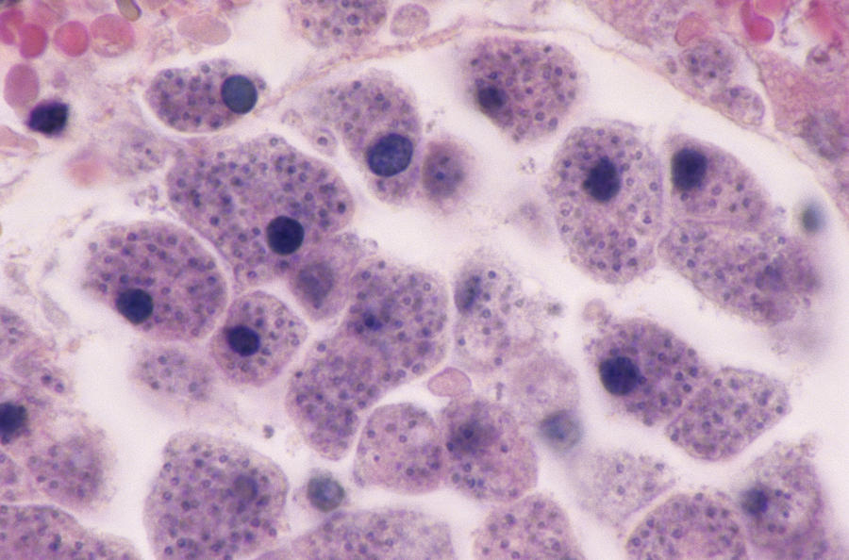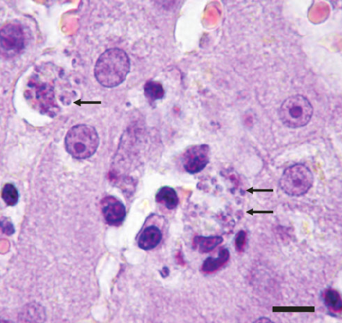

3-Leishmania brazilensis :Causes muco-cutanous lieshmaniasis (espundia)
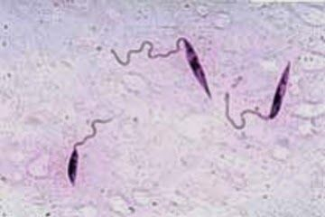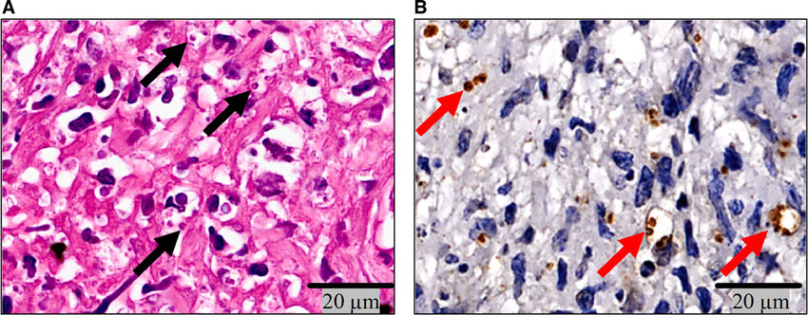
Hosts:
**Final host: human & some vertebrates.
**Intermediate host: female of sand fly (genus Phlebotomus).
Infective stage: Promastigote stage in salivary glands of sand fly.
Mode of infection: Through the skin by of biting of infected (insect vector) female of sand fly.
Life cycle
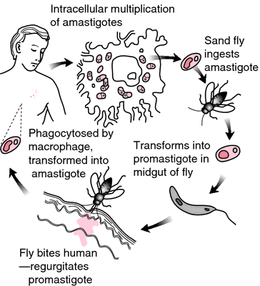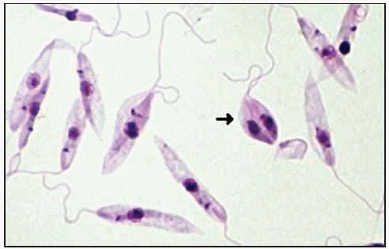
After infected blood meal ( contain amastigote form ) is taken by the vector sand fly Phlebotomus then develop into flagellate promastigote form in the gut of the insect in 8-20 days. The infective sand fly transmits the disease by biting a man. Due to partial/complete blockage of mouthparts Parasites is lodged at the site of bite when it ingests blood.
The promastigotes penetrate the host macrophage and are converted to amastigote forms. They multiply and rupture the macrophages. There is ingestion of amastigote by other macrophages.
Incubation period: Usually 3-6 months, but can extend up to 1-2 years, Transmission can also occur through infected blood transfusion.
Diagnostic sample:
- L. tropica: in blood & scraping from the skin lesion.
- L. donovani: blood & tissue of reticulo-endothelial system.
- L. brazilensis : blood &tissue of mucous membranes. Diagnostic stage: Amastigote stage.
Morphology: All Lieshmania parasite are similar morphology.
a. Amastigote stage: found in man & some mammalians.
Body is oval or spherical shape, Nucleus is rounded or oval usually position in the posterior half of the body, Kinetoplast of variable size (smaller than the nucleus) rod shaped or rounded, located at the anterior end of the body, No undulating membrane, No Free flagellum.
b.Promastigote: found in female sand fly , Body is elongated shape, Nucleus in the middle, Kinetoplast located near the posterior end, No undulating membrane, Free flagellum is present.
Laboratory diagnosis of leishmaniasis:
- Examin for Amstigote
Type of samples:
- Skin scraping from the lesion.
- Biopsy from the spleen, liver.
- From mucous membrane.
Smear --------Fixed-------stain by leishman stain
- If the sample is blood —»blood film —> stain by leishman —> microscopic Examination for Amstigote , Blood shows a normocytic , normochromic anemia , leucopenia , neutropenia and thrombocytopenia .
- Serological methods to demonstration of Abs by using specific leishmanial –Ags prepared from cultures. Serological methods such as: ELISA, IFIA
- Montenegro test: 0.1 ml of antigen injected intradermaly-----> after 48h his postive. The Leishmanin skin test (LST), also called Montenegro test, is an immunologic skin test that measures delayed-type hypersensitivity to Leishmania antigen. It can be used for diagnosis of cutaneous leishmaniasis.
- Leishman test : (+ve in about 90% of cases when ulcer is present.)

