Parasitology lecture 5
Biotechnology 3ed stage by Dr Alia Alubadi
Phylum: protozoa. Class: sporozoa or coccidia
1-Plasmodium vivax cause benign tertian malaria.
2-Plasmodium falciparum :cause malignant tertian malaria
3-Plasmodium malariae: cause quartan malaria.
4-Plasmodium ovale: mild tertian malaria.
Malaria is caused by obligate intracellular protozoan parasites of the genus "Plasmodium". The four species of human malarial parasites are Plasmodium vivax, P falciparum, P malariae, and P ovale.
General features of parasitic Sporozoa: * Habitat in blood & tissues. * Require intermediate host. * No locomotion organs,. * Multiply sexually by sporogony & asexually by schizogony.
Hosts: Final host; female Anopheline mosquito (it is the insect vector). Intermediate host: human and some vertebrates
Infective stage: Sporozoite.
Mode of infection: Through the skin_by biting of infected female Anopheline mosquito.
Diagnostic sample: Blood Diagnostic stage: All Erythrocytic stages (Ring, amoebic, schizont and gametocytes).
Life cycle

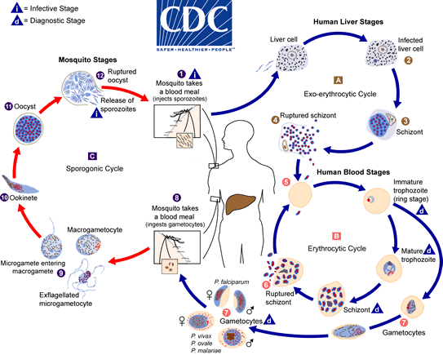
Asexual Cycle in the human
• Hepatic or pre-erythrocyte schizogony phase: Sporozoites invade and develop in liver cells into schizonts (exoerythrocytic schizogony, schizogony asexual reproduction by multiple fission of a trophozoite or schizont into merozoites). The infected hepatocyte ruptures to release merozoites. Duration of this phase depends on the species. *The schizont may also differentiate into hypnozoites (a stage in the liver), its dormant forms of the parasite which may remain in the liver Merozoite s for several months or years
• Erythrocytic phase: Merozoites then invade red blood cells, (Erythrocytic schizogony). The red cells lyse and this causes bouts of fever and the other symptoms of the disease. This cycle repeats as merozoites invade other red cells, the cycle takes over 24 hours (P.knowlesi), 48 hours (P. falciparum, vivax or ovale) or 72 hours (P. malariae) to form between 8 and 32 parasites, whereupon the red cell bursts to release them to infect new red cells
Some merozoites differentiate into male or female gametocytes(sexual stages), by gametogony which occurs when a few merozoites develop into the sexual form ( into male and female gametes) of the parasite known as gametocytes, which may stay in circulation for several weeks until its takes by the female mosquito through blood-feeding.
• Sexual Cycle in the Mosquito: Sexual forms of the parasites develop and are ingested when another female anopheles mosquito feeds.
These male and female gametes fuse to form an ookinete in the gut lumen of the mosquito. The ookinete invades the stomach wall to form the oocyst, (sporogony, a process of multiple divisions in which many sporozoites are produced), and releases sporozoites which migrate to the salivary gland of the mosquito. This mosquito then goes on to infect another human host.
Pathogencity and symptoms
After a week or two of bitten by an infected mosquito, the first noticeable symptoms start to appear, “flu-like” symptoms such as headache, slight fever, muscle pain, and nausea, which coincide with increasing numbers of parasites in the bloodstream. A few days later these symptoms are often followed by periodic febrile attacks, also known as malarial paroxysms which character by a shiver, feel very cold and sweating stage during which your fever drops rapidly.
In all types of malaria, paroxysms occur when many infected blood cells burst at the same time, releasing thousands of merozoites into the bloodstream all at once. Malarial paroxysms occur periodically - 48 hours for P. vivax, P. ovale, and P. falciparum, and 72 hours for P. malariae.
The 72 hour cycles with P. malariae is due to its slower growth and maturation.
The most frequent symptoms include fever and chills, which can be accompanied by headache, myalgias, arthralgias, weakness, vomiting, and diarrhoea. Other clinical features include splenomegaly, anaemia, thrombocytopenia, hypoglycemia, pulmonary or renal dysfunction, and neurologic changes.
Prevention
Bite prevention – avoid mosquito bites by using insect repellent, covering your arms and legs, and using a mosquito net.
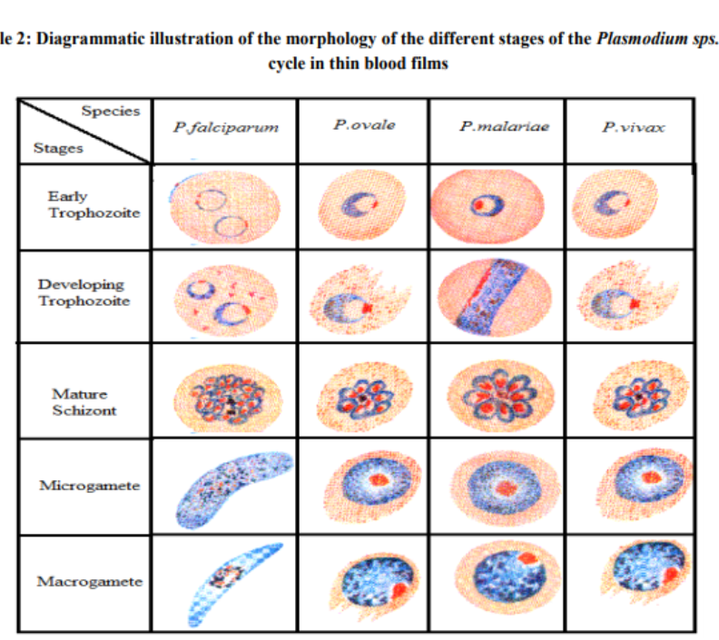
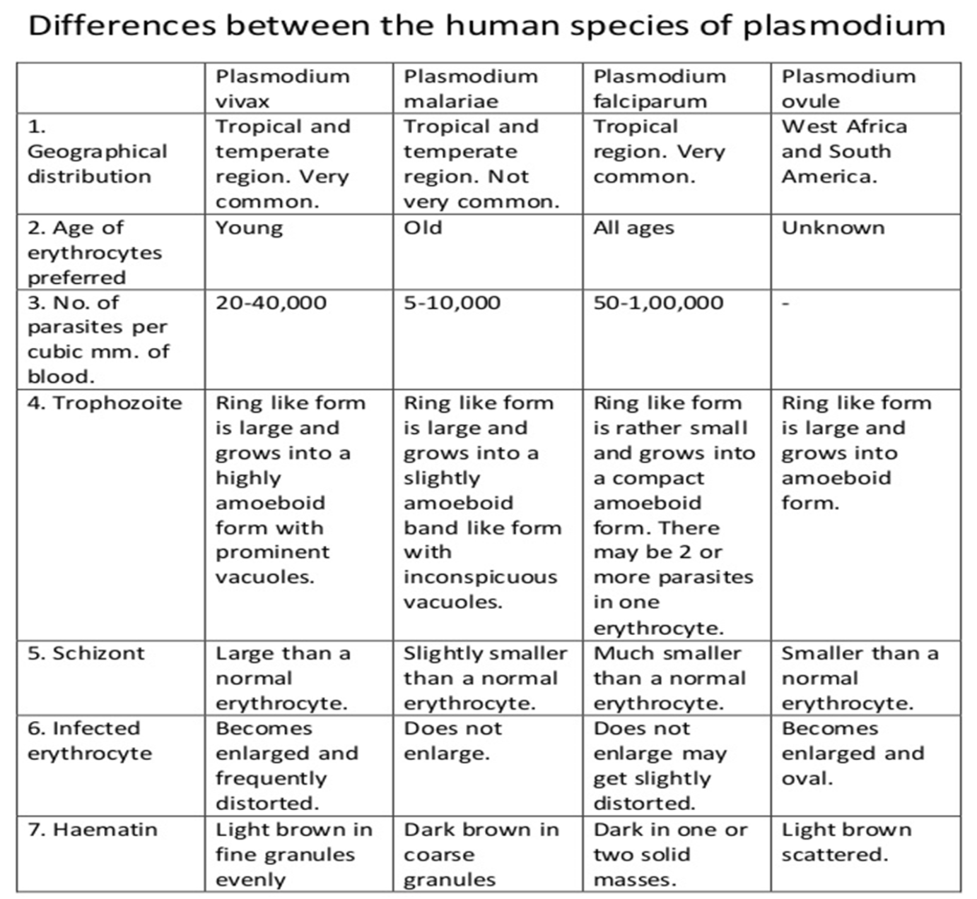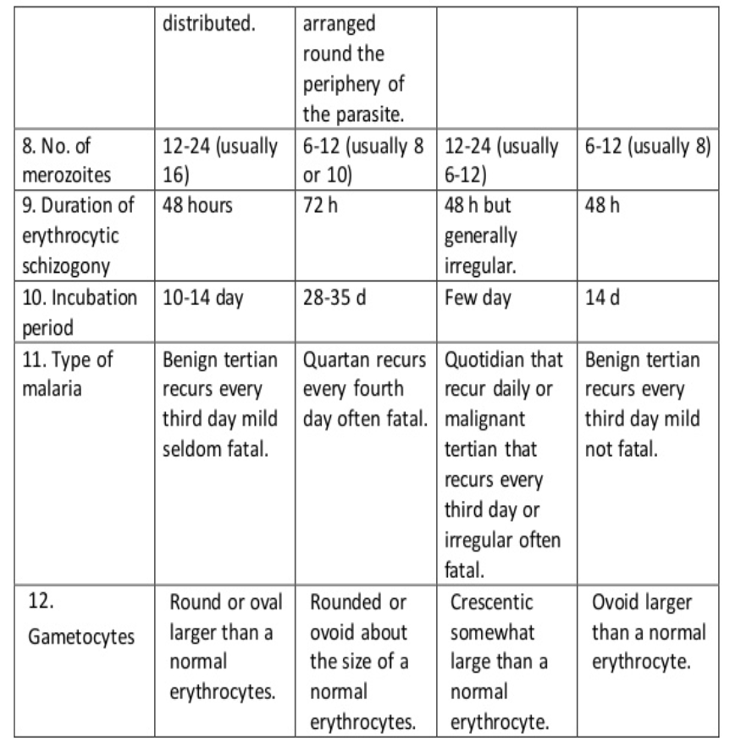

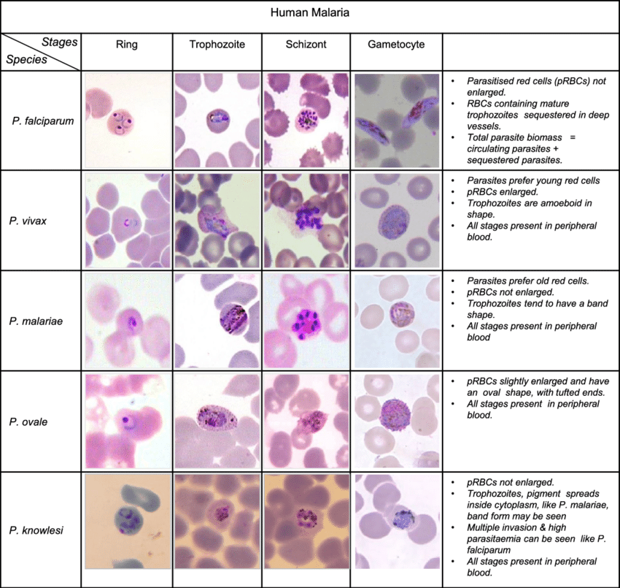

Schuffner's dots (RBCs) is the characteristic feature of P. vivax and P. ovale, maurer dots is seen in P. falciparum
5- Toxoplasma gondii
Obligate intracellular parasite cause Toxoplasmosis
Three morphological forms Asexual forms Tachyzoite Bradyzoite (Tissue cyst) while the the oocyst is formed by sexual reproduction (gametogony or sporogony).
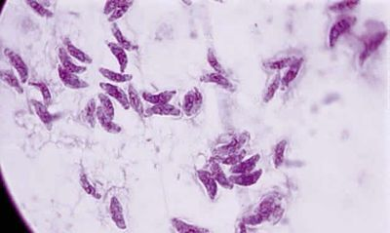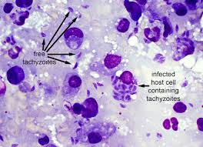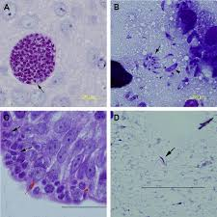
Defi nitive hosts ; domestic cats and other felines which have the sexual forms
intermediate hosts: humans, other animals and birds which have the asexual forms
Trophozoites (Tachyzoites) is crescentshaped, with one end pointed and the other end rounded. *It measures 3–7 μm in length. The nucleus is ovoid and is situated at the blunt end of the parasite.
*The actively multiplying trophozoite is seen intracellularly in various tissues during early acute phase of infection. Extracellular trophozoites can also be seen in impression smears. *It can invade any nucleated cell and replicate within cytoplasmic vacuoles by a process called endogony (internal budding).
Tissue cyst
Tissue cysts are the resting form of the parasite.
*They are found during the chronic stage of the infection and can be found in the brain (most common site), skeletal muscles, and various other organs.
*The cyst wall is eosinophilic and stains with silver, in contrast to the pseudocyst.
* The slowly multiplying parasites within the cyst are called bradyzoites.
*The cyst is round or oval, 10–20 μm in size and contains numerous bradyzoites. Cysts remain viable in tissue for several years.
*In immunologically normal hosts, the cysts remain silent, but in the immunodeficient subjects, they may get reactivated, leading to clinical disease.
*It is relatively resistant and when the raw or undercooked meat containing the cysts is eaten, infection occurs.

A Toxoplasma infection occurs in one of the following:
1- Eating or accidental ingestion undercooked, contaminated meat.
2- Drinking water contaminated with Toxoplasma gondii.
3- Accidentally swallowing the parasite through contact with cat faeces that contain Toxoplasma.
4- Accidentally ingesting contaminated soil (e.g., not washing hands after gardening or eating unwashed fruits or vegetables from a garden).
5- Mother-to-child (congenital) transmission.
6- Receiving an infected organ transplant or infected blood via transfusion, though this is rare.

*The cyst wall is disrupted by peptic or tryptic digestion and the released parasites initiate infection by invading intestinal epithelial cells.
*They reach various tissues and organs through blood and lymphatic dissemination.
*Cysts are susceptible to desiccation, freezing, and thawing, and heat above 60°C.
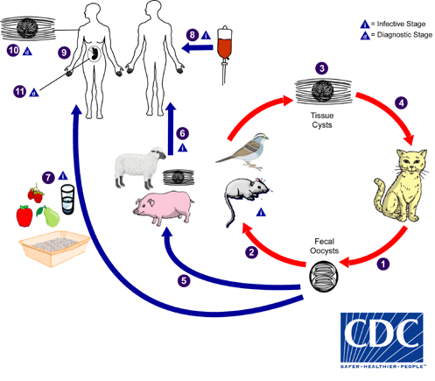
Life cycle
The cat is the definitive host in which the sexual phase of the cycle is completed.Cats become infected after consuming intermediate hosts harboring tissue cysts . Cats may also become infected directly by ingestion of sporulated oocysts.
Tissue cysts that contain bradyzoites are transmitted in undercooked meat. After an intermediate host (e.g., a human, mouse, sheep, pig, or bird) ingests the oocyst, it is rapidly digested by the acidic-pH gastric secretions. Sporulated oocysts that contain sporozoites are products of the sexual cycle in feline intestines and are acquired by ingestion of food or water contaminated with infected cat faeces. sporozoites are released, enter the intestinal epithelium, and transform into rapidly dividing tachyzoites. The tachyzoites can infect and replicate in all mammalian cells except red blood cells. The parasite actively penetrates the cell and forms a parasitophorous vacuole. Parasite replication continues within the vacuole.
The host cell is destroyed, and the released tachyzoites infect adjoining cells. Parasites can disseminate throughout the body as free tachyzoites or within phagocytic cells in the bloodstream or via lymphatics. Tachyzoites actively invade host cells and can cross epithelial barriers.
Pathogenicity
Healthy people who become infected with Toxoplasma gondii often do not have symptoms because their immune system usually keeps the parasite from causing illness. When illness occurs, it is usually mild with “flu-like” symptoms (e.g., tender lymph nodes, muscle aches, etc.) that last for weeks to months and then go away. However, the parasite remains in the person’s body in an inactive state.
Symptoms of the infection vary
Most people have no symptoms at all.
Some people have the “flu-like” with swollen lymph glands or muscle aches and pains that may last for a month or more.
Severe toxoplasmosis, causing damage to the brain, eyes, or other organs, can develop from an acute Toxoplasma infection or one that had occurred earlier in life and is now reactivated. Severe toxoplasmosis is more likely in individuals who have weak immune systems, though occasionally, even persons with healthy immune systems may experience eye damage from toxoplasmosis.
Diagnosed : primarily by serological testing, diagnosis can also be made by direct observation of the parasite in stained tissue sections, cerebrospinal fluid (CSF), or other biopsy material.
Prevention
- Wear gloves when you garden or handle soil.
- Don't eat raw or undercooked meat.
- Wash kitchen utensils thoroughly.
- Wash all fruits and vegetables.
- Don't drink unpasteurized milk.
- Cover children's sandboxes.

6- Cryptosporidium parvum
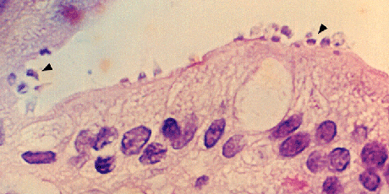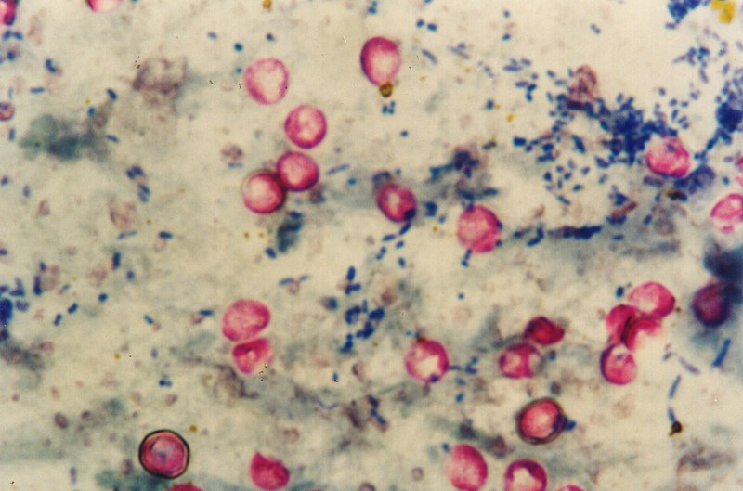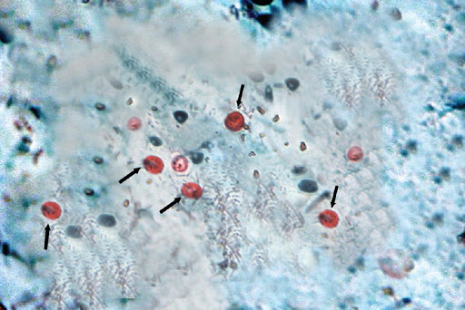
its unicellular eukaryotes with a complex life cycle involving both asexual and sexual reproduction in the gastrointestinal tract of a single host.
The transmittable stage, the oocyst, is shed with the faeces of infected hosts, and infections via the faecal-oral route (human-to-human and animal-to-human contacts) or indirectly by ingestion of contaminated water and food.
Hosts: infects both humans and animals, and can be transmitted zoonotically.
Disease name cryptosporidiosis causes the diarrheal the duration of the disease is 9–15 days.
Life cycle
The Cryptosporidium life cycle can be divided into six major developmental phases: excystation (the release of infective sporozoites), merogony (asexual multiplication within host cells), gametogony (the formation of micro- and macrogametes), fertilization (the union of micro- and macrogametes), oocyst wall formation (to produce the environmentally resistant stage responsible for the transmission of the infection from one host to another), and sporogony (the formation of infective sporozoites).

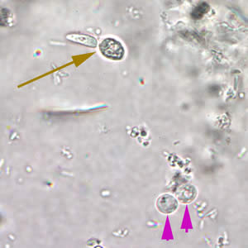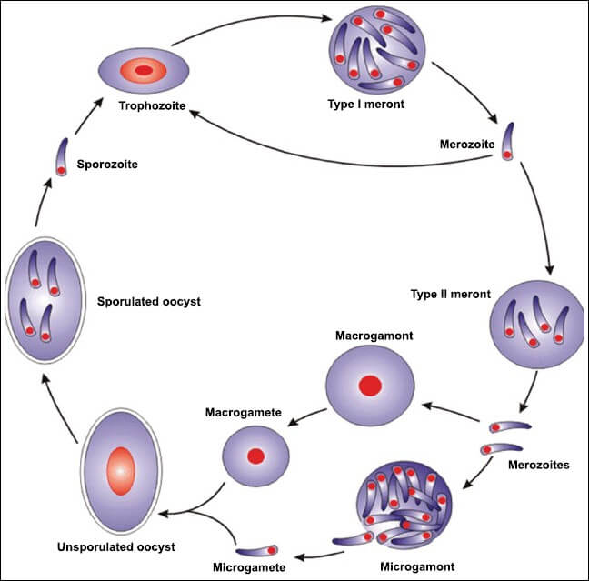
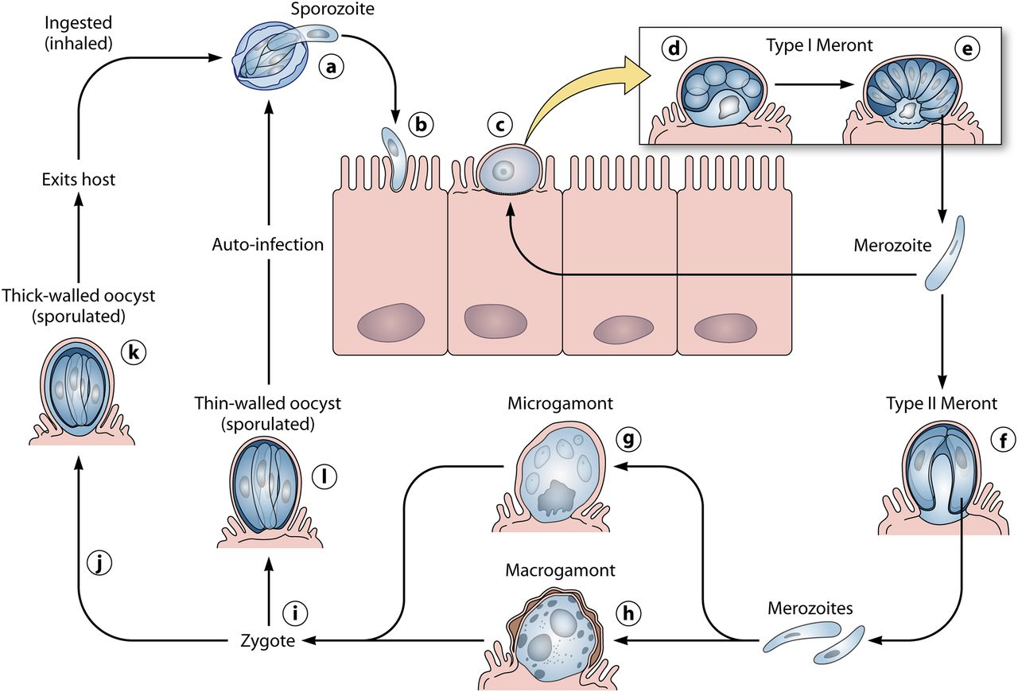

The major symptom of the infection is watery diarrhoea associated with abdominal cramps, anorexia, weight loss, nausea, vomiting, fatigue and low-grade fever.
dehydration, weight loss and malnutrition, extended hospitalizations, and mortality, characterize infection of immunocompromised individuals.
Cryptosporidium is one of the four major contributors to moderate-to-severe diarrheal diseases in children.
Diagnosis of Cryptosporidium is primarily based on the identification of the oocysts in stool, also oocysts can also be detected by serological methods, and could be made on small intestinal biopsy of developmental stages, found individually or in clusters, on the brush border of the mucosal epithelial surfaces into the GI lumen.
Prevention :
Practice good hygiene. Wash your hands for at least 20 seconds with soap and water after using the toilet and changing diapers, and before and after eating. Thoroughly wash with uncontaminated water all fruits and vegetables that you will eat raw, and avoid eating food you suspect could be contaminated.
Avoid faecal exposure during sexual activity.

