Parasitology lecture 6 Biotechnology 3ed stage by Dr Alia Alubadi
Helminthes
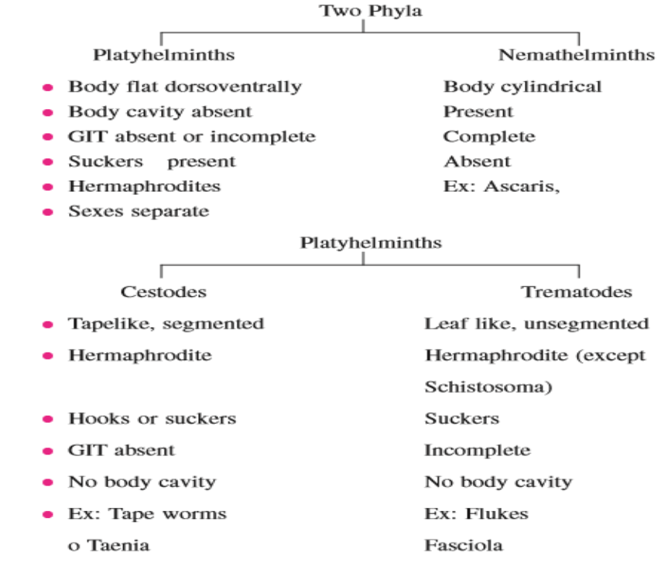
Phylum Platyhelminthes
1)Bilaterally symmetrical.
2)Body having 3 layers of tissues with organs and organelles. 3)Body contains no internal cavity.
4)Possesses a blind gut (i.e. it has a mouth but no anus), no circulation system.
5)Has Protonephridial excretory organs instead of an anus.
6)Has normally a nervous system of longitudinal fibres rather than a net.
7)Generally dorsoventrally flattened.
8)Reproduction mostly sexual as hermaphrodites.
9)Mostly they feed on animals and other smaller life forms. 10)Some species occur in all major habitats, including many as parasites of other animals.
Phylum Platyhelminthes classification
- Class Turbellaria 2- Class Monogenea 3- Class Digenea (Trematoda) 4- Class Cestoda
Class Digenea (Trematoda) – The Flukes
General characteristics:
1. The information on the Platyhelminthes providedin the previous section should be reviewed, as it still applies.
2. All have complex life cycles requiring one or more intermediate hosts. Most are hermaphroditic, many capable of self-fertilization.
3. Body is non-segmented , flattened dorsal-ventrally, leaf-shaped, and covered with a cuticle which may be smooth or spiny.
4. Attachment organs are two cup-shaped suckers,two cup-shaped suckers,- oral and ventral. Tegument is metabolically active.
5. Oral cavity leads to muscular esophagus, from which intestines branch to form 2 cecae, which run parallel to each other ending blindly near the posterior end of the worm, no anus - waste products are regurgitated تتقيئها.
7. Reproductive system a. Uterus is usually the largest organ with a single ovary, two testes & a series of glandular structures that produce shell material that covers the ovum. b. Uterus may be filled with thousands of eggs.
8. Trematode eggs :
a. Trematode eggs usually have a smooth,hard, transparent, yellow - brown shell and eggs may have "shoulders" and/or spines.
b. Most have an operculum (escape hatch for the miracidium).
The life stages :-
Miracidium a free-swimming ciliated, pyriform motile larval stage in which a parasitic fluke passes from the egg to its first host, typically a snail.
The sporocysts, rediae and cercariae all occur in the snail Sporocysts are pleomorphic sac-like bodies containing germinal cells which give rise to small rediae (embryos). * Redia is long with two lateral projections, it give rise to cercaria stage. (these two stages represented asexual reproduction).
Cercariae are free-swimming stage , has a simple tail and an oval body, which contains oral and ventral suckers.
Metacercariae its encyst of cercariae on second intermediate host, and when the definitive host taken this stage the infection occur, and the juvenile adult fluke migration, through the definitive host tissue to the site of infection.
- Liver fluke
- Fasciola hepatica
[causes liver rot or fasciolosis in ruminants and humans]
1. Definitive host: Adults in the bile ducts, rare in man, very common in Sheep, Gattle and other herbivorous animals.
2. Intermediate hosts:
a.snails are the first intermediate host
b.Aquatic vegetations are harbor the infective metacercariae stage(infective stage for definitive host).
Mature flukes are leaf-shaped with a conical apex demarcated by wider ‘shoulders’. They are dorsoventrally flattened, the tegument is covered with scaly spines, and they have two suckers (distome arrangement with the oral sucker and acetabulum close together). They have a bifurcate blind gut and each worm is hermaphroditic, possessing both male and female reproductive organs.
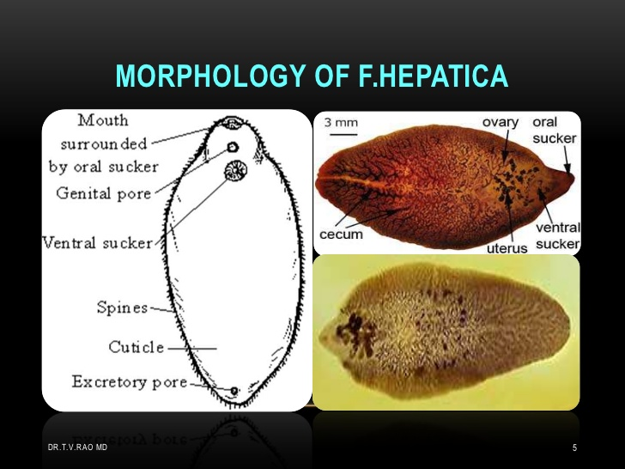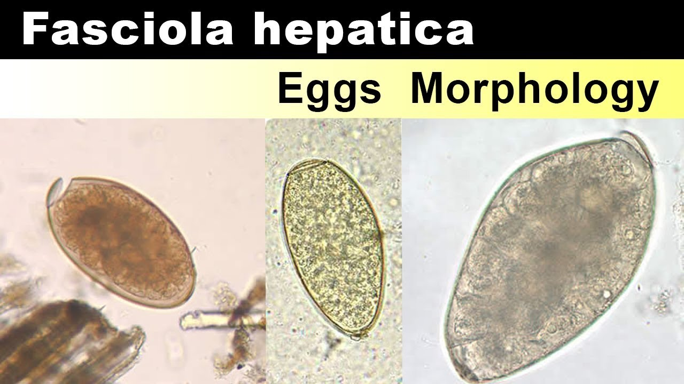
Have seven different developmental stages: eggs, miracidia, sporocysts, rediae, cercariae, metacercariae, and adult flukes.
The eggs are operculate (‘hatch’ at one end), brown and ovoid. passed in faeces of the infected organism.
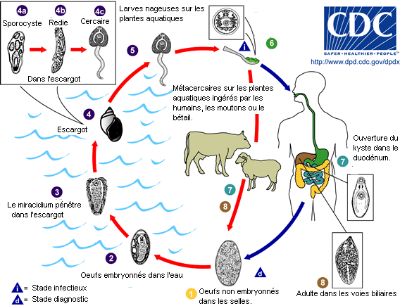Pathogenesis
Sudden death due to massive invasion of liver by young fluke with acute hepatic insufficient and hemorrhage in peritoneal cavity, while
chronic form develop slowly due to mature liver fluke in bile duct which cause cholangitis, billiary obstruction, destruction of hepatic tissue, fibrosis and hemorrhagic anemia, and cause decrease of appetite, weakness, pale and edema in conjunctiva, enlargement in liver and ascites, diarrhea and wool shedding, loss weight
Diagnosis
based on finding the eggs in the faeces or in the bile by duodenal tube.
* Serological test
Prevention * Avoiding eating watery plant otherwise cooked or dried well. * boiling of possibly polluted water. * washing raw vegetables well. * Combat snails.
- Clonorichis sinensis
(oriental liver fluke) also known as the Chinese liver fluke cause Clonorchiasis with Trematode characteristics, the fluke is tapered at the anterior end and rounded at the posterior end. The intestine is bifurcated and ends blindly. A thick and elastic cuticle lacks any kind of spines or scales and can either be a translucent gray color or yellow color (due to absorption of bile).
1-Final host Infections occure by all members of mammals that eating raw fish- man is the definitive hosts
2-Intermediate hosts 1- water snails 2- fish
Site of infection a liver, gallbladder and bile duct in humans.
Life cycle
Excystation takes place in the duodenum and a juvenile adult fluke emerges and reaches to the bile ducts within 4-7 hours after ingestion of the intermediate host. From the duodenum, it penetrates the gut wall and is carried to the biliary system via the ampulla of Vater. After one month it matures enough to produce eggs.
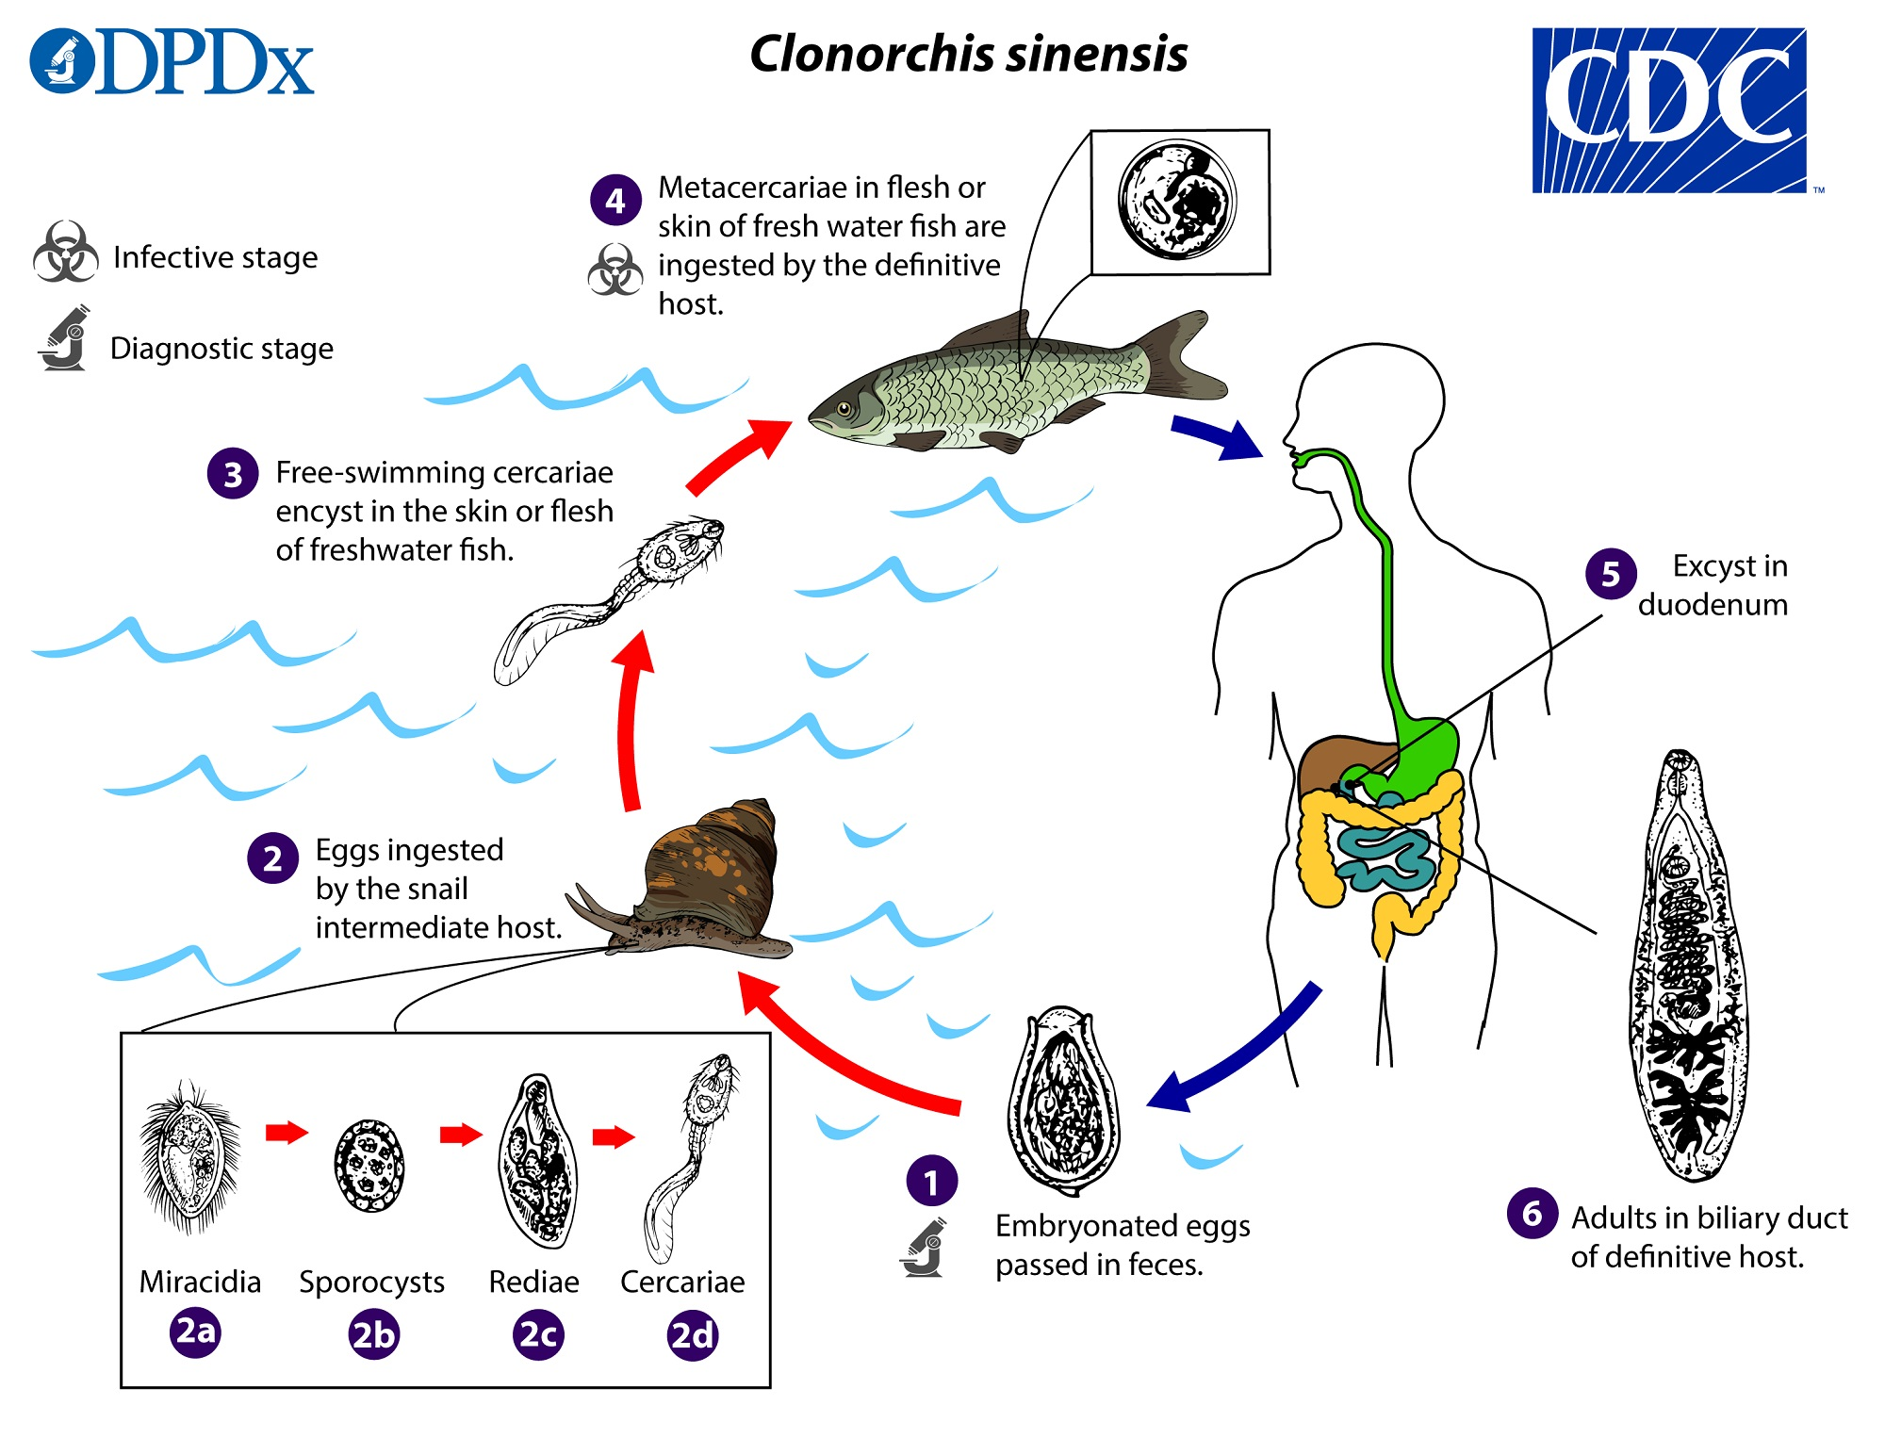
Pathogenicity and clinical signs
Worms mechanical stimulation proliferate inflammatory reaction in the biliary epithelium. The wall of the bile ducts thickened ,fibrous tissue around the bile duct, and worm obstruction cause cholestasis. When bacteria infection occur, cause cholecystitis, cholangeitis, sometimes cholelithiasis happens, hepatomegaly, necrosis of liver tissue, may cause liver cirrhosis. Associate with cholangiocarcinoma and hepatic carcinoma.
symptoms appear in heavy infection: chill, high fever, slight jaundice, hepatomegaly, eosinophilia, other patients have splenomegaly, and chronic stage develops. Continuous re-infection: cirrhosis and portal hypertension. It may cause stunted growth in children.
Prevention Clonorchis infection by avoiding raw or undercooked freshwater fish. Lightly salted, smoked, or pickled fish can contain infectious parasites.
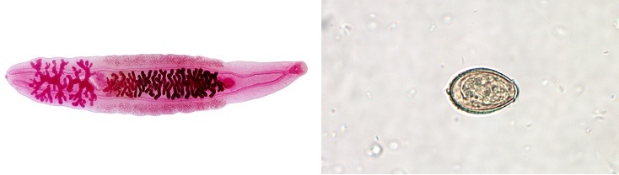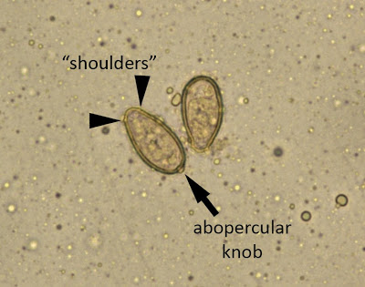
Diagnosis microscopic observation of eggs in feces, bile, or duodenal aspirates. Serologic testing.
2-Lung fluks
Paragonimus westermani (Oriental Lung Fluke) cause Paragonimiasis.
The adult flukes are fleshy, reddish brown, oval, and adults have 2 muscular suckers, an oral sucker situated anteriorly and a ventral sucker at mid body on the ventral surface. The eggs are golden brown, oval, distinctly operculated.
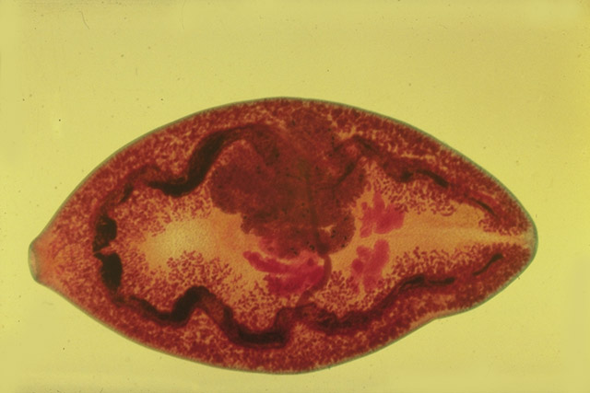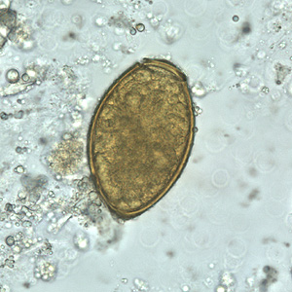
Life cycle
Infection occure by eating raw, pickled, or poorly cooked freshwater crustaceans, contain metacercariae, excyst in the host GI tract, penetrate the intestinal wall, and move into the peritoneal cavity, then through the diaphragm into the pleural cavity; they enter lung tissue, become encapsulated, and develop into hermaphroditic adult worms.
Worms primarily in the lungs and also have been found rarely in other viscera or the brain, liver, lymph nodes, skin, and spinal cord and develop there. However, in these organs, the life cycle cannot be completed because the eggs have no way to exit the body.
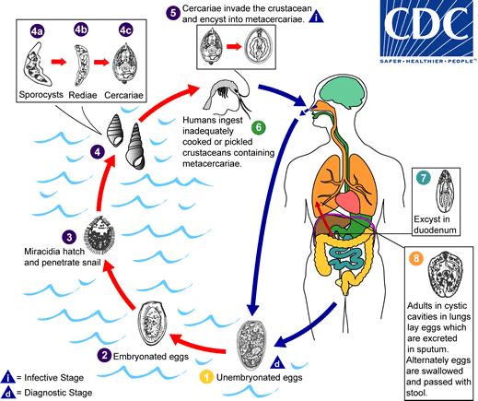
Pathogenicity and clinical signs
Early invasive stages usually asymptomatic, but worm stimulates an inflammatory response, makes a capsule out of granulation tissue, these capsules often ulcerate and forms pseudotubertules. In the CNS, they can cause paralysis and in rare cases can be fatal. In the heart they can cause severe damage and can be fatal.
Lung infections cause chronic cough, bloody sputum, pneumonia -like conditions.
Diagnosis
- Microscopic examination of sputum and stool
- Serologic tests to detect antibodies
- Chest x-rays and CT
Prevention never eats raw crustaceans, eliminating the snails that are required to maintain the parasite’s life cycle.
3-Blood flukes
Blood flukes of the genus Schistosoma spp cause Schistosomiasis, the organisms infect the vasculature of the gastrointestinal or genitourinary system, adult worms live in the blood vessels where the females release eggs.
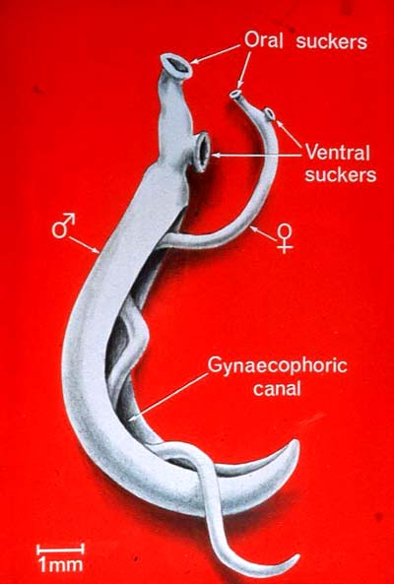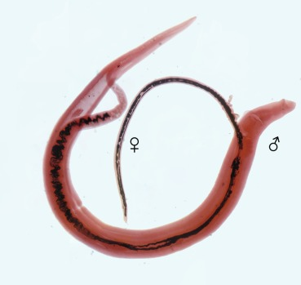
Schistosoma haematobium cause urinary schistosomiasis
Schistosoma mansoni & Schistosoma japonicum cause intestinal schistosomiasis
Adult worms have elongate tubular bodies, each male having a unique gynecophoral canal in which a female worm resides. They live inside visceral blood vessels and are commonly known as blood flukes.
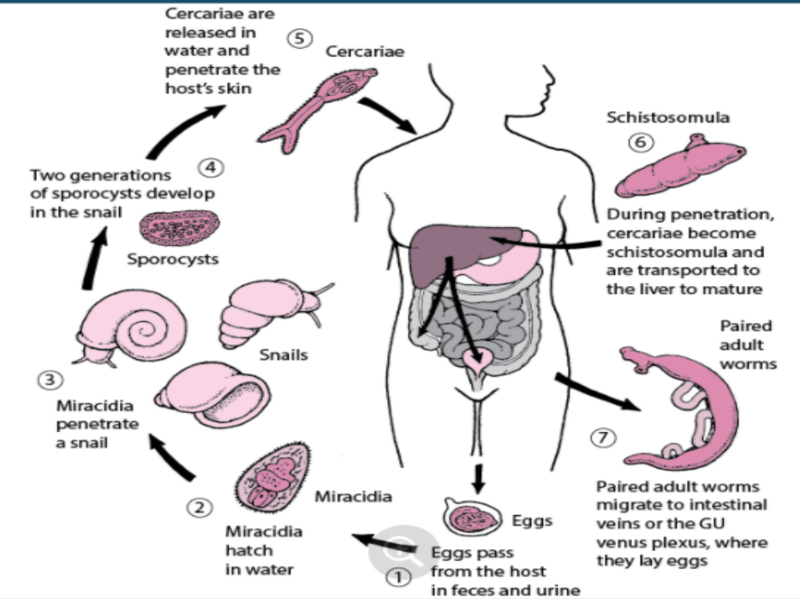
life-cycles Eggs deposited in the circulation penetrate the gut or bladder to be excreted with faeces or urine.
schistosomula is the stage in the life cycle of a blood fluke of the genus Schistosoma immediately after cercaria penetration of the skin marked by loss of the tail and gaining of physiologic modifications allowing it to survive in a mammalian bloodstream.
Pathology of schistosomiasis
Adult schistosomes live in the blood vessels where the females release eggs, some of the eggs are passed out of the body in the faeces or urine to continue the parasite life-cycle. Others become trapped in body tissues (intestinal and urinary system), causing an immune reaction and progressive damage to organs.
• S. mansoni and S. japonicum includes: Katayama fever, periportal fibrosis, portal hypertension, and embolic egg granulomas in brain or spinal cord.
• S. haematobium includes: hematuria, calcification, squamous cell carcinoma, and occasional embolic egg granulomas in the brain or spinal cord.
Pathology of Schistosomiasis • Schistosoma haematobium Causes urinary schistosomiasis.
Signs & symptoms
Low-grade fever. Fatigue, weight loss, anaemia and hepatosplenomagly.
Intestinal schistosomiasis
1. Abdominal pain2. Diarrhea3. Blood in stool, fresh or melena4. Hematemesis5. Liver enlargement.
Urogenital schistosomiasis
1. Hematuria (terminal)2. dysuria3. Frequent need to urinate (polykauria)4. In females; genital lesions, vaginal bleeding, pain during sexual intercourse and nodules on the vulva, irregular menstruation
Diagnosis
Microscopic examination of stool search for eggs (S. mansoni oval with Lateral spine & S. japonicum round with a vague spine or urine (S. haematobium oval with Terminal spine).
Serologic tests
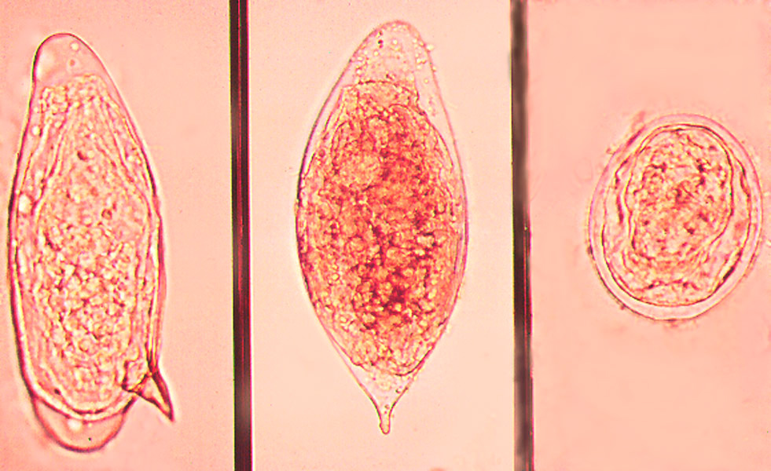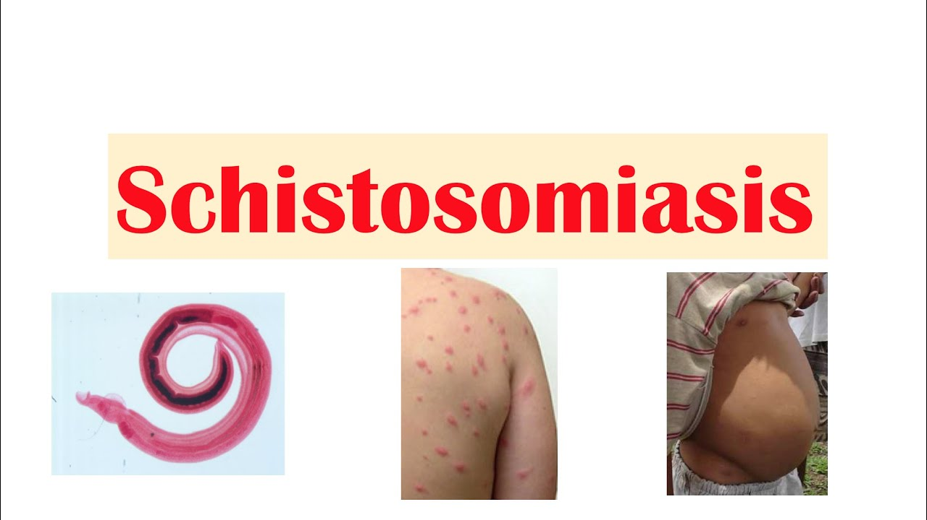
Prevention & Control
Eliminating the snails , Avoid swimming and contact with fresh water in endemic areas, Boiling water and Filtration of drinking water, Improved sanitation could reduce or eliminate the transmission of this disease.
4- Intestinal flukes
1-Fasciolopsis buski (giant intestinal fluke) because its largest trematode residing in the small intestine of man and pig causing a disease called “fasciolopsiasis, its produce about 25,000 eggs per day, cannot be distinguished from the eggs of Fasciola hepatica, its thinner shell with an operculum.
Adult shape elongated ellipsoid has even been described as “meat worm” or “reddish worm” because looks like a slice of raw meat, the ventral sucker (filler-like/ funnel-shaped) is larger and nearby the much smaller oral sucker.
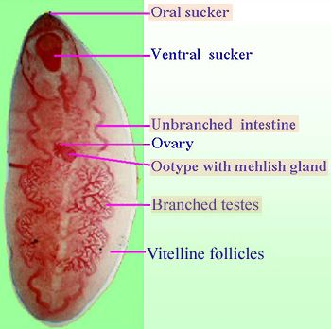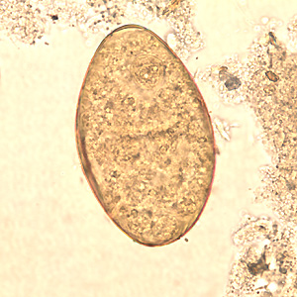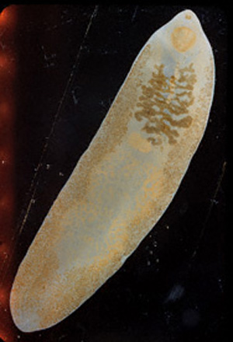
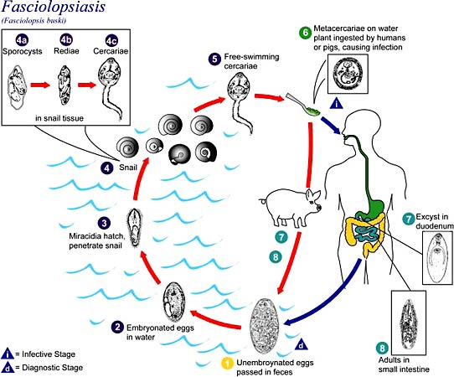
Pathogenicity and clinical signs
The worm is huge and attaches to the duodenal or jejunal wall, at point of attachment may ulcerate and become enteritis, causing pain that resembles that of a peptic ulcer, abdominal discomfort, nausea, vomiting and diarrhoea. Acute symptoms may be caused by an intestinal obstruction or by toxins released by large numbers of worms.
Diagnosis of Stool examination for eggs
Prevention
The treatment of the patients, carriers and pigs, Health education, Deal right with night soil. Avoid feeding pigs on raw water plants.
- Heterophyes heterophyes (a minute intestinal fluke) cause heterophyiasis infection happens when uncooked or inadequately cooked fish contain infective stage metacercaria.
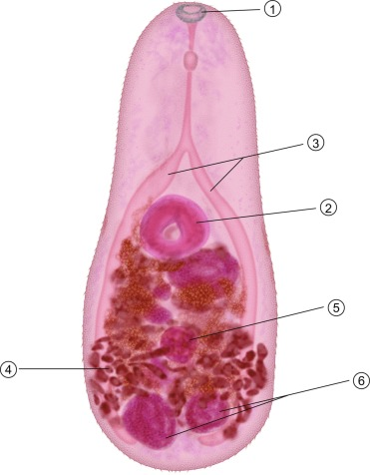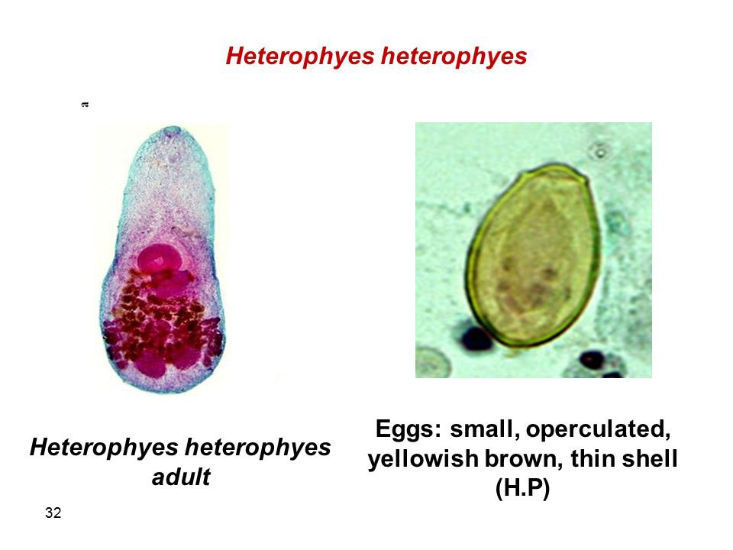

Adult Minute teardrop-shaped flukes found in the small intestines of fish-eating birds and mammals, integument has fine scale-like spines.
Life cycle
Eggs Light brown in colour, Ovoid in shape, Operculated, eggs that are laid contain a miracidium but do not hatch until they are ingested by a snail, Inside the snails gut, the miracidium becomes a sporocyst which then begin to produce rediae, that produce cercariae which then exit the snail, swim toward the fish, the definitive host eats the undercooked or raw meat of a fish and ingest the parasite.
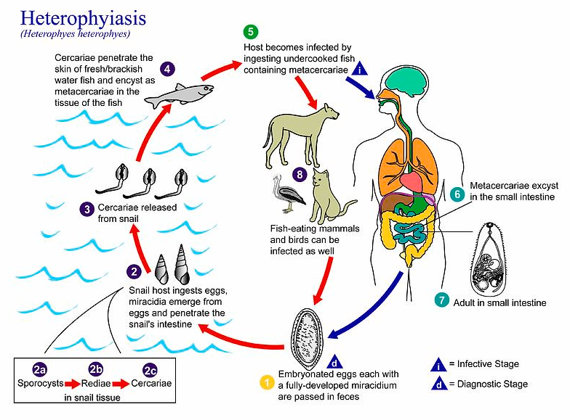
Pathology
• Each worm causes a mild inflammatory reaction at its site of contact with the intestine. • Heavy infections which are common cause damage to the mucosa and produce intestinal pain and are associated with diarrhea, mucus-rich feces, pain, dyspepsia, anorexia, nausea and vomiting.
Sometimes eggs can enter the blood and lymph vascular systems through mucosa go into the heart can be affected with tissue reaction in the valves and myocardium that cause heart failure. Eggs can also get into the brain or spinal cord and cause neurological disorders.
Diagnosis: microscopic examination of eggs in feces via sedimentation concentration, sometime the adult stages a tiny could be seen in the stool.
Prevention involves not eating raw or undercooked fish.

Class Cestoda (tapeworms)
characters
1. Endoparasitic.
2. Hermaphroditic.
3. The body covering is a tough cuticle(tegument), through which food is absorbed. There is neither a mouth nor a digestive tract, lack a circulatory system and an organ specialized for gas exchange.
4. The body segments like tape
1- Scolex, has one or more hooked suckers for firm attachment to the host.
2- Neck which is the growing region.
3- Body segments called proglottids, each segment containing reproductive organs male and female.
Classification
Order Pseudophyllidean
• Scolex with 2 elongated bothria, genital pore lateral or median.
• Adult worms in Intestine » Diphyllobothrium latum: Fish Tapeworm
• Larval stages: Plerocercoid , Sparganum
Order Cyclophyllidean
• Scolex possess 4cup-like suckers and round suckers
• Adult Worms in the Intestine » Taenia saginata » Taenia solium » Hymenolepis nana » Hymenolepis diminuta » Dipylidium caninum Classification of Cestodes Infecting Man
• Larval Stages in Man » Hydatid cyst of Echinococcus granulosus and Echinococcus multilocularis » Cysticercus cellulosa of Taenia solium
