Parasitology lecture 7 Biotechnology 3ed stage by Dr Alia Alubadi
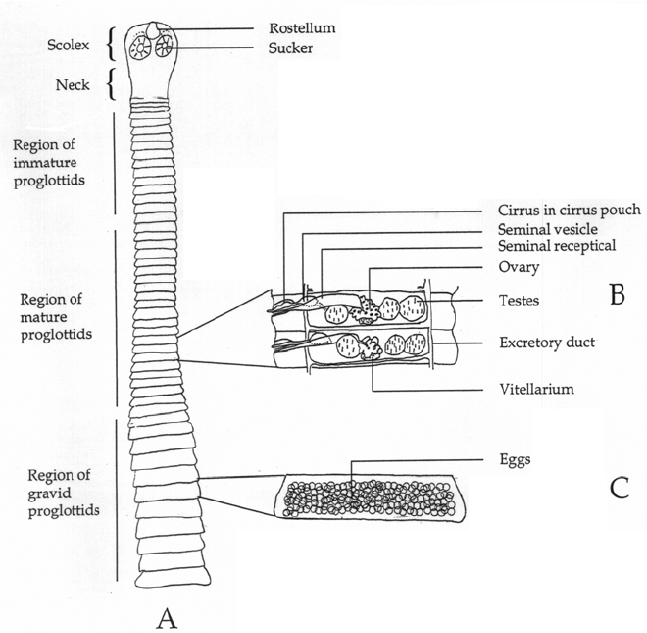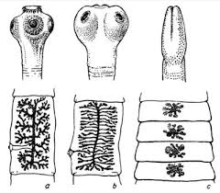
Class: Cestoda
Order: Diphyllobothriidea
Family: Diphyllobothriidae
Diphyllobothrium latum (the fish or broad tapeworm) are the largest known tapeworms that can infect human cause Diphyllobothriasis
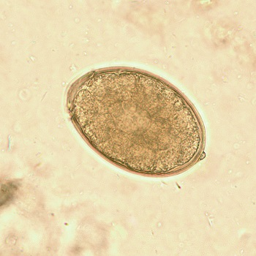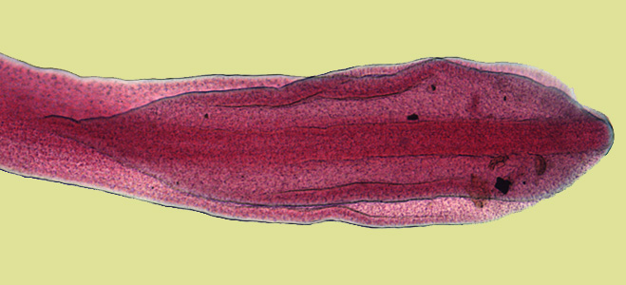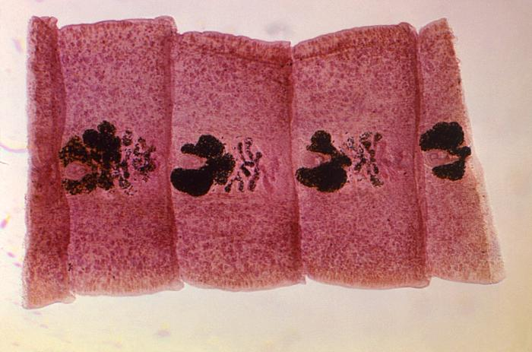
Morphology of parasite
• Scolex elongated has two slit-like grooves known as botheria
• Mature segments are wider than they are long, have a centrally positioned genital pore.
Egg Pale yellow and oval in shape • Has an operculum • Small projection is seen at the non-operculated end of the egg.
Transmission • By ingesting the infective larva which is knowing as plerocercoid in raw or insufficiently cooked freshwater fish
Life cycle
• The adult worm resides in the small intestine laying upwards of 1,000,000 eggs daily. The eggs are released with the faeces and hatch to form a ciliated coracidium which is ingested by the copepod, Cyclops • In the gut of Cyclops a proceroid develops. Cyclops are a food source for many small freshwater fish, proceroid penetrates the intestinal wall of fish, migrates to muscle tissue and forms a pleroceroid • When undercooked fish is ingested by man the scolex of the pleroceroid attaches itself to intestinal mucosa and matures into the adult worm
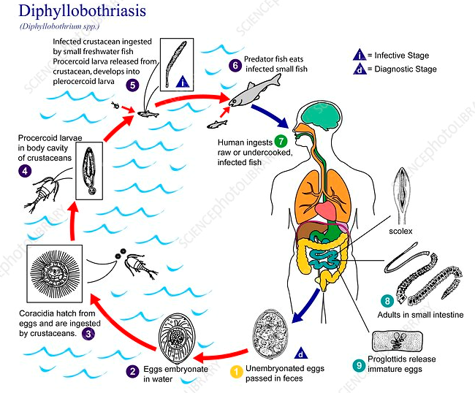
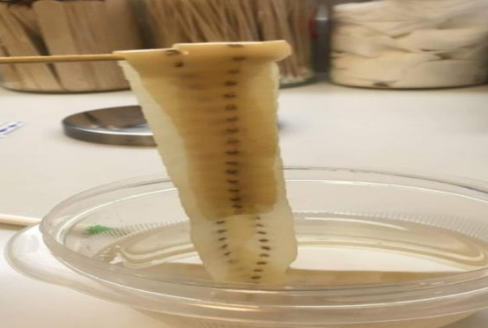
Clinical symptoms usually asymptomatic • diarrhoea, abdominal pain, vomiting, weight loss, fatigue, constipation and discomfort.
This worm leads to severe vitamin B12 deficiency due to the parasite absorbing 80% or more of the host’s B12 intake, anaemia symptoms appear.
Prevention & control
• Avoiding eating raw freshwater fish which may contain plerocercoids
• Preventing the eggs from reaching water by providing adequate latrines combined with health education.
Phylum: Platyhelminthes Class: Cestoda Order: Cyclophyllidea
1-Family: Taeniidae
- Taenia saginata is a beef tapeworm.
- Taenia solium is a pork tapeworm.
Disease name Taeniasis
Humans are the only definitive hosts for T. saginata and T. solium. The adults produce proglottids which mature, become gravid, detach from the tapeworm, and migrate to the anus or are passed in the stool.
Intermediate host Cattle (T. saginata) and pigs (T. solium) become infected by ingesting vegetation contaminated with eggs or gravid proglottids.
In the animal's intestine, the oncospheres hatch, invade the intestinal wall, and migrate to the striated muscles, where they develop into cysticerci. A cysticercus can survive for several years in the animal.
Humans become infected by ingesting raw or undercooked infected meat.
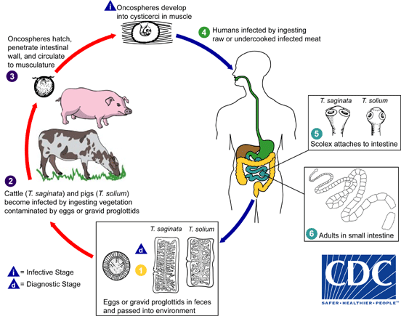
Properties | Taenia solium | Taenia saginata
Common Name | 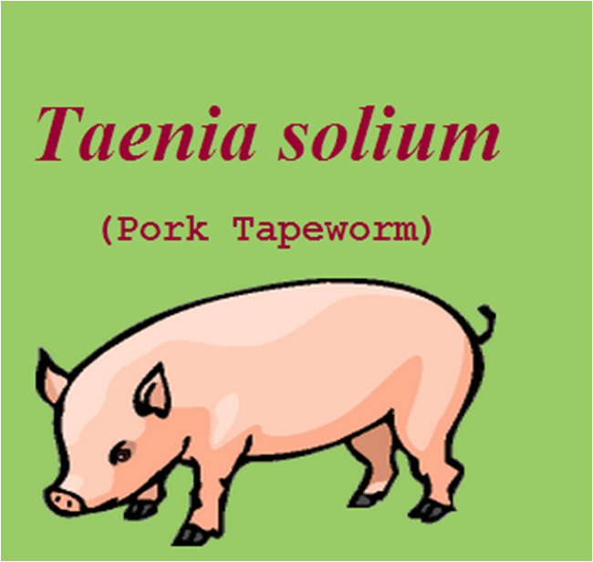 | 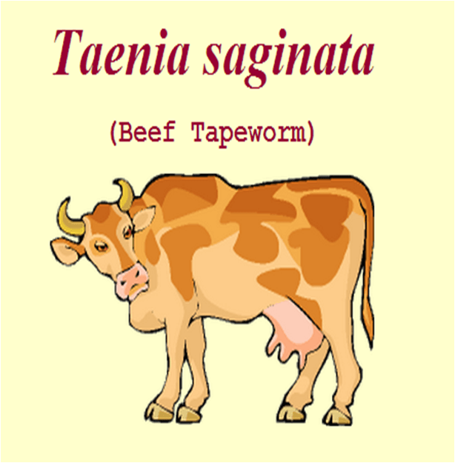
Definitive host | Human | Human
Intermediate Host | Pig in the striated muscle of intermediate hosts  Sometime human serve as intermediate hosts in the striated muscle | Cow/Cattle in the striated muscle of intermediate hosts
Disease | Taeniasis and Cysticercosis | Taeniasis only
Transmission | Infection is common among those eating raw or insufficiently cooked measly pork containing the cysticerci. | Human beings are infected through the eating of undercooked beef containing the cysticerci bovis (“measly” beef)
Size | Size of adult worm: 2-7 m | Size of adult worm: 5 m or less (sometime up to 25 m)
Scolex | 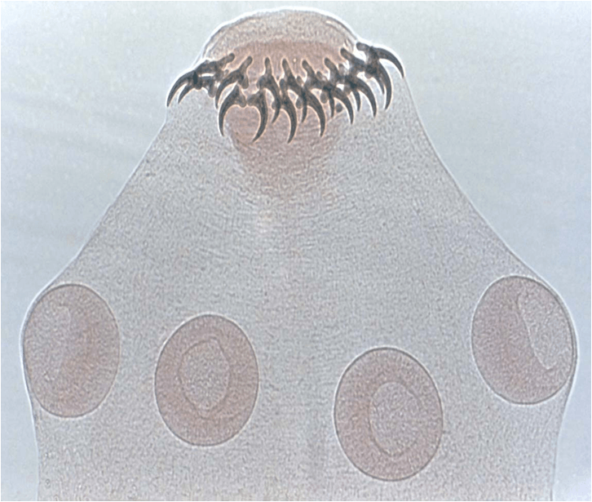  - The scolex head is globular in outline and has four circular suckers.  - The head is provided with the rostellum armed with double row of alternating large and small hooklets. The rostellar hooklets are shaped like daggers or Arbian poniards (armed scolex) | 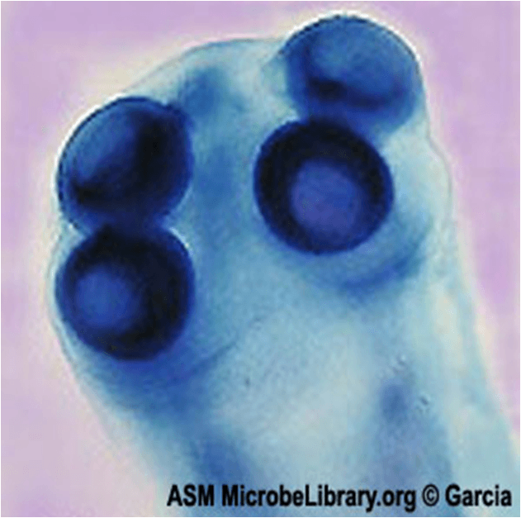  - The scolex (“head”) is quadrate in outline and has four circular suckers.  - Rostellum and hooklets are absent (i.e. unarmed scolex)
Proglottids | 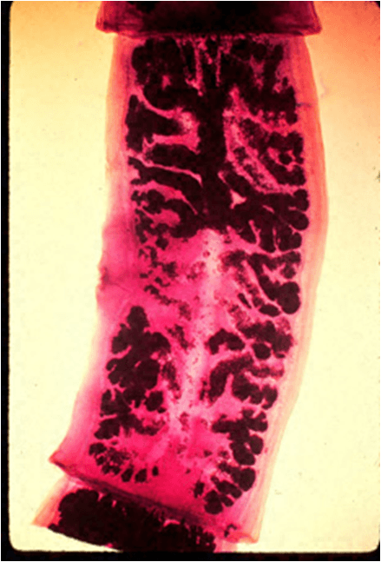  - The total number of proglottids (segments) is an average of 1000.  - The gravid uterus consists of a median longitudinal stem with 5- 13 compound lateral branches on each side  - T. solium may produce 50,000 eggs per proglottid. | 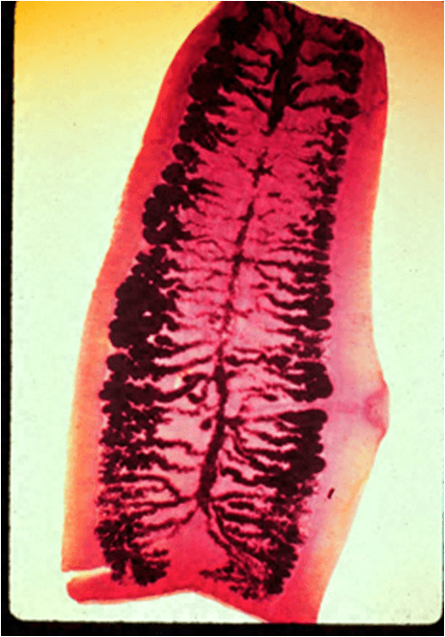  The number of proglottids varies from 1000- 2000.  - The gravid uterus consists of a central longitudinal stem with 15-30 lateral branches on each side  - T. saginata may produce up to 100,000 eggs per proglottid.
Eggs | 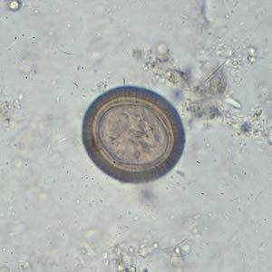  - The eggs are bile stained.  - The internal oncosphere contains six refractile hooks. | Eggs of Taenia solium and Taenia saginata are morphologically indistinguishable.
Eggs (Infectious nature) | Infectious to humans (Human who ingested food contaminated with egg of Taenia solium may develop cysticercosis) | Eggs of Taenia saginata are not infectious. Human who ingest T. saginata eggs do not develop cysticercosis.
Infective stage | cysticercus, | Cysticercus bovis
Pathogensis and symptoms
Taeniasis in general is asymptomatic.
Infected people may become aware of infection by noticing proglottid segments of the tapeworm in their feces.
Symptoms of infection, if any, are general: nausea, intestinal upset, vague abdominal symptoms such as hunger pains, diarrhea and/or constipation, or chronic indigestion. Increased eosinophils may be a sign of infection, and anaemia.
Cysticercosis: T. solium eggs can also infect humans (occur by autoinfect or contaminated food with eggm these eggs hatch in the small intestine and migrate to various tissues of the body)and cause cysticercosis (larval cysts in lung, liver, eye and brain) resulting in blindness and neurological disorders.
Diagnosis1- Taeniasis diagnosis made by finding gravid proglottides or egg in stool through direct fecal smear while
2-Cysticercosis diagnosis made by biopsy of subcutaneous nodules, X-ray, CT scan or MRI are used for the diagnosis of brain type.
Prevention
Health education
Avoid eating raw pork; make sure that meat has been cooked properly and thoroughly by adequate boiling or heating.
Avoid pigs eating human stool
Sanitary inspection of slaughter and sanitary disposal of night soil
• Class: Cestoda • Family Taeniidae
Echinococcus granulosus cause Hydatid disease cause Echinococcus multilocularis cause Alveolar hydatid disease
Common name hydatid worm
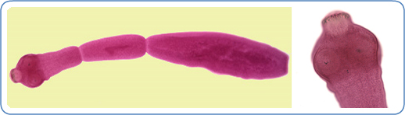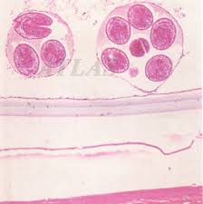
Habitat • The adult worm lives in the jejunum and duodenum of Definitive hosts such as dogs and other canine carnivora (wolf and fox).
• The larval stage (hydatid cyst) is found in liver and other visceral organs of Intermediate hosts such as humans[Accidental Humans (Dead end hosts)] and herbivorous animals (sheep, goat, cattle and horse)
disease name Ecchinococcosis (cystic hydatid ) disease.
Morphology • Size (adult): Ranges in length from 2mm to 9mm • It comprises of a scolex (head) , neck and strobilla or proglottids consisting of 3 or 4 segments, – immature, mature & a gravid link that is longer and wide.
• The scolex (head) has 4 suckers and also has a rostellum with two rows of hooks.
Egg : ovoid in shape and resembles other taenia, contains a hexacanth embryo with 3 pairs of hooks.
Larval Form ; the hydatid cyst represents the structure of the scolex of adult worm and remains invaginated within a vesicular body [developing inside various organs of the intermediate host].
• After entering the definitive host, the scolex with suckers and rostellar hooklets, becomes exvaginated and develops into adult worm.
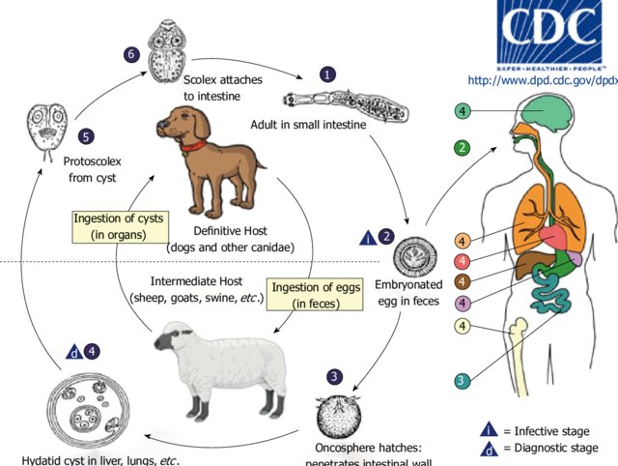
Pathogenesis Hydatid cyst Slow growth Asymptomatic for years
Up to 20 years (unless in nervous system), Pathology depends on
location, size, how many. Pathogenesis host tissues destroys tissues-replaces with cyst grows continuously which contain fluid and protoscolices, rupture of the cyst fatal due to anaphylactic shock hydatid fluid (death), Pressure effect of the enlarging cyst, Secondary bacterial infection can cause pyogenic abscess formation in the hydatid cysts.
Diagnosis by MRI, CT scan, Ultrasound, X-ray to searching of hydatid cyst, Serodiagnosis.
• Class: Cestoda • Family Taeniidae
Taenia multiceps rare cause of human infection, is acquired by accidental ingestion of eggs from dog feces. Canines are the definitive hosts for adult
sheep and other herbivorous animals are intermediate hosts.
The larvae invade and form a cyst (coenurus) in human tissue, usually in the CNS. Symptoms require several years to develop and depend on the organ infected. Involvement of the brain causes increased intracranial pressure, seizures, loss of consciousness, and focal neurologic deficits.
In the definitive hosts eggs and gravid proglottids are shed in feces into the environment , where they are ingested by an intermediate host(rodents, rabbits, horses, cattle, sheep and human accidentally). Eggs hatch in the intestine, and oncospheres are released that circulate in blood until they lodge in suitable organs (including skeletal muscle, eyes, brain and subcutaneous tissue). After about three months, oncospheres develop into coenuri.
The definitive host becomes infected by ingesting the tissue of an infected intermediate host containing a coenurus containing a coenurus .
Coenuri of T. multiceps are usually found in the eyes and brain and subcutaneous tissue. The parasite is not transmissible to man from the intermediate hosts. Coenuri in the central nervous system may cause headache, fever and vomiting. Coenuri in the eye cause both intraocular and orbital infections, and patients may present with varying degrees of visual impairment. If not removed, coenuri in the eye may cause painful inflammation, glaucoma and eventually blindness.
Diagnosis is made by the observation of coenuri in biopsy.

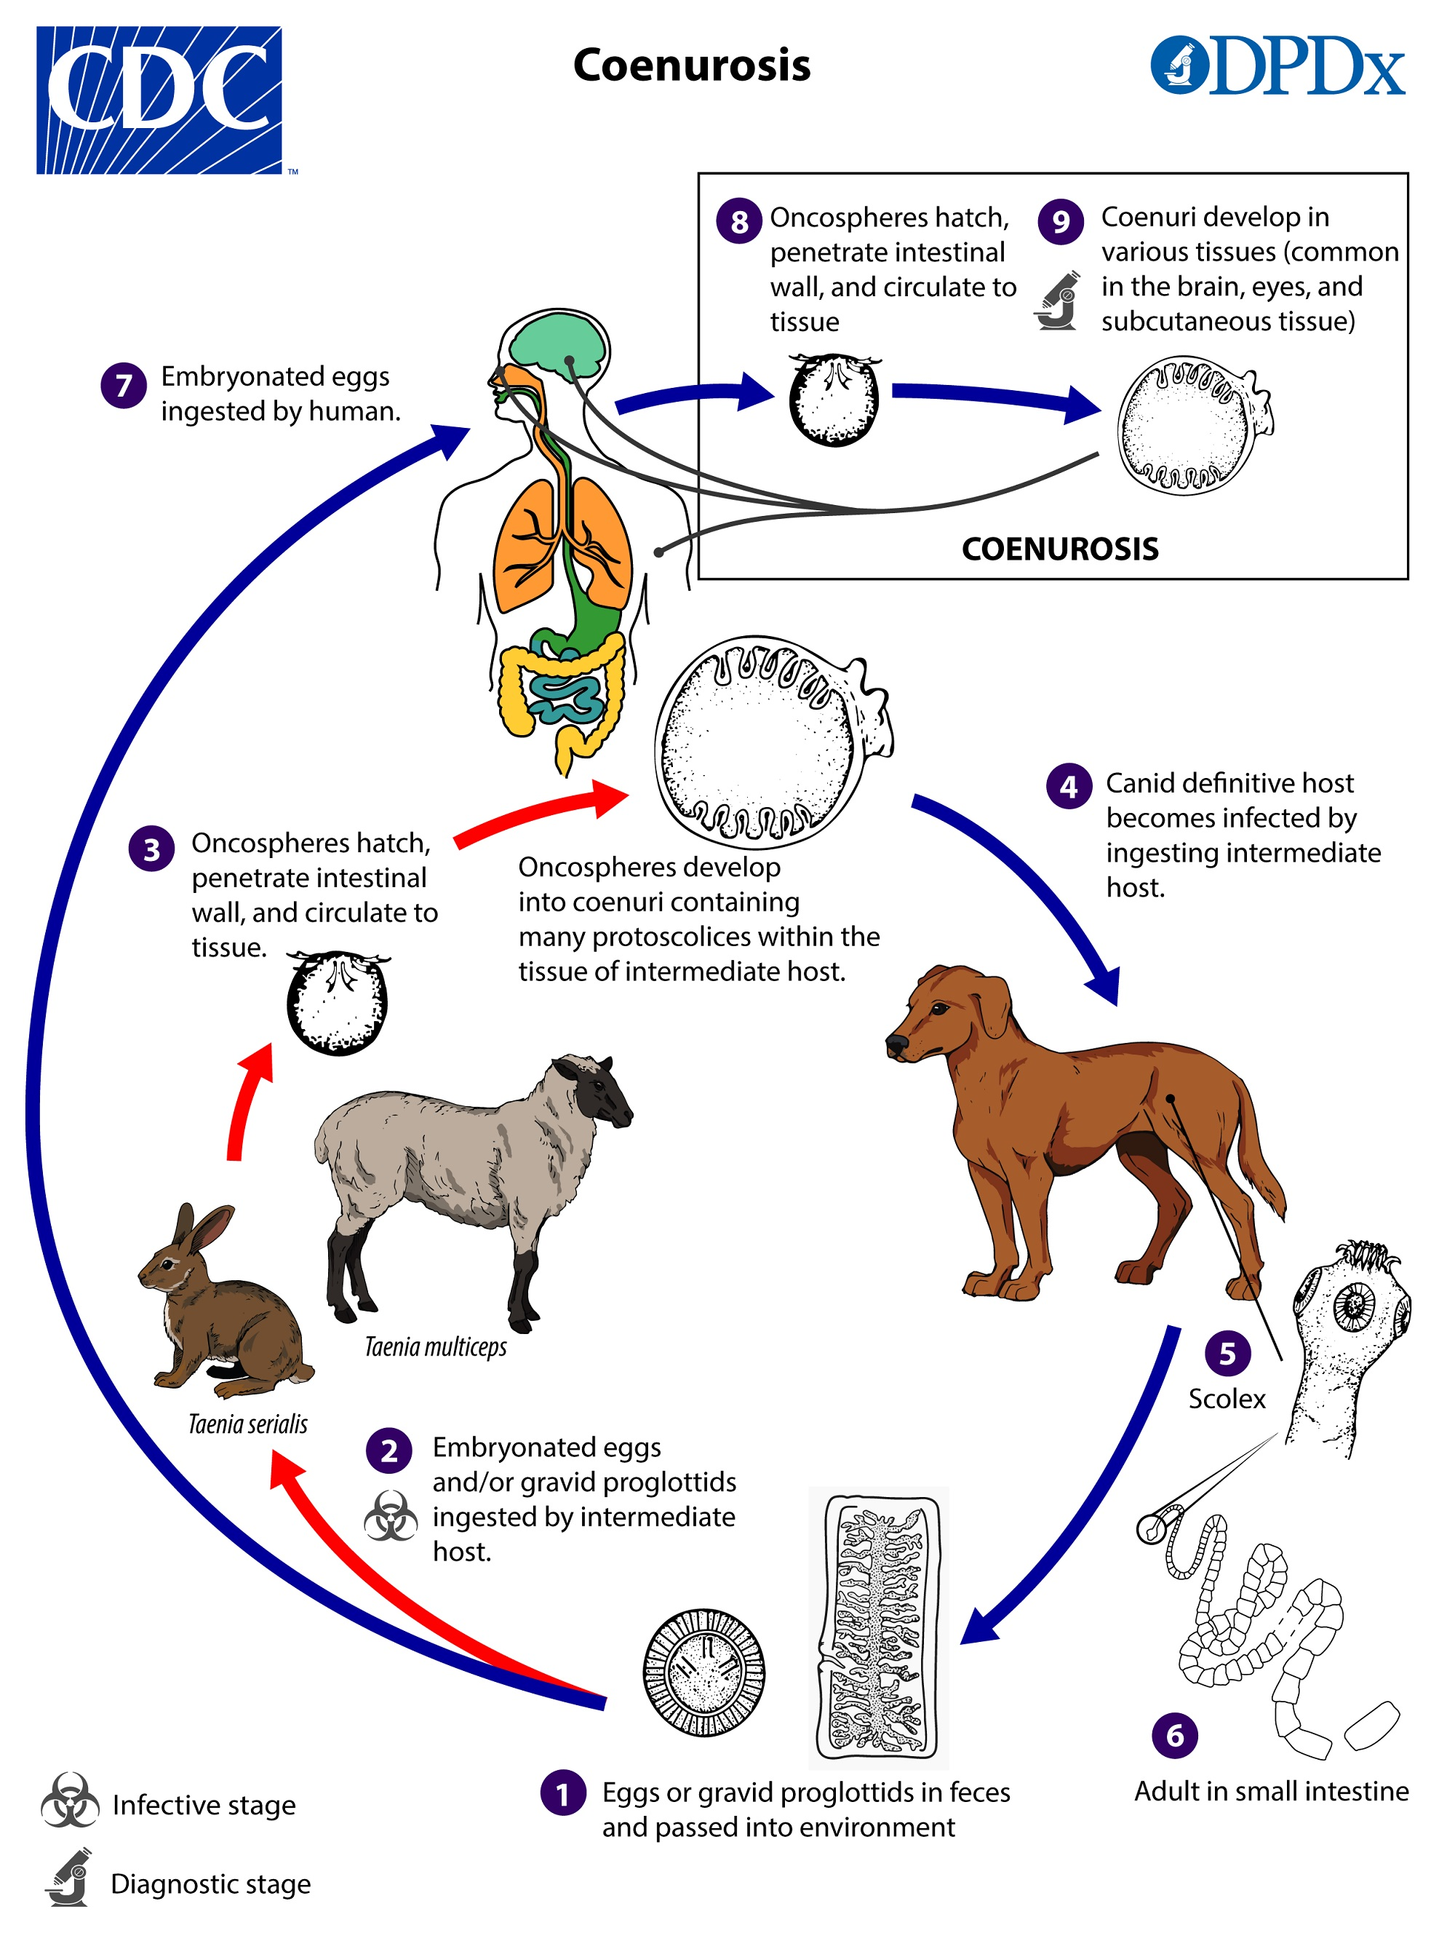
Phylum: Platyhelminthes Class: Cestoda Order: Cyclophyllidea
  - Family: Hymenolepididae Genus: Hymenolepis
  - Hymenolepis nana 2- Hymenolepis diminuta
• Disease name Hymenolepiasis caused by two cestodes (tapeworm) species, Hymenolepis nana (the dwarf tapeworm due to its particularly small size, adults measuring 10-45 mm long) and Hymenolepis diminuta (rat tapeworm, adults measuring 20 to 60 cm in length). Hymenolepis diminuta is a cestode of infrequently seen in humans and frequently found in rodents.
1. Hymenolepis nana is the most common tapeworm in humans.
The definitive host: human, mice and rats, It is the only cestode that does not require an intermediate host to develop into its infective stage, but some time optional (various species of beetles and fleas may serve as intermediate hosts).
Morphology
Adult worm is 10-45 mm long
Scolex is small, globular (rounded), cup-like four suckers and retractile rostellum with a single row of 20–30 hooks.
Neck is long and slender
proglottid development, have 100-200 segments that are wider then they are long Gravid (mature, full of eggs) proglottids filled with eggs,
Genital pores are unilateral (side of the segment)
egg is colourless, almost transparent, round to oval, has polar filaments, they are embryonated and have 6-hooked oncospheres inside the shells. The shell consists of two membranes.
Transmission 1- Eggs are infective when passed with the stool, When eggs are ingested (in contaminated food or water or from hands contaminated with feces), the oncospheres contained in the eggs are released.
2- autoinfection, where the eggs release their oncospheres, which then penetrate the villi continuing the infective cycle without leaving the host's body.
oncospheres penetrate the intestinal villi and develop into cysticercoid (encysted) larvae. Upon rupture of the villus, the cysticercoids return to the intestinal lumen, attach to the intestinal mucosa and develop into adults that reside in the ileal part of the small intestine and produce gravid proglottids.
Symptoms are nausea, weakness, loss of appetite, diarrhoea, and abdominal pain. headache, itchy bottom, or have difficulty sleeping. -H. nana can be deadly in children or people with a weak immune system -Dehydration can result from prolonged diarrhoea.
Diagnosis - detection of eggs in faeces.
-Seeing tapeworm in the intestine.
Life cycle
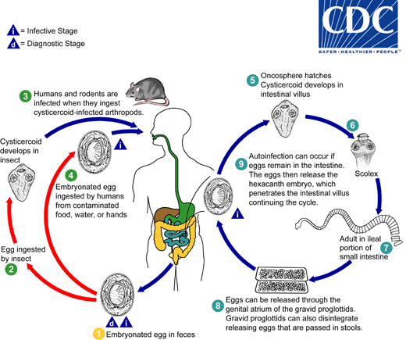

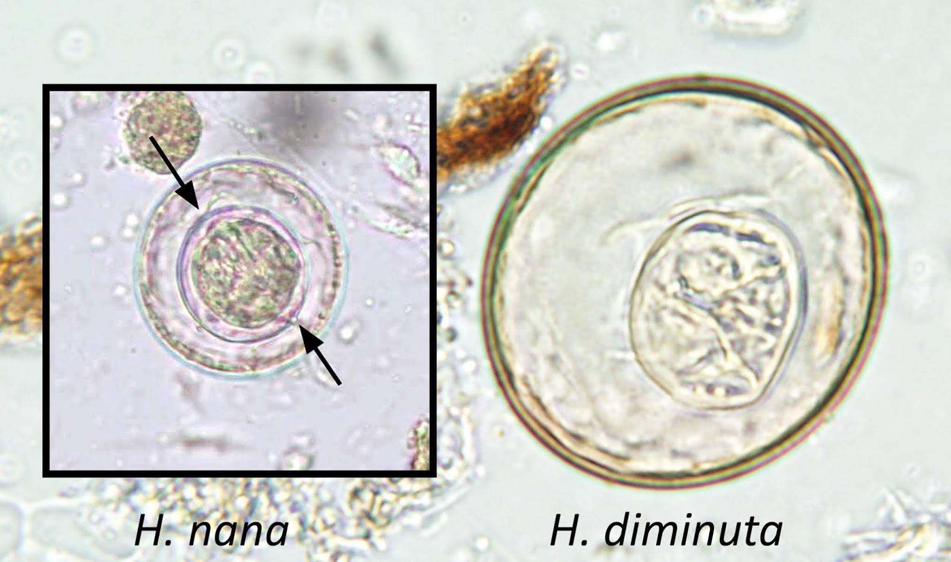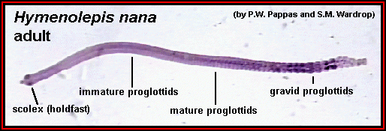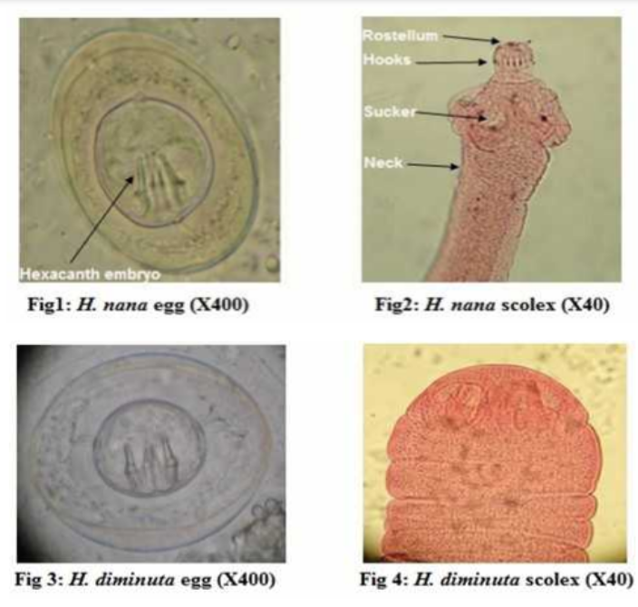
2- Hymenolepis diminuta
Morphology about 20 - 60cm or more in length.
The scolex has four suckers and a retractable rostellum that does not have hooks.
• Consists of up to 1000 proglottids that are wider than long. Each proglottid gental pore opening to a lateral genital pore.
• Eggs are around or slightly oval and yellowish-brown in colour, Can produce over 250,000 eggs per day.
• The oncosphere (hexacanth) has six hooks,
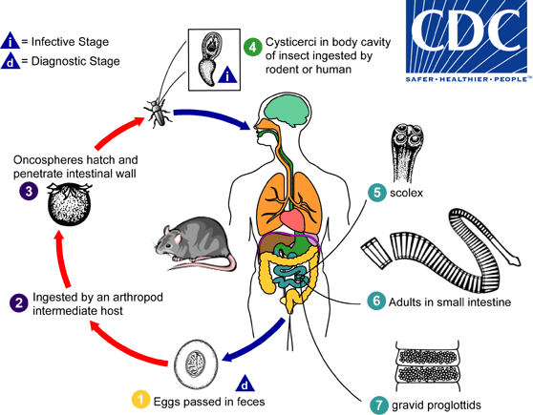
Life cycle
Eggs are passed out in the faeces of the infected definitive host (rodents & man). The mature eggs are ingested by an intermediate host (various arthropod adults or larvae), which develop into cysticercoid larvae, humans can be accidentally infected through the ingestion of insects.
Diagnosis detection of eggs in faeces.
Prevention -Good hygiene -Elimination of rats and mice -Public health and sanitation programs
Family: dipylidiidae
Dipylidium caninum
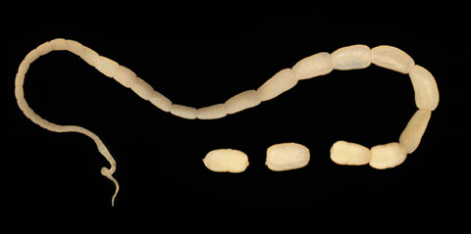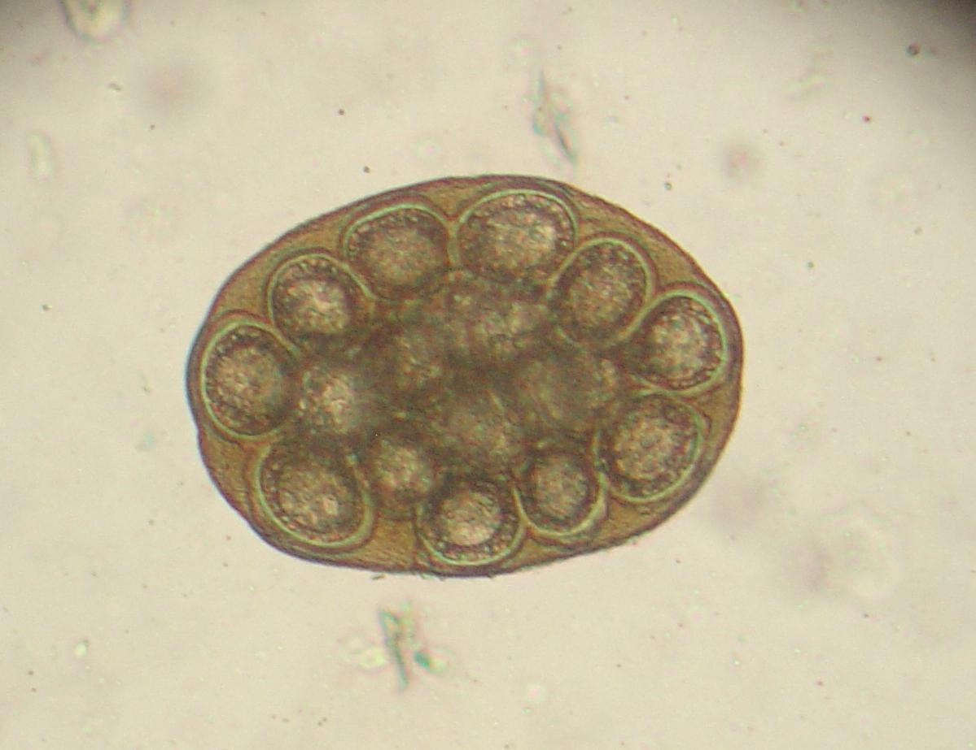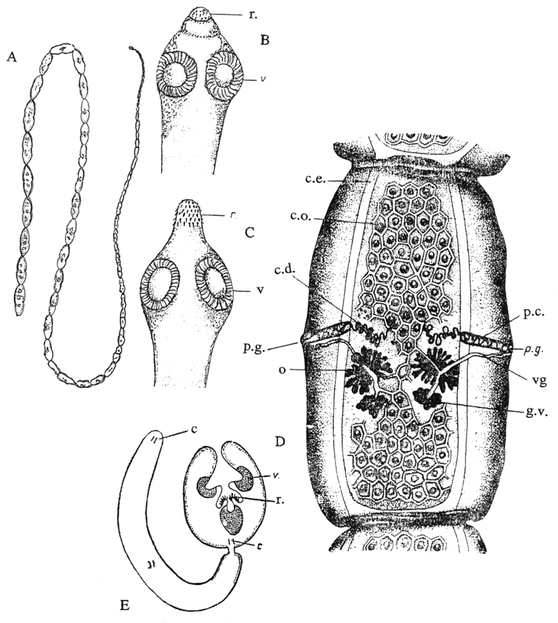
Common name dog tapeworm -cucumber tapeworm, disease name: Dipylidiasis that commonly infects as final host dogs and cats. And occasionally affects humans, especially children, intermediate host:- fleas, lice.
Infective stage: cysticercoid for F.H & egg for I.M.H.
Morphology 10-70 cm in length Scolex:
Scolex is conical-shaped and has four suckers. There is rostellum armed with several rings of small hooks.
Segments(strobila) 200 segments, diagnostic feature resemble grains of rice or cucumber, they contain two sets of male and female reproductive organs. They, therefore, demonstrate two genital pores that lead to their name as the “double-pored” one in the middle of each lateral margin.
gravid segments: contain egg capsule, eggs are round to oval and contain an oncosphere that has 6 hooklets. And present as egg capsule contain 5 to 30 or more eggs.
The larvae of D. caninum are known as cysticercoids because the scolex is enclosed in a fluid-filled cyst at this stage.
Pathogenisity
Human infection is rare and normally restricted to young children.
- Light infections of D. caninum often are asymptomatic.
- Infection, however, can still cause abdominal pain, diarrhoea, and anal itch in some individuals.
Diagnosis Detection of segments and eggs capsule in stool.
