Parasitology lecture 8 Biotechnology 3ed stage by Dr Alia Alubadi
1- “Nematos” - a round body with elongate, cylindrical , tapered at both ends non-segmented, parasitic and free-living , It has separate sexes, the female is usually larger than a male
2- Bilateral Symmetry
3- Triploblastic – Three tissue layers – Endoderm, Mesoderm, Ectoderm
4- Body Cavity: Pseudocoelom
5- Digestive System: – Complete digestive system (mouth and anus separate) – Specialized organs for breakdown and absorption of nutrients
6- Reproduction: – Sexual: Dioecious (sexes separate) – Asexual: None.
7- Circulation: Diffusion
8- Nervous System: – Ganglion (brain), dorsal and ventral nerve cords & sensory organs
9- Respiration: Diffusion through skin
10- Excretion: anus & tubes
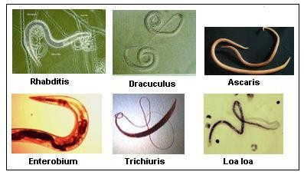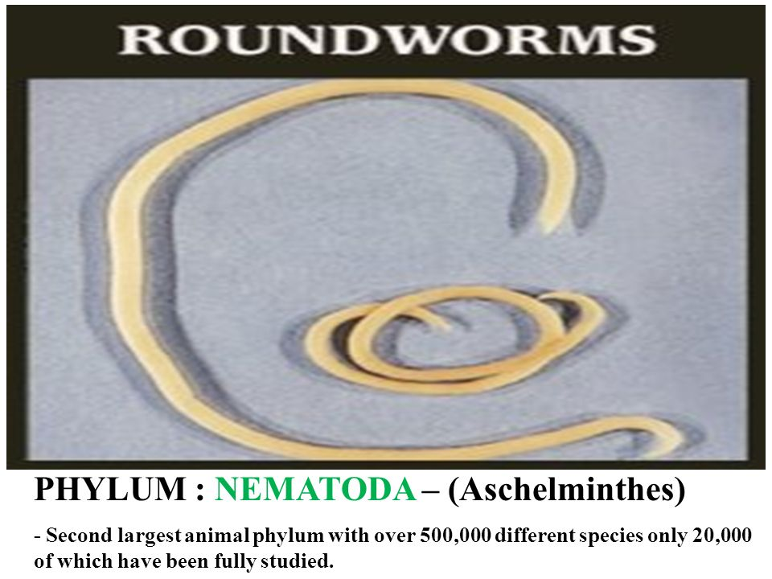
Nematoda divided them into 2 classes phasmidia and Aphasmidia on the basis of presence and absence of phasmids.
Class 1. Aphasmidia | Class 2. Phasmidia
Phasmid (caudal (tail) sensory organs) absent. | Phasmids present.
Amphids (anterior sense organs) of various types, rarely pore-like. | Pore-like amphids.
Excretory system absent. If present poorly developed. | Well-developed excretory system.
Well-developed mesenterial tissue. | Weekly developed mesenterial tissue.
Caudal adhesive glands present | No caudal adhesive glands.
Order 1. Trichuroidea (Trichinelloidea)
Body filiform anteriorly.
Mouth without lips; pharynx slender.
Female with 1 ovary and male with 1 or none spicule.
Parasites of vertebrates.
Examples: Trichuris trichiura (Whipworm) a very common intestinal helminthic infection and about one-quarter of the world's population is thought to carry the parasite. Only patients with a heavy parasite burden become symptomatic.
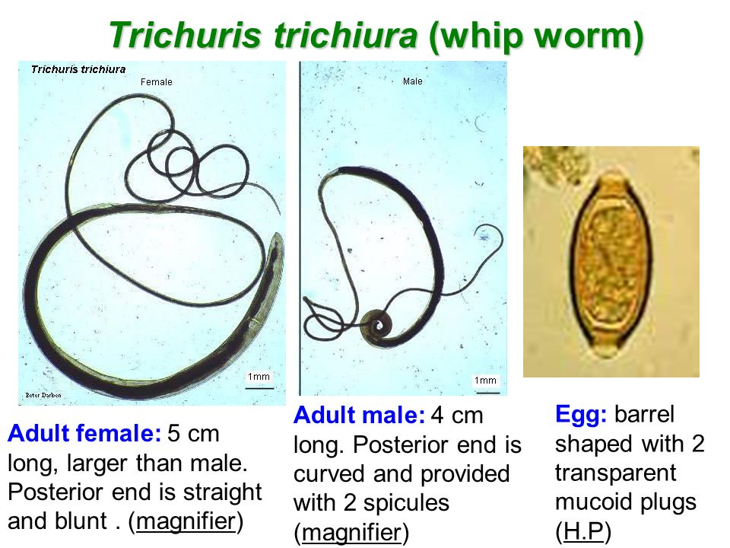
Poor hygiene is associated with trichuriasis transmission, and children and in the schools are high prevalence due to lacking hygiene conditions.
1. Male, 30-45 mm; female, 35-50 mm
2. Adults reside in the large intestine, cecum, and appendix of the host.
3. Buries its thin, threadlike anterior half into the intestinal mucosa and feeds on tissue secretions, not blood.
4. Transmission: faecal-oral via embryonated ova.
5. Pathology the major pathology resembles that of inflammatory bowel disease due to mechanical disruption and toxicity of whipworms.
Symptoms hyperemiaاحتقان oedema haemorrhage/bleeding In a few cases, there are cellular proliferation and thickness of the intestinal wall causing inflammatory and granulomas
6. Clinical manifestations Light infestations (<100 worms) are frequently asymptomatic.
Heavy infestations may have bloody diarrhoea. Long-standing blood loss may lead to iron-deficiency anaemia. Rectal prolapse is possible in severe cases. Vitamin A deficiency may also result due to infection. Mechanical damage to the mucosa may occur as well as toxic or inflammatory damage to the intestines of the host.

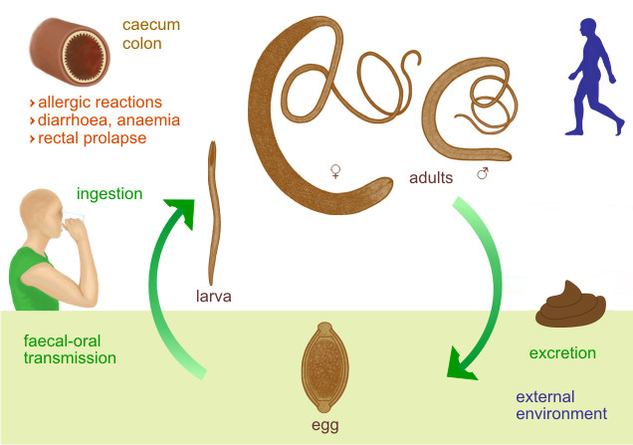
7. Diagnosis T. trichiura eggs are detected in stool examination. Eggs will appear barrel-shaped and unembryonated, having bipolar plugs and a smooth shell.
8. Prevention & Control
1- Application of hygiene conditions(good wash, cook well, etc).
2- Avoid ingesting soil that may be contaminated with human faeces, including where human faecal matter ("night soil") or wastewater is used to fertilize crops.
Order 2. Rhabdiasoidea
Size medium. Smooth cuticle. Pharyngeal bulb absent. The parasitic stage in vertebrates is either hermaphroditic or parthenogenetic.
Examples: Strongyloides stercoralis
Habitat: females live in the superficial tissues of the small intestine (duodenum and jejunum)of definitive host: Human, dogs and cats
• Route of infection: Filariform larvae penetrate the skin of a human.
• Infective stage: Third stage larvae ( filariform).
• Diagnostic stage: First-stage larvae(Rhabditiform) in faeces.
life cycle: Free life cycle and Parasitic life cycle.
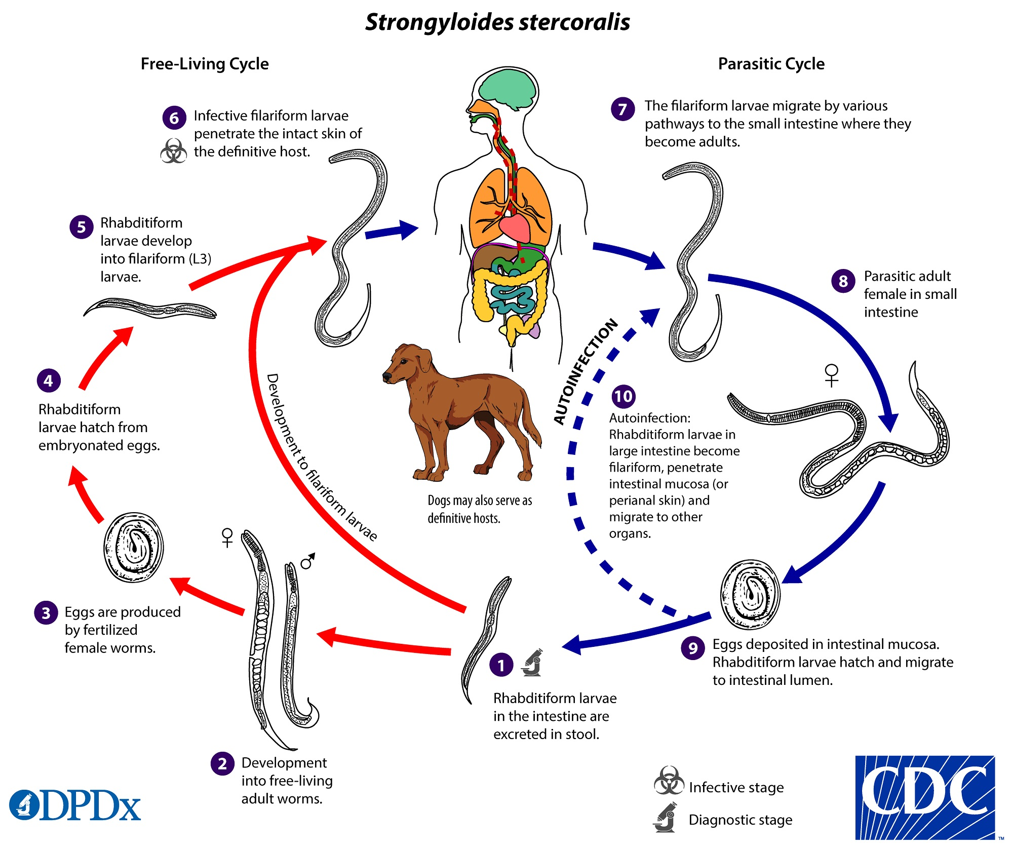
• Cause by direct contact with contaminated soil
Egg shape: oval, clear, thin-shelled Similar to hookworm but are smaller, laid in the mucosa, hatch into rhabditiform larvae that penetrate the glandular epithelium and pass into the lumen of the intestine and out the faeces (Eggs are seldom seen in stools).
Adult: Male (free-living): - 0.7 mm in length - Rhabditiform oesophagus - Posterior end curved ventrally with Spicules
Parasitic female: - 2.2 mm in length - Cylindrical oesophagus (1/3 body length) - Posterior end straight
Free-living female: - 1 mm in length - rhabditiform oesophagus - posterior end straight.
Rhabditiform larvae Short buccal cavity.
Life Cycle in the parasitic stage, no male form of this organism has been reliably identified, and the female reproduces in a parthenogenetic manner.
When filariform larvae encounter a human or another suitable host they penetrate the skin and are carried by cutaneous veins to the vena cava, they enter the right side of the heart and are carried to the lungs via the pulmonary artery, following a 3rd moult, the larvae rupture from the pulmonary capillaries and enter the alveoli, the larvae move to the epiglottis and subsequent swallowing by the host, they migrate over the epiglottis to the oesophagus and down into the small intestine, where they undergo a final moult and become sexually mature females and produce embryonated eggs parthenogenetically and hatch in the mucosa into 1st stage rhabditiform larvae and exit the intestine with the faeces, feeding down the length of the intestine.
Autoinfection • During passage through the host digestive system, rhabditiform larvae may undergo 2 moults to filariform larvae and by penetrating the intestinal mucosa, enter the circulatory system and continue their parasitic lives without leaving the host Autoinfection can also occur when larvae remain on and penetrate the perianal skin. • Autoinfection often leads to very high worm burdens in humans.
In the free-living phase dwell in moist soil in warm climates copulation occurs in the soil; egg oviposition, eggs hatch in the soil and give rise to 1st stage rhabditiform larvae and go through several moults and become sexually mature adults. This free-living heterogenic life cycle may continue indefinitely
Pathology
• Invasive: Skin Penetration. • Pulmonary: During Cycle or Immigration. • Intestinal: Tissue Destruction
– Commonly asymptomatic
– But symptoms may include:1. Gastrointestinal (diarrhoea, abdominal pain, malabsorption)
2. Respiratory (coughing, wheezing)
3. Dermatologic (ground itch, rash)
4. Anemia
Transmission • Direct penetration of unbroken skin by larva • Autoinfection - internal (larva becomes infectious in intestinal tract) & external
Diagnosis direct stool smears larvae (rhabditiform and occasionally filariform) in the stool. Histology the microscopic tissues larvae typically found.
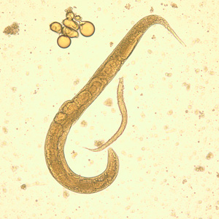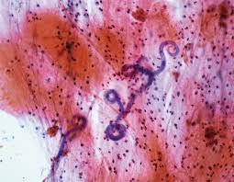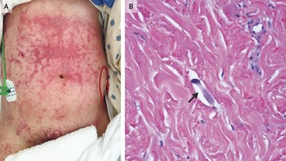
Order 3. Oxyuroidea
Pin-shaped small worm.
Mouth surrounded by 3-6 small lips.
Pharynx with valvular posterior bulbs.
Female with a long pointed tail.
Parasitic in invertebrates and vertebrates.
Examples: Enterobius vermicularis is a common intestinal parasite in humans, the body is covered with cuticle. The male worm is inconspicuous and has a length of 2 to 5mm. The female is dominant and has a length of 8 to 13mm.
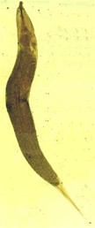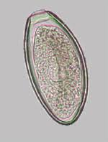
Humans are the host Infections occur by ingesting eggs The larvae hatch from the egg in the small intestine The larvae develops into male and female worms Fertilization occurs in the colon, after that males die.
Gravid female migrates nocturnally to the anus and lay eggs, after that females die. The eggs become infectious within 6 hours. The movement of the female worm and the eggs cause itching Scratching the area may result in retro infection The time period from ingestion of infected eggs to the ovideposition is approximately one month.
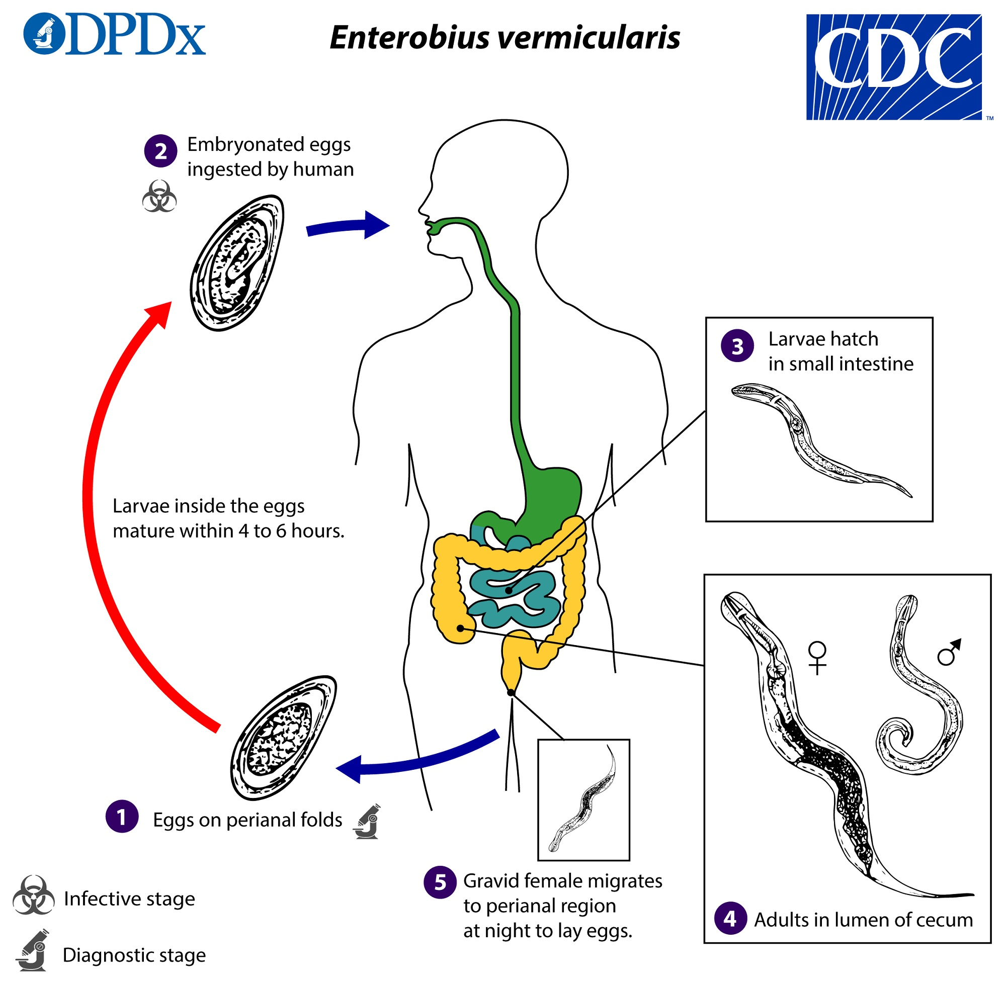
Symptoms perianal pruritus is the most common symptom It is thought to be an allergic reaction to the presence of either the adult female or the eggs Itching of the perianal and vaginal area is commonly notable, especially during night Weight loss is also observed in severe infections Scratching predisposes to secondary bacterial infection
Diagnosis the eggs are recovered from perianal skin by using the scotch tape technique for microscopic examination
Prevention Application of hygiene conditions(good wash, cook well, etc).
Change underwear and bed linen daily. Launder the bed sheets in hot water. Don't scratch and avoid nail biting. Clean toilet seats daily.

Order 4. Ascaroidea
Large-sized worm. Mouth surrounded by 3 lips. Pharynx without bulb. Male with a ventrally coiled tail. Parasitic in the vertebrates.
Examples: Ascaris lumbricoides ( Giant Intestinal round worms) is the largest nematode (roundworm) parasitizing the human intestine found in the small intestine of man. • They are more common in children then in adult.
Disease:-Ascariaisis , Host :- The human in small intestines , Infective stage :- Ovum
Female pink- creamy-white in color. The female averages 20-35cm in length, the male is smaller, averaging 15-31cm in length, the typical curled tail with a pair sickle like copulatory spines. On the tip of the head there are three toothed lips, arranged as a Chinese word “ 品 ”, the lips are one dorsal and two ventrolateral. • These lips bear sensory structures called labial papillae
Site of infection: small intestine
Infetive stage: embryonated eggs by mouth through contaminated food or water with eggs
A female may produce approximately 200,000 eggs per day, which are passed with the faeces . Fertile eggs embryonate infective, the larvae hatch , invade the intestinal mucosa - hepatic portal vessels, then systemic circulation to the lungs- penetrate the alveolar walls, ascend the bronchial tree to the throat, and are swallowed and reaching the small intestine, they develop into adult worms.
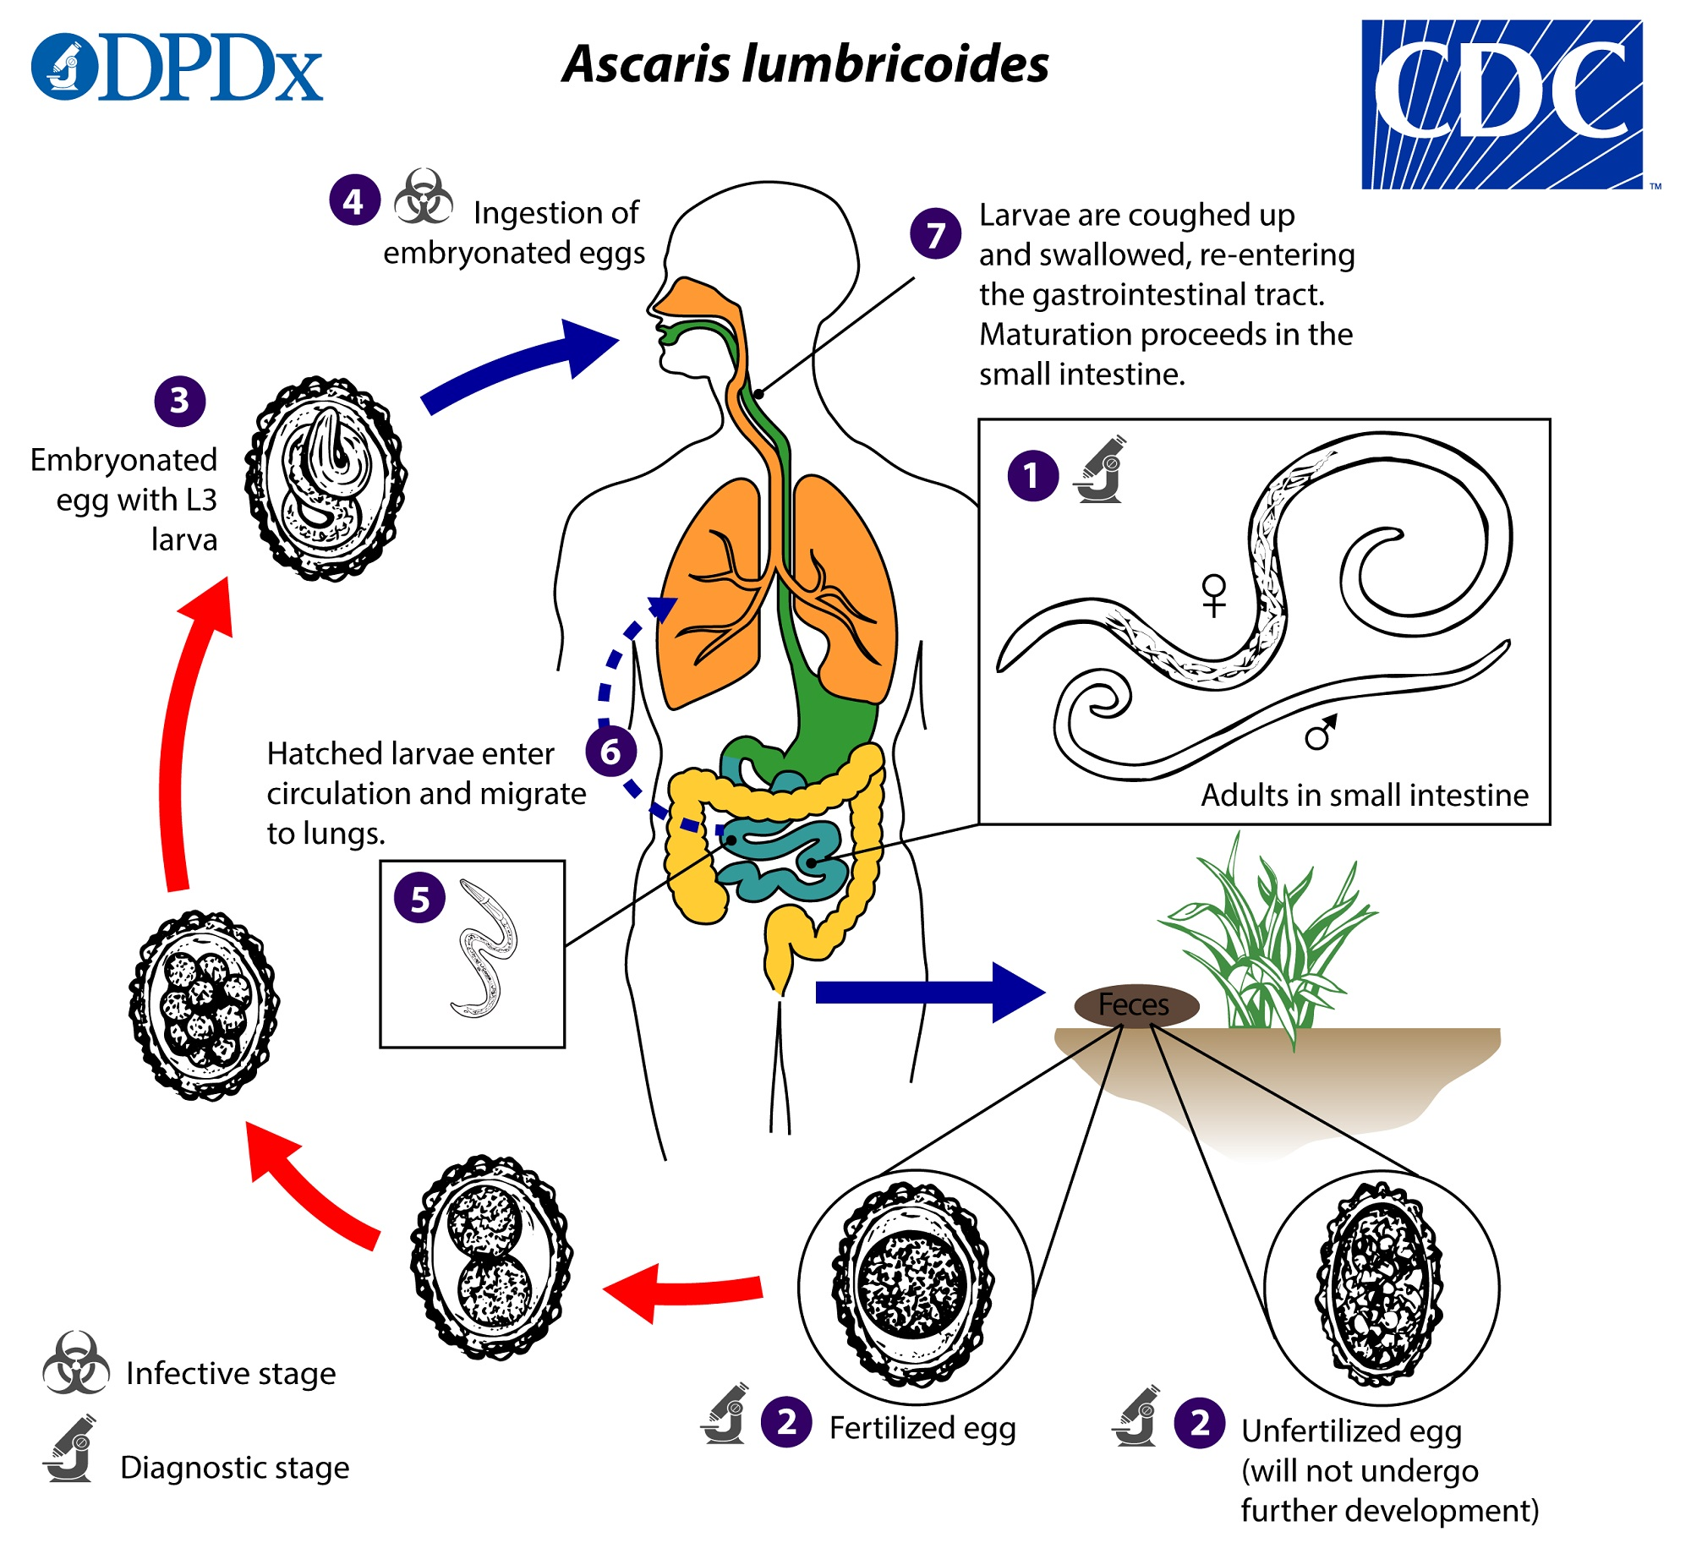
Pathogenesis there are two phase in ascariasis: 1. The blood-lung migration phase of the larvae may cause a pneumonia. The symptoms of the pneumonia are low fever, cough, blood-tinged sputum, asthma. Large numbers of worms may give rise to allergic symptoms. Eosionophilia is generally present. These clinical manifestation is also called Loeffler’s syndrome.
2. The intestinal phase of the adults. The presence of a few adult worms usually produces no symptoms, but heavy infection cause
1- diarrhoea, abdominal pains or intermittent colic, especially in children. 2-malnutrition. 3- Intestinal blockage - may be partial or complete • Partial intestinal blockage • Total intestinal blockage • Severe abdominal pain • Vomiting • Restlessness • Disturbed sleep.
Diagnosis identify worm or egg in the Stool examination.
oval shell:-Thick,consisting of 3 layers coarse consist of regular albuminous,There is crescent shaped clear space at the each end inside the shell with Golden brown color
Prevention
- Keeping good sanitation conditions.
- Should be avoided pollution of soil with human faeces.
- Health education. Hygienic habits such as cleaning of hands before meals.
Order 5. Strongyloidea
Mouth without lips but leaf crown. Well-developed buccal capsule.
Pharyngeal bulb absent. Male with expanded copulatory brusa; female usually with ovijector. Parasites of vertebrates.
Examples: Necator, Ancylostoma
Hookworms are the voracious blood-feeders of the nematode world. • Two principal species that infect around the earth are
• Necator americanus ( the american killer or the new world hookworm).
• Ancylostoma duodenale ( the old world hookworm).
Adult – Cylindrical with the head bent sharply backwards, head have buccal cavity 2 ventral plates and two large teeth – Males are smaller than the females and possess a bursa at their posterior end
Definitive host • Human • No Intermediate host
Adult mouthpart of Necator americanus Note : The large buccal capsule is open dorsally with one pair of cutting plate teeth.
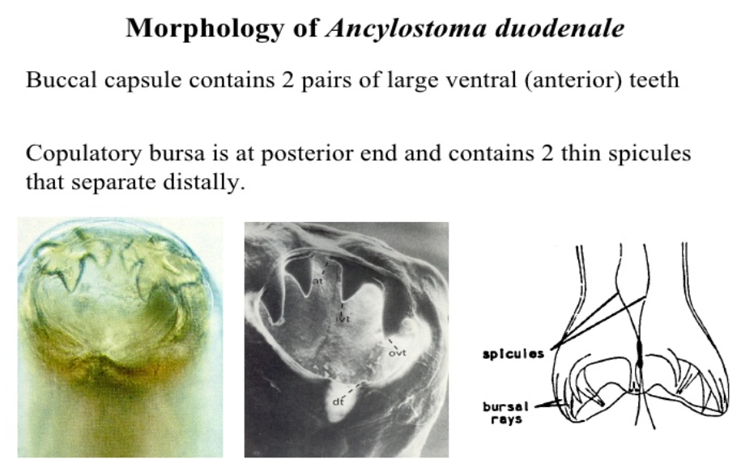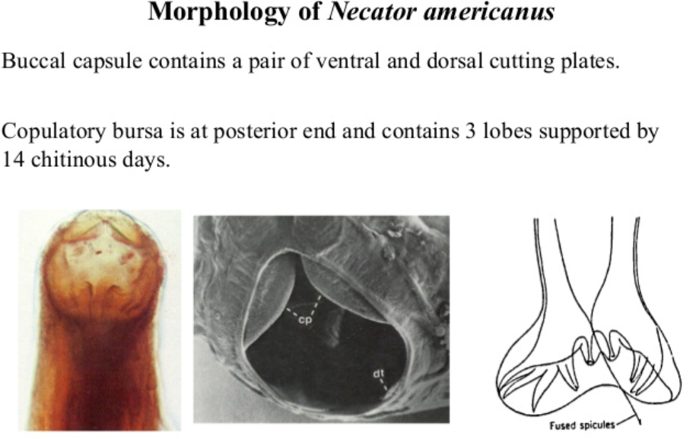
Hookworm infection/disease depends on three factors: 1)Number of worms present 2)Species of hookworm 3)Nutritional conditions of the infected person.
Transmission • Hookworm infection is contracted from contact with soil contaminated by hookworm, by walking bare foot or accidentally swallowing contaminated soil. • Children are at high risk because they play in dirt and often go bare foot.

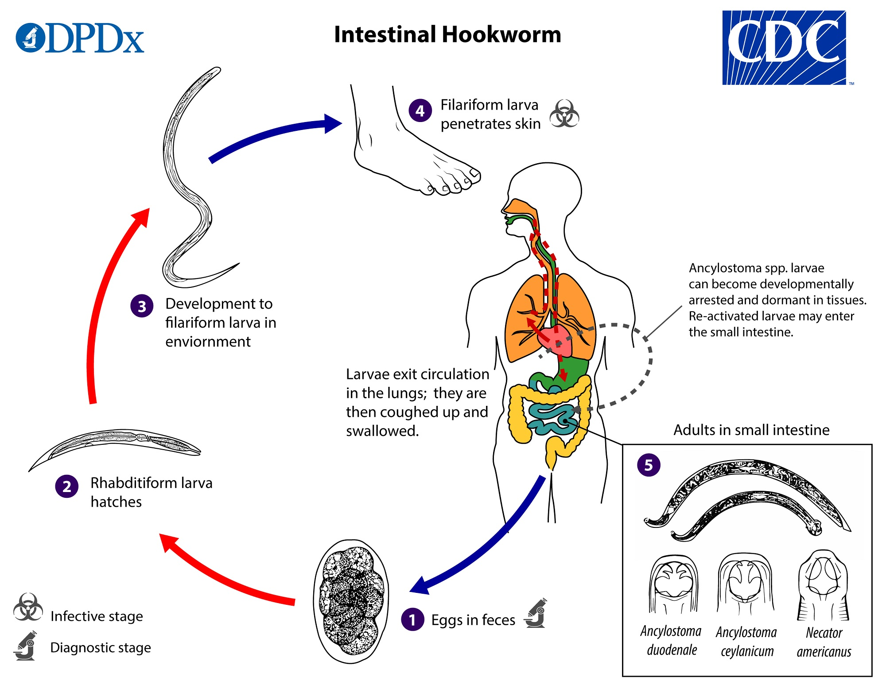
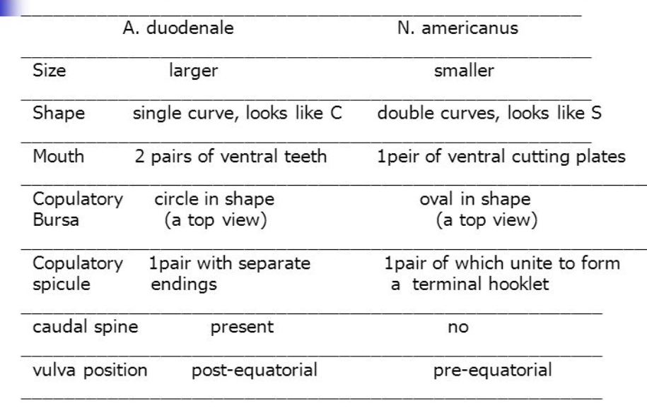
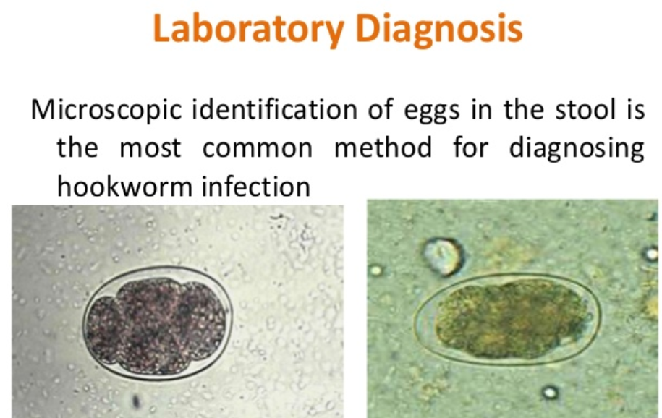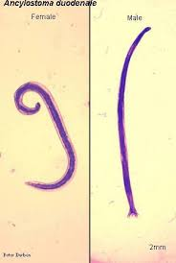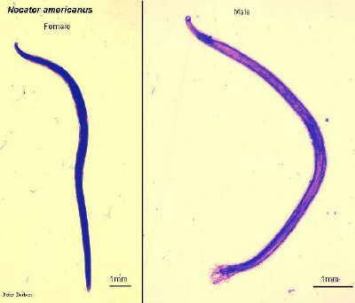
Laboratory diagnosis microscopic identification of eggs in the stool.
Prevention • Proper sanitation practices. • Appropriate fecal disposal. • Do not walk barefoot or contact with bare hands in areas where hookworms is common or there are likely to be feces in the soil or sand.

Order 8. Spiruroidea

Mouth with 2 lateral lips.
Pharynx with bulb, muscular anteriorly and glandular posteriorly.
Copulatory brusa absent in male but spirally coiled tail.
Parasites in animals.
Examples: Thelazia, Gnathostoma, Spiroxys.
Order 9. Dracunculoidea

Lips and buccal capsule absent.
Mouth surrounded by ring or papillae.
Pharyngeal bulb absent; pharynx muscular anteriorly and glandular posteriorly.
No copulatory brusa in male.
Parasites of vertebrates.
Examples: Dracunculus, Philometra.
Order 10. Filarioidea

Filiform slender worm.
Lips and buccal capsule absent.
6 labial papillae present.
No pharyngeal bulb.
Male small with a coiled tail.
Microfilariae in blood or skin and developed in blood-sucking insects.
Parasites of vertebrates.
Examples: Wuchereria, Loa, Microfilaria.

Order 2. Rhabditoidea

Size small or moderate.
The smooth or ringed cuticle.
Sensory bristles as papillae in 2 rings, an inner ring of 6 and outer ring of 4,6 or 10.
Copulatory spicules in male accompanied by the gubernaculum
Free-living or parasitic in animals and plants.
Examples: Rhabditis,

- Monoecious having both the male and female reproductive organs in the same individual; hermaphrodite.
- Dioecious having the male and female reproductive organs in separate individuals.
- Monoxenous requiring one kinds of host to complete the life cycle.
- Heteroxenous requiring at least two kinds of host to complete the life cycle.

