Microscopic techniques for plant organs analysis

This process have several steps:-
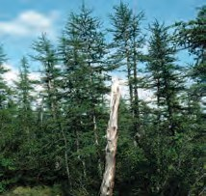
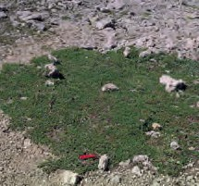
1- Collecting samples of plants: - All terrestrial biomes contain important plant material with different life forms like trees, shrubs, dwarf shrubs, palms, lianas, succulents, annual and perennial herbs, grasses, mosses, lichens and algaewhich can be analyzed in relation to taxonomy, morphology and environmental conditions.
Trees Dwarf shrubs
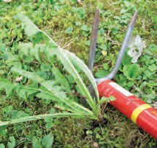
2- Samplingdifferent parts of plants: -If anatomical analyses is needed,parts of stems, roots, rhizomes of dicots and monocots and leaves can be cut by scissors, knives and borer (trees).
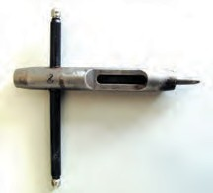

Borer
3- Fixation plant materials:- After sampling, the cutparts are put on plastic bag and add a few drops of 40% ethanol or vials which contain 70% ethanol or FAA solution. It is very useful to use very soft pencils for labeling the bags because ethanol dissolves pen ink and ink of permanent markers.
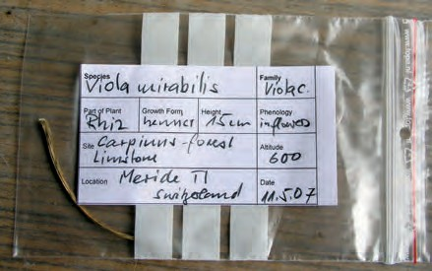

4- Dehydration and paraffin infiltration: -The removal of water is a necessary preliminary step to the infiltration of specimens toallow theplant material to be infiltrated with an appropriate supporting medium (paraffin wax; polyester wax or a polymer, such as glycol methacrylate) to provide adequate support for the material during sectioning. Paraffin is the very classical embedding medium introduced into microtechniqueas melts at high temperatures (54–60 °C), is strongly hydrophobic and easy cutting.Various solvents were proposed for use in dehydration (isopropanol, acetone, methyl cellosolve, etc.). There are various protocols for the paraffin infiltration and embeddingwhich contain an increasing proportion of the dehydrating agent and progressively less water. Some anatomists regard tertiary butyl alcohol (TBA) as being an ideal dehydrating agent and other use xylene. The procedure for infiltrating plant tissues through a TBA series is begin in 50% liquid paraffin, 50% wax for 24 hours, and then followed by three changes of wax as illustrated in table.

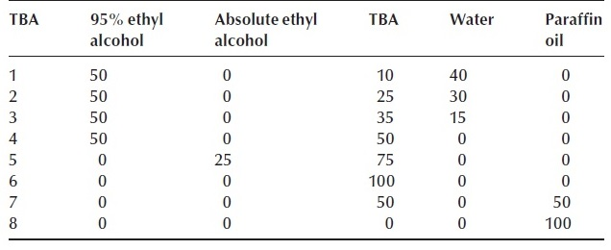
5- Sectioning: -There are two types of sectioning:-
A- Sectioning by microtomes: -A rotary or rocking microtome should be used where wax-embedded specimens are going to be used to prepare thin sections under 10 µm thick. It usually used for the production of large quantities of slides of the same specimen.
This process is done by:-
1-Sections are cut into a ribbon as it is always more difficult to cut the first section but slow and steady strokes usually result in best sections with least compression.
2-A moistened brush used to manipulate ribbons, as it is easier than forceps and less probable to cause blade damage.
3- Ribbons are transferred on black cardboard and cut it into equal pieces to be placed on the glass slides. Their length should be less then length of available cover slips.
4- The slides are heated on hot plate to stretch and flatten the sections. The temperature of the plate should be approx. 5 °C lower than paraffin melting temperature.
5- Then slides are removed from hot plate, let it cool down and dried to keep it in box for staining.

B- Sectioning by hand
The free hand sectioning is fast and easy method of fresh/fixed specimen and a suitable method for fast microscopic observation and microphotography as parts of plants can be clamped between holders of elder pith or carrot with straight razor blade and then cut.Hand sectioning has no necessity for infiltration and embedding.
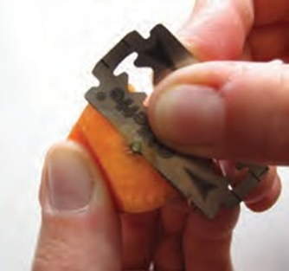

6- Staining:-
The natural color state of plant tissues in slide is important but it may be difficult to differentiate, for example, between unlignified and lignified tissues and it is for this reason that we recommend staining sections. Several staining combinations may be used to enhance details with-in sections. Sections of freshly cut material should be washed gently, to re-move cell debris, which will obscure details once the section has been stained.Stains can be selected to give the maximum contrast between the various cell and tissue types in the plant.
There are several types of stains:-
1- Temporary stainsas Sudan IV. Sections can be mounted directly in the stain. Stains fats,cuticles turn orange.
2- Double simple stain:-Safranin (1% in 50% alcohol) and Delafield’s haematoxylin is a very useful combination to stain plant materials, in cell walls cellulose turns dark blue; lignin turns red and cellulose walls with some lignins turn purple. Also, Fuchsin, aniline blue and iodine in lactophenol is useful stain and mountant for all types of plant material.
7- Mounting: -Freehand sections can be turned into permanent preparations quite easily. Once sections are cut, a Canada balsam or nail polish is added to unstainedor stained sections.Once the material has been mounted in mounting medium, cover slips placed over the specimens, they should be placed tobe flatten the sections and let dry overnight to thoroughly harden the mounting medium.
8- Microscopy and imaging:-Prepared slides are placed on the microscope stage and begin to identify plant structures. If resources are available, a microscope camera and corresponding software can be utilized to capture images. On the other hand, mobile-phone images offer a cheaper alternative to microscope imaging equipment.

