8- Hydropower Energy
8-1 Hydropower:
Renewable energy technology exists in many forms. Recent thinking often relates renewable energy to electricity from either wind energy, solar energy or geothermal energy. Yet the largest source of renewable energy comes from a proven technology, hydropower. Hydropower is renewable because it draws its essential energy from the sun which drives the hydrological cycle which, in turn, provides a continuous renewable supply of water. Hydropower represents more than 92 percent of all renewable energy generated, and continues to stand as one of the most viable sources of new generation into the future. It also provides an option to store energy, to optimize electricity generation.
Hydroelectric power comes from flowing water in winter and spring runoff from mountain streams and clear lakes. Water, when it is falling by the force of gravity, can be used to turn turbines and generators that produce electricity. Consumed, projects have long lives relative to other forms of energy generation, and hydroelectric generators respond quickly to changing system conditions. These favorable characteristics continue to make hydroelectric projects attractive sources of electric power. At present hydropower supplies about 20 per cent of the world's electricity. Hydro supplies more than 50 per cent of national electricity in about 65 countries, more than 80 per cent in 32 countries and almost all of the electricity in 13 countries. A number of countries, such as China India, Iran and Turkey, are undertaking large-scale hydro development programmes, and there are projects under construction in about 80 countries. According to the recent world surveys, conducted for the World Atlas & Industry Guide, published annually by Hydropower & Dams, a number of countries see hydropower as the key to their future economic development: Examples are Sudan, Rwanda, Mali, Benin, Ghana, Liberia, Guinea, Myanmar, Bhutan, Cambodia, Armenia, Kyrgyzstan, Cuba, Costa Rica, and Guyana.
8-1-1 Benefits of Hydropower
Hydropower provides unique benefits, rarely found in other sources of energy. As the most important of the clean, renewable energy options, hydropower is often one of a number of benefits of a multipurpose water resources development project. As hydro schemes are generally integrated within multipurpose development schemes, they can often help to subsidize other vital functions of a project. Typically, construction of a dam and its associated reservoir results in a number of benefits associated with human well-being, such as secure water supply, irrigation for food production and flood control, and societal benefits such as increased recreational opportunities, improved navigation, the development of fisheries, cottage industries, etc. This is not the case for any other source of energy.

8-1-2 Characteristics of Hydropower:
- Its resources are widely spread around the world. Potential exists in about 150 countries, and about 70 per cent of the economically feasible potential remains to be developed. This is mostly in developing countries.
- It is a proven and well-advanced technology (more than a century of experience), with modern powerplants providing the most efficient energy conversion process (> 90 per cent), which is also an important environmental benefit.
- The production of peak load energy from hydropower allows for the best use to be made of base load power from other less flexible electricity sources.
- It has the lowest operating costs and longest plant life, compared with other large scale generating options. Once the initial investment has been made in the necessary civil works, the plant life can be extended economically by relatively cheap maintenance and the periodic replacement of electromechanical equipment (replacement of turbine runners, rewinding of generators, etc - in some cases the addition of new generating units). Typically, a hydro plant in service for 40-50 years can have its operating life doubled.
- The ‘fuel’ (water) is renewable, and is not subject to fluctuations in market. Countries with ample reserves of fossil fuels, such as Iran and Venezuela, have opted for a large-scale program of hydro development, recognizing environmental benefits. Hydro also represents energy independence for many countries.
- Hydroelectric facilities have many characteristics that favor developing new projects and upgrading existing power plants:
- Hydroelectric power plants do not use up limited nonrenewable resources to make electricity.
- They do not cause pollution of air, land, or water.
- They have low failure rates, low operating costs, and are reliable.
- They can provide startup power in the event of a system wide power failure.
- As an added benefit, reservoirs have scenic and recreation value for campers, fishermen, and water sports enthusiasts.
- The water is a home for fish and wildlife as well.
- Dams add to domestic water supplies, control water quality, provide irrigation for agriculture, and avert flooding. Dams can actually improve downstream conditions by allowing mud and other debris to settle out.
8-1-3 HOW HYDROPOWER WORKS
Hydroelectric power comes from water at work, water in motion. It can be seen as a form of solar energy, as the sun powers the hydrologic cycle which gives the earth its water. In the hydrologic cycle, atmospheric water reaches the earth=s surface as precipitation. Some of this water evaporates, but much of it either percolates into the soil or becomes surface runoff. Water from rain and melting snow eventually reaches ponds, lakes, reservoirs, or oceans where evaporation is constantly occurring. Moisture percolating into the soil may become ground water (subsurface water), some of which also enters water bodies through springs or underground streams. Ground water may move upward through soil during dry periods and may return to the atmosphere by evaporation. Water vapor passes into the atmosphere by evaporation then circulates, condenses into clouds, and some returns to earth as precipitation. Thus, the water cycle is complete. Nature ensures that water is a renewable resource.
8-2 Generating Power
In nature, energy cannot be created or destroyed, but its form can change. In generating electricity, no new energy is created. Actually, one form of energy is converted to another form. To generate electricity, water must be in motion. This is kinetic (moving) energy. When flowing water turns blades in a turbine, the form is changed to mechanical (machine) energy. The turbine turns the generator rotor which then converts this mechanical energy into another energy form -- electricity. Since water is the initial source of energy, we call this hydroelectric power or hydropower for short. At facilities called hydroelectric power plants, hydropower is generated. Some power plants are located on rivers, streams, and canals, but for a reliable water supply, dams are needed. Dams store water for later release for such purposes as irrigation, domestic and industrial use, and power generation. The reservoir acts much like a battery, storing water to be released as needed to generate power. The dam creates a height from which water flows. A pipe carries the water from the reservoir to the turbine. The fast-moving water pushes the turbine blades, something like a pinwheel in the wind. The waters force on the turbine blades turns the rotor, the moving part of the electric generator. When coils of wire on the rotor sweep past the generator=s stationary coil (stator), electricity is produced. As in figure 8-1. This concept was discovered by Michael Faraday in 1831 when he found that electricity could be generated by rotating magnets within copper coils. When the water has completed its task, it flows on unchanged to serve other needs.
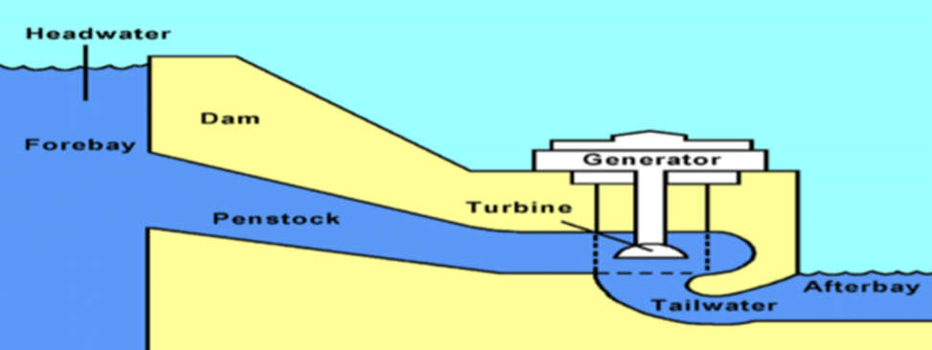
Fig.8-1 Dam scheme
8-4 How is Power computed and Power Estimation
Before a hydroelectric power site is developed, engineers compute how much power can be produced when the facility is complete. The actual output of energy at a dam is determined by the volume of water released (discharge) and the vertical distance the water falls (head). So, a given amount of water falling a given distance will produce a certain amount of energy. The head and the discharge at the power site and the desired rotational speed of the generator determine the type of turbine to be used. The head produces a pressure (water pressure), and the greater the head, the greater the pressure to drive turbines. This pressure is measured in pounds of force (pounds per square inch). More head or faster flowing water means more power.
To find the theoretical horsepower (the measure of mechanical energy) from a specific site, this formula is used
THP = (Q x H)/8.8 --------------------8-1
Where: THP = theoretical horsepower
Q = flow rate in cubic feet per second (cfs)
H = head in feet
8.8 = a constant

A more complicated formula is used to refine the calculations of this available power. The formula takes into account losses in the number of head due to friction in the penstock and other variations due to the efficiency levels of mechanical devices used to harness the power. To find how much electrical power we can expect, we must convert the mechanical measure (horsepower) into electrical terms (watts). One horsepower is equal to 746 watts (U.S. measure).

The potential electric power of the water in terms of flow and head can be Estimated calculated from the following equation.

KW = 9.81 x Q x H x η --------------8-2
Where:
kW = electric power in kW
Q = quantity of water flowing through the hydraulic turbine in cubic meters per second. Discharge (quantity of water) flowing in a stream and available for power generation has daily and seasonal variation. Optimum discharge for power generation is determined on the basis of energy generation cost.
H = Net available head in meters (gross head – losses).
η = overall efficiency of the hydro power plant. For general estimation purposes, η is normally taken as 0.85

8-5 Classification of hydropower plants:
As such there are no hard and fast rules to classify Hydro power plants. Some of the basis are as follows:
• Based on Hydraulic Characteristics
• Based on Head
• Based on Capacity
• Based on Turbine Characteristics
• Based on Load Characteristics
• Based on Interconnection
The amount of energy that a hydropower plant can generate is proportional to the product of hydraulic head and volume of the flow rate. Hydraulic head is the difference in water levels between the intake and the discharge point of the installation. Water flow (or discharge) is the volume of water, expressed as cubic meters per second, passing a point in a given amount of time. The greater the hydraulic head and rate of water flow, the greater the potential energy that can be converted to electricity. Hydropower plants with low flows require high head, while plants with low head needs high flow to generate the same amount of electric energy. Thanks to the higher water pressure, higher heads also allow to force a higher flow rate through a smaller turbine (thus reducing the cost of the equipment). Different types of turbines have been developed, as Pelton, Francis and Kaplan to mention the most often used, in order to have the highest efficiency in power generation for different ranges of head and flow Hydropower plants are often classified in terms of operation and type of flow. According to this classification we can distinguish two main types of hydropower plants:
- Installations equipped with a reservoir, which can be further divided into:
a- Storage power plants;
b- pumped-storage power plants
- Run-of-river power plants, which do not have any reservoir.
Additionally, it is also important to consider:
• offshore and tidal power plants based on in-stream technologies;
• hybrid power plants
Hydropower plants can also be classified according to their size, which varies consistently and spans from a few kilowatts to several gigawatts. This classification has led to the distinction between ‘mini hydro’, ‘small hydro’ and ‘large hydro’. Nevertheless, there is no universally accepted definition of these categories: in fact, different countries have different legal definitions of size categories that match their local energy and resource management needs. In Europe in most of the countries ‘mini hydro’ is considered below 1 MW, ‘small hydro’ below 10 MW and ‘large hydro’ above 10 MW. In any case, it is important to highlight that the great variety in the size of power plants allows hydropower to meet each large centralized urban energy needs as well as decentralized rural needs. Although the main role of hydropower is to provide electricity to a centralized energy system, it also often operates in isolation (off-grid) in rural and remote areas to meet local energy demand.
8-5-1 Storage power plant:
Storage power plants are based on impounding water behind a dam. To produce electricity, water is released from the reservoir and sent to the turbine. The generating stations can be located directly at the dam toe without diversion of water or further downstream with diversion of water from the river; in this case the stations are connected to the reservoir through channels, tunnels or penstocks. Storage plants have the advantage that they are less dependent on the natural flow of water; in fact, according to their storage capacity, they can operate independently of the hydrological inflow by storing water during the wet season and using it the dry season and even inter-annual. In other words, they can easily store potential energy to be converted into electrical energy when needed in a flexible way. For this reason, these plants are commonly used for intense load following and to meet peak demand, allowing the optimization of base-load power generation from other less flexible electricity sources.
The larger the reservoir of a hydropower plant, the more storage it can provide. Hydropower plants with large reservoirs offer the best level of services. First, they can store energy on a large-scale during periods of low demand and make it available in periods of peak demand on an hourly, weekly, monthly or even seasonal basis. Moreover, their fast response time enable them to meet sudden fluctuation in demand. Hydropower plants with a small reservoir are mainly designed to modulate generation on a daily or maximum weekly basis.

8-5-2 Pumped-storage power plant:
Pumped-storage hydropower plants are similar to storage hydropower plants, but they operate with two reservoirs, a lower and an upper one. The two reservoirs are connected to each other through tunnels or penstocks. A pumped-storage plants move waters between the two reservoirs. In production mode, the plant operates like a conventional hydroelectric plant: water is released from the upper reservoir through the turbines to generate electricity; In pumping mode, electrical energy from the grid is used to pump the water from the lower reservoir to the upper one (usually during off peak periods using surplus electricity generated by base-load power plants). Figure 8-2.
In this case, a motor–generator is used to work either as a generator in the production mode or as a motor in the pumping mode. As regard to the hydraulic system the choice is between reversible pump turbines able to work in both directions (usually these turbines are of the Francis type) or separate pump and turbine, such as in ternary systems. Reversible pump-turbine are more common for heads lower than 600 to 700 m. In this configuration, the direction of rotation must be reversed when the pumping mode is switched to the production mode and vice versa. A ternary system brings additional flexibility, since the pump and the turbine are separated on the same shaft an no change of direction is necessary.
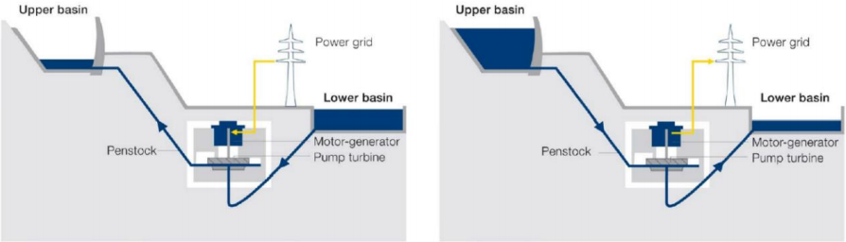
Figure 8-2- Functioning of PSH in pumping and turbining mode
8-5-3 Run-of-river (RoR) power plant:
Run-of-river hydropower plants use the natural flow on river of water from upstream and do not involve any substantial storage. Therefore, these plants are less flexible than (pumped-) storage hydropower plants; in fact, run-of-river power plants operate under the constraint of precisely controlling the water level at the intake in accordance with incoming river flow. The electricity output of run-of-river power plants depends on the availability of water in the river and, therefore, can vary considerably throughout the year. Run-of-river hydropower plants typically provide baseload power, since the hydrological forecast is sufficiently good for the timescales required in the electricity market.

8- 6 Infrastructures: Storage facilities and appurtenant structures

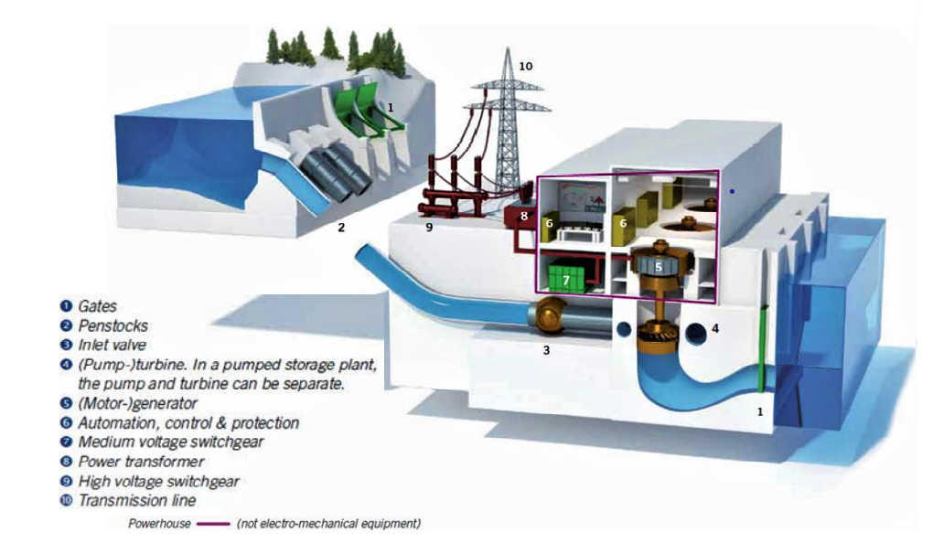
Figure 8 -1 - Electro-mechanical equipment in a hydro plant
8-6-1 Dam:
Dam is a structure designed to retain water from a river. The dam structure is composed of a body lying on a foundation built on the riverbed and the banks of the valley. The dam slopes are called upstream and downstream faces, while the crest is the part in between. There are two main families of dams according to the construction materials used, namely embankment and concrete dams. Embankment dams are made of earth or rockfill or combination of earth and rockfill, while concrete dams are built in conventional concrete or in roller compacted concrete (RCC).
There are two types of dams:
- Diversion dams, which use diversion systems to keep water surface at constant level and avoid changing river regime. Diversion dams, also called weirs, are used for run-of-river plants, waterways, recreational activities, etc.
- Retention dams which create a barrier to store water in a reservoir, thus changing river regime and keeping water surface at a variable level.
Retention dams can be built for two types of reservoirs:
- Supply reservoirs, in which water is extracted from the river for other uses, such as irrigation, navigation, drinking water, industrial use.
- Regulation reservoir, whose primary function is to regulate water flow. In this case, the water is stored and released into the river for different reasons, such as irrigation, flood protection, drought prevention, compensation of irregular water releases of upstream plants or other uses.
8-6-2 Turbines
While there are only two basic types of turbines (impulse and reaction), there are many variations. The specific type of turbine to be used in a power plant is not selected until all operational studies and cost estimates are complete. The turbine selected depends largely on the site conditions. Hydropower machine, water turbine or hydro turbine are the designations used for a machine that directly convert the hydraulic power in a water flow to mechanical power on the machine shaft. The specific type of turbine to be used in a power plant is not selected until all operational studies and cost estimates are complete. The turbine selection largely depends on the site conditions, like water flow and hydraulic head. There is a considerable variety of designs, which are suitable for different applications. Turbine selection should also include a comparison of the relative efficiency of turbine types and their operation under all conditions, especially under reduced flow. Turbines can be divided by their principle of operation:
1-Impulse Turbine:
An impulse turbine is a horizontal or vertical wheel that uses the kinetic energy of water striking its buckets or blades to cause rotation. The wheel is covered by a housing and the buckets or blades are shaped so they turn the flow of water about 170 degrees inside the housing. After turning the blades or buckets, the water falls to the bottom of the wheel housing and flows out. which are driven by a high-velocity jet (or multiple jets) of water. There are three main types of impulse turbine in use: the Pelton, the Turgo, and the Crossflow turbine. The impulse turbine generally uses the velocity of the water to move the runner and discharges to atmospheric pressure. The water stream hits each bucket on the runner. There is no suction on the downside of the turbine, and the water flows out the bottom of the turbine housing after hitting the runner. An impulse turbine is generally suitable for high head, low flow applications.
2-Reaction Turbine:
A reaction turbine is a horizontal or vertical wheel that operates with the wheel completely submerged a feature which reduces turbulence. In theory, the reaction turbine works like a rotating lawn sprinkler where water at a central point is under pressure and escapes from the ends of the blades, causing rotation. Reaction turbines are the type most widely used.
The runner blades are profiled so that pressure differences across them impose lift forces, just as on aircraft wings, which cause the runner to rotate faster than is possible with a jet. A reaction turbine generate power from the combined action of pressure and moving water. The runner is placed directly in the water stream flowing over the blades, rather than striking each individually. Reaction turbines are generally used for sites with lower head and higher flows than compared with the impulse turbines. The two main types of reaction turbine are the Francis turbine (the most common) and the Propeller turbine with its variants Kaplan (most common), Bulb, Straflo and Tube type. Another type of reaction turbine are the hydrokinetic or free-flow turbines without any pressure casing and draft tube.

3- Pump Hydro Turbines:
Pump turbines can reverse the water flow and operate as a pump to fill a higher located reservoir in off-peak periods, and then revert to a classical water turbine for power generation during peak demand. The multitude of configurations available include horizontal or vertical, single or multiple stage, fixed or variable speed, with or without cylindrical ring gate, and individual or combined actuation of guide vanes. Pump turbines, usually based on the Francis type, are custom designed to meet the most demanding requirements and environmental criteria in pump storage applications worldwide. With some special design provisions, also Bulb units can be operated in pump mode, when rotation is reversed. Pump turbines, with their ability to master rapid mode changes, are ideally suited for generation as well as storage of energy, predestined to stabilize electrical grid fluctuations. Fast start-up times of just 90 seconds for up to 400 MW allow for an increased number of daily starts and stops, adding flexibility and availability.

4-Gravity Turbine;
which is driven simply by the weight of water entering the top of the turbine and falling to the bottom, where it is released – for example, an overshot waterwheel or an Archimedes screw. These are inherently slow-running machines.
Archimedes screws are used to pump large volumes of water at relatively low heads and is extremely reliable and durable so application operators are fully satisfied. The Archimedes Screw has been used as a pump for centuries but has only recently been used in reverse as a turbine. It’s principle of operation is the same as the overshot waterwheel, but the clever shape of the helix allows the turbine to rotate faster than the equivalent waterwheel and with high efficiency of power conversion (over 80%). A key advantage of the Screw is that it avoids the need for a fine screen and automatic screen cleaner, because most debris can pass safely through the turbine. The Archimedes screw is proven to be a ‘fish-friendly’ turbine.

8-7 Generators, transformers and high voltage equipment
Generators convert the mechanical energy from the turbine into electrical, energy using an excitation system. Generators are characterized by their compact design, high efficiencies, and long lifetime, thanks to the use of modern calculation methods and optimized manufacturing procedures and materials. Depending on required runner speed and power station characteristics, the generator types are classified as follows:
• Horizontal vs vertical: hydro generators are classified by their axis locations.
• Brushless excitation generator with rotating exciter machine vsstatic excitation with sliprings and brushes.
• Synchronous vs asynchronous generators: ynchronous generators (the usual type) are equipped with a DC electric or permanent magnet excitation system, associated with a voltage regulator that controls output voltage before the generator is connected to the grid.

1 Vertical Shaft Generators
2 PIT type Generators
3 Motor Generators
4 Variable Speed Motor-Generators
5 Transformer and high voltage equipment.

8-8 Hydraulic steel structures
Hydraulic steel structures are installed in hydropower plant schemes to control water flow using gates or valves, which are classified according to their operational purpose:
• service gates for continuous flow regulation in the waterway or of the water level in the reservoir include spillway gates, bottom outlet gates, and lock gates (for navigation).
• emergency gates are used to shut down water flow in conduits or open channels; typically, they are designed only to be fully open or fully closed and they include intake gates, gates upstream of penstock service valves, draft tube gates, and gates installed upstream of bottom outlet gates.
• maintenance gates are used to empty the conduit or canal for equipment maintenance (turbines, pumps or other gates); the most common type is the stoplog gate. Distributor vanes or turbine needle valves are used for flow regulation.

8-8-1 Gates
The most commonly used gate types are flap, cylinder, stoplog, slide, caterpillar, miter, roller, segment, sector, drum, fixed-wheel and visor. Each gate type is unique in terms of purpose, movement, water passage, leaf composition, location and skin-plate shape. Gate type selection depends on purpose, dimensions of the opening to be gated, climatic conditions (e.g., passage of ice slabs) and options for gate operation.
There are several types of Gates:
• Radial Gates
• Wheel Gates
• Slide Gates
• Flap Gates
• Rubber Gates

8-8-2 Valves
Valves fulfil various important tasks: from safety enhancement in powerhouses or penstocks to tight sealing in waterways for maintenance purposes on hydraulic machinery. Hydropower makes an indispensable contribution to safe, environment friendly generation of electric power. The fate of both today ‘s world and of the future depends on having a secure energy supply from hydropower plants that are dependable and operational at all times. Safety remains in the foreground when it comes to hydropower plants. Valves and shut-off equipment that are dependable and durable play a vital role to that end.
The function of the penstock and main inlet valves is to isolate the unit and completely cut-off the water flow on the location where such valve is installed. They usually serve as a safety device and are capable of closing at the maximum water discharge. Main inlet valves are positioned between the penstock and the turbine spiral case, while the penstock valves can be located anywhere inside the penstock. To prevent large damage in case of a rupture of the penstock, a pipe break valve is normally installed in the pipe just downstream of the shut off valve. These valves close automatically when the water velocity exceeds a certain set value. They exist in different types and design depending on function and requirements. The most relevant types of valves are:
• Spherical valves
• Butterfly valves
• Gate valves
• Ring valves

8-8-3 Penstocks
Penstocks supply one or more hydraulic units with high pressure water. Penstock engineering and construction involves different disciplines like civil engineering and pressure vessel making.

8-8-4 Pumped Storage
Like peaking, pumped storage is a method of keeping water in reserve for peak period power demands. Pumped storage is water pumped to a storage pool above the power plant at a time when customer demand for energy is low, such as during the middle of the night. The water is then allowed to flow back through the turbine-generators at times when demand is high and a heavy load is place on the system. The reservoir acts much like a battery, storing power in the form of water when demands are low and producing maximum power during daily and seasonal peak periods. An advantage of pumped storage is that hydroelectric generating units are able to start up quickly and make rapid adjustments in output. They operate efficiently when used for one hour or several hours. Because pumped storage reservoirs are relatively small, construction costs are generally low compared with conventional hydropower facilities Hydropower, the Environment, and Society.

