**Wind Energy 5**

The purpose of this lecture

1. **Probability Distribution Functions for Wind.**
2. **Mathematical models.**
3. Logarithmic Law
4. Power Law
5. **Statistical Models for Wind Data Analysis.**
6. **Distributions used for wind speed**
7. Gaussian (Normal) distribution
8. Rayleigh distribution
9. Weibull distribution

References:

* Wind Power Fundamentals Alex Kalmikov and Katherine Dykes With contributions from: Kathy Araujo PhD Candidates, MIT Mechanical Engineering, Engineering Systems and Urban Planning
* Wind energy engineering. New York: McGraw-Hill, Jain, P. (2011).
* Lecture Notes on Wind Energy Systems, 2018 Summer Semester

Prof. Moritz Diehl and Rachel Leuthold

***5- Use of*** ***Probability Distribution Functions for Wind***

***5-1Wind shear***

The flow of air above the ground is retarded by frictional resistance offered by the earth surface (boundary layer effect). This resistance may be caused by the roughness of the ground itself or due to vegetations, buildings and other structures present over the ground.

The rate at which the velocity increases with height depends on the roughness of the terrain. Presence of dense vegetations like plantations, forests, and bushes slows down the wind considerably. Level and smooth terrains do not have much effect on the wind speed. The surface roughness of a terrain is usually represented by the roughness class or roughness height. The roughness height of a surface may be close to zero (surface of the sea). Some typical values are 0.005 for flat and smooth terrains, 0.025-0.1 for open grass lands, 0.2 to 0.3 for row crops, 0.5 to 1 for orchards and shrubs and 1to 2 for forests, town centers etc.

*Roughness height is an important factor to be considered in the design of wind energy plants*.

**5-2** **Mathematical models**

There are two mathematical models that are widely used to model the vertical profile of wind speed over regions of homogeneous and flat terrain, which are:

1. Logarithmic Law profile.
2. Power Law profile.

***5******-2-1*** ***Logarithmic Law***

The logarithmic law origins lie in the boundary layer fluid mechanics and atmospheric research. To determine wind speed $(v)$ at a height $\left(z\right),$ it is commonly expressed as follows:

$v\left(z\right)=(\frac{u_{*}}{ĸ})\ln{(\frac{z}{z_{o}}})$----------------------------5-1

Where, $(z)$ is the elevation above the ground, ${(z}_{o})$ is the surface roughness length, and $ĸ$ =0.4 is von Karman constant. $u_{*}={\left(\left.\frac{τ}{ρ}\right)\right.}^{\frac{1}{2}}$, is defined as the friction velocity, where (*ρ*)is the density of the air and (*τ*) is the surface value of the shear stress. The roughness length ${(z}_{o})$ describes the roughness of the ground or terrain where the wind is blowing. There are cases where wind speed $(v_{1})$ is known at a reference height ${(z}_{1}$) and required at another ${(z}_{2})$ in a case that can be derived from equation 5-1: as in fig.

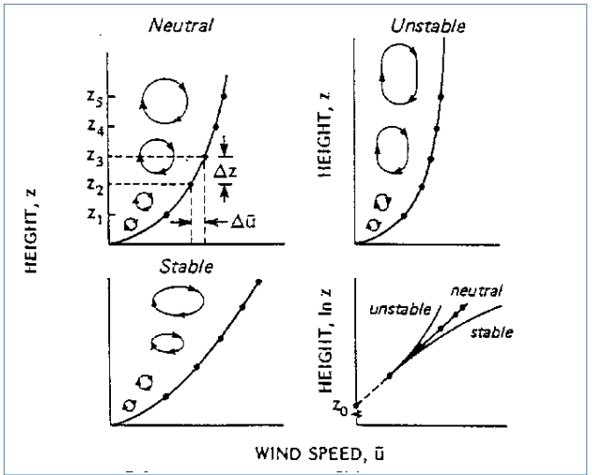

Figure 5-1: typical wind speed profiles vs. static stability (stable, unstable, neutral) in the surface layer

$v_{2}=v_{1}\frac{\ln{{(z}_{2})-} \ln{{(z}_{o})}}{\ln{{(z}_{1})-} \ln{{(z}_{o})}}$--------------------------5-2

It is a simple expression to solve, as it eliminates the need to calculate the friction velocity and von Karman constant, which could be difficult to estimate in the atmosphere.

***5-2-2*** ***Power Law***

The power law equation is a simple, yet useful model of the vertical wind profile which was first proposed by Hellman (1916). The power law profile assumes that the ratio of wind speeds at different heights can be found by the following equation:

$v_{2}=v_{1}{\left(\left.\frac{z_{2}}{z_{1}}\right)\right.}^{α}$---------------------------------------5-3

Where ${(v}_{1})$ is the wind speed at a reference height ${(z}_{1})$ (anemometer height), ${(v}_{2})$ is the wind speed at a height ${(z}_{2})$ (hub height), and (α) is the shear exponent (dimensionless parameter). As in fig. 5-2

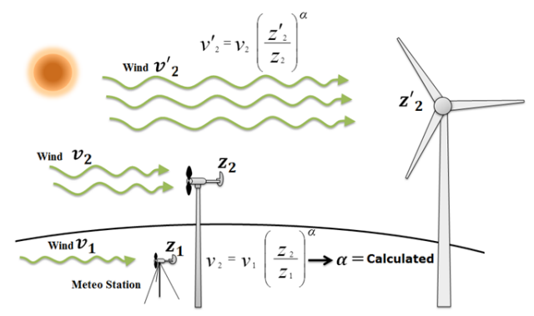

Fig.5- 2. Wind speed determination using more than one sensor

The power law is widely used due to its simplicity, and it seems to give a better fit to most of the data over a greater height range and for higher wind conditions, compared to the log logarithmic law. Therefore, the power Law is often used in assessment wind power. An exponent (α) of approximately (1/7) is commonly used to describe atmospheric wind profiles over the range (up to 100 m), sufficiently during near-neutral conditions, and low surface roughness. This value of the exponent has led the extrapolation wind speed to the hub heights of wind turbines from the measuring levels. This called the one: seventh power law and it can be written as follows:

$v_{2}=v_{1}{\left(\left.\frac{z_{2}}{z_{1}}\right)\right.}^{\frac{1}{7}}$--------------------------------------5-4

The shape of the power law profile is determined by (*α*), and the shape of the log law profile is determined by the roughness length (zo). Figure (1, a, b) respectively, depicts both types of profiles.

 (a) Log law (b) power law

Fig.5-3: Example wind shear profiles using Log law and power law models

***5-3.*** ***Statistical Models for Wind Data Analysis***

In recent years, many efforts have been devoted to construct an adequate statistical model to describe the wind speed frequency distribution, which can be used to predict the energy output of a wind energy conversion system. The wind is influenced by the *weather system*, the *local land terrain*, and the *height above the ground surface*. The speed of the wind is continuously changing making it desirable to describe the wind using statistical models. To identify a suitable statistical distribution to represent wind regimes, various probability functions were fitted with field data, which states that **Weibull and Rayleigh distributions** were found with an acceptable accuracy level and can be applied to describe the wind variations in an area.

The behavior of wind velocity at a given site can be specified as a probability distribution function, f(V). The quantity f(V)dV represents the fraction of the wind speeds that lie within a range, dV, about the given velocity, these notes discuss the basics ideas of probability distribution functions with specific application to wind velocity and energy distributions.[1]

***5-3-1* Probability Distribution Functions (PDF)**

A Probability Distribution Function (pdf) for a random variable x is written as f(x). The best-known pdf is the normal distribution.

$f(x)=\frac{1}{\sqrt{2πσ^{2}}}e^{{-{\left(x-μ\right)}^{2}}/{2σ^{2}}} -∞<x<∞$--------5-5

This distribution has two parameters (**)** and (**)**. Sketches of this distribution for different values of these parameters are shown in the figure 5-4 to the right. The distribution is seen to be symmetric about the value of **** and the width of the distribution increases as **** increases.

All pdf’s are interpreted as follows: the probability that the random variable, **x**, lies in a differential range, **dx**, about a value **x\***is **f(x*) dx**. Specific statements about the probability that the random variable, x, lies in a particular range **a ≤ x ≤ b**, which is denoted by the expression **P (a ≤ x ≤ b)** is obtained by integrating **f(x)dx** between the limits of **a** and **b**. As in equation 5-6

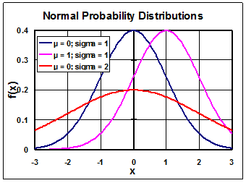

Fig. 5-4. Normal probability distributions

--------------------5-6

Probabilities, P, range from zero (no chance of occurring) to 1 (certain to occur). Because a random variable is certain to lie between its minimum and maximum values, the probability that a pdf lies between its maximum and minimum values, P (xmin ≤ x ≤ xmax), must be 1. We can write this as the following equation 5-7. The fact that this integral of the pdf must be one is sometimes called the normalization condition or the normalization integral.

 ----5-7

Using the geometric definition of the integral as the area under a curve, we see that the area under the pdf between **xmin** and **xmax** must be 1. In the normal distributions shown in the figure 5-4 above, the distribution for **** = 2 has a lower peak, but a wider area, compared to the distribution for **** = 1; both distributions have their integral from **xmin** to **xmax** equal to 1.

In addition to the pdf, we define the cumulative distribution, F(b) which is the probability that x ≤ b. This is the probability that x lies between xmin and b. We can use equation 5-7, to write this cumulative distribution as follows.

-----------5-8



We can use the usual relationship for the difference of two integrals with the same lower limit to write the probability that x lies in a certain range in terms of this cumulative distribution.

---5-9



For the area below the PDF is unity, which is shown by the equation given below:

$\int_{0}^{∞}{f\left(v\right)}dv=1$----------------------------------5-10

The probability density function of wind speed is important in various wind energy applications. The Cumulative Distribution Function (CDF), F (*v*) is given by:

$\int_{0}^{∞}{f\left(x\right)}dx$-----------------------------------------5-11

The (*x*) variable inside the integral is a dummy variable just representing the wind speed for the use of integration.

Both of the above integration equations (5-10 ,5-11) starts with zero as the wind speed cannot be negative. While considering the wind speed as a continuous random variable, the cumulative distribution function has the properties F (0) = 0 to F ($∞$) = 1. The quantity F (0) may not necessarily be zero in the discrete case.

**5-4 Distributions used for wind speed**

There are several density functions which can be used to express the wind speed frequency curve. The most common three are:

1. *Gaussian (Normal) distribution*.

2. *Rayleigh distribution.*

3. *Weibull distribution*.

***5-4-1 Gaussian (Normal) Distribution***

The wind speed (*v*) is distributed as the Gaussian (Normal) distribution if its probability density function is: **equation 5-5**

$f\left(v\right)=\left(\frac{1}{σ_{v}\sqrt{2π}}\right)exp\left[- \frac{(v-v_{m})^{2}}{2σ_{v}^{2}}\right]$------------5-12

The normal distribution has two parameters, ${(v}_{m}$) and ${(σ}_{v})$.

***5-4-2 Rayleigh Distribution:***

The *Rayleigh distribution* which has a single parameter c. It is given by:

$f(v)=\frac{2V}{c^{2}}e^{-{\left(V/c\right)}^{2}} 0≤V<∞$------------5-13

Where (*c*)is the scale parameter and *f*(*v*)being *Rayleigh (PDF). The Rayleigh distribution is actually a special case of the Weibull distribution with* ***k*** = 2.

And the cumulative distribution function is defined by the equation 5-8

As:

---5-14

Setting k = 2 in this result gives the cumulative Rayleigh distribution get:

$f(v)=1-e^{-{\left(V/c\right)}^{2}} Rayleigh$---------------5-15

Where $f\left(v\right)$ is the (CDF) of the Rayleigh distribution.

**5-4-3** **Weibull distribution**

The Weibull distribution shown below has two parameters ***k*** and ***c***.

$f(V)=\frac{k}{c}{\left(\frac{V}{c}\right)}^{k-1}e^{-{\left(V/c\right)}^{k}} 0≤V<∞$----------5-16

In fig.5-5 setting k = 2 in the Weibull distribution gives the Rayleigh distribution.

For both distributions, Vmin = 0 and Vmax = .The figure at the left shows the Weibull distribution for various valuables of the parameters k and ***c***. The figure shows that as the value of c increases for a given value of ***k*** the shape of the distribution gets wider. Because of this c is called the scale parameter; it has dimensions of velocity. The figure also shows that as, ***k*** increases from 2 to 4 for a given value of c, the maximum in the pdf increases. Because of this k is called the **shape parameter**; it is dimensionless

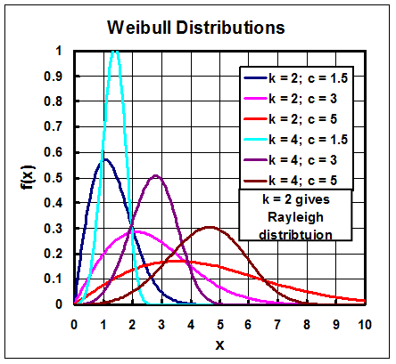

Fig.5-5 Weibull distributions

The two probability distribution functions are commonly used for wind speed are Rayleigh distribution and Weibull distributions.

1. Because f(x)dx represents a fraction, it is a dimensionless quantity. Thus, the pdf, f(x), must have dimensions of 1/x. In the normal distribution function in equation [1], x, , and  must all have the same dimensions. (This is required because the arguments to transcendental functions like the exponential must be dimensionless.) The normal distribution in equation [1] has dimensions of 1/ which is the same as the dimensions of 1/x which is required for the pdf, f(x).