Lab -7-
Cell division
2) Meiosis
-Reduces the number of chromosomes in new cells to half the number in the original cell.
- New cells have a single copy of chromosomes (23 total) but are not identical to each other or the original parent cell.
-Used for making gametes (sperm and eggs) with the haploid or n number.
- In meiosis, cells divide twice after a single DNA duplication.
-Meiosis I separates homologous chromosomes & the Meiosis II separates sister chromatids.
-Meiosis I stages are: 1) prophaseI 2) MetaphaseI 3) AnaphaseI 4) TelophaseI.
- Meiosis II stages are: 1) prophaseII 2) MetaphaseII 3) AnaphaseII 4) Telophase II.
-Produces 4 haploid cells or gametes.
-When a sperm fertilizes an egg to form a zygote, the diploid number of chromosomes is restored (23 +23=46).
-Egg cells or ova (ovum, singular) are larger, non-motile cells.-Gametogenesis is meiosis producing eggs & occurs in the females ovaries.
- Sperms contain less cytoplasm so they are smaller & have a flagellum to swim to the egg.
- Spermatogenesis is meiosis producing sperm cells & occurs in the testes.

*Meiosis I
-The cell that undergoes meiosis I is a primary spermatocyte or oocyte.

1) Prophase I
-Chromosomes coil tightly and visible.
-Nuclear membrane & nucleolus disintegrate.
-spindle forms.
-Synapsis (joining) of homologous chromosomes occurs making tetrads.
-Kinetochore fiber forms on each chromosome.
-Chromosomes in tetrad exchange fragments by a process called crossing over.
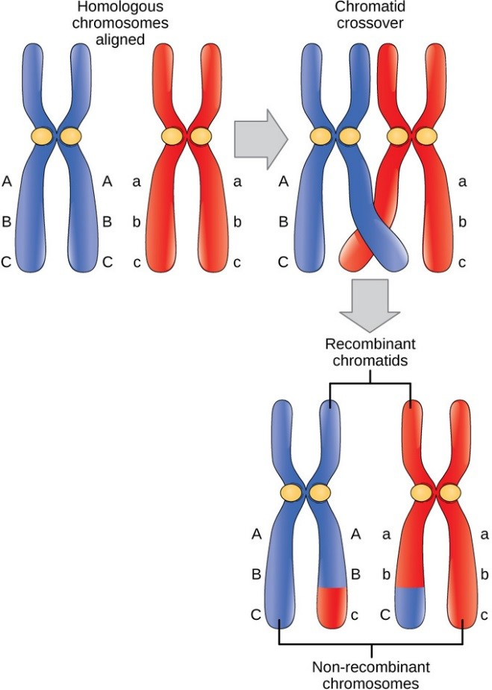
*Crossing over process*

2) Metaphase I
-Tetrads become aligned in the center of the cell attached to spindle fibers.

3) Anaphase I
-Homologous chromosomes separate.

4) Telophase I
-May not occur in all species.
-Cytokinesis occurs producing 2 cells.
-In females, 2nd cell in females is called the 1st Polar Body.
-1st Polar Body dies due to uneven splitting of the cytoplasm.
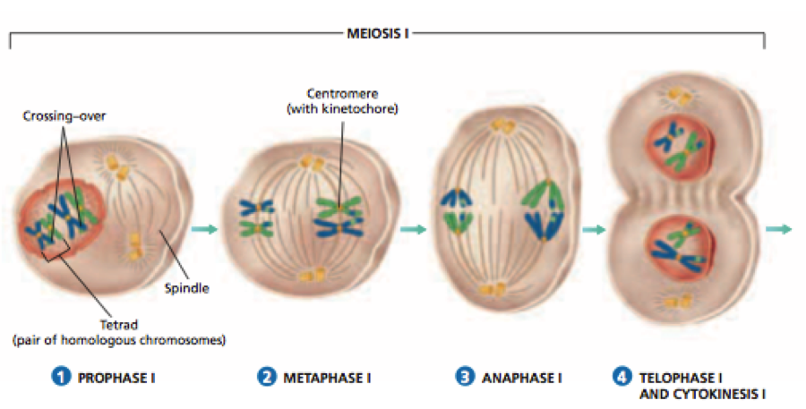

*Stages of meiosis I *
*Meiosis II

1) Prophase II
-Cells called Secondary Spermatocytes or oocytes.
-DNA is not copied before cell divides.
-Chromatids attach to spindle fiber.

2) Metaphase II
-Chromosomes become aligned in the center of the cell attached to spindle fibers.

3) Anaphase II
-Sister chromatids separate randomly.
-Called independent assortment.

4) Telophase II
-Cytokinesis occurs producing 4 cells in males called spermatids.
-Spermatids mature & form flagellum to become sperm.
-Cytokinesis in females produces a 2nd Polar Body that dies and an ootid.
-Ootids mature to become ovum or egg.

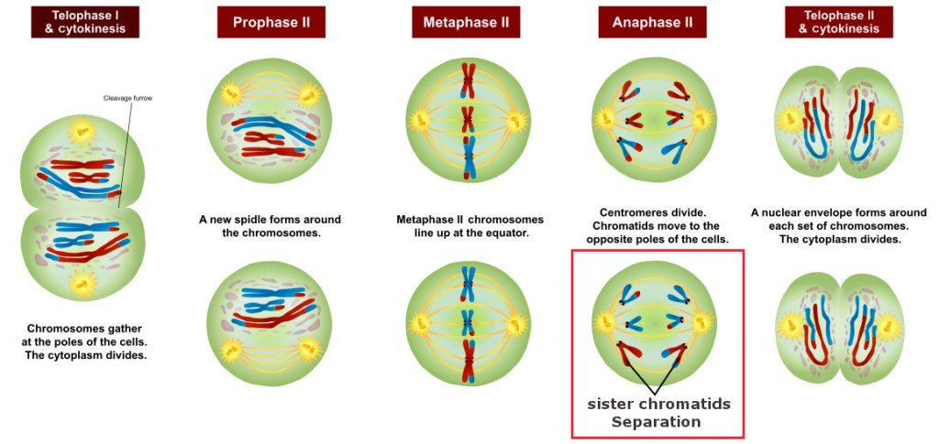
*Stages of meiosis II*

**Practical part
Cell squash method
The Cell squash was used for study the mitosis of onion root edge.
Take the root edge and begin the process of squash, this process depend on fixation of the cell and press by finger (in the case of solid it must squash by needle edge and squash the sample directly then put slide cover directly and by wood part of needle press on slide cover (the fixer used was formalin acetic acid). It common fixer for plant product and put in root edge for 24 hr before examined. The fixer kills the cells rapidly and maintain on contents from spoilage.
**Method
1- Cut the root of onion with distance 1 cm from apex edge of root and put it in fixative (formalin acetic acid ) for 24 hr.
2- Take apex and put it on clean glass slide with droop of KOH , The fixation was done by needle. The useful of KOH for disassemble cellular plate.
3- Add drop of acetocarmin stain with pass on flame lamp without burned the sample.
4- Put the slide cover and press with finger and paper for disassemble the cells and complete differentiation.
**The difference between meiosis and mitosis
 | Meiosis | Mitosis
End result | Normally four cells, each with half the number of chromosomes as the parent | Two cells, having the same number of chromosomes as the parent
Function | Sexual reproduction, production of gametes (sex cells | Cellular reproduction, growth, repair, asexual reproduction
Where does it happen? | Animals, fungi, plants, protists | All eukaryotic organisms
Steps | Prophase I, Metaphase I,AnaphaseI,elophaseI, ProphaseII, Metaphase II,AnaphaseII,telophase II | Prophase, Metaphase, Anaphase, Telophase
Genetically same as parent? | No | usually
Crossing over happens? | Yes, in Prophase I | Sometimes
Pairing of homologous chromosomes? | Yes | No
Cytokinesis | Occurs in Telophase I and Telophase II | Occurs in Telophase
Centromeres split | Does not occur in Anaphase I, but occurs in Anaphase II | Occurs in Anaphase

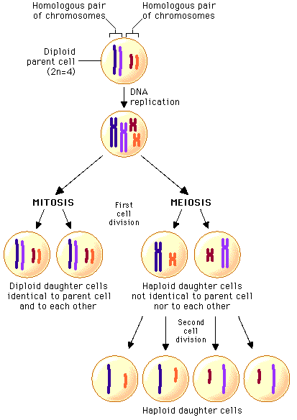

The difference between meiosis and mitosis

