**Lab:1**

***TYPES OF MICROSCOPS***

1. **Light Microscopes**

**Light microscope** (**LM**) is an instrument that uses visible **light** and magnifying lenses to examine small objects not visible to the naked eye, or in finer detail than the naked eye allows.

**working Principle**

**Light** from a mirror is reflected up through the specimen, or object to be viewed, into the powerful objective lens, which produces the first magnification. The image produced by the objective lens is then magnified again by the eyepiece lens, which acts as a simple magnifying glass.

**Parts of a Compound Microscope**

1. **Eye piece:** The lens the viewer looks through to see the specimen. The eyepiece usually contains a 10X or 15X power lens.
2. **Diopter Adjustment:** Useful as a means to change focus on one eyepiece so as to correct for any difference in vision between your two eyes.
3. **Body tube (Head):** The body tube connects the eyepiece to the objective lenses.
4. **Arm:** The arm connects the body tube to the base of the microscope.
5. **Coarse adjustment:** Brings the specimen into general focus.
6. **Fine adjustment:** Fine tunes the focus and increases the detail of the specimen.
7. **Nosepiece:** A rotating turret that houses the objective lenses. The viewer spins the nosepiece to select different objective lenses.
8. [**Objective lenses**](https://www.microscopemaster.com/objective-lenses.html)**:** One of the most important parts of a compound microscope, as they are the lenses closest to the specimen. A standard microscope has three, four, or five objective lenses that range in power from 4X to 100X. When focusing the microscope, be careful that the objective lens doesn’t touch the slide, as it could break the slide and destroy the specimen.
9. **Specimen or**[**slide**](https://www.microscopemaster.com/microscope-slides.html)**:** The specimen is the object being examined. Most specimens are mounted on slides, flat rectangles of thin glass.The specimen is placed on the glass and a cover slip is placed over the specimen. This allows the slide to be easily inserted or removed from the microscope. It also allows the specimen to be labeled, transported, and stored without damage.
10. **Stage:** The flat platform where the slide is placed.
11. **Stage clips:** Metal clips that hold the slide in place.
12. **Stage height adjustment (Stage Control):** These knobs move the stage left and right or up and down.
13. **Aperture:**The hole in the middle of the stage that allows light from the illuminator to reach the specimen.
14. **On/off switch:** This switch on the base of the microscope turns the illuminator off and on.
15. **Illumination:**The light source for a microscope. Older microscopes used mirrors to reflect light from an external source up through the bottom of the stage; however, most microscopes now use a low-voltage bulb.
16. **Iris diaphragm:** Adjusts the amount of light that reaches the specimen.
17. **Condenser:**Gathers and focuses light from the illuminator onto the specimen being viewed.
18. **Base:**The base supports the microscope and it’s where illuminator is located.

**The types of Light Microscopes**

Some of the major types of light microscopes are as follows:

1. Dark-field Microscope.
2. Phase-Contrast microscope.
3. interference-contrast microscope.
4. Ultraviolet Microscope.
5. Fluorescence microscope.
6. Confocal microscope.

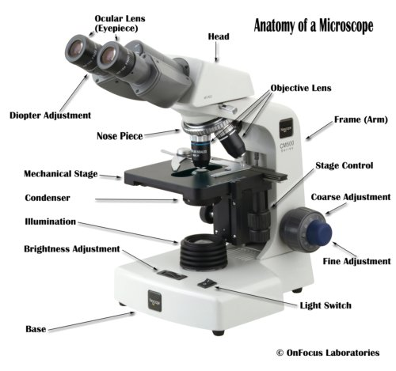

***(Parts of a Compound Light Microscope)***

[www.explainthatstuff.com](https://www.google.com/search?q=electron+microscope&hl=ar-IQ&authuser=0&tbm=isch&source=iu&ictx=1&fir=l1Rsy_dZHpgTXM%253A%252CHG1skZXuQVSlRM%252C_&vet=1&usg=AI4_-kRxnc7w54rEQcTqjEEGP7jHyYalOA&sa=X&sqi=2&ved=2ahUKEwjhzvG2-PbkAhWOT30KHdD3A1wQ9QEwAHoECAEQAw" \l "imgrc=l1Rsy_dZHpgTXM:)

1. **Electron microscope**

Electron microscope (EM) is a type of microscope that uses **electrons** to create an image of the target. It has much higher magnification or resolving power than a normal light microscope.

**working Principle**

An electron microscope uses an **'electron beam'** to produce the image of the object and magnification is obtained by 'electromagnetic fields'; unlike light or optical microscopes, in which 'light waves' are used to produce the image and magnification is obtained by a system of 'optical lenses.

**Parts of an electron microscope**

1. Electron gun
2. Electron magnetic lenses :
3. Condenser lens
4. Objective lens
5. Projector lens
6. Fluorescent screen
7. Camera
8. Deflation device
9. Voltage measuring device

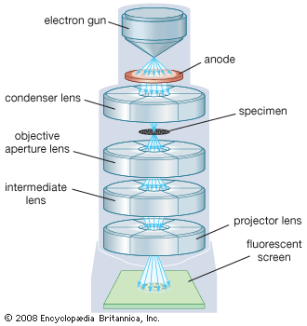

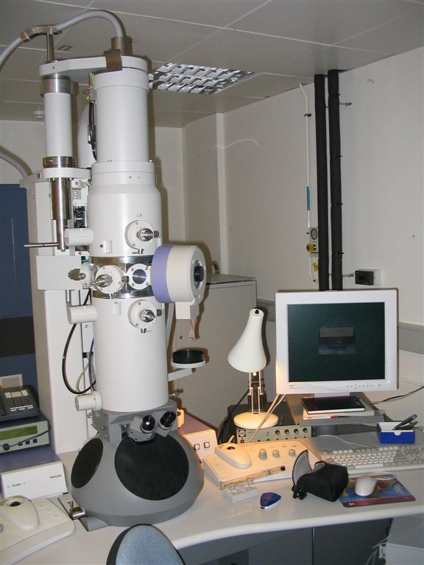

***(Parts of an Electron Microscope)***

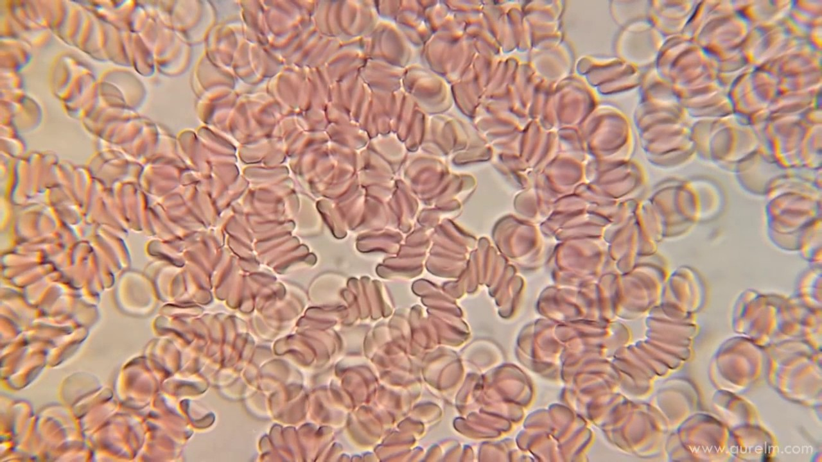

***(Red blood cells in compound light microscope (L.M.) )***

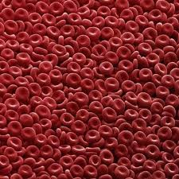

***(Red blood cells in electron microscope (E.M.) )***

**The types of Electron Microscopes**

The major types of Electron Microscopes are as follow

1. Transmission electron microscope (TEM).

The transmission electron microscope (TEM) is used to view thin specimens (tissue sections, molecules, etc) through which electrons can pass generating a projection image.

1. Scanning electron microscope (SEM).

The scanning electron microscope  (SEM) scans a focused electron beam over a surface to create an image. The electrons in the beam interact with the sample, producing various signals that can be usedto obtain information about the surface topography and composition.

1. Reflection electron microscope (REM).

Is now well established as a technique for the study of the structure of surfaces of crystals.

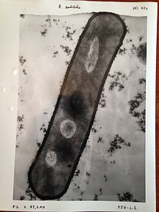

1. ***(An image of***[***Bacillus subtilis***](https://en.wikipedia.org/wiki/Bacillus_subtilis)***taken with a transmission electron microscope)***

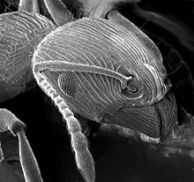

1. ***(An image of an***[***ant***](https://en.wikipedia.org/wiki/Ant)***in a scanning electron microscope)***

**\*Why is the light microscope called the compound microscope?**

Compound microscope are so called because they are designed with a compound lens system. The objective lens provides the primary magnification which is compounded (multiplied) by the ocular lens (eyepiece).

**\*What can you see in a light microscope?**

Using a light microscope, one can view cell walls, vacuoles, cytoplasm, chloroplasts, nucleus and cell membrane. Light microscopes use lenses and light to magnify cell parts. However, they usually can achieve a maximum of 2000x magnification which is not sufficient to see many other tiny organelles.

### \*How Does a Microscope Work?

### All of the parts of a microscope work together - The light from the illuminator passes through the aperture, through the slide, and through the objective lens, where the image of the specimen is magnified. Then magnified image continues up through the body tube of the microscope to the eyepiece, which further magnifies the image the viewer then sees.

**\*What is the difference between TEM and SEM?**

**TEM** is a high resolution tool (Transmission Electron Microscope) , able analyze at high resolution at nano level. **SEM** is based on scattered electrons while **TEM** is based on transmitted electrons. • **SEM** focuses on the sample's surface and its composition whereas **TEM** provides the details about internal composition. As a result, TEM offers valuable information on the inner structure of the sample, such as crystal structure, morphology and stress state information, while SEM provides information on the sample’s surface and its composition. **TEM** has up to a 50 million magnification level while **SEM** only offers 2 million as a maximum level of magnification. The resolution of **TEM** is 0.5 angstroms while **SEM** has 0.4 nanometers. However, **SEM** images have a **better** depth of field compared to **TEM** produced images

**\*Why would you use an electron microscope?**

An electron microscope allows us to see at these small scales. Electron microscopes work by using an electron beam instead of visible light and an electron detector instead of our eyes. An electron beam allows us to see at very small scales because electrons can also behave as light.