Bacterial Physiology Lec-10

Metabolism; Anabolism or Biosynthesis
Microorganisms can obtain energy in many ways, much of this energy is used in biosynthesis or anabolism. During biosynthesis m.o begins with simple precursors,such as inorganic molecules or monomers ,and construct more complex until new organelles and cells arise .
Synthesis of Sugars and Polysaccharides
Many M.O can carry out photosynthesis (in which CO₂ is incorporate or fix), these autotrophs can convert this inorganic molecule to organic carbon, most common pathway is Calvin-Benson cycle: three different stages can be differentiated :
- Carboxylation phase: addition CO₂ to riboues 1,5- biphosphate, forming two molecules of 3-phosphoglycerate.
- Reduction phase: reduction of 3-phosphoglycerate to glyceraldehydes 3-phosphate.
- Regeneration phase: trioses are used to reform ribulose 1,5-biphosphate ,and some hexose sugars like ; glucose and fructose.
The formation of glucose from CO₂ may be summarized by the following balanced equation :
6 CO₂ + 6 H₂O → C₆H₁₂O₆ + 6 O₂
Where:
CO₂ = carbon dioxide
H₂O = water
light is required
C₆H₁₂O₆ = glucose
O₂ = oxygen
Sugars formed in the Calvin cycle can then be used to synthesize other essential molecules. The synthesis of glucose from non carbohydrate precursors is called gluconeogenesis. Beside carbon and oxygen, M.O also requires large quantities of phosphorus, sulfur and nitrogen for biosynthesis .
Synthesis of Amino Acids
Amino acid synthesis requires construction of the proper carbon skeletons, amino acid skeletons are derived from acetyl-CoA and intermediates of the TCA cycle, glycolysis and Calvin cycle. Most biosynthetic pathways are more complex and common intermediates often are used in the synthesis of families of related amino acids. The ribosome is the site of protein synthesis, synthesis is accurate and rapid .The final step in gene expression is protein synthesis or translation ; the mRNA nucleotide sequence is translated into the a.a sequence of polypeptide chain. Protein synthesis may be divided into 3 stages ;
Initiation ,Elongation ,Termination ,this process is discussed in molecular biology .
The Synthesis of Purines , Pyrimidines and Nucleotides
Purine and pyrimidine biosynthesis is critical for all cells because these molecules are used in the synthesis of ATP , several cofactors ,ribonucleic acid (RNA ) ,deoxyribonucleic acid (DNA), and other important cell components.Purines and pyrimidines are cyclic nitrogenous bases with several double bonds, purines consist of two joined rings, whereas pyrimidines have only one. Purines (adenine and guanine) the pyrimidine (uracil, cytosine and thymine) are commonly found in microorganisms. A nucleoside : is a purine or pyrimidines base joined with a pentose sugar, either ribose or deoxyribose. A nucleotide is a nucleoside with one or more phosphate groups attached to the sugar.
Purine Biosynthesis
The biosynthetic pathway for purines is a complex, 11-step sequence in which seven different molecules contribute parts to the final purine skeleton, the cofactor folic acid is very important in purine synthesis. Folic acid derivatives contribute carbons two and eight to the purine skeleton. The drug sulfonamide inhibits bacterial growth by blocking folic acid synthesis ,this interferes with purine biosynthesis and other processes that require folic acid .
Pyrimidine Biosynthesis
Biosynthesis begins with aspartic acid and carbamoyl phosphate (high-energy molecule synthesized from CO₂ and ammonia). Aspartate carbamoyl transferase catalyzes the condensation of these two substrates to form carbamoylaspartate, which is then converted to the initial pyrimidine product and orotic acid .
Lipid Biosynthesis
A variety of lipids are found in microorganisms, particularly in cell membranes and most contain fatty acids or their derivatives. Fatty acids are monocarboxylic acids with long alkyl chains (the average length is 18 carbons). Some are unsaturated that have one or more double bonds . Most microbial fatty acids are straight chain, but some are branched .Gram-negative bacteria have cyclopropane fatty acids (fatty acids with one or more cyclopropane rings in their chains ). Fatty acid synthesis is catalyzed by the fatty acid synthetase complex with acetyl-CoA and malonyl-CoA as the substrates and NADPH as the electron donor, the process need ATP and CO₂. In addition to fatty acid synthesis ,microorganisms also synthesize Triacylglycerol and phospholipids in different pathway.
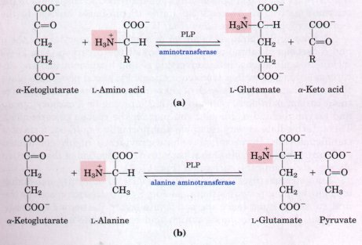
Figure: Transamination

