Section One
Carbohydrates
Carbohydrates:
They are defined as poly hydroxyl compounds - aldehyde or ketone functional group , they have a general formula (CH₂O)n where n>4.When water hydrolyzed, they give poly- hydroxyl aldehyde or ketone. Carbohydrates can be classified according to the number of forming units into:
1) Monosaccharide:
It consists of one sugar unit and cannot be hydrolyzed into smaller units ( also called as simple sugars ) , the most important monosaccharides are:

2) Oligosaccharides:
These sugars contain (2-10) sugar units that are linked to each other by glycoside bond, such as the disaccharides, which consist of two sugar units linked to each other by C-O-C (glycoside bond ), The most abundant disaccharide sugars are:

3) Polysaccharides:
Carbohydrates with high molecular weight that are polymers of monosaccharide such as starch, glycogen and cellulose Polysaccharides. are essential material for energy storage in plants and animals respectively( more than mono saccharides units) . All polysaccharides are non-reducing sugars because of their high molecular weight although they contain a terminal free OH group.

Chemical Tests of Carbohydrate:
1) Molisch’s Test:
It is a general test for all carbohydrates, it depends on the withdrawal of water molecules from the sugar by a strong acid, such as sulfuric acid Furfural is produced if the sugar has five C atoms furfural derivative is formed if the sugar has six C atoms the sugar, then the furfural combines with the solution α-naphthol to give a violet ring complex.

Procedure:
For (0.5mL) of sugar add two drops of α-naphthol solution mix well, then add approximately (2mL) of concentrated sulfuric acid gradually on the walls of the tube , see A violet ring separating the aqueous and organic layerscan be seen .
Reagent Preparation: Prepare α-naphthol solution by dissolving 1 g of α-naphthol in 100 ml of ethanol.
+

Violet Complex
α- naphthol

A violet ring separating (Molisch’s Test)

Carbohydrate as a reducing sugar:
Sugars generally have the reduction properties because they have free aldehydes and ketones groups , Reductive properties are reduced with increasing the sugar unit number, therefore, disaccharides have less reduction ability than monosaccharide, Although they contain a free carbonyl group, polysaccharides are not considered to have reducing properties because of their high mass molecular weight.
The percentage of open chain form which is responsible for reduction is about 1% in the solution, while 99% is closed ring form:

α-D- Glucose
β-D- Glucose

2) Benedict’s Test:
It is a general detection for all reducing sugars in which the cupric ions Cu⁺² are reduced in a weak base media to cuprous ions Cu⁺ with a reddish-yellow precipitate. This depends on the type and the concentration of the sugar. The reactions that occur during the test can be summarized as follows:

Gluconic acid

Shape of the precipitate

Note: The Benedict detector is also used to detect the sugar in urine.

Procedure:
Take (0.5) mL of the sugar solution into a test tube and mix with (1mL) of the Benedict reactions . Place the tube in a boiling water bath for 5 minutes, cool the tube spent and easily see the precipitate formation.

Note: All sugars give a positive results with a Benedict test except sucrose because it is does anon reducing sugar group.

Reagent Preparation:
In 1000 mL volumetric flask dissolve 173 g of sodium citrate with 100 g of sodium carbonate in 800 ml of distilled water, filter the solution and add 17.3 g copper sulfate dissolved in 100 mL distilled water, then fill of to 1000 mL.

3) Barfoed's Test:
This is a specific test for reducing monosaccharide, where monosaccharide is oxidized only in slightly acidic solutions containing cupric ion Cu(II) that are converted into cuprous ions cu(II) . cuprous hydroxide is formed during the heating cuprous hydroxide is converted to cuprous oxide with give red precipittate that appears in the bottom of the tube after cooling. Since the reduction in the weak acid medium occurs with difficulty, so only monosaccharide can reduce the Cu⁺² ions and thus we can distinguish between the monosaccharide and disaccharides (increasing the time boiling can give a false positive result for disaccharides due to their hydrolysis in the acid medium to mono saccharide units). The general reaction is:
Gluconic acid

Barfoed's Test

Procedure:
Take (0.5ml) of the sugar solution add (1mL) of Barfoed's reagent solution. Shake the tube well and then put in boiling water for only 3 minutes and note the red precipitate formed.

Reagent Preparation:
Dissolve 13.3 g copper acetate in 200 mL of distilled water, filter the solution and add 1.8 ml of glacial acetic acid to the filtrate
4) Bial's Test:
Bial’s test is used to detect the presence of pentoses (five carbon sugars) such as ribose and Xylose. In this test, the pentose is dehydrated by concentrated Hcl to form furfural that combines with orcinol and the solution turns to blue-green. Hexoses form a hydroxy methyl furfural with Hcl , which then combines with orcinol to form a brown complex.

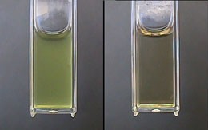
Pentose give Blue green complex
Hexoses give brown complex
Procedure:
Take (0.5) ml of the sugar solution in a test tube and add (1mL) of the Bial's reagent solution. Shake the tube well and place in a boiling water bath for 3-5 minutes. the blue-green precipitate formed.

Note: In the case of large quantities usage of pentose saccharides a blue-purple color is formed.

Reagent Preparation:
Dissolve 1.5 g of orcinol in 500 ml of concentrated hydrochloric acid and then add 1 ml of 10% ferric chloride solution.

5) Seliwanoff's Test:
Seliwanoff’s Test distinguishes between aldose and ketose sugars. Ketoses are distinguished from aldoses via their ketone/aldehyde functionality. This test is based on the fact that, when heated, ketoses are more rapidly dehydrated than aldoses. The ketose reacts with Hcl (3M) to give furfural derivative, which condenses with resorcinol to give a pink complex, so attention to the heating time should be given.

Procedure:
Take 0.5 ml of the sugar solution in a test tube and add 1mL of Seliwanoff's reagent solution, heat the tube for 3-5 minutes in a boiling water and note the appearance of the pink color.

Preparation of the reagent:
Dissolve 0.05 g of resorcinol in 100 mL of Hcl (3M).

3M Hcl h

Seliwanoff's Test

6) Disaccharides Test:
The maltose, lactose and sucrose are the most important colorless, water-soluble, sweet and visually active polysaccharides. These sugars are hydrolyzed into mono crystalline sugars by diluted acid, heat or by the use of enzymes. Sucrose is the only binary sugar that does not have the reducing properties because it doesn’t contain a free reducing group. Maltose and lactose are decomposed using acetic acid, while sucrose is Hydrolyzed by using of sulfuric acid

Procedure:
A) Take (3 mL) of each of maltose and lactose in a test tube and then add 10 drops of concentrated acetic acid, heat both tubes for 15 minutes in a boiling water bath. Cool and divided into two parts then apply Benedict and Barfoed test (with heating in a boiling water bath for 5-15 minutes).
B) Take (3mL) of sucrose solution in a test tube and add three drops of concentrated sulfuric acid. Place the tube is in a boiling water bath for 5 minutes. Cool and neutralize with 10% sodium hydroxide and then divided into three parts. Apply Benedict, Barfoed's and Seliwanoff's test.

Procedur :
C) to 5 mL sucrose add 8-10 drops of concentration Hcl . Boil for 3 min. coll , divide the solution into two parts. Neutralize one part by 10 drops of 20% solution carbonate

Benedict's test ofter acid hydrolysis.

Procedur : take 5mL of Benedict's reagent in a test tube add 8 drops of Neutralized solution . boil for 2 min – brick-red precipitate is formed.
Note : on acid hydrolysis . sucrose is converted to reducing mono saccharrides ( GLUCOSE + Fructose).

7) Osazone Test:
Compounds containing free aldehyde or ketone reducing group (including sugars) combine with phenyl hydrazine to form yellow crystalline derivatives with different geometric shapes and certain melting points that can be readily detected under microscope. This test is a specific for detecting sugars that show similar behavior in some of the previous tests, for example, glucose can only be charecterized from galactose by the difference in the crystals shape. Sucrose is the only sugar that does not produce ozazone crystal because it does not contain the free reducing group. The monosaccharide crystals except galactose crystals are insoluble in the hot solution. In contrast, the maltose and lactose crystals are soluble but precipitate when leaved to cool. The general reaction is:

Procedure:
1- Take about 2mL of the sugar solution in a test tube and add an excess amount of phenylhydrazine reagent (a mixture of 3 g of crystalline sodium acetate + 3 g of phenylhydrazine). Shake well to dissolve the reagent and place the tube in a boiling water 30 minute .
2- Crystals of monosaccharide will be separated from hot solution quickly after ten minutes.
3- If the crystals are didn’t separate ever the heating increase for more than (30 minutes), there is possibility of disaccharides (maltose or lactose) presence. In this case, cool slowly to get the crystals clearly.
4- Put the crystals on a slide and examine their forms carefully under the microscope and record your observations.

Osazone Test

Polysaccharides:
These compounds consist of a large number of monosaccharide and disaccharide chains. These chains may be branch, such as glycogen or straight like cellulose.

8) Iodine Test:
This test depends on the adsorption of iodine on the surface of starch or dextrin, giving a blue color for starch and purple for dextrin. This process occurs at room temperature, because the high temperature does not help adsorption due to dissociation of partially , there fore , the color disappears.of particles. This test is effected by:
A- Heat: The color disappears at high temperature and returns when cooled.

B- PH: This test can be conducted only in acidic or neutral medium, and it could not be conducted in alkaline medium because free iodine will react with the base forming iodides and iodates salts according to the following reaction:
While adding Hcl produce iodine according to the following reactions (note that the color returns again):
Procedure:
Add (3-5) drops of iodine solution to (1mL) of starch solution in a test tube. Notice the appearance of the blue color. When heating, the color will disappear and reappear when cooling. As the heating and cooling process continues, we will reach a stage where the tube is heated and the color disappears. When cooled, the color does not reappear, and this occurs because of the total evaporation of iodine.

9) Hydrolysis of starch by acid:
The process of starch degradation occurs gradually using Hcl, where the continuous heating catalyzed ,the hydrolysis reaction is as follows:

Procedure:
Place 10ml of starch solution (1%) in a test tube and add 3ml of Hcl (2N), shake the tube well and place in a boiling water . Every three minutes (0, 3, 6, 9, 12 and 15 min) withdrawn 1 ml of the tube mixture and divide into two parts, apply Iodine test on the first and Benedict test after neutralization to the second ,one.

Benedict’s Test | Iodine Test | Sugar
(-) Non-reduced sugar | (+) Blue | Starch
(-) Non-reduced sugar | (+) Purple | Amylodextrin
(-) Non-reduced sugar | (+) Cherry Red | Erthrodextrin
(-) Non-reduced sugar | (+) Yellow Brown | Achrodextrin
(+) Reduced sugar | (-) Iodine Yellow | Maltose
(+) Reduced sugar | (-) Iodine Yellow | Glucose

Molisch’s Test

كاربوهيدرات (+ve)
Iodine Test
سكر متعدد (نشا) (+ve)
سكريات أحادية و ثنائية (-ve)
Benedict’s Test
سكريات مختزلة أحادية و ثنائية (+ve)
سكر غير مختزل (السكروز) (-ve)
Barfoed's Test
سكريات ثنائية (لاكتوز و مالتوز) (-ve)
Bial's Test
سكر خماسي (الرايبوز) (+ve)
سكر ألديهايدي (كلوكوز و كالاكتوز) (-ve)
سكر كيتوني (الفركتوز) (+ve)
Seliwanoff's Test

unknown

(+ve) Carbohydrates
water (-ve)

(+ve)Polysaccharides(starch)
(-ve) Mono&Oligo, (saccharides )

(-ve) unreducing sugars (sucrose)

(+ve) Mono&Oligo , (reducing sugars )

(+ve) Monosaccharide

(-ve) Oligosaccharides (Lactose , Maltose)

(-ve) Hexoses ( sugar)

(+ve)pentose ( sugar) Ribose

Keto sugar (Fructose) (+ve)
(-ve)Aldo sugar ( Glucose , calactose)

Scheme 1: identification of unknown Carbohydrate

Lipids

Lipids are heterogeneous organic material soluble in non-polar organic solvents such as benzene, ether, chloroform, etc. However, it does not dissolve in water. Lipid is used to perform two basic functions:
1- structure component of the cell membranes.
2- a form of storage energy form.
There are different types of lipids, all of which contain non-polar structures similar to hydrocarbons which give them an oily or waxy nature.
Based on Structure, lipids can be classified as:
1-Simple Lipids: include Fats, oils and waxes.
2- Complex Lipids: include phospholipids, glycolipids and sphingolipids
3- Derived Lipids: include cholesterol (steroids) and fat soluble vitamins.
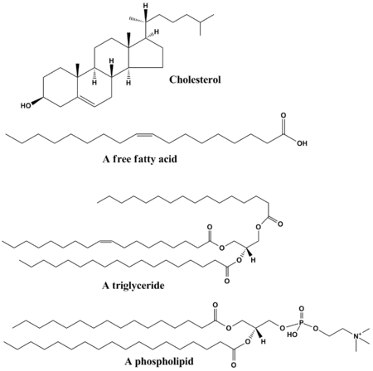

Fatty acids:
A fatty acid is a saturated or unsaturated carboxylic acid with a long aliphatic chain . Most naturally occurring fatty acids have an un-branched chain of an even number of carbon atoms, from 4 to 28.
Fatty acids and their associated derivatives are the primary components of lipids; the following are examples of fatty acids:

1) 16:0 Palmitic acid (saturated)

2) 18:0 Stearic acid (saturated)

3) 18:1 cis Δq Oleic acid (unsaturated )

Chemical tests of Lipids:
1) Unsaturation test (by copper acetate):
Triglycerides are not able to react with copper acetate solution, but the saturated free fatty acids are able to react to produce a bluish green deposit (in the lower aqueous layer), while unsaturated fatty acids give green copper salts that are soluble in petroleum ether layer, so that the saturated and unsaturated fatty acids can easily be characterized by this reaction.

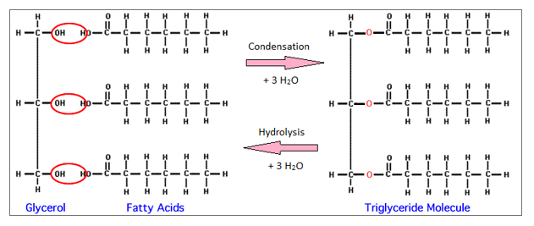
Triglycerides

Procedure:
Take (1mL) of unsaturated fatty acid in a test tube and (1mL) of saturated fatty acid in another test tube. Add 10 drops of 10% copper acetate solution to both tubes.
A) Green solution appears in the first tube in the upper ether layer.
B) A bluish green precipitate appears in the lower aqueous layer in the second tube.
Note: Avoid strong of shacking to prevent heavy emulsion formation.

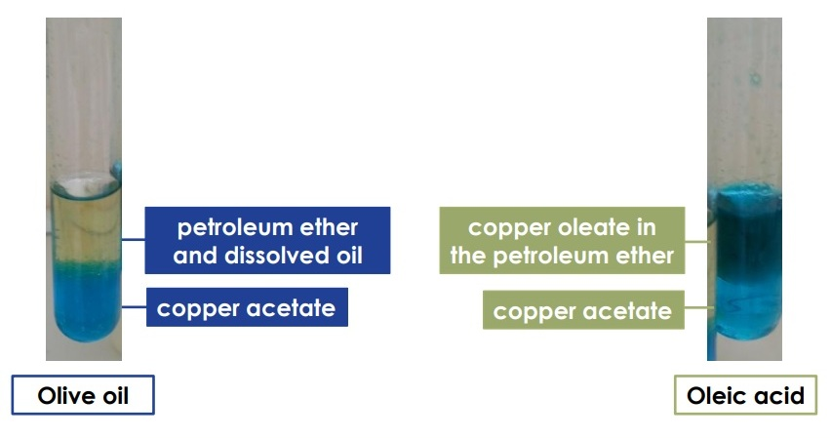

2) Iodine Test:
The fatty acids found in animal fats are completely saturated while those in vegetable oils contain one or more of double bonds, Addition of iodine to the double bonds on the unsaturated fatty acids leads to the saturation and disappearance of iodine solution color, while in saturated fatty acids the iodine color is still appear.

Procedure:
Iodine solution is added drop by drop to two test tubes the first contain saturated fatty acid and the second unsaturated fatty acid, The Iodine disappearance of the color in the second tube gradually until all the double bonds are saturated and iodine color appears again, The iodine color appears in the first tube as soon as the first drop is added.

3) Cholesterol Detection Tests:
When steroids containing unsaturated bonds are treated with strong acids in non-aqueous conditions , they react to give products with distinct colors depending on the conditions of the experiment, the resulting color shows significant differences from one compound to another, and the mechanism of these reactions are complex.

A- Salkowski,s Test:
It is an important test used to detect cholesterol; it depends on the formation of distinctive clear colors when cholesterol is treated with concentrated sulfuric acid. To achieve the success of this test, the glassware used in the experiment should be dry and the solutions used should be anhydrous. Why?

Procedure:
Take (1ml) of cholesterol dissolved in chloroform and add the same volume of concentrated sulfuric acid, shake well and leave until it is separated into two layers. The upper layer should be red while the lower layer will be green.

B- Liberman-Burchards Test :
Glacial acetic acid and concentrated sulfuric acid are used in this test to detect cholesterol, where the appearances of a pink color that change to violet and then to bluish green is evidence on cholesterol presence. It is also possible to estimate the amount of cholesterol quantitatively (relatively amounts) by measuring the intensity of the color.

Procedure:
Add (1 mL) of glacial acetic acid to a clean and dry test tube containing (1ml) of (5 %) cholesterol dissolved in chloroform, then add two drops of concentrated sulfuric acid, mix the contents of the tube carefully and leave for several minutes and follow the color changes.

4) Acrolin Test:
It is an important test for glycerol, where glycerol loses two molecules of water by heating with a dehydrating agent and turns into a volatile substance with a strong odor (like burned lipid) called acrolin. This test is distinctive for glycerol either free or bound with fatty acids.

2H₂O

Potassium persulfate works to withdraw water molecules from the glycerol under heating and turns into acrolin.

Procedure:
Equal amounts of glycerol and potassium bicarbonate are placed in a dry test tube; the tube is carefully heated at the beginning then strongly heated while the change in the contents of the tube is followed.

5) Rancidity:
It is the complete or incomplete oxidation or hydrolysis of fats and oils when exposed to air, light, moisture or by bacterial action, resulting in unpleasant taste and odor and changes in physical and chemical properties of the fatty acid because it contains volatile fatty acids. Rancidity occurs by two pathways:

A- Hydrolytic rancidity:
It refers to the odor that develops when triglycerides are hydrolyzed and free fatty acids are released. This reaction of lipid with water may require a catalyst, leading to the formation of free fatty acids and glycerol; this phenomenon could occur in butter , for example.

B- Oxidative rancidity:
This type is associated with the degradation by oxygen in the air. The double bonds of an unsaturated fatty acid can be degraded by free-radical reactions involving molecular oxygen. This reaction causes the releasing of malodorous and highly volatile aldehydes and ketones. Because of the nature of free-radical reactions, the reaction is catalyzed by sunlight.

Procedure:
A solution of two drops of 1% phenolphthalein and (2 ml) of 0.5% sodium hydroxide is freshly prepared, then this solution is added drop by drop to two tubes one containing old fat and the other containing a new fat and the changes in colors formed is notice .

6) Determination of fat acid value (acid number):
As a result of storage, fat may be exposed to rancidity resulting in fatty acids releaseing . As a result, the amount of fatty acids found in fat gives an indication of the age and quality of fat.

Acid value (acid number): it is the number of mg of potassium hydroxide required to neutralize free fatty acids found in one gram of fat.

Procedure:
Place 2ml of oil (12% olive oil) in a conical flask and add two drops of phenolphthalein. Titrate with 0.1N of KOH until light pink color appears and record the volume of the base.

Calculations:
1- Calculate the fat weight in the model sample
From the Burette
2- Calculate the weight of the base

We multiply (M x 1000) to convert it to milligram unit. M represents the number of KOH needed to neutralize free fatty acids found in 0.24g of fat.
؟

X = mg of potassium hydroxide required to neutralize free fatty acids found in one gram of fat.
7) Saponification number:
It is the number of milligrams of potassium hydroxide required to neutralize the fatty acids resulting from the complete hydrolysis of 1g of fat.
Glycerol esters in fat are converted by refluxing with KOH to glycerol and potassium salts of the fatty acids. Saponification number gives important information about the nature of fatty acids found in fat.

Procedure:
Take (1) gm of the fat in a clean baker and mix it with about 3mL of a suitable solvent. Transfer mixture to a 250mL round bottom flask by washing the baker several times with small amounts of the solvent used. Add 25ml of (0.5 mol/L) potassium hydroxide. At the same time prepare another round bottom flask with same contents except the fat. Reflux each flask for 30 minutes then leave to cool at room temperature, titrate against (0.5 mol/L) hydrochloric acid in presence of phenolphthalein indicator.

Calculations:
The difference in reading between the two rounds gives the number of milliliters of KOH required for 1 gm of fat.
Molecular weight of KOH is equal to (56); since three molecules of fatty acid are removed from triglyceride, then:

Amino Acids

Amino acids:
They are organic compounds containing amine (-NH₂) and carboxyl (-COOH) functional groups, along with a side chain (R group) specific to each amino acid, so amino acids behave as weak acid and weak base so-called Amphoteric behavior . most important 20 amino acids, which are the basic structural units of the protein molecules found in living tissues, eight of them are essential because the body cannot produce them and must be get from food or through medication.
Amino acids are crystalline materials that are different from each other in taste. Some are sweet, such as glycine, alanine, serine and proline. Some have No taste as tryptophan, while others bitter, such as arginine; also they have high melting point. All amino acids dissolve in polar solvents such as water and ethanol ,while not soluble in non-polar solvents such as benzene, hexane and ether. All amino acids except glycine are optically active as they contain an asymmetric carbon atom. The amino acids are always found as Zwitter ion when the PH is equal to PI, where the latter (PI) is defined as the PH in which the total negative charges are equal to the sum of the positive charges, i.e., the charge is zero.

Amino acids undergo different reactions because of the difference of their chemical composition. These reactions are called colorimetric reactions, the most important of which are:

1) Ninhydrin Reaction:
It is a general detection test for all amino acids and proteins, it is highly sensitive detection; amines and ammonia give positive results with this test as well but without CO₂ release. The reaction depends on the presence of the amine group and the free carboxyl group. The ninhydrin solution is a very powerful oxidizing agent that works on oxidizing the amino acid by producing aldehyde (RCHO), carbon dioxide (CO₂), ammonia (NH₃) and hydrindantin, which reacts with ammonia and in the presence of a second molecule of ninhydrin to produce a blue or purple complex. This test can be used in quantitative estimation of amino acids since the amount of CO₂ released can be used to estimate the amount of amino acids.

Procedure:
Take (1ml) of the amino acid in a test tube, then add 10 drops of (0.2%) ninhydrin solution, shake the tube well and then put in a boiling water for 5 minutes, notice the color formed.

2) Xanthoprotic Test:
This test depends on the presence of the aromatic ring (benzene ring) in the amino acid it is possible to identify of the aromatic and aliphatic amino acids by this test. This test is performed by the reaction of the aromatic amino acid with concentrated nitric acid, where a yellow color converted orange when a strong base such as sodium hydroxide or ammonia is added.
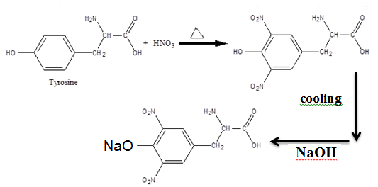

Procedure:
Add (1 mL) of concentrated nitric acid to a test tube containing (2 mL) of amino acid, then put the tube in a boiling water bath for 3 minutes. Cool and add 4ml of (10 N) NaOH and notice the changes.

3) Millons Test:
This test is specific for amino acids that contain phenolic group; therefore, it is specific for tyrosine, where a red colored solution is formed by tyrosine reaction with mercury nitrate dissolved in nitric acid.

Procedure:
Take (1 mL) of tyrosine in a clean test tube and add 1 mL of Mellon reagent. Shake well and put in a boiling water for 3 minutes. A red brown precipitate is an evidence of (positive test).

Reagent Preparation:
Dissolve (15 %) mercuric sulfate solution in (15 % v/v) sulfuric acid.

4) Hopkins-Coles Test:
This test is specific for tryptophan which has an endol group which , where purple ring is formed when tryptophan reacts with the glyoxylic acid in the presence of concentrated sulfuric acid.

Procedure:
Add (1 mL) of glyoxylic acid to (2 mL) of the amino acid solution in a clean test tube, then add 2ml of concentrated sulfuric acid on the inner wall of the to form two layers separated by a violet ring indicating the presence of tryptophan.

5)-Sakaguchi Test:
This test is specific for arginine because it contains quinidine group, which , it reacts with α-naphthol and then by treating it with a strong oxidative agent such as chlorine water (sodium hypochlorite), under heat to produce a red-colored solution will be formed.

مجموعة الكوانيدين

Quinidin group

Procedure:
Put (1 mL) of the amino acid solution in a test tube, add (10) drops of sodium hydroxide (40%), and then add (2) drops of α-naphthol solution into the tube. Shake well then add (3) drops of KHBr water and note the formed color.

6) Pauly’s Test:
This test is specific for histidine and tyrosine, which have the ability to bind with diazonium salts to form strong and distinctive colored azo compounds. This reaction could be successful only in cold conditions.

Procedure:
Mix (1 ml) of Sulfanilic acid with (2 ml) of the amino acid solution in a test tube. Place the tube in an ice bath and add (1 ml) of (5 %) NaNO₂, wait for three minutes and then add (2 ml) of (1%) Na₂CO₃ to achieve alkaline media and observe the color formed.

Reagent preparation: (1 %) concentration prepared by dissolving in (1 N) HCl.

7) Lead Sulfide Test:
When the amino acids cysteine and cystine are treated with a strong base such as sodium hydroxide, sodium sulfide is formed which is detected by precipitation as black lead sulfide in alkaline media by adding lead acetate solution, as in the following equations:

Procedure:
Take (1 ml) of the amino acid solution in a test tube and add (1 mL) of sodium hydroxide. Heat in a boiling water for 2 minutes and then add (5) drops of lead acetate solution and notice the changes in the tube.
8) Nitroprusside Test:
In this test the thiol group (SH) found in cysteine reacts with Na₂Fe(CN)₅NO in presence of excess of ammonia to give a red-colored solution. Therefore this test used identify Cysteine &Cystine.

Procedure:
Add (0.5 mL) of freshly prepared sodium nitro proxide to (2 mL) of the amino acid in a clean and dry test tube then add (0.5 mL) of ammonium hydroxide and notice the resulting color.
UNKnown
Ninhydrin test
(-ve) water
Amino acid (+ve)
Xanthoprotic Test
(+ve)(Tyr,Trp,Phe,His) aromatic
(-ve)(Cystine,Cysteine,Gly,Arg) aliphatic
Lead Sulfide Test
(+ve) )(Cystine, Cysteine)
(-ve)(Gly, Arg)
Millons Test
(-ve)(Trp,Phe,His)
(+ve)Tyr
Sakaguchi Test
(+ve)Arg
(-ve)Gly
(-ve)Cystine
(+ve)Cysteine
Nitroprusside Test
Hopkins-Coles Test
(-ve)(Phe, His)
(+ve)(Trp)
(-ve)(Phe)
(+ve)(His)
Pauly’s Test

جدول يوضح الأحماض الأمينية العشرين الموجودة في جسم الأنسان .

Proteins

Proteins:
Proteins are organic compounds with high molecular weights consist of a large number of amino acids, have linked to gether by peptide bonds. The proteins consist of the essential elements like carbon, nitrogen, oxygen, hydrogen and other elements such as sulfur, phosphorus and iron; they form the essential component of animal and plant tissues.
Proteins are required for the structure, function, and regulation of the body's cells, tissues, and organs. They act as catalysts and regulate the reactions as hormones. In addition, they are found within the components of cell walls.

Proteins are classified according to their chemical composition or their solubility properties to:
1- Simple proteins.
2- Associated proteins.
3- Derivative proteins.
Proteins have four building structures:
1-Primary structure: Represents the number and sequence of amino acids in the peptide series, peptide bonds are responsible for this structure only.
2-Secondary structure: Regularly repeating local structures stabilized by hydrogen bonds. The most common examples are the α-helix, β-sheet . Because secondary structures are local, many regions of different secondary structure can be present in the same protein molecule. Hydrogen bonds mainly.
3-Tertiary structure: Tertiary structure is generally stabilized by nonlocal interactions, most commonly the formation of a hydrophobic core, but also through salt bridges, hydrogen bonds and disulfide bonds. The tertiary structure is what controls the function of the protein.
4-Quaternary structure: The structure formed by several protein molecules (polypeptide chains), usually called protein subunits, which function as a single protein complex.

The most important bonds that share in the stabilization of the protein segment are:

- Peptide bonds.
- Hydrogen bonds.
- Sulfur bonds.
- Hydrophobic interactions.
- Ionic bonds.
- Vander Val's forces.

Solubility of Proteins:
The proteins differ in their solubility. Generally they have low solubility in water and polar solvents, but they form gluey solution in water with special viscosity (some proteins are soluble in water such as Albumin and others do not dissolve in water like Keratin).
The solubility of proteins depends on four main factors that effect on structure of protein:
1- PH: The degree of solubility of proteins is greatly affected by the value of PH due to its amphoteric behavior, where the solubility rate is at the lowest at the iso-electric point and increases if it moved far from this point by increasing either by increasing acidity or basicity that forms negative or positive ions. This behavior is used to separate proteins with different pI value from each other.
2- Heat: The heating process leads to a change in secondary, tertiary and quaternary structure of the protein (protein synthesis), which causes loss of its biological efficiency; this process is called denaturation, where the protein will be precipitated from the solution when exposed to extreme heating.
3- Ionic Concentration: The solubility of low soluble protein increases by adding low concentration of neutral solution such as (0.9%) of table salt; this is known as salting-in. On the other hand, the addition of high concentrations of neutral salts will cause proteins precipitation from their aqueous solutions; this is known as salting-out.
4- Solvent Charge: Proteins are precipitated from their aqueous solutions by adding polar solvents that are mixed with water such as alcohol and acetone, denaturation occur and the protein is precipitated.

General Tests of Proteins:

1) Biuret Test:
It is a general test for all proteins and peptides consist of three or more amino acids (i.e. containing two or more peptide bonds) where violet complex is formed between the cupeir ions present in the reagent solution and the nitrogen atoms of the peptide bonds of the protein.

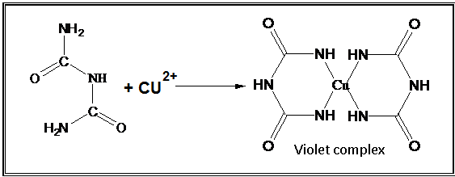
2

The test name is derived from the Biuret compound, which can be obtained from urea heating. Biuret compound is capable of forming a violet complex with copper ions found in the reagent solution.

Procedure:
Put (1 mL) of protein solution in a clean test tube and add (0.5 mL) of Biuret reagent, shake the solution well and note the color formed.
Note: Filterate which contains protein gives violet color with Biuret
test
Preparation of Biuret Reagent:
Dissolve (3 g) of hydrous copper sulfate and (9 g) of sodium-potassium tartrate in 500 ml of (0.2 N) NaOH solution. Add (5 g) of potassium iodide and fill with (0.2 N) NaOH solution till (1 L).

2) Precipitation by Heat:
Proteins have a thermal precipitation property when they denaturate and this process is irreversible so it doesn’t dissolve by cooling.

Denaturation: It is a process of changing the tertiary structure of protein, which leads to the loss of its activity; many factors cause in denaturation such as heat, strong acids and bases.
Procedure:
Take (2 ml) of protein solution in a test tube and heat directly on a benzene burner until the protein is aggregated and precipitated.

3) Precipitation Using Concentrated Acids:

A- Precipitation Using Nitric Acid:
Put (1 mL) of protein solution in a test tube and slowly add drops of concentrated nitric acid until the precipitate is formed. This type of precipitation is irreversible because it affects the tertiary structure of protein.

B- Precipitation Using H₂SO₄ and HCl:
Repeat the same experiment (A) and use H₂SO₄ acid and HCl acid instaed of HNO₃, this reaction is reversible ?

4) Precipitation by Heavy Metal Salts (Positive Ions):
Proteins are usually charged with a negative charge at PH 7 or more. The addition of metals with a positive charge (heavy metals) leads to the neutralization of these charges and thus bringing the proteins to the iso-electric point hence precipitated.
This type of precipitation has a particular importance; therefore in the case of poisoning by one of these salts, egg or milk can be used as an antidote that can precipitate the heavy metal and prevents its absorption by the body.

Procedure:
Take (2 mL) of protein solution in a clean test tube and add several drops of concentrated solution (0.1M) of the heavy metals (copper sulfate , ferric chloride, lead acetate) until the precipitate is formed. Then add excess of heavy metals solution where the precipitate is dissolved again. (Give the reason for this).

6) Precipitation by Alkaline Reagents (Complex Acids):
Tannic, Picric, Tungstic acid and Sulfosalicylic acids are the most effective alkaline reagents that can precipitate proteins from their solutions. These acids carry large negative charges that have the ability to neutralize positive charges of proteins and form insoluble salts. Therefore, these reagents are highly active at acidic PH where proteins are charged with a positive charge.

Procedure:
Add drops of (20 %) alkaline reagent to (2 ml) of the protein solution in a clean test tube until the precipitate is formed then add an excess of alkaline reagent and observe what happens to the precipitate.

6) Precipitation Using Organic Solvents:
Add several drops of alcohol (ethanol) to (2 mL) of the protein solution in a clean test tube until the precipitate is formed. (Precipitation here is irreversible).

7) Precipitation Using Neutral Salts (Salting-out):
A protein is precipitated using high concentrations of neutral salts due to its rival on water molecules. Precipitation ability depends on salt type, salt concentration and protein type. This method of protein precipitation has a great importance.

Procedure:
Add (1 mL) of ammonium sulfate to (1 mL) of protein solution in a clean test tube. Repeat the experiment using sodium chloride and magnesium sulfate and record the obtained results.

