4- Clostridium perfringens

*Characteristics of Clostridium perfringens :
1- Is a Gram-positive.
2- Anaerobic or microaerophilic bacteria .
3- Rod-shaped, spore-forming bacterium and non-motile.
4- Rounded end, the arrangement in single or double or short chains, forming capsule when the presence of tissue and can appear as endospore.
5- C. perfringens is present in nature as decaying vegetation, marine sediment, the intestinal tract of humans and other vertebrates, insects, and soil.
- The natural environment of these bacteria in the intestines of humans and animals, which are present in most feces samples in low numbers, but in case food poisoning or gas gangrene their presence in large numbers.
- Its presence in the water with absent E. coli bacteria can be taken as a sign of old fecal contamination.
- It's a good indicator of fecal pollution even in the absence of other bacteria E.coli and Fecal Streptococci .
- Ability to form spores, makings it no affected by concentrations of chlorine that used in disinfecting water ( Stiff resistance to unsuitable conditions and their ability to stay a long time in the water ). Spores resistant to chemical disinfectants , antiseptics and physical factors such as dry heat.
- Possess ability to lysis many sugars like sucrose, maltose and glucose to produce acids & gas to give it a significant feature of (Stormy fermentation) to identify Clostridium.

- Also can lysis the proteins and amino acids containing Sulfur/ Sulphur.

- When bacterium grows on the culture media is reduce the elements from nutrients like C, H, O, N, S. P, K, Mg, Fe, Ca and Mn which is required for energy generation and cellular biosynthesis by special enzymes so they faster growth at the media containing glucose or maltose of carbohydrates or amino acids of proteins, considered as reductive factors.
- Sulphite-reducing Clostridia: reduce sulphite to sulphide at 37° C within 24 hours.

Detection methods of Clostridium :
- MPN .
2. The method of Litmus milk.
3- Wilson and Blair sulfite medium.

- Differential Reinforced Clostridium Broth by the MPN technique:
It contains in its ingredients ferric citrate and sodium disulfite.
Principle : Clostridium reduces sulfite to sulfide, the iron sulfide produced causes the culture medium to turn black.
Presumptive test :
- The vegetative forms must first be removed from the sample by a pasteurization , the pasteurization temperature is much lower than the boiling temperature . Water sample pasteurization at 70-80 temperature for 10 Minutes .
- Double concentration for large volumes and single concentration for small volumes .
3) To provide anaerobic conditions for the growth of these bacteria; Either, fills almost the tube & left little space near the tube cover and used tube plugs and do not close completely and do not fill up completely to allow the gases formed during growth out so as not to explosion tubes due to pressure if they closed strongly. OR, Inserted wire of iron heated until the redness to the media.
4 ) Incubated tubes containing the media inoculated at 37 C /24-48 hours .
After incubation : we observe black precipitate in the media as a result of the growth of Clostridium its reduce sulfites found in the media and turn it into a black precipitate of FeS, which indicates that test positive and to make sure there are C . perfringens .
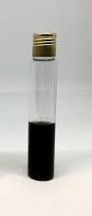
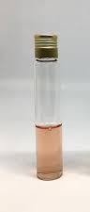
NOTE :
Definition of thermotolerant coliform bacteria: Thermotolerant coliform bacteria are the coliform organisms that are able to ferment lactose at 44–45°C; the group includes the genus Escherichia and some species of Klebsiella, Enterobacter, and Citrobacter.

2- Litmus milk broth of confirmatory testing :
* Litmus milk : it is a multipurpose medium distinguish between different species of bacteria, contains the lactose ( milk sugar ), casein ( milk protein ) { bacterium can use one of these, both of these, neither of these } and litmus ( pH indicator ).
** Sugar users will make ( acid reaction ) causing a change to ( pink ), whereas casein protein users will produce ( alkaline reaction ) causing a change to ( blue ),
and if the casein is completely hydrolyzed, the medium turns a clear brown, in addition some organisms produce enzyme renin ( curd formed ) and gas in the curd.

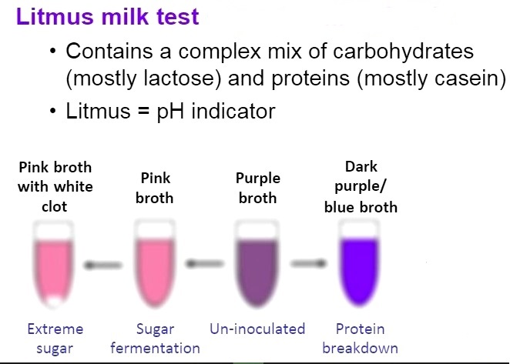

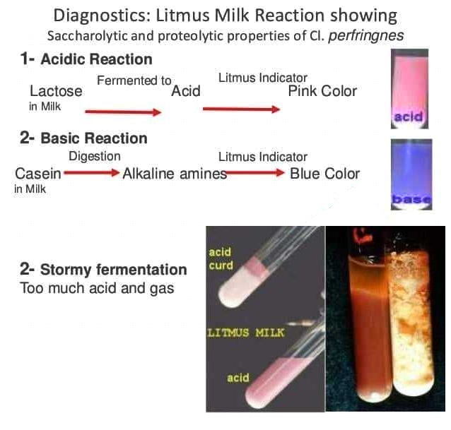
Procedures:
1) By loopful take from a tube that gave a positive result in presumptive test , then inoculate tubes containing Litmus milk .
2) The inoculated tubes are incubated at a temperature 37C for 48 hours in anaerobic conditions (add candle in jar or fill the tubes completely ).
3) Record the results and observe if the Stormy fermentation phenomenon occurred by appearing broken apart of clots or cracks in curd.
4) Bacterial staining by slide.
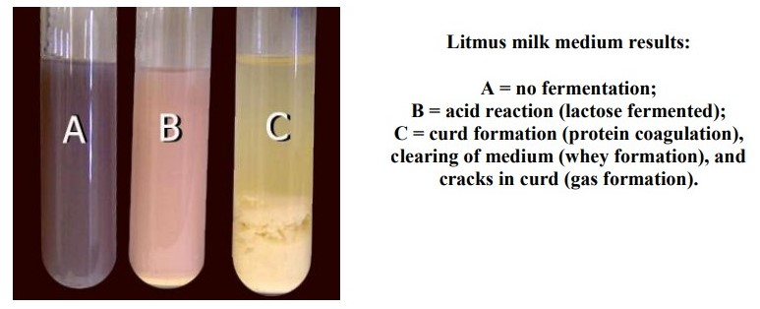
Some examples of these results and its interpretation :
Pink = acid reaction (lactose fermented with acid production(
Purple = lactose not fermented
Blue = alkaline reaction (bacteria degraded amino acid in milk)
Clots or curds = milk protein coagulation
Clearing of medium = whey formation (milk protein digested(
Cracks in curds = Stormy fermentation /Too much gas formation (CO2 and/or H2).


