Lecture 7- Serology and Vaccination for Biotechnology 4thstage
Prf. Dr. Rajwa Hasen Essa
Prf.Dr. Alia Essam Mahmood
Vaccination is immunization against infectious disease through the administration of vaccines for the production of active (protective) immunity in humans or other animals, similar to that produced by the natural infection.
A heterologous vaccine (also known as a "Jennerian" vaccine) is a type of live vaccine where one pathogen is introduced in order to provide protection against a different one. The vaccines are pathogens of other animals that either do not cause disease or cause mild disease in the organism being treated. Examples include: historically, Jenner's administration of cowpox (vaccinia) to protect against smallpox (variola);
the administration of BCG vaccine made from Mycobacterium bovis to protect against human tuberculosis.
Homologous vaccine Are those which are produced from one and used against the same.
The vaccine can be classified in to:
A- Routine vaccines: are well tolerated provide adequate protection against dangerous and widespread infection e.g diphtheria, polio, measles, mumps Most people think of these as childhood vaccines that you get before starting school, but some vaccines are routinely recommended for adults, and some are recommended every year (a flu vaccine) or every 10 years (a tetanus booster).
B- Indicated vaccines: are performed only under certain conditions, tourist vaccines belong to this group.
Precaution and Contraindication
1- The injection of vaccines May causes general anaphylactic reactions therefore 1:1000 epinephrine should always be readily available.
2- when a child is not good health or is suffering from acute febrile illness, routine vaccines should be postponed until recovery.
3- treatment with steroids or radiation may reduce immune response if the treatment is not short duration any routine vaccination should be postponed, if the treatment is not a long-term basis, killed vaccines can be administered during the course of treatment. all live vaccines (BCG, OPV, Measles) are postponed for at least three months.
4- All live vaccines are also Contraindicated when there is:
- Malignant proliferative affection of lymphoreticular tissues.
- Congenital or acquired immunodeficiencies.
- Pregnancy
- Recent administration of immunoglobulin.
All infants should be given the standard vaccines against diphtheria, pertussis, and tetanus(DPT) and against poliomyelitis and measles. this should be done as early as possible according to the immunization schedules of the country.
it may countries the BCG vaccines are given to all infant at the birth to prevent tuberculosis.
Anaphylaxis An acute, multi-system, allergic reaction (IgE mediated) to a substance, such as vaccination, drugs, and food.
Vaccine antigens and components can cause this allergic reaction( is a very rare occurrence, one in a million vaccines and can be fatal if not dealt with adequately ). These reactions can be locally or limited to a specific body part or region, or systemic, or affecting the entire body (e.g., fever), and can include mild-to-severe anaphylaxis or anaphylactic-like responses.
Symptoms may include one or more of the following:-
Urticaria, or hives, itching, wheezing, swelling of the mouth and throat, breathing difficulties, hypotension, loss of consciousness, and a drop in blood pressure.
Antitoxin, antibody, formed in the body by the introduction of a bacterial poison, or toxin, and capable of neutralizing the toxin.
For medical use in treating human infectious diseases, antitoxins are produced by injecting an animal with toxin; the animal, most commonly a horse, is given repeated small doses of toxin until a high concentration of the antitoxin builds up in the blood. The resulting highly concentrated preparation of antitoxins is called an antiserum.
When we inject the antisera intravenous we should be.
- Only purified antiserum can be used
- Sub cutaneous hypersensitivity test must be done
- The injection must be done slowly
- The patient must be observed for 1 hour.
How to make anti sera
Horses that were vaccinated three times with increasing sizes of the dose. The time between each vaccination varied from each horse and its health condition. Normally the horses needed a few weeks to produce the serum in the blood after the last vaccination.
In order to find the moment when most antitoxins in the blood cells of the horses are produced, frequent blood samples were taken from the horses. At the point when the highest amount of antibodies were produced, five litres of blood, a tenth of the blood volume of a horse, was taken through a cannula. The blood was collected and separated the serum varied from milky to brown. Concentration and sterility of the serum were checked carefully, and the serum was filtered many times. Protein content was decreased in order to use the serum for humans. Now they use procedure is called plasmapheresis
a method of removing blood plasma from the body by withdrawing blood, separating it into plasma and cells, and transfusing the cells back into the bloodstream.
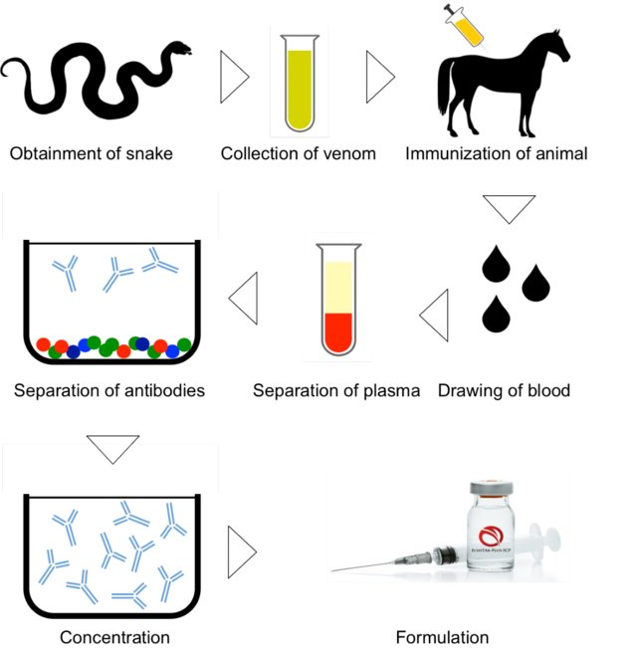
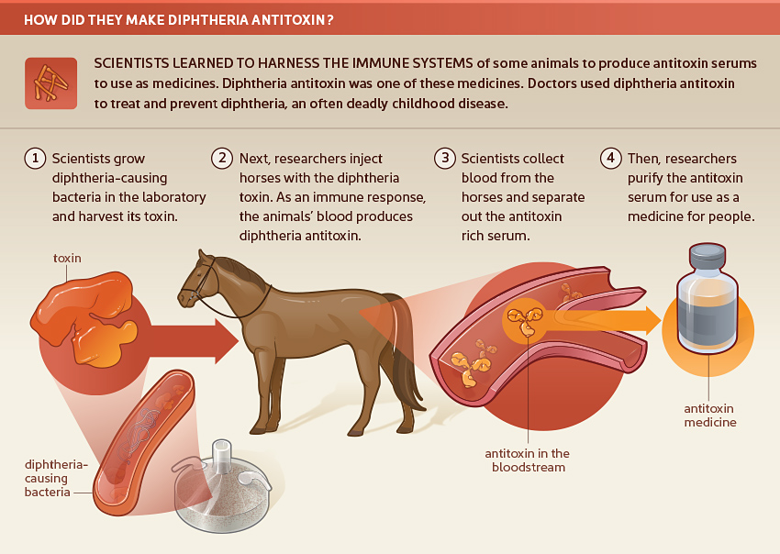
How did they make diphtheria antitoxin?
Scientists learned to harness the immune systems of some animals to produce antitoxin serums to use as medicines. Diphtheria antitoxin was one of these medicines. Doctors used diphtheria antitoxin to treat and prevent diphtheria, an often deadly childhood disease.
1. Scientists grow diphtheria-causing bacteria in the laboratory and harvest its toxin.
2. Next, researchers inject horses with the diphtheria toxin. As an immune response, the animal's blood produces diphtheria antitoxin.
3. Scientists collect blood from the horses and separate out the antitoxin rich serum.
4. Then, researchers purify the antitoxin serum for use as a medicine for people.
A vaccination schedule is a series of vaccinations, including the timing of all doses, which may be either recommended or compulsory, depending on the country of residence.
BCG
About-BCG stands for Bacillus Calmette-Guerin vaccine. It is given to infants to protect them from tubercular meningitis and disseminated TB.
When to give – BCG vaccine is given at birth or as early as possible till 1year of
Route and site- BCG is given as an intradermal injection in the left upper arm.
OPV
About-OPV stands for Oral Polio Vaccine. It protects children from poliomyelitis.
When to give- OPV is given at birth called zero dose and three doses are given at 6, 10 and 14 weeks. A booster dose is given at 16-24 months of age.
Route and site - OPV is given orally in the form of two drops.
Hepatitis B vaccine
About – Hepatitis B vaccine protects from Hepatitis B virus infection.
When to give- Hepatitis B vaccine is given at birth or as early as possible within 24 hours. Subsequently, 3 doses are given at 6, 10 and 14 weeks in combination with DPT and Hib in the form of pentavalent vaccine.
Route and site- Intramuscular injection is given at the anterolateral side of mid-thigh
Pentavalent Vaccine
An about-Pentavalent vaccine is a combined vaccine to protect children from five diseases Diptheria, Tetanus, Pertussis, Haemophilus influenza type b infection and Hepatitis B.
When to give - Three doses are given at 6, 10 and 14 weeks of age (can be given till one year of age).
Route and site-Pentavalent vaccine is given intramuscularly on anterolateral side of mid-thigh
Rotavirus Vaccine
About -RVV stands for Rotavirus vaccine. It gives protection to infants and children against rotavirus diarrhoea. It is given in select states.
When to give - Three doses of vaccine are given at 6, 10, 14 weeks of age.
Route and site-5 drops of vaccine are given orally.
PCV
About- PCV stands for Pneumococcal Conjugate Vaccine. It protects infants and young children against disease caused by the bacterium Streptococcus pneumoniae. It is given in select states.
When to give - The vaccine is given as two primary doses at 6 & 14 weeks of age followed by a booster dose at 9 months of age
Route and site- PCV is given as intramuscular (IM) injection in outer right upper thigh. It should be noted that pentavalent vaccine and PCV are given as two separate injections into opposite thighs.
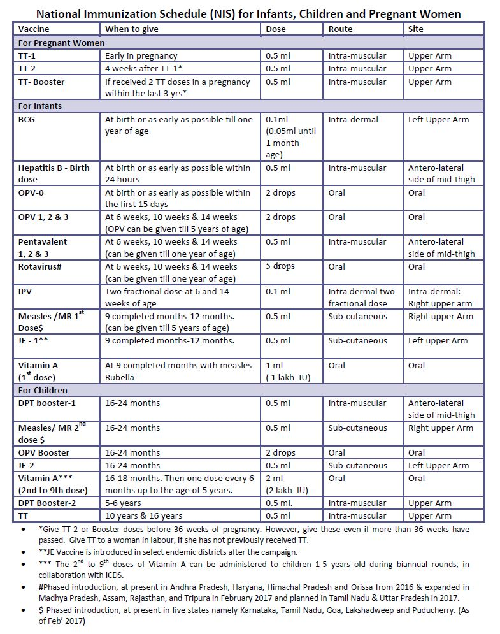
fIPV
About- fIPV stands for Fractional Inactivated Poliomyelitis Vaccine. It is used to boost protection against poliomyelitis.
When to give- Two fractional doses of IVP are given intradermally at 6 and 14 weeks of age.
Route and site- It is given as an intradermal injection at the right upper arm.
Measles/ MR vaccine
About-Measles vaccine is used to protect children from measles. In a few states Measles and Rubella a combined vaccine is given to protect from Measles and Rubella infection.
When to given- The first dose of Measles or MR vaccine is given at 9 completed months to12 months (vaccine can be given up to 5 years if not given at 9-12 months age) and the second dose is given at 16-24 months.
Route and site – Measles Vaccine is given as a subcutaneous injection in right upper arm.
JE vaccine
About- JE stands for Japanese encephalitis vaccine. It gives protection against Japanese Encephalitis disease. JE vaccine is given in select districts endemic for JE.
When to given- JE vaccine is given in two doses first dose is given at 9 completed months-12 months of age and the second dose at 16-24 months of age.
Route and site- It is given as a subcutaneous injection.
DPT booster
About-DPT is a combined vaccine; it protects children from Diphtheria, Tetanus and Pertussis.
When to give -DPT vaccine is given at 16-24 months of age is called as DPT first booster and DPT 2nd booster is given at 5-6 years of age.
Route and site- DPT first booster is given as an intramuscular injection in the anterolateral side of mid-thigh in the left leg. DPT second booster is given as an intramuscular injection in the left upper arm.
TT
About- Tetanus toxoid vaccine is used to provide protection against tetanus.
When to give- Tetanus toxoid vaccine is given at 10 years and 15 years of age when previous injections of pentavalent vaccine and DPT vaccine are given at scheduled age.
Pregnant women-TT-1 is given early in pregnancy, and TT-2 is given 4 weeks after TT-1.TT booster is given when two doses of TT are given in pregnancy in the last three years.
Route and site- TT is given as Intramuscular injection in the upper arm.

How are vaccines produced?
The production of a vaccine can be divided in the following steps:

1. Generation of the antigen
The first step in order to produce a vaccine is generating the antigen that will trigger the immune response.

2. Release and isolation of the antigen
the antigen will be separated from the cells and isolated from the proteins and other parts of the growth medium that are still present.

3. Purification
This will be accomplished using different techniques for protein purification.

4. Addition of other components
The fourth step may include the addition of an adjuvant, which is a material that enhances the recipient’s immune response to a supplied antigen.

5. Packaging

