Lecture 6- Serology and Vaccination for Biotechnology 4th stage
Prf.Dr.Rajwa Hasen Essa Prf.Dr. Alia Essam Mahmood
Immunogen: a substance that produces a humoral or cell-mediated immune response.
Antigens are any substance that binds specifically to an antibody or a T-cell receptor.
All immunogens are antigens, but all antigens may not be immunogens, some very small molecules called haptens can bind to antibodies or B-cell receptor but they cannot initiate an immune response.

Antigens that induce protective antibodies against pathogens (or their products) are known as critical antigens, so if vaccines are to elicit a protective or therapeutic antibody response they must contain pathogen-specific critical antigens.

Vaccine a substance used to stimulate the production of antibodies and provide immunity against one or several diseases, prepared from the causative agent of a disease, its products, or a synthetic substitute, treated to act as an antigen without inducing the disease.

The external coat of most viruses is relatively simple since it contains a limited number of antigens, which can be targeted by the immune system. Poliovirus has just three protein components exposed on the surface of its capsid. By contrast, bacteria are structurally more complex and generally induce antibodies against a variety of proteins.

Protective immune responses are directed against critical antigens in the pathogen's structure, or in its products (e.g. toxins, enzymes).

Antibodies that bind to critical antigens can neutralise or inhibit bacterial toxins and enzymes, immobilise pathogens, prevent them from binding to host cells and enhance their destruction by phagocytes and cytotoxic cells.
Antigen presentation partly determines whether a T helper-1 (Th1) or a T helper-2 (Th2) type of response is favoured.
1- Antigens presented to Th1 cells initiate the sequence of events culminating in cell-mediated immune responses.
2- Antigens presented to Th2 cells initiate antibody-mediated responses.
In practice, both types of response can occur simultaneously, but the route of administration can favour one or the other. It can also influence the class of antibodies that appear: antigens presented in the gut will tend to induce IgA production since large numbers of IgA-producing B cells are located there; by contrast, antigens injected into the skin will usually be transported to local lymph nodes, where IgM- and IgG-producing B cells predominate.

Types of vaccines
All vaccines contain an active component (the antigen) which generates the protective immune response. Vaccines may also contain additional components.
Vaccines can be broadly classified as live or inactivated. They contain antigen that may be a weakened or killed form of the disease-causing organism, or fragments of the organism. The body responds to the shapes of these antigens, which are very specific. Other ingredients vary depending on both the manufacturing process and the nature of the antigen.

Classification of vaccines​

1- Whole Organism
One of the first reports of successful vaccination was by Edward Jenner in 1796. He noted that a crude isolate of cow pox virus prevented infection with potentially fatal and disfiguring smallpox. With this discovery the field of vaccinology was born and takes its name from vacca, the Latin for cow.

Live attenuated vaccines (activated vaccine)
Live vaccines are made using ‘wild’ viruses or bacteria that have been attenuated, or weakened, before being included in the vaccine.
After immunisation, the weakened vaccine viruses or bacteria replicate (grow) in the vaccinated person. This means a relatively small dose of virus or bacteria can be given in order to stimulate an immune response.
Live attenuated vaccines do not usually cause disease in vaccine recipients who have a healthy immune system. When a live attenuated vaccine does cause ‘disease’ , e.g. chickenpox vaccine, it is usually more mild than ’wild’ disease.
Live attenuated vaccines given by injection are generally effective following one dose. However, those given orally usually require three doses.
If administered to a person who has an impaired immune system response, e.g. they have leukaemia or HIV infection, or are taking immunosuppressing medications, administration of a live attenuated vaccine may cause severe disease as a result of uncontrolled replication (growth) of the vaccine virus.
Rotavirus, chickenpox, and measles, mumps and rubella vaccines are live attenuated vaccines. The BCG vaccine is also a live attenuated vaccine however, due to an international shortage of vaccine there is no BCG vaccine stock in New Zealand.

Inactivated vaccines (killed vaccine)
Inactivated vaccines are made using ‘wild’ viruses or bacteria that have been grown in a culture medium and inactivated before being included in a vaccine, or made using a toxin, protein or polysaccharide (sugar) fragment derived from viruses or bacteria (subunit vaccines).
Nothing in an inactivated vaccine is alive. After immunisation, the vaccine antigens cannot replicate (no grow) in the vaccinated person or cause disease. This means these types of vaccine can be safely given to a person with an impaired immune system response. However, a person with an impaired immune system response may not develop the same amount of protection after immunisation as a healthy person receiving the vaccine.
Inactivated vaccines usually require multiple doses. Some inactivated vaccines may also require periodic supplemental doses to increase, or ‘boost’ protection against disease.
Hepatitis A, influenza and polio vaccines are inactivated vaccines. Diphtheria, tetanus, pertussis, hepatitis B, human papillomavirus, Haemophilus influenzae type b, meningococcal.

Subunit vaccines

Toxoid vaccines
Tetanus, diphtheria and pertussis toxins are inactivated to create toxoids.
Toxoid vaccines use a toxin (harmful product) made by the germ that causes a disease. They create immunity to the parts of the germ that cause a disease instead of the germ itself. That means the immune response is targeted to the toxin instead of the whole germ. Like some other types of vaccines, you may need booster shots to get ongoing protection against diseases.

Polysaccharide vaccines
Polysaccharide (sugar) molecules are taken from the outside layer of encapsulated bacteria such as Streptococcus pneumonia (pneumococcal) serotypes 23.

Conjugate vaccines
Conjugate vaccines use polysaccharide (sugar) molecules are taken from the outside layer of encapsulated bacteria and join the molecules to carrier proteins. Polysaccharide molecules are taken from Haemophilus influenzae type b (Hib), 13 Streptococcus pneumoniae (pneumococcal) serotypes, and either one of 4 Neisseria meningitidis (meningococcal) serogroups and joined to carrier proteins for the Schedule vaccines Act-HIB, Prevenar 13, NeisVac-C and Menactra respectively.

Recombinant vaccines
The gene segment for a protein from the disease-causing organism that is known to stimulate a protective immune response (protein of interest) is inserted into the gene of another cell, such as a yeast cell. When the cell replicates it has the same shape as the protein of interest. Yeats cells are used for the hepatitis B and human papillomavirus Schedule vaccines Infanrix-hexa, HBvaxPRO and Gardasil, Gardasil 9 respectively.
Vaccine type | Vaccines of this type on U.S. Recommended Childhood (ages 0-6) Immunization Schedule
Live, attenuated | Measles, mumps, rubella (MMR combined vaccine)  Varicella (chickenpox)  Influenza (nasal spray)  Rotavirus
Inactivated/Killed | Polio (IPV)  Hepatitis A
Toxoid (inactivated toxin) | Diphtheria, tetanus (part of DTaP combined immunization)
Subunit/conjugate | Hepatitis B  Influenza (injection)  Haemophilus influenza type b (Hib)  Pertussis (part of DTaP combined immunization)  Pneumococcal  Meningococcal
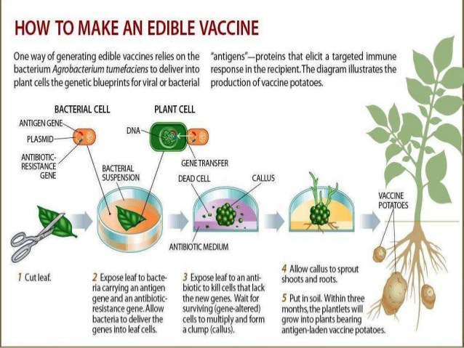

Edible vaccines are nothing but transgenic plant and animal based production of or those that contain agents that trigger an animal's immune response.
Now transgenic plants are being developed through genetic engineering techniques, where the vaccine is synthesised in the edible part of a food plant (edible vaccines). Transgenic bananas, melons, and tomatoes are choice candidates for carrying edible subunit vaccines, as for example against rabies. The obvious advantage is the ease of transportation and storage of the vaccine bearing material and administration without technical support. Conventional vaccination programmes in many countries are seriously handicapped due to a lack of equipment for storage and transport of the vaccines and the shortage of paramedical staff to administer the vaccines. This essay highlights the importance of edible vaccines produced in plants.
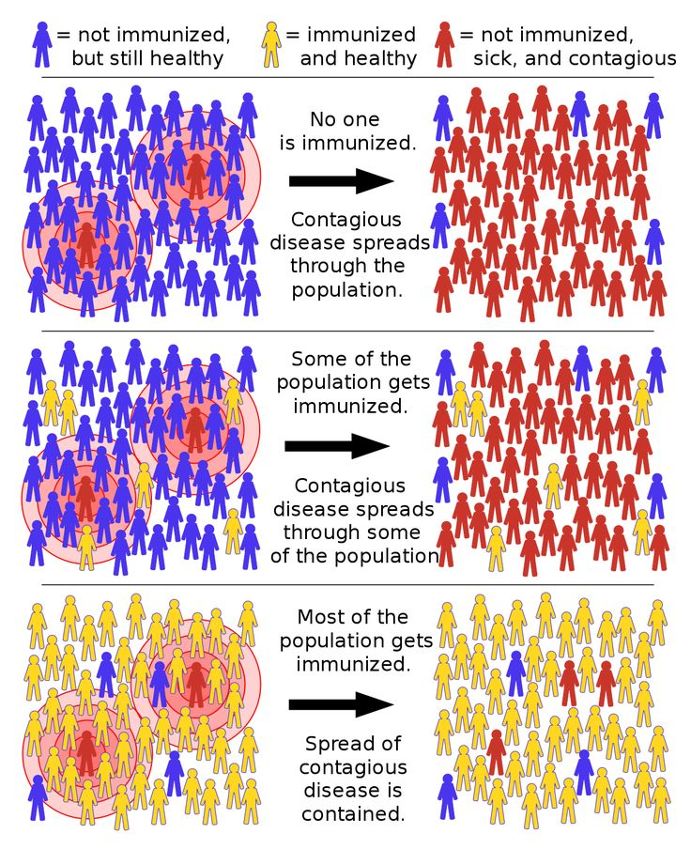
Herd immunity
Use of vaccines to prevent disease in communities is herd immunity, which affords protection by decreasing the number of susceptible people in a community, with time. This basically constitutes mass immunisation.
Booster doses
booster dose is an extra administration of a vaccine after an earlier (prime) dose. After initial immunization, a booster injection or booster dose is a re-exposure to the immunizing antigen. It is intended to increase immunity against that antigen back to protective levels, after memory against that antigen has declined through time. For example, tetanus shot boosters are often recommended every 10 years, after which memory cells specific against tetanus have lost their function or undergone apoptosis.
The effectiveness of certain vaccines is life long as for example of smallpox, measles, mumps and rubella. Attenuated vaccines normally afford life long immunity. But in the case of certain others, the effectiveness is short lived and the immune system needs to be re-educated through periodical booster doses. The vaccine is administered one or more times, with appropriate time gaps, after the initial vaccination, to boost to the immune system to produce adequate quantities of antibodies against the intended pathogen. Toxoid vaccines require a booster every ten years or so. Booster doses are also needed in case of inactivated or acellular vaccines, which are very safe, as they cannot cause the disease.
Multiple vaccines
most vaccines contain antigens of a single pathogen, there is a practice of multiple vaccines, which combine antigens of more than one pathogen. For example, diphtheria, tetanus and pertussis are administered together as DTP vaccination.
A monovalent vaccine contains a single strain of a single antigen (e.g. Measles vaccine), whereas a polyvalent vaccine contains two or more strains/serotypes of the same antigen (e.g. OPV oral polio vaccine).
Vaccine administration

The route of administration is the path by which a vaccine is brought into contact with the body. This is a critical factor for the success of the immunization. A substance must be transported from the site of entry to the part of the body where its action is desired to take place.
- Intramuscular (IM) injection administers the vaccine into the muscle mass. Vaccines containing adjuvants should be injected IM to reduce adverse local effects.
- Subcutaneous (SC) injection administers the vaccine into the subcutaneous layer above the muscle and below the skin.
- Intradermal (ID) injection administers the vaccine in the topmost layer of the skin. BCG is the only vaccine with this route of administration. Intradermal injection of BCG vaccine reduces the risk of neurovascular injury. Health workers say that BCG is the most difficult vaccine to administer due to the small size of newborns' arms. A short narrow needle (15 mm, 26 gauge) is needed for BCG vaccine. All other vaccines are given with a longer, wider needle (commonly 25 mm, 23 gauge), either SC or IM.
- Oral administration of the vaccine makes immunization easier.
- Intranasal spray application of a vaccine offers a needle-free approach through the nasal mucosa of the vaccine.

Vaccines are administered, as injections (DTP), or dermally (smallpox, anthrax), or orally (polio) or as a nasal spray (influenza virus).

