Lecture 4- Serology and Vaccination for Biotechnology 4th stage
Prf. Dr. Rajwa Hasen Essa
Prf.Dr. Alia Essam Mahmood
Immunogen: a substance that produces a humoral or cell-mediated immune response.
Antigens are any substance that binds specifically to an antibody or a T-cell receptor.
All immunogens are antigens, but all antigens may not be immunogens, some very small molecules called haptens can bind to antibodies or B-cell receptor but they cannot initiate an immune response.
Hapten is a molecule that reacts with a specific antibody but is not immunogenic by itself , it can be made immunogenic by conjugation to a suitable carrier. Many drugs like penicillins are haptens.
This type of serologic testing employs known antiserum (serum containing specific known antibodies). The preparation of known antibodies is prepared in one of two ways: in animals or by hybridoma cells.
1. Polyclonal antibodies; preparation of known antisera in animals, involves inoculating animals with specific known antigens such as a specific strain of a bacterium. After the animal's immune responses have had time to produce antibodies against that antigen, the animal is bled and the blood is allowed to clot. The resulting liquid portion of the blood is the serum and it will contain antibodies specific for the injected antigen.
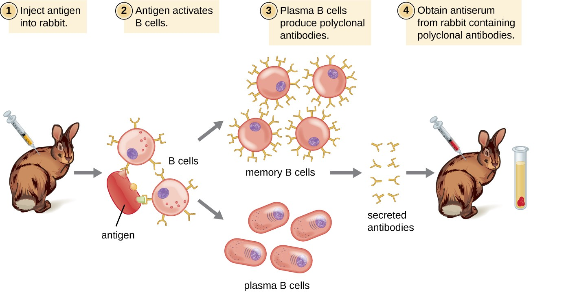
Because most antigens are complex structures with multiple epitopes, they result in the production of multiple antibodies in the lab animal. This so-called polyclonal antibody response is also typical of the response to infection by the human immune system. Antiserum drawn from an animal will thus contain antibodies from multiple clones of B cells, with each B cell responding to a specific epitope on the antigen.
Lab animals are usually injected at least twice with antigen when being used to produce antiserum. The second injection will activate memory cells that make class IgG antibodies against the antigen. The memory cells also undergo affinity maturation, resulting in a pool of antibodies with higher average affinity.
On re-exposure to the antigen, those B cells capable of producing an antibody with higher affinity antigen-binding sites will be stimulated to proliferate and produce more antibody than their lower-affinity peers. An adjuvant, which is a chemical that provokes a generalized activation of the immune system that stimulates greater antibody production, is often mixed with the antigen prior to injection.
Antiserum obtained from animals will not only contain antibodies against the antigen artificially introduced in the laboratory, but it will also contain antibodies to any other antigens to which the animal has been exposed during its lifetime. For this reason, antisera must first be “purified” to remove other antibodies before using the antibodies for research or diagnostic assays.
2. Monoclonal antibody technique, preparation of known antibodies
Monoclonal antibodies (mAb) are defined as the antibodies derived from a single clone of plasma cell; all having the same antigen specificity, produced against a single epitope of an antigen.
In this technique, an animal is injected with the specific antigen for the antibody required. After the appropriate time for antibody production, the animal's spleen is removed. The spleen is rich in plasma cells and each plasma cell produces only one specific type of antibody. However, plasma cells will not grow artificially in cell culture. Therefore, a plasma cell producing the required antibody is fused with a myeloma cell, a cancer cell from bone marrow which will grow rapidly in cell culture, to produce a hybridoma cell. The hybridoma cell has the characteristics of both parent cells. It will produce specific antibodies like the plasma cell and will also grow readily in cell culture like the myeloma cell. The hybridoma cells are grown artificially in huge vats where they produce large quantities of the specific antibody (Myeloma tumour cells used for hybridoma production are deficient in the enzyme hypoxanthine phosphoribosyltransferase. This defect leads to their inability to survive in a medium containing hypoxanthine, aminopterin, and thymidine (HAT medium). Antibody-producing spleen cells, however, contain the enzyme. Thus, fused hybridoma cells survive in the selective medium and can be recognized by their ability to grow indefinitely in the medium. Unfused antibody-producing lymphoid cells die after several multiplications in vitro because they are not immortal, and unfused myeloma cells die in the presence of the toxic enzyme substrates. The only surviving cells are true hybrids.
However, when only one clone of B cell is stimulated by a single epitope of an antigen and then is allowed to proliferate and produce antibodies; such antibodies are referred to as monoclonal antibodies (mAb). Monoclonal antibodies are produced by Hybridoma technique, developed by G Kohler and C Milstein (1975), for which they were awarded Nobel Prize in 1984.
Monoclonal antibodies are now used routinely in medical research and diagnostic serology and are being used experimentally in treating certain cancers and a few other diseases.
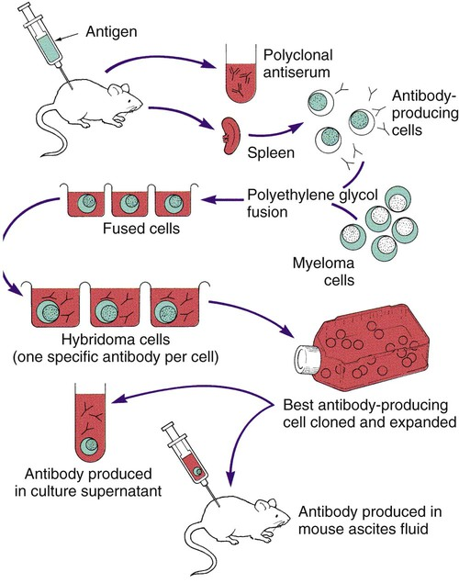
Monoclonal Antibodies | Polyclonal Antibodies
Expensive production | Inexpensive production
Long production time | Rapid production
Large quantities of specific antibodies | Large quantities of nonspecific antibodies
Recognize a single epitope on an antigen | Recognize multiple epitopes on an antigen
Production is continuous and uniform once the hybridoma is made | Different batches vary in composition

Human antibodies are classified into five isotypes (IgM, IgD, IgG, IgA, and IgE) according to their heavy chain (Mu, Delta, Gamma, Epsilon, or Alpha) which provide each isotype with distinct characteristics and roles.

Allotypes represent the genetically determined differences in antibodies between people. Allotypes are used for paternity testing.
Idiotypes are antibodies that recognize different specific epitopes. Through the end of the variable region; so it known as the set of genetic determinants of an individual; a set of antigen-binding sites which characterizes the antibodies produced by a particular clone of antibody-producing cells.
Nanobodies it’s a camelid (single-domain) antibodies, are composed of only heavy chains (no light chains). These antibodies are potential candidates to be used in antibody-based therapies because of some special characteristics, such as smaller size, good solubility, high thermostability, high affinity and specificity, low immunogenicity, and higher tissue penetration rate.
Paratope is a part of an antibody molecule composed of the variable regions of both the light and heavy chains that combine with the antigen.
Epitope ( antigenic determinant ) a site on the surface of an antigen molecule to which a single antibody molecule binds; generally an antigen has several or many different antigenic determinants and reacts with many different antibodies.
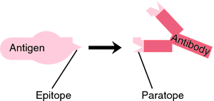
In a primary immune response, naive B cells are stimulated by antigen, become activated, and differentiate into antibody-secreting cells that produce antibodies specific for the eliciting antigen. A secondary immune response is elicited when the same antigen stimulates memory B cells, leading to the production of greater quantities of specific antibodies that are produced in the primary response.
S.N. | Characteristics | Primary Immune Response | Secondary Immune Response
1 | Definition | Primary Immune Response is the reaction of the immune system when it contacts an antigen for the first time. | Secondary Immune Response is the reaction of the immune system when it contacts an antigen for the second and subsequent times.
2 | Appearance | Appears mainly in the lymph nodes and spleen. | Appears mainly in the bone marrow and then, in the spleen and lymph nodes.
3 | Occurrence | This occurs in response to the primary contact of the antigen. | This occurs in response to the second and subsequent exposure to the same antigen.
4 | Antibody Peak | The antibody level reaches its peak in 7-10 days. | The antibody level reaches its peak in 3-5 days.
5 | Affinity of Antibody | Low affinity to their antigens. | High affinity to their antigens.
6 | Responding Cells | Naive B cells and T cells | Memory B cells
7 | Antibodies | Both thymus-dependent and thymus-independent antibodies are involved in the primary immune response. | Only thymus-dependent antibodies are involved in the secondary immune response.
8 | Lag Phase | Long (4-7 days) | Short (1-4 days)
9 | Types of Antibodies | A large amount of IgM and a small amount of IgG are produced during the primary immune response. | A large amount of IgG, a small amount of IgM, IgA, and IgE are produced during the secondary immune response.
10 | Amount of Antibody | Few antibodies are produced in the primary immune response. | 100-1000 times more antibodies are produced in the secondary immune response.
11 | Strength of the Response | The primary immune response is usually weaker than secondary immune response. | The secondary immune response is stronger.
12 | Antibody level | Antibody level declines to the point where it may be undetectable. | The antibody level tends to remain high for longer.
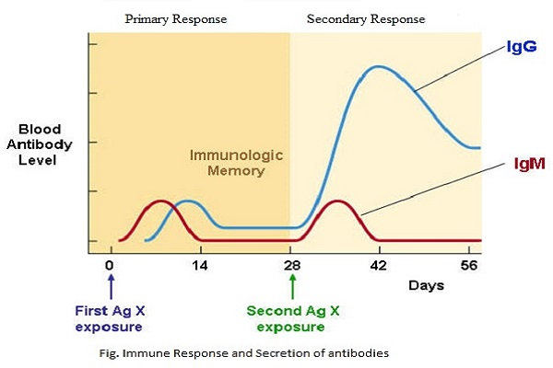
The first time the human body is exposed to some particular type of pathogen, the immune system responds in a specific way and this response is called the primary response. It consists of a relatively long latent phase during which our innate immunity is working but the adaptive immune system is still being mobilized. When our adaptive immunity is fully functional, plasma cells begin to produce antibodies and their concentration rises logarithmically. Eventually, as the pathogen is destroyed, the concentration of antibodies begins to drop and this is called the decline phase. During the primary response, memory cells that contain a copy of the antibody remain in our system. If we are ever reinfected with that same type of pathogen, our body will respond with a secondary immune response. This is a much quicker and more efficient response because our body now contains the memory cells with the antibodies that are specific to that reinvading antigen. The secondary response has a shorter latent phase and reaches a much higher peak antibody concentration. In addition, the dominant antibody produced during the secondary response is immunoglobulin G as compared to immunoglobulin M that is released during the primary phase.

