Lecture 1- Serology and Vaccination for Biotechnology 4th stage
Prf. Dr. Rajwa Hasen Essa
Prf.Dr. Alia Essam Mahmood

Serology is the scientific study of serum and other body fluids with regard to the response of the immune system to pathogens or introduced substances, study of the antigen-antibody reaction of diagnosis of infectious diseases, autoimmune disorders immune allergies and neoplastic diseases.
Serum defined as blood plasma without fibrinogens, which includes all proteins not used in blood clotting; all electrolytes, antibodies, antigens, hormones; and any exogenous substances (microorganisms), and does not contain any type of cells.
Plasma the liquid part of the blood and lymphatic fluid, which makes up about half of the volume of blood. Plasma is free of cells and, unlike serum, has not clotted, that consists of water and its dissolved constituents including especially proteins (such as albumin, fibrinogen, and globulins).
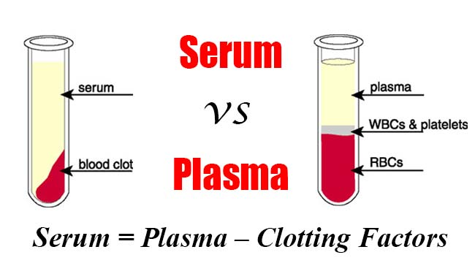
Immune Sera: a serum containing naturally or artificially produced antibodies to a given antigen either by immunization or infection, obtained from human or animal sources.
Antisera a blood serum containing antibodies against specific antigens injected to treat or protect against specific diseases, either in human or animal.
Immunization is the process whereby a person is made immune or resistant to an infectious disease, typically by the administration of a vaccine against subsequent infection or disease.
Vaccination is a treatment with a vaccine to produce immunity against disease; inoculation (this term is often used interchangeably with vaccination). Vaccine, suspension of weakened, killed, or fragmented microorganisms or toxins or of antibodies or lymphocytes that is administered primarily to prevent disease.
Difference between Vaccinations and immunizations
Vaccination is the term used for getting a vaccine. Immunisation refers to the process of both getting the vaccine and becoming immune to the disease following vaccination.
Antigen: a substance, usually a protein, that stimulates the immune system to produce a set of specific antibodies and that combines with the specific site of antigen.
Epitope: a part of a protein molecule that acts as an immunogenic/antigenic determinant, may contain many different epitopes each one capable of stimulating the production of specific antibodies, each one capable binding with a specific binding site.
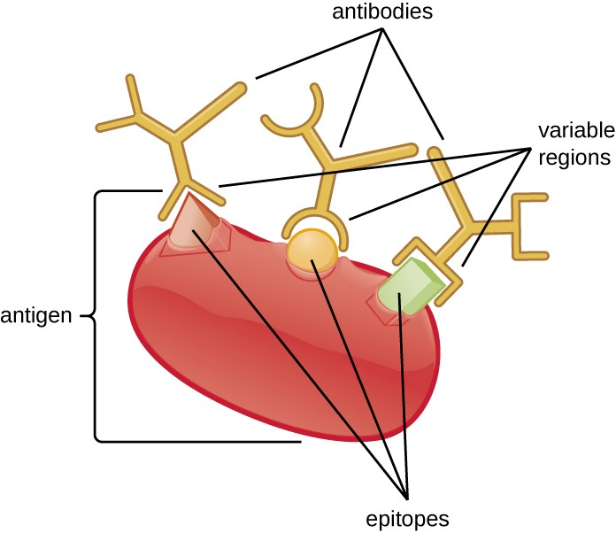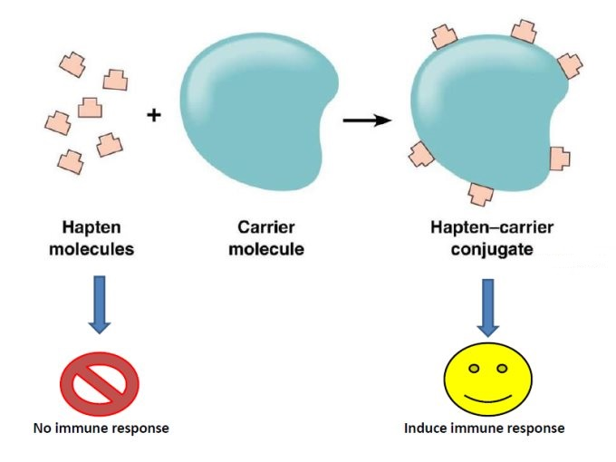
Immunogen: a substance usually a protein that produces an immune response.
Hapten: a low-molecular-weight non-protein molecule which contains an antigenic determinant but which is not itself antigenic unless it complexes with an antigenic carrier, to be antigenic, the hapten must bind to an exogenous protein carrier.
Antigen-antibody interaction, or antigen-antibody reaction, is a specific chemical interaction between antibodies and antigens during immune reaction, either in the body during immune response or during diagnosis, the antigens are specifically and with high affinity bound by antibodies to form an antigen-antibody complex, in blood and then transported to cellular systems where it can be destroyed or deactivated.
Immunoassay a procedure for detecting or measuring specific proteins or other substances through their properties as antigens or antibodies, by measures the presence or concentration of a macromolecule or a small molecule in a solution through the use of an antibody (usually) or an antigen (sometimes).
Seroconversion: a change from a seronegative to a seropositive condition, to detect antibodies in the blood after a disease occurring or immunization.
Seroreversion spontaneous or induced conversion from a seropositive to a seronegative state.
Specificity of a clinical test refers to the ability of the test to correctly identify those patients without the disease. (No false positive results) (Also called the true negative rate).
Sensitivity of a clinical test refers to the ability of the test to correctly identify those patients with the disease. (No false negative results) (Also called the true positive rate).
Validity: (or accuracy), A serological test should provide an indication of which individuals actually have the disease and which do not.

