Lecture 2- Serology and Vaccination for Biotechnology 4th stage
Prf. Dr. Rajwa Hasen Essa
Prf.Dr. Alia Essam Mahmood
Dilution is the act of making a weaker solution from a stronger solution, by adding water or saline, dilution is usually expressed as one unit of the original solution to the total number of units of final solution. Since the dilution-fold is the same in each step, the dilutions are a geometric series (constant ratio between any adjacent dilutions). Serial dilution is decreasing the volume of serum progressively by maintaining a constant volume of fluid. Most commonly serial dilutions are two-fold or ten-fold range of dilutions, but finally the total volume in each tube is the same.
A general rule for calculating the concentration of solutions
M1V1=M2V2
A titer is a way of expressing concentration, through employs serial dilution to obtain approximate quantitative information. The titer corresponds to the highest dilution factor that still yields a positive reading.
Antibody titer is a measurement of how much antibody an organism has produced that recognizes a particular epitope, expressed as the inverse of the greatest dilution (in a serial dilution) that still gives a positive result.
The endpoint titer is defined as the reciprocal of the highest analyte dilution that gives a reading above the cutoff, or the point in a titration at which a reaction is complete, often marked by a colour change.
Cutoff defines as a level or limit at which something stops.
Cross-reactivity is the ability of an antigen to bind with an antibody that was raised to a different antigen. It may arise by one of two mechanisms: shared epitopes on multivalent antigens, or conformational similarity of epitopes.
Serology-Techniques
Serology refers to using antigen-antibody reactions in the laboratory for diagnostic purposes. Its name comes from the fact that serum, the liquid portion of the blood where antibodies are found is used in testing. Serologic testing may be used in the clinical laboratory in two distinct ways:
a. To identify unknown antigens (such as microorganisms). This is called direct serologic testing. Direct serologic testing uses a preparation known antibodies, called antiserum, to identify an unknown antigen such as a microorganism.
b. To detect antibodies being made against a specific antigen in the patient's serum. This is called indirect serologic testing. Indirect serologic testing is the procedure by which antibodies in a person's serum is made by that individual against an antigen associated with a particular disease are detected using a known antigen.
Antigen-antibody reactions may be detected in the laboratory by a variety of techniques. Some of the commonly used techniques for observing in vitro antigen-antibody reactions are briefly described below.
1- A precipitation reaction is based on the principle of “Antigen-Antibody Reaction”, which occurs at the zone of equivalence. At the region of equivalence, the ratio or concentration of both antigen and antibody are equal which bring out the formation of “Immunocomplex” or lattice or cross-linked structure at the zone of equivalence where the concentration of both are equal, both antigen and antibody diffuse either in one dimension or two dimensions in liquid or semi-solid media, which results in the formation of the antigen-antibody complex as a visible ring or line of a precipitate.
Precipitin is the antibodies which react with their respective antigens to form a “Precipitate”, the free antigens and antibodies will remain as the “Supernatant”. For the precipitation reaction, polyclonal or multivalent antibodies and antigens are used because if it is not so, the formation of the lattice will not occur. For the appearance of a precipitin ring or band, the reaction may take a few hours to days.
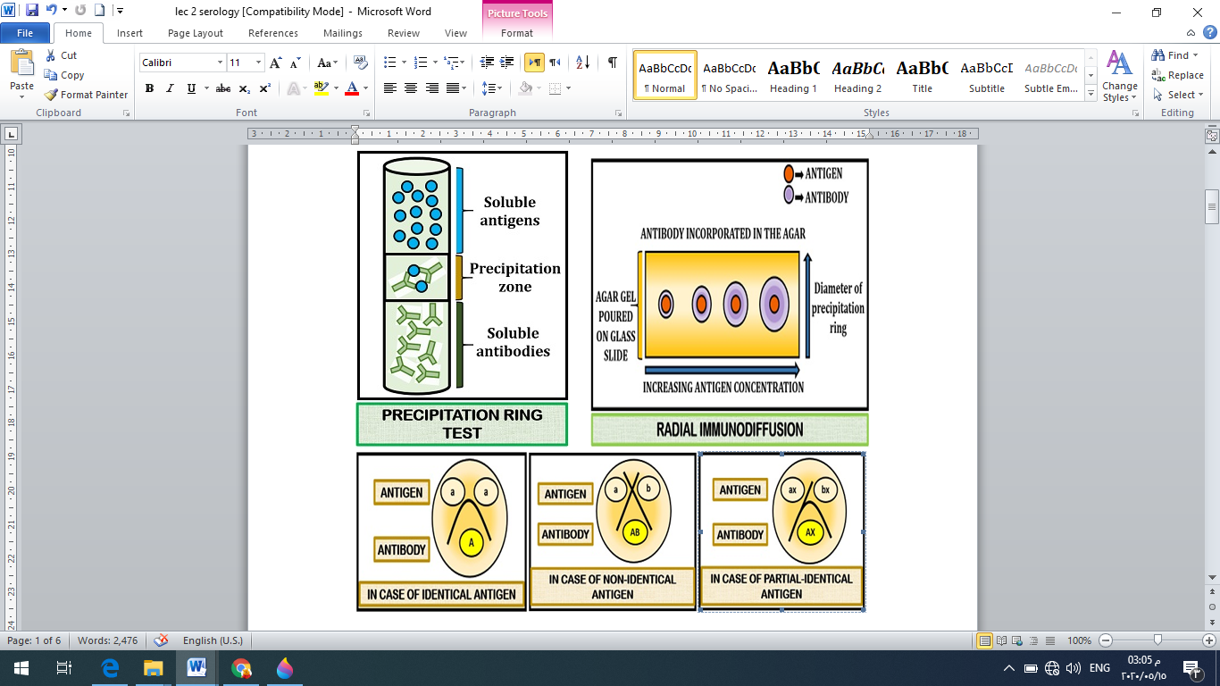

2- Agglutination
The reaction between a particulate antigen as bacteria, RBC, latex particles and an antibody results in visible clumping called agglutination. Antibodies that produce such reactions are known as agglutinins. The principle of agglutination reactions is similar to precipitation reactions; they depend on the cross-linking of polyvalent antigens.
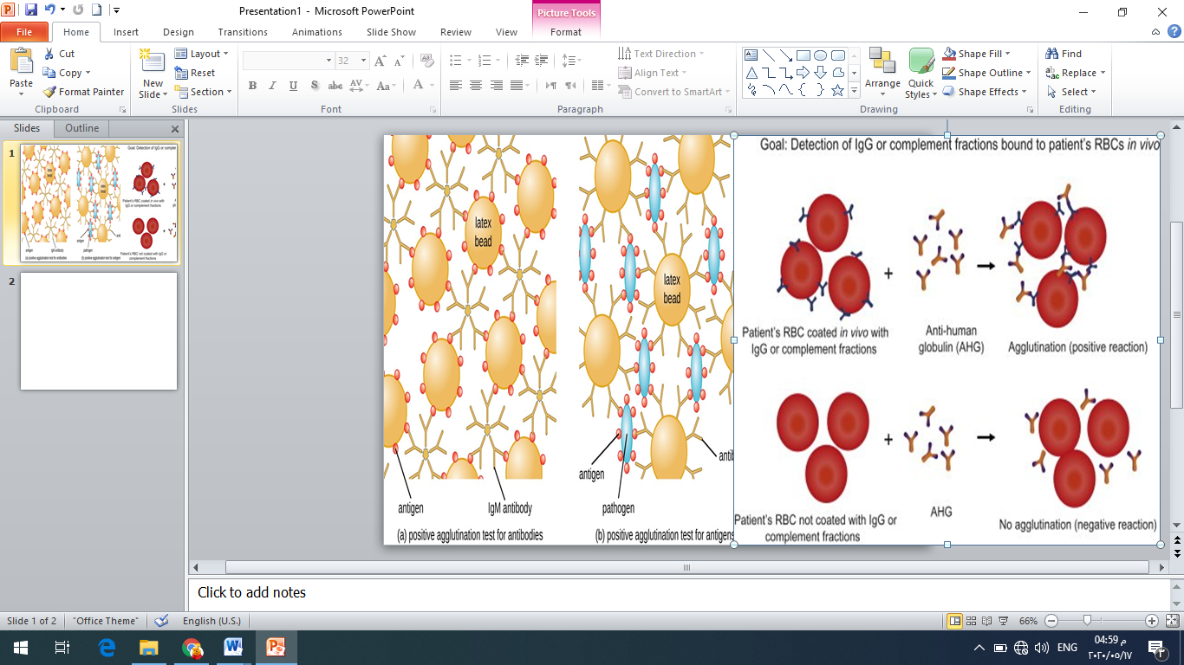
There is no agglutination can be observed when the concentration of the antibody is high, (lower dilutions), and then the sample is diluted, agglutination occurs. Prozone effect is defined as the invisibility of agglutination at high concentrations of antibodies. It is due to the reason that excess antibody forms very minute complexes that do not clump to form visible agglutination.

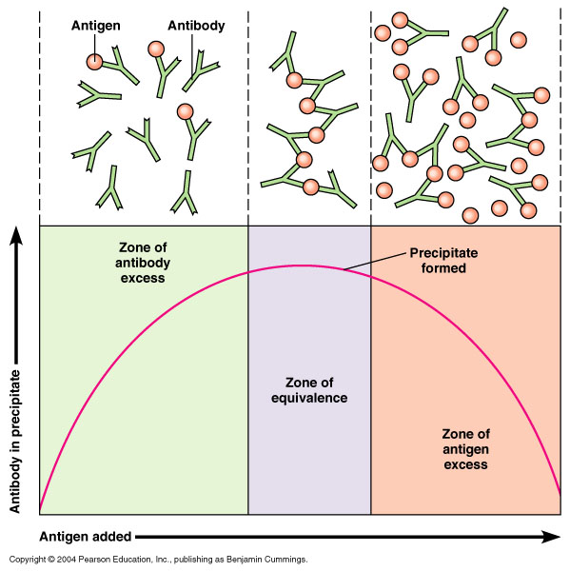
3- Complement fixation test is based on the principle that when antigen and
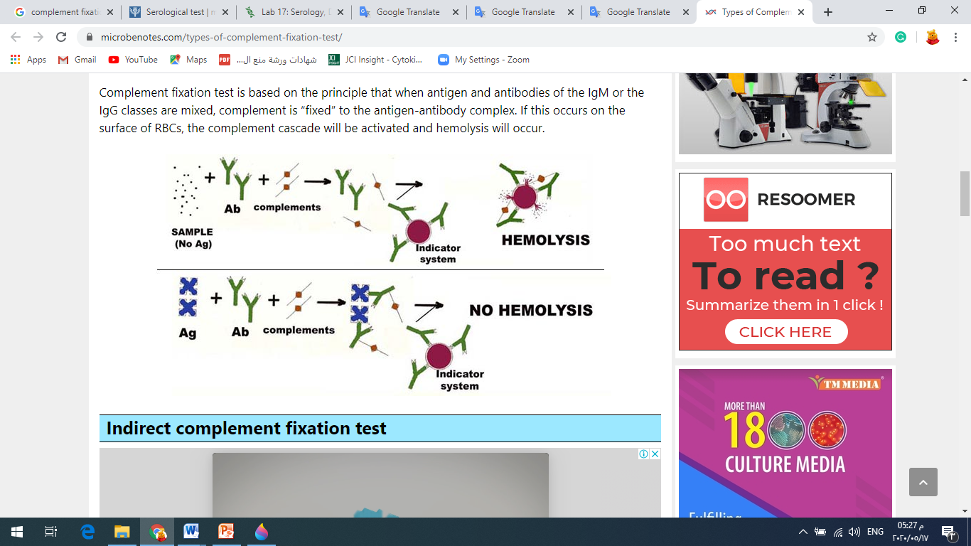
antibodies of the IgM or the IgG classes are mixed, complement is “fixed” to the antigen-antibody complex. If this occurs on the surface of RBCs, the complement cascade will be activated and hemolysis will occur.
4- Radioimmunoassay: A specific laboratory test (assay) that uses radiolabeled and unlabeled substances in an immunological (antibody-antigen) reaction, and it is a test procedure that integrates immunologic and radiolabeling techniques to measure minute quantities of a substance, as a protein, hormone, or drug, in a given sample of body fluid or tissue. Basically, radioimmunoassay is based on three principles which give it high sensitivity:
• A strong immune binding reaction: Antigen vs Antibody reaction
• The competitive binding reaction which gives specificity
• The radio emission gives the specificity
The major advantages of RIA, are higher sensitivity, easy signal detection, and well-established, rapid assays.
The major disadvantages are the health and safety risks posed by the use of radiation and the time and expense associated with maintaining a licensed radiation safety and disposal program. For this reason, RIA has been largely replaced in routine clinical laboratory practice by other serology techniques.
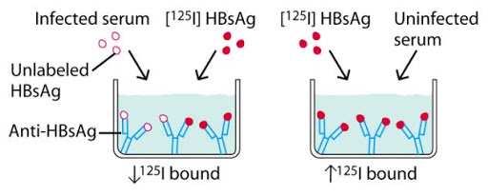
5- Fluorescent antibody technique
A fluorescent dye is chemically attached to the known antibodies. When the fluorescent antibody reacts with the antigen, the antigen will fluoresce when viewed with a fluorescent microscope.
