Lecture 3- Serology and Vaccination for Biotechnology 4th stage
Prf. Dr. Rajwa Hasen Essa
Prf.Dr. Alia Essam Mahmood
6- The enzyme-linked immunosorbent assay (ELISA) is an immunological assay commonly used to measure antibodies, antigens, proteins and glycoproteins in biological samples.
Principle of ELISA: Based on Enzyme conjugate substrates which bound to antibody (a detection antibody conjugated to biotin and streptavidin-conjugated horse radish peroxide that react with 3,3′,5,5′-Tetramethylbenzidine or TMB is a chromogenic substrate used in staining procedures in immunohistochemistry and ELISA ) that binds with the antibody-antigen complex, and later react with a substrate to provide a color change, allowing for the quantification of the analytic. The intensity of the colour that develops is therefore proportional to the amount of enzyme-linked antiglobulin that is bound, which in turn is proportional to the amount of antibody present in the serum under test. The colour intensity estimated by spectrophotometry.

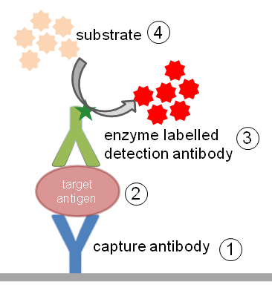
There are two main variations on the ELISA method is
◉ ELISA can be used to detect the presence of antigens that are recognized by an antibody or
◉ It can be used to test for antibodies that recognize an antigen.
Types of ELISA Assays
There are 4 main types of ELISA assays, Depending on the antigen-antibody combination, the assay is called a direct ELISA, indirect ELISA, sandwich ELISA, competitive ELISA etc.
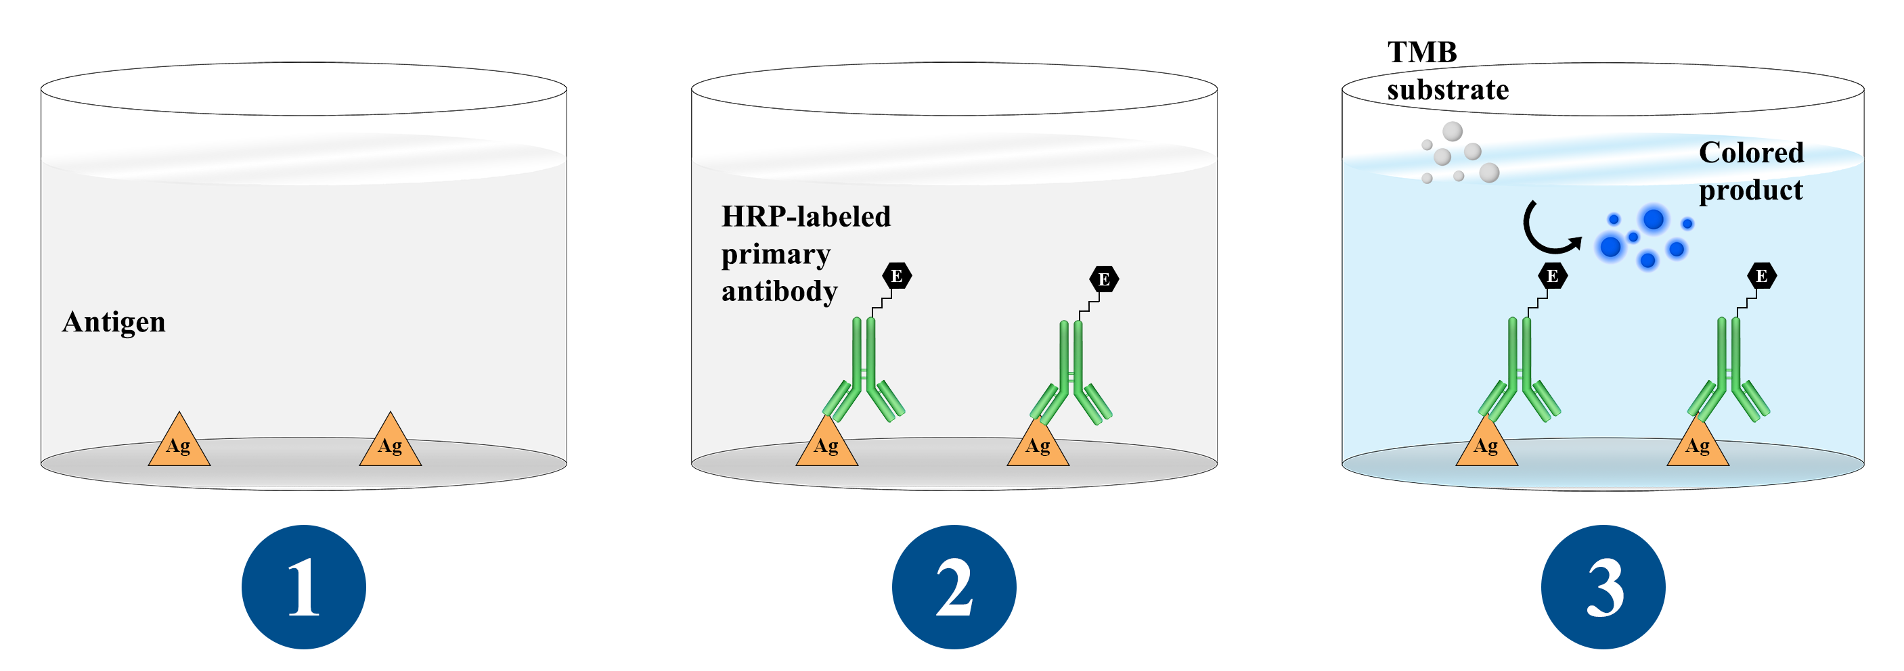
- Direct ELISA assay,
The antigen is detected by an antibody directly conjugated to an enzyme such as HRP (horseradish peroxidase).

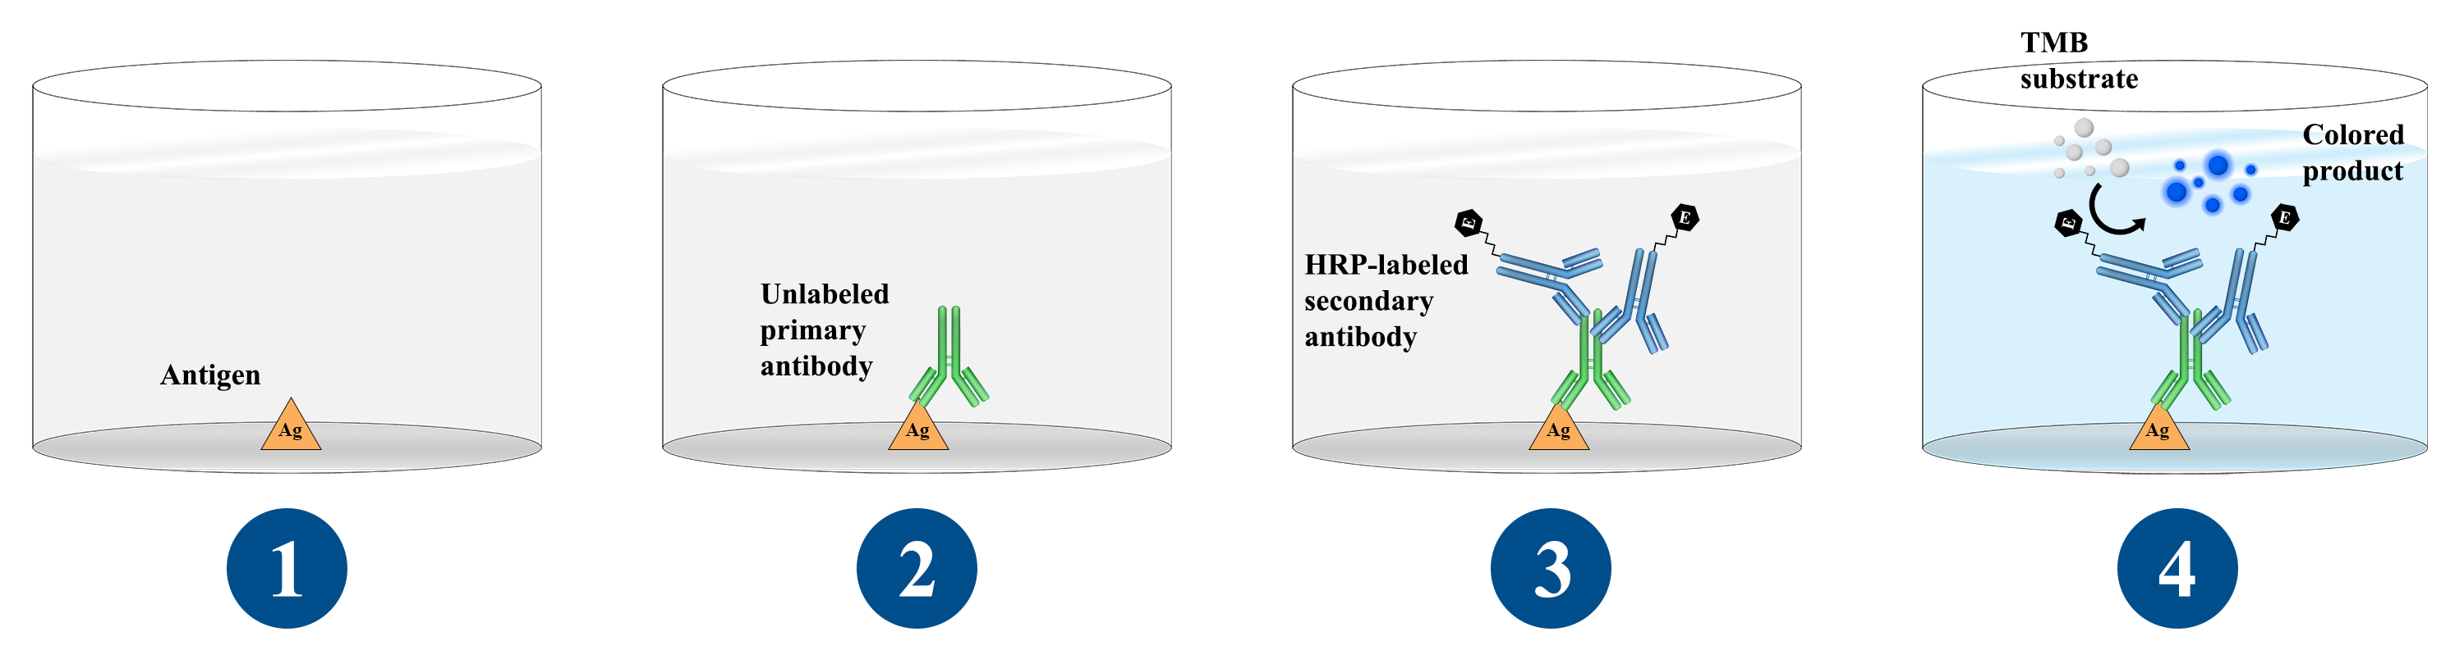

- Indirect ELISA assay,
The antigen of choice is bound to the experimental surface, and an unlabeled primary antibody specific for it is added and binds to the antigen. Subsequently, an enzyme-labelled secondary antibody is added and binds to the primary antibody.

- Sandwich ELISA assay 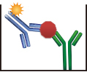
The sandwich ELISA quantifies antigens between two layers of antibodies (i.e. capture and detection antibody). The antigen to be measured must contain at least two antigenic epitopes capable of binding to the antibody, since at least two antibodies act in the sandwich. The Sandwich ELISA, the most popular assay choice for many research applications, is unique. Although it also uses two antibodies in conjugation with the target antigen like the Indirect ELISA, one of the antibodies will be used to coat the experimental surface first. After the microplate is thoroughly coated, the target antigen is added to the sample wells and binds to the first antibody. The second antibody is then added to the microplate and binds to the target antigen as well, effectively ‘sandwiching’ the target protein between the two antibodies. This test is highly specific, highly sensitive, and has the advantage of not requiring any form of sample purification.
- Competitive ELISA assay, 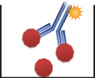
The sample antigen competes with a reference antigen ( pre-coated on a multi-well plate) for binding to a specific amount of labelled antibody. The sample is pre-incubated with the labelled antibody and added to the wells. Depending on the amount of antigen in the sample, more or less free antibodies will be available to bind the reference antigen. This means the more antigen there is in the sample, the less reference antigen will be detected and the weaker the signal, and an enzyme-labelled antibody specific to the test antibody (conjugate) are added together Chromogenic substrate is added, which in the presence of the enzyme, changes colour. The amount of colour that develops is inversely proportional to the amount of antibody in the test specimen.
Determination of antigen concentration in a sample requires the production of a standard curve using antigens of a known concentration. The concentration of antigen in a sample can then be calculated using the optical density (OD).
7- Western blotting technique: In this technique, a mixture of proteins is separated based on molecular weight, and thus by type, through gel electrophoresis. The term “blotting” refers to the transfer of biological samples from a gel to a membrane and their subsequent detection on the surface of the membrane. The membrane is then incubated with labels antibodies specific to the protein of interest.
Southern blot is used for transferring DNA, Northern blot for RNA and Western blot for Protein. Western blotting (also called immunoblotting, because an antibody is used to specifically detect its antigen) was introduced by Towbin, et al. in 1979 and is now a routine technique for protein analysis.
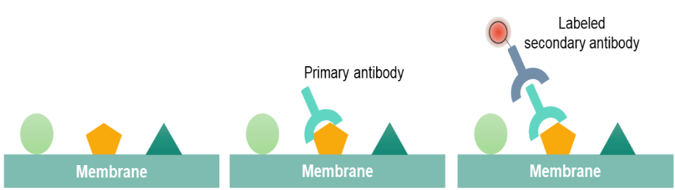
Western blotting (protein blotting or immunoblotting) is a rapid and sensitive assay for detection and characterization of proteins. It is based on the principle of immunochromatography where proteins are separated into polyacrylamide gel according to their molecular weight.
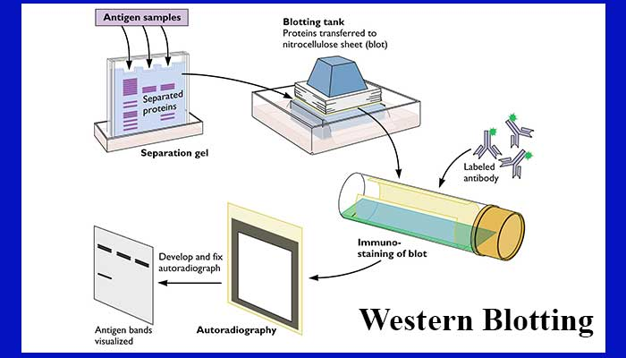
The proteins thus separated are then transferred or electro transferred onto nitrocellulose membrane and are detected using a specific primary antibody and secondary enzyme-labelled antibodies such as horseradish peroxidase (HRP) and substrate. The bound enzyme activity is used to detect the target protein and visualized by a chromogenic method.
The unbound antibody is washed off leaving only the bound antibody to the protein of interest. The bound antibodies are then detected by developing the film. The thickness of the band corresponds to the amount of protein present; thus doing a standard can indicate the amount of protein present.
Three groups of immunological techniques are used to detect and measure antigen-antibody reaction; these are:
- Primary binding tests
Primary binding tests are tests that directly measure the binding of antigen and antibody (i.e.; directly measure the immune complex). They are the most sensitive techniques in terms of the amount of detectable antigen or antibody. Examples ; Radioimmunoassays, Immunofluorescence Assays, Particle Concentration Fluorescence Immunoassays, Immunoenzyme Assays Enzyme-Linked Immunosorbent Assay Tests, Western Blotting, Immunohistochemistry.
- Secondary binding tests
Secondary binding tests are tests that detect and measure the consequences (secondary effect) of antigen-antibody interaction. Examples ; Precipitation Tests, Immunodiffusion, Immunoelectrophoresis.
- Tertiary binding tests
Tertiary binding tests measure the consequences of immune responses in vivo. These tests are much more complex than primary and secondary tests, but their results reflect the practical significance of the immune response. E.g. measurement of the protective effects of the antibody.
Examples Agglutination, Complement Fixation, Cytotoxicity Tests, and Assays in Living Systems, such as Neutralization Tests, Protection Tests, and Molecular Methods.

