Nematodes
Roundworms (nematodes) – the adult forms of these worms can reside in the gastrointestinal tract, blood, lymphatic system or subcutaneous tissues. Alternatively, the immature (larval) states can cause disease through their infection of various body tissues.
They cause diseases such as Ascariasis, Trichuriasis, Hookworm, Enterobiasis, Filariasis, and Angiostrongyliasis in humans.
They are characterized and categorized in the following ways.
Characteristics of Nematoda
Following are the important characteristics of Nematoda:
- Not segmented
- Their body is bilaterally symmetrical and triploblastic and their body has a cavity or pseudocoelom.
- They are cylindrical in shape.
- The alimentary canal is distinct, with the mouth and the anus.
- They are sexually dimorphic. Sex separate.
- They are don't have the circulatory system and respiratory system.
- They are free-living or parasitic.
- Parasitic nematodes cause diseases in the host.
- Fertilization is internal and reproduction is sexual.
- Their cuticle moults periodically.
- The epidermis is syntactical and contains dorsal or ventral nerve cords.
- The body-wall muscles are longitudinal.
- They consist of chemosensory organs called aphids situated on the lips.
- Femal are either viviparous(produce larvae/ embryos) , or oviparous (lay eggs) or ovo-viviparous (lay eggs which hatch immediately).
Modes of transmission
- Ingestion of Embryonated eggs of contaminated food and drinks like Enterbius vermicularis (pin worm), Trichuris trichiura (whip worm), Ascaris lumbricoides (round worm)
- Penetration of skin; filariform larvae bores the skin like; Ancylostoma duodenal (hook worm)
- By blood suking insects like filarial worms
- Iiinhalation of infect dust containing embryonated eggs like Enterbius vermicularis (pin worm), Ascaris lumbricoides (round worm
- Intestinal nematode
- Small intestinal only
- Ascaris lumbricoides (round worm)
- Ancylostoma duodenal (hook worm)
- Trichinella spiralis ( trichina worm)
- Caecum and vermiform appendix
- Enterbius vermicularis (pin worm)
- Trichuris trichiura (whip worm)
- Tissue nematode
- Wuchereria bancrofti
- Loa loa

Small intestinal only
Ascaris lumbricoides (Large intestinal roundworm) disease: ascariasis .
Morphology :
Adult:
- separate sexes , MALE nematodes are generally smaller in size than female.
- cylindrical in shape, creamy-white or pinkish in color.
- The female averages 20-35cm in length, the largest 49cm.
- The male is smaller, averaging 15-31cm in length and distinctly more slender than the female.
- The typical curled tail with a pair sickle like copulatory spines. On the tip of the head there are three lips, arranged as a Chinese word
Eggs The egg is ovoidal, 75x60 microns, covered by albuminous mamillatins Development is similar in all nematodes. Consists of 4 larval (=juvenile) stages between the egg and adult. Each stage is separated by a molt of the cuticle. M1 M2 M3 M4 Egg → L1 → L2 → L3 → L4 → Adult
Direct life cycle with migration , the host is human. Ingested eggs hatch in the duodenum. The larvae penetrate the intestinal wall and circulate in the blood. From the heart they migrate to the lungs, ascend to the trachea, descend to the esophagus and finally reach the small intestine to become adult. The female pass immature eggs which pass to the soil and mature in 2 weeks. infective stage :embryonated eggs , diagnostic stage : eggs or adult
Pathogenecity and clinical features: Adult worms in the intestine cause abdominal pain and may cause intestinal obstruction especially in children. Larvae in the lungs may cause inflammation of the lungs (Loeffler’s syndrome) – pneumonialike symptoms.
Diagnosis 1. Examination of stool for eggs by direct saline smear method. 2. Demonstration of adult worms

mature in 2 weeks. 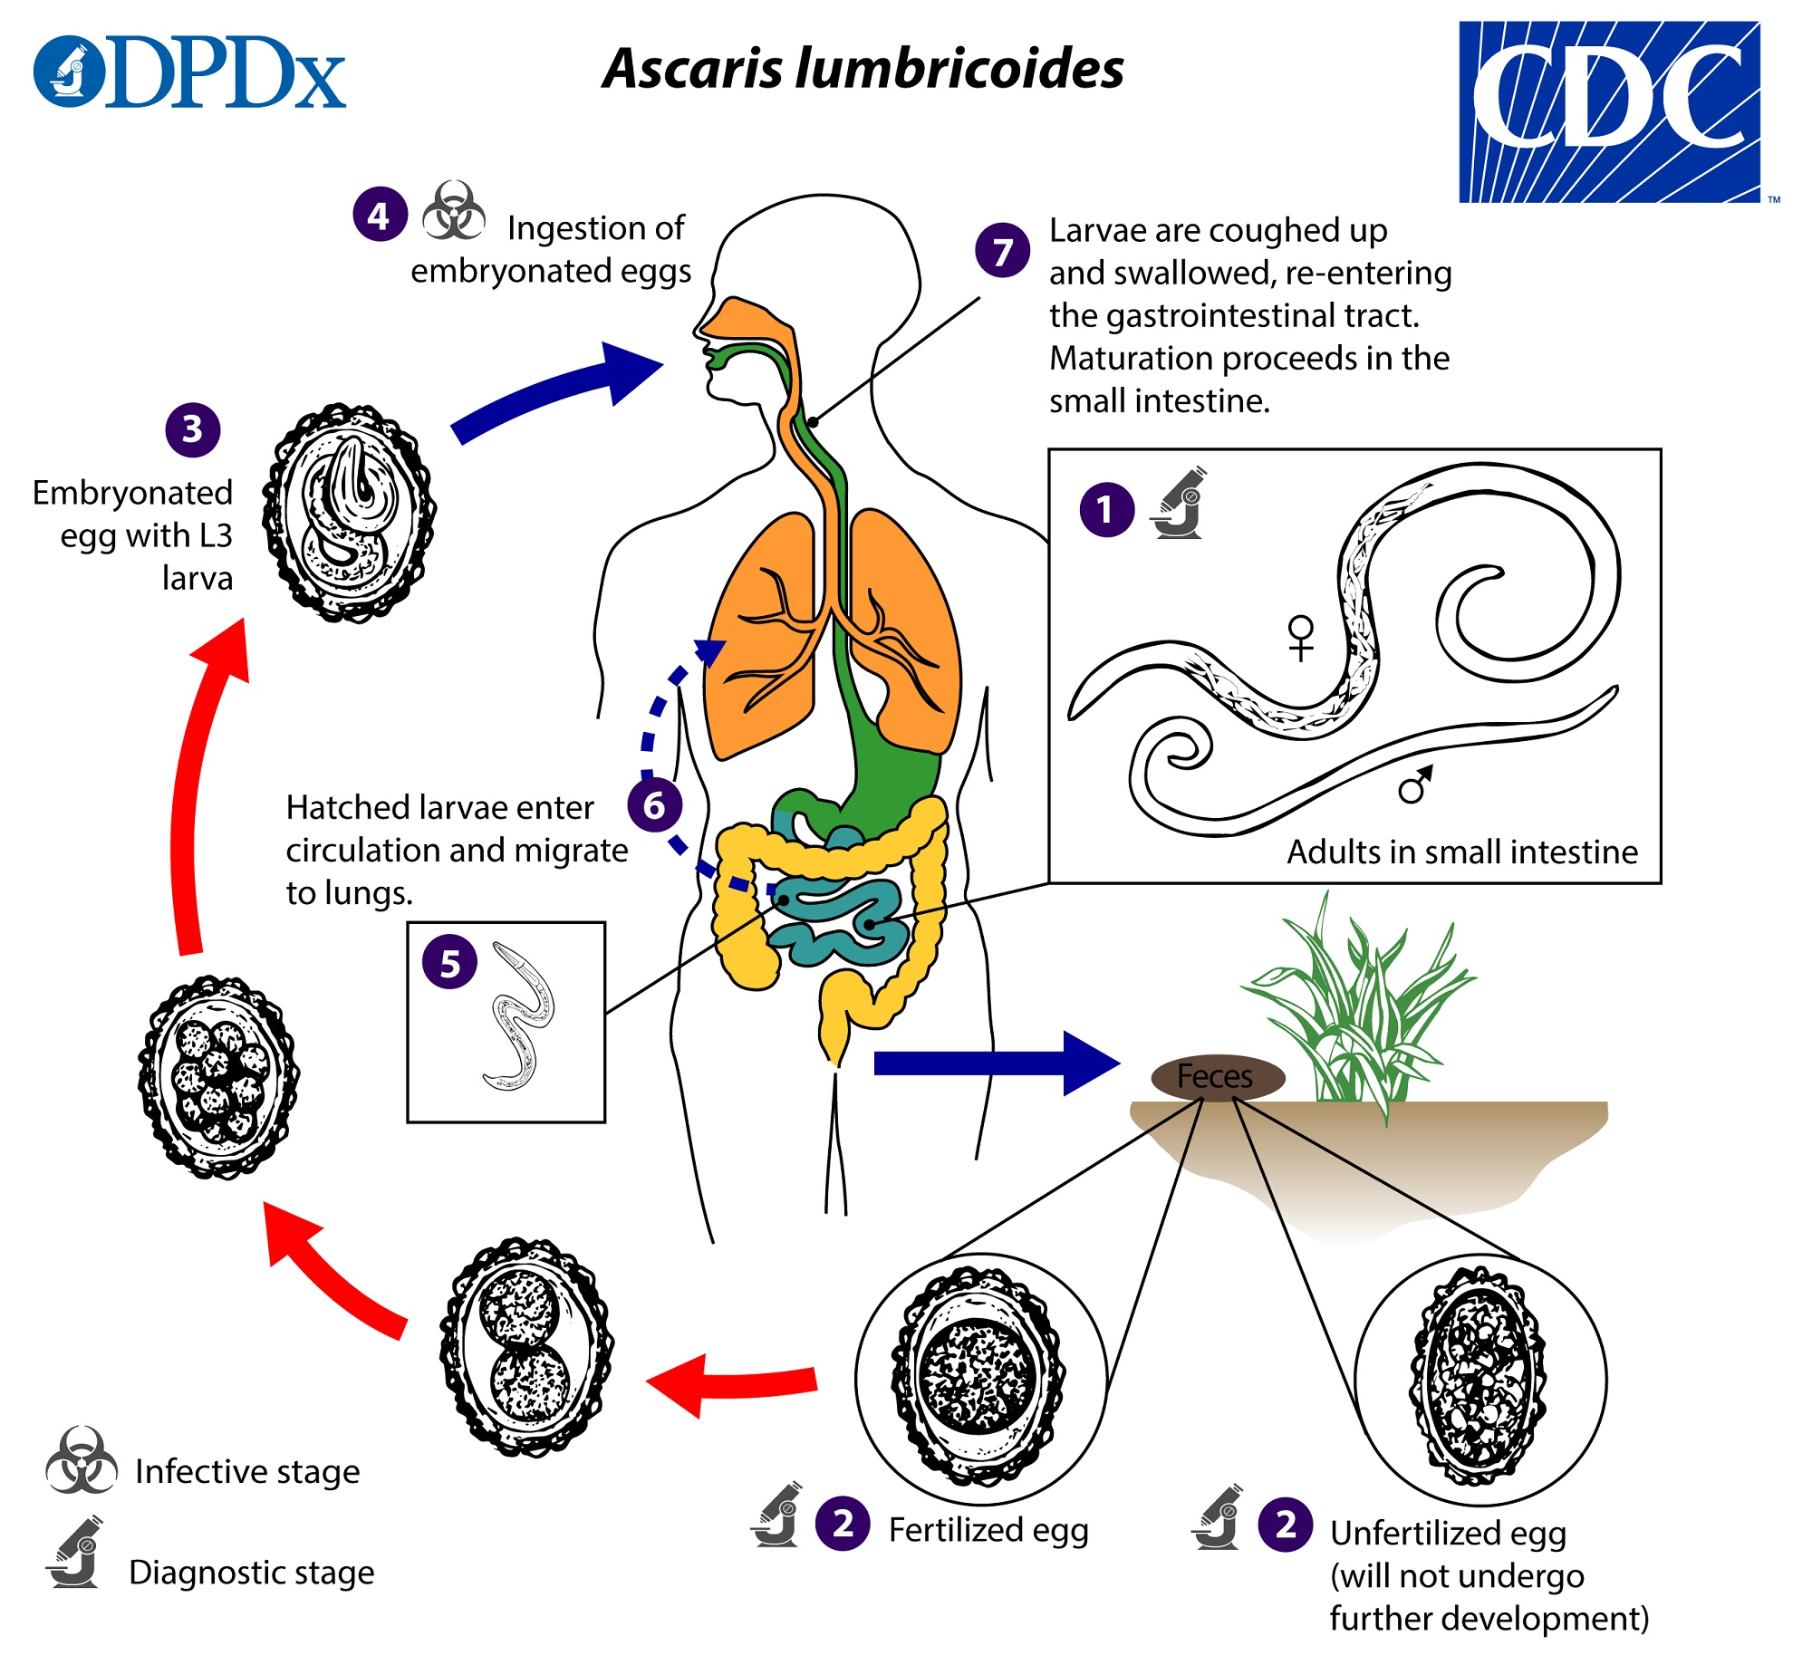
Necator americanes and Ancyclostoma duodenale (Hookworms)
- They look like an odd piece thread and are about 1cm. They are white or light pinkish when living. Female is slightly larger than male. The male’s posterior end is expanded to form a copulatory bursa.
- Head is slightly bend (hook) and the ‘mouth’ carries characteristic teeth.
- The posterior end of the male worm is elaborated into a copulatory bursa.
- 4. Eggs: 60×40 μm in size, oval in shape, shell is thin and colorless. Content is 2-8cells. host: human.
- Infective Stage: filariform larva.
- diagnostic stage : eggs.
Infective Route: by skin. Blood-lung migration: skin, cavum, right heart, lungs
Life cycle Adult male and female worms live in the small intestine. The female lays eggs (oval, 60x40 microns), which contain immature embryo in the 4 cell stage. When the eggs pass in the stool to the soil and under favorable conditions of temperature, moisture and oxygen, they hatch into larvae, which molt twice and become infective. When the filariform larvae penetrate the skin, they circulate in the blood, reach the lungs, ascend to the trachea, descend to esophagus to reach the small intestine and become adults. 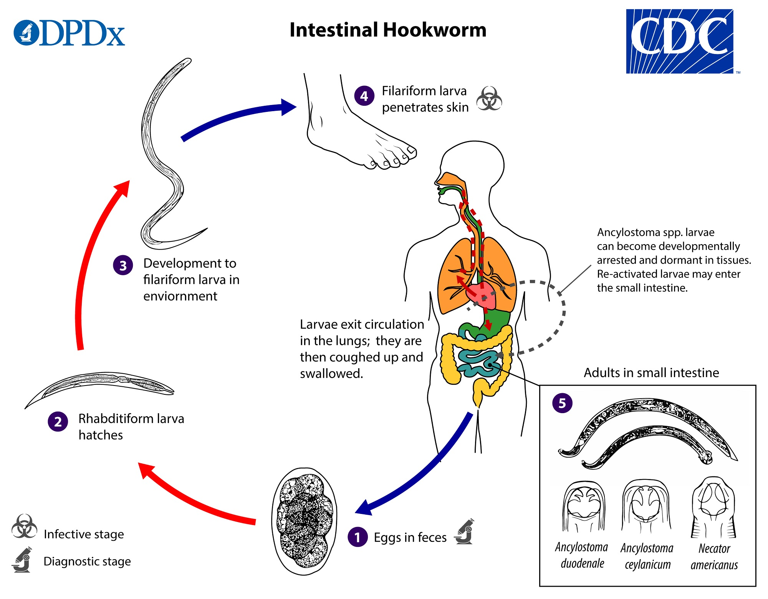
Pathogenecity
- commonly asymptomatic.
- (Adult worms) abdominal pain, nausea, and anorexia and in the intestine feed on blood causing iron deficiency anemia.
- (The larvae) may cause inflammation of the lungs.
- urticarial dermal reaction (“ground itch”) associated with filariform (L3) larvae penetration,
Diagnosis: Examination of stool by direct saline smear to detect the eggs.
Caecum and vermiform appendix
Intestinal nematodes without tissue stage
Enterobius vermicular (PIN WORM OR THREAD WORM)
is is a small white worm with thread-like appearance. The worm causes enterobiasis. Infection is common in children.
Morphology
- Male: The male measures 5 mm in length. The posterior end is curved and carries a single copulatory spicule.
- Female: The female measures 13 mm in length. The posterior end is straight. Infective stage : embryonated eggs Mode of infection :
- By direct infection from a patient (Fecal-oral route).
- Autoinfection: the eggs are infective as soon as they are passed by the female worm. If the hands of the patient get contaminated with these eggs, he/she will infect him/herself again and again.
- Aerosol inhalation from contaminated sheets and dust.
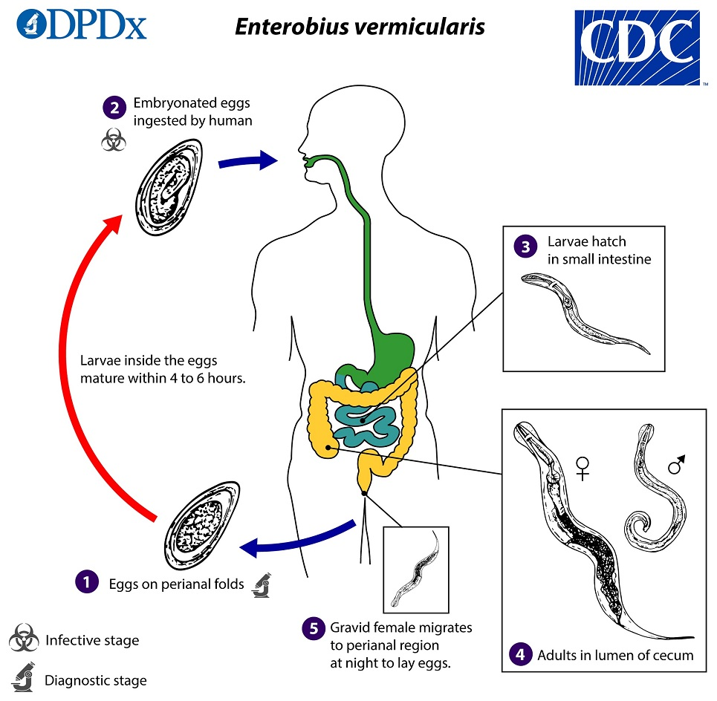

Life cycle Adult worm lives in the large intestine. After fertilization, the male dies and the female moves out through the anus to glue its eggs on the perianal skin. This takes place by night. The egg is 50x25 microns, planoconvex and contains larva. When the eggs are swallowed, they hatch in the small intestine and the larvae migrate to the large intestine to become adult.
Man-to-man and auto infection are common. Man is the only host.
Pathogenicity and Clinical presentation
- The migration of the worms causes allergic reactions around the anus.
- During night it causes nocturnal itching (pruritus ani) and enuresis. The worms may obstruct the appendix causing appendicitis.
Diagnosis
- Eggs in stool: Examination of the stool by direct saline smear to detect the egg: this is positive in about 5% of cases because the eggs are glued to the peri-anal skin.
- Peri-anal swab: The peri-anal region is swabbed with a piece of adhesive tape (cellotape) hold over a tongue depressor. The adhesive tape is placed on a glass slide and examined for eggs. The swab should be done in the early morning before bathing and defecation.
Trichuris trichiura (Whip Worm )
The worm is divided into a thin whip-like anterior part measuring 3/5 of the worm and a thick fleshy posterior part of 2/5 the length.
Male: The male measures 3-4.5 cm in length. Its posterior end is coiled and possesses a single cubicle.
Female: The female measures 4-5 cm in length. Its posterior end is straight
Infective stage and mode of infection Infection is by ingestion of embryonated eggs (containing larvae) with contaminated raw vegetables.
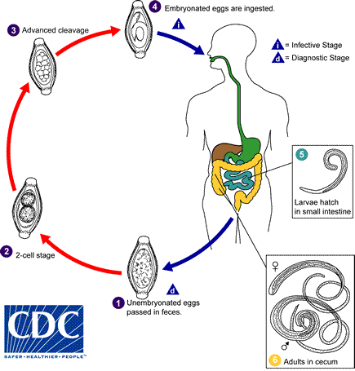
Life cycle: Ingested eggs hatch in the small intestine and the larvae migrate to the large intestine to become adult. After mating, the female lays immature eggs, which pass with the stool to the soil and mature in 2 weeks.
Symptoms 1- The patient complains of dysentery (blood and mucus in stool together with tenesmus). 2- (Rectal prolapse) المستقيم تدلي is also possible.
Diagnosis Stool examination : Finding of characteristic eggs. The egg of trichuris is barrel-shaped, the shell is thick with a one mucoid plug at each pole.
B-Tissue nematode
Extra intestinal nematodes Tissue nematodes
Wuchereria bancrofti
Humans are the only known reservoir host of W. bancrofti.
Infection rates in some communities in East Africa exceed 30% of adults causing revolting swellings of the legs or genital system, known as elephantiasis in man.
The adult worm occurs in tightly coiled nodular masses in the major lymphatic ducts.
The main vector is Culex a mosquito that is particularly common in towns and cities
Infective stage: larvae (microfilaria)
Diagnostic stage : microfilaria
Disease : elephantiasis
Vector: Culex mosquitoes
Morphology The adult worms are white and threadlike. The male measures between 2.5–4cm whereas the female is larger, measuring between 8- 10cm. The microfilariae are 230-275μm in length. The tail of the microfilariae of W. bancrofti tapers to a delicate point and exhibits no terminal nuclei. The sheath the microfilariae of W. bancrofti stains with hematoxylin stain.
Life Cycle Microfilariae enter the host during a blood meal when the vector, a mosquito, punctures the skin. The infective larvae enter through the wound and migrate to the peripheral lymphatics where they grow to mature male and female worms. They can live there for several years. After mating, the gravid females release sheathed microfilariae into the peripheral blood where they can be detected 8-12 months after the initial infected bite. The mosquito acquires the infection by ingestion of the microfilaria in the blood meal. The microfilariae lose their sheath on arrival in the stomach of the mosquito due to gastric juices. The larvae migrate to the thoracic muscles and develop into infective larvae over a period of 6-14 days. The larvae then migrate to the mouthparts of the mosquito which infects the host during a blood meal.

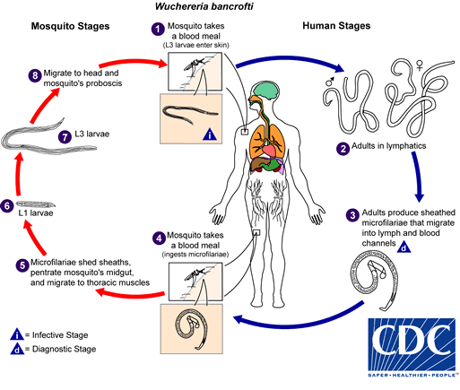

Pathogenecity and clinical features:
♦ The adult worm obstructs the flow of lymph in the lymph nodes and the lymphatic vessels draining the lower limbs and the external genitalia.
♦ The lower limbs and external genitalia become swollen. The skin becomes thick and fissured. The disease is called bancroftian elephantiasis.
♦ The major symptoms and findings include: lymphangitis, lymphedema, fever, headache, myalgia, hydrocele and chyluria.
Diagnosis
♦ Blood film examination after staining by Giemsa or Leishman stain to detect microfilaria. The film should be taken by night

