**Role of Bacteriophage in Bacterial physiology By:Dr.Neihaya Heikmat**

**Introduction**

A **bacteriophage** is a [virus](http://en.wikipedia.org/wiki/Virus) that infects and replicates within [bacteria](http://en.wikipedia.org/wiki/Bacteria). The term derived from 'bacteria' and the [Greek](http://en.wikipedia.org/wiki/Greek_language) *phagein* "to eat". Bacteriophages are composed of [proteins](http://en.wikipedia.org/wiki/Proteins) that [encapsulate](http://en.wikipedia.org/wiki/Capsid) [DNA](http://en.wikipedia.org/wiki/DNA) or [RNA](http://en.wikipedia.org/wiki/RNA) [genome](http://en.wikipedia.org/wiki/Genome), and may have relatively simple or elaborate structures. Phage replicates within bacteria following the injection of their genome into the [cytoplasm](http://en.wikipedia.org/wiki/Cytoplasm). Phages are widely distributed in locations populated by [bacterial](http://en.wikipedia.org/wiki/Bacteria) hosts, such as soil or the intestines of animals.

**History**

Since ancient times, reports of river waters having the ability to cure infectious diseases have documented, such as [leprosy](http://en.wikipedia.org/wiki/Leprosy). In 1896, [Ernest Hanbury Hankin](http://en.wikipedia.org/wiki/Ernest_Hanbury_Hankin) reported that something in the water of the [Ganges](http://en.wikipedia.org/wiki/Ganges) and [Yamuna](http://en.wikipedia.org/wiki/Yamuna) rivers in [India](http://en.wikipedia.org/wiki/India) had marked [antibacterial](http://en.wikipedia.org/wiki/Antibacterial) action against [cholera](http://en.wikipedia.org/wiki/Cholera) and could pass through a very fine porcelain filter. In 1915, [British](http://en.wikipedia.org/wiki/United_Kingdom) [bacteriologist](http://en.wikipedia.org/wiki/Bacteriologist) [Frederick Twort](http://en.wikipedia.org/wiki/Frederick_Twort), superintendent of the Brown Institution of London, discovered a small agent that infected and killed bacteria. D.Hérelle in 1922 called the virus a bacteriophage or bacteria-eater.

**Morphology:**

Most phages range in size from 24-200 nm in length. T4 is among the largest phages; it is approximately 200 nm long and 80-100 nm wide. All phages contain a head structure, which can vary in size and shape. Some are icosahedral (20 sides) others are filamentous. The head encloses nucleic acid and acts as the protective covering. Some phages have tails attached to the phage head. The tail is a hollow tube through which the nucleic acid passes during infection. T4 tail surrounded by contractile sheath, which contracts during infection of the bacterium. At the end of the tail, phages like T4 have a base plate and one or more tail fibers attached to it.

The base plate and tail fibers are involved in the binding of the phage to the bacterial cell. Not all phages have base plates and tail fibers.



**Bacteriophage classification.**

Based on two major criteria:

* phage morphology (by electron microscopy)
* nucleic acid properties

At present, over 5000 bacteriophages have studied by electron microscopy and can divide into 13 virus families.

**Replication**

Bacteriophages may have a [lytic cycle](http://en.wikipedia.org/wiki/Lytic_cycle) or a [lysogenic cycle](http://en.wikipedia.org/wiki/Lysogenic_cycle), and a few viruses are capable of carrying out both. With *lytic phages* such as the [T4 phage](http://en.wikipedia.org/wiki/T4_phage), bacterial cells are broken open (lysed) and destroyed after immediate replication of the virion. As soon as the cell destroyed, the phage progeny can find new hosts to infect. Lytic phages are more suitable for [phage therapy](http://en.wikipedia.org/wiki/Phage_therapy). Some lytic phages undergo a phenomenon known as lysis inhibition, where completed phage progeny will not immediately lyse out of the cell if extracellular phage concentrations are high. This mechanism is not identical to that of [temperate phage](http://en.wikipedia.org/wiki/Temperateness_(virology)) going dormant and is usually temporary.

In contrast, the [*lysogenic cycle*](http://en.wikipedia.org/wiki/Lysogenic_cycle) does not result in immediate lysing of the host cell. Those phages are able to undergo lysogeny known as [temperate phages](http://en.wikipedia.org/wiki/Temperate_phage). Their viral genome will integrate with host DNA and replicate along with it harmlessly, or may even become established as a [plasmid](http://en.wikipedia.org/wiki/Plasmid). The virus remains dormant until host conditions deteriorate, perhaps due to depletion of nutrients; then, the [endogenous](http://en.wikipedia.org/wiki/Endogenous) phages (known as [prophages](http://en.wikipedia.org/wiki/Prophage)) become active. At this point, they initiate the reproductive cycle, resulting in lysis of the host cell. As the lysogenic cycle allows the host cell to continue to survive and reproduce, the virus reproduced in all of the cell’s offspring. An example of a bacteriophage known to follow the lysogenic cycle and the lytic cycle is the phage lambda of *E. coli.*

Sometimes prophages may provide benefits to the host bacterium while they are dormant by adding new functions to the bacterial [genome](http://en.wikipedia.org/wiki/Genome) in a phenomenon called [lysogenic conversion](http://en.wikipedia.org/wiki/Lysogenic_conversion). Examples are the conversion of harmless strains of [*Corynebacterium diphtheriae*](http://en.wikipedia.org/wiki/Corynebacterium_diphtheriae) or [*Vibrio cholerae*](http://en.wikipedia.org/wiki/Vibrio_cholerae) by bacteriophages to a highly virulent ones, which cause [Diphtheria](http://en.wikipedia.org/wiki/Diphtheria) or [cholera](http://en.wikipedia.org/wiki/Cholera), respectively. Strategies to combat certain bacterial infections by targeting these toxin-encoding prophages proposed.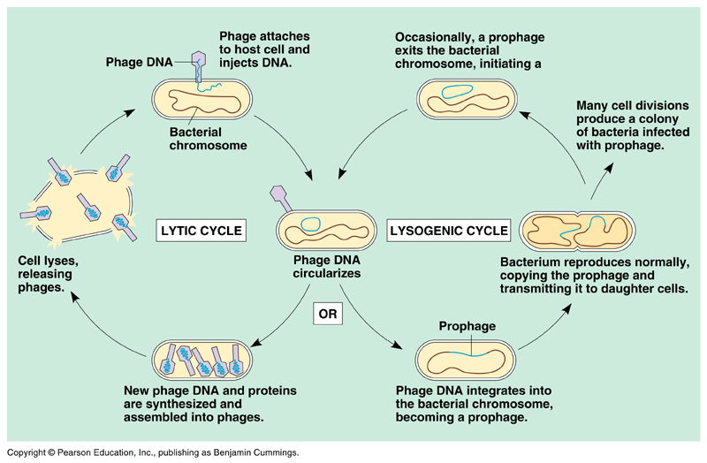

**Attachment and penetration**

[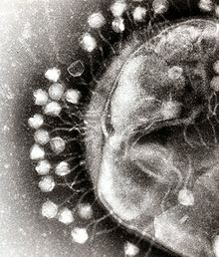](http://en.wikipedia.org/wiki/File:Phage.jpg)

To enter a host cell, bacteriophages attach to specific receptors on the surface of bacteria, including [lipopolysaccharides](http://en.wikipedia.org/wiki/Lipopolysaccharide), [teichoic acids](http://en.wikipedia.org/wiki/Teichoic_acid), [proteins](http://en.wikipedia.org/wiki/Protein), or even [flagella](http://en.wikipedia.org/wiki/Flagella). This specificity means a bacteriophage can infect only certain bacteria bearing receptors to which they can bind, which in turn determines the phage's host range. Host growth conditions also influence the ability of the phage to attach and invade them.

**Synthesis of proteins and nucleic acid**

Within minutes, bacterial [ribosomes](http://en.wikipedia.org/wiki/Ribosome) start translating viral mRNA into protein. For RNA-based phages, [RNA replicase](http://en.wikipedia.org/wiki/RNA_replicase) synthesized early in the process. Proteins modify the bacterial [RNA polymerase](http://en.wikipedia.org/wiki/RNA_polymerase) so it preferentially transcribes viral mRNA. The host’s normal synthesis of proteins and nucleic acids disrupted, and it forced to manufacture viral products, instead. These products go on to become part of new virions within the cell, helper proteins that help assemble the new virions, or proteins involved in cell [lysis](http://en.wikipedia.org/wiki/Lysis).

**Virion assembly**

In the case of the [T4 phage](http://en.wikipedia.org/wiki/T4_phage), the construction of new virus particles involves the assistance of helper proteins. The base plates assembled first, with the tails being built upon them afterwards. The head capsids, constructed separately, will spontaneously assemble with the tails. The DNA packed efficiently within the heads. The whole process takes about 15 minutes.

[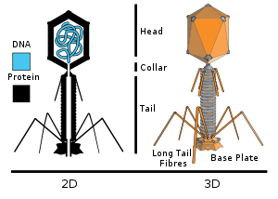](http://en.wikipedia.org/wiki/File:Tevenphage.svg)

**Diagram of a typical tailed bacteriophage structure**

**Release of virions**

Phages may release via cell lysis, by extrusion, or, in a few cases, by budding. Lysis, by tailed phages, achieved by an enzyme called [endolysin](http://en.wikipedia.org/wiki/Endolysin), which attacks and breaks down the cell wall [peptidoglycan](http://en.wikipedia.org/wiki/Peptidoglycan). An altogether different phage type, the filamentous phages, makes the host cell continually secrete new virus particles. Released virions are described as free, and, unless defective, are capable of infecting a new bacterium. In contrast to virion release, phages displaying a [lysogenic](http://en.wikipedia.org/wiki/Lysogenic) cycle do not kill the host but, rather, become long-term residents as [prophage](http://en.wikipedia.org/wiki/Prophage).

The lysogenic state of a bacterium can terminated anytime when it exposed to adverse conditions. This process called induction. Conditions that favor the termination of the lysogenic state include: desiccation, exposure to UV or ionizing radiation, exposure to mutagenic chemicals, etc.

**Application of phages**

* **Model system of molecular biology.**
* **Cloning and expression.**
* **Phage display system.**
* **Phage typing.**
* **Phage therapy:**

**-phage as natural, self-replicating, self-limiting antibiotics.**

**Bacteriophage:**

* Used for cloning foreign genes among other applications.
* Proteins and peptides are fused to the **Capsid**(surface) of the phage
* The combination of the phage and peptide is known as a **Fusion Protein**.
* Different sets of genes are inserted into the genomes of multiple phages.
* These separate phages will only display one protein, peptide, or antibody.
* Collections of these phages can comprise Libraries.
* These Libraries are exposed to selected targets and only some phages will interact with targets.

**Phage therapy**

Phages discovered to be antibacterial agents and used in Georgia and the United States during the 1920s and 1930s for treating bacterial infections. It has successfully used bacteriophages in administering [Phage therapy](http://en.wikipedia.org/wiki/Phage_therapy) to patients suffering from bacterial infections, including: [*Staphylococcus*](http://en.wikipedia.org/wiki/Staphylococcus)(including [MRSA](http://en.wikipedia.org/wiki/Methicillin-resistant_Staphylococcus_aureus)), [*Streptococcus*](http://en.wikipedia.org/wiki/Streptococcus)*,* [*Pseudomonas*](http://en.wikipedia.org/wiki/Pseudomonas)*,* [*Salmonella*](http://en.wikipedia.org/wiki/Salmonella), skin and soft tissue, gastrointestinal, respiratory, and orthopedic infections.

**In the environment**

Methods in phage community ecology have developed to assess phage-induced mortality of bacterioplankton and its role for food web process and [biogeochemical](http://en.wikipedia.org/wiki/Biogeochemical) cycle to genetically fingerprint phage communities or populations and estimate viral [biodiversity](http://en.wikipedia.org/wiki/Biodiversity) by metagenomics. The [lysis](http://en.wikipedia.org/wiki/Lysis) of bacteria by phages releases organic carbon, which makes the carbon more available to other organisms. Phages are not only the most abundant biological entities but also probably also the most diverse ones.

Bacteriophages have also used in [hydrological](http://en.wikipedia.org/wiki/Hydrology) tracing and modeling in [river](http://en.wikipedia.org/wiki/River) systems, especially where surface water and [groundwater](http://en.wikipedia.org/wiki/Groundwater) interactions occur. The use of phages is preferred to the more conventional [dye](http://en.wikipedia.org/wiki/Dye) marker because they are significantly less absorbed when passing through ground waters and them readily detected at very low concentrations.

**Other areas of use]**

Since 2006, the [United States Food and Drug Administration](http://en.wikipedia.org/wiki/United_States_Food_and_Drug_Administration) (FDA) and USDA have approved several bacteriophage products, as a food additive to target and kill [*Listeria monocytogenes*](http://en.wikipedia.org/wiki/Listeria_monocytogenes).

Other uses include spray application in horticulture for protecting plants and vegetable produce from decay and the spread of bacterial disease. Other applications for bacteriophages are as biocides for environmental surfaces, e.g., in hospitals, and as preventative treatments for catheters and medical devices prior to use in clinical settings. The technology for phages applied to dry surfaces, e.g., uniforms, curtains, or even sutures for surgery now exists.

**Examples of phages:**

􀂾 T-even phages such as T2, T4 and T6 that infect *E.coli*

􀂾 Temperate phages such as lambda and mu

􀂾 Spherical phages with single stranded DNA such as PhiX174

􀂾 Filamentous phages with single stranded DNA such as M13

   􀂾 RNA phages such as Qbeta

# Lambda phage

***Enterobacteria phage λ*** ([**lambda**](http://en.wikipedia.org/wiki/Lambda) **phage**, **coliphage λ**) is a bacterial virus, or [bacteriophage](http://en.wikipedia.org/wiki/Bacteriophage), that infects the bacterial species [*Escherichia coli*](http://en.wikipedia.org/wiki/Escherichia_coli). This virus is [temperate](http://en.wikipedia.org/wiki/Temperate_(virology)) and may reside within the [genome](http://en.wikipedia.org/wiki/Genome) of its host through [lysogeny](http://en.wikipedia.org/wiki/Lysogeny).

Lambda phage consists of a virus particle including a head (also known as a [capsid](http://en.wikipedia.org/wiki/Capsid)), a tail, and tail fibers. The head contains the phage's double-stranded circular [DNA](http://en.wikipedia.org/wiki/DNA) genome. The [phage](http://en.wikipedia.org/wiki/Phage) particle recognizes and binds to its host, [*E. coli*](http://en.wikipedia.org/wiki/Escherichia_coli), causing DNA in the head of the phage to eject through the tail into the cytoplasm of the bacterial Cell.

[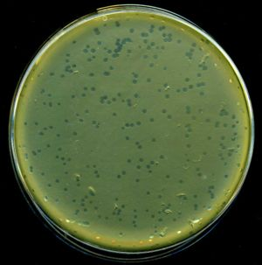](http://en.wikipedia.org/wiki/File:LambdaPlaques.jpg)

**Lysis plaques of lambda phage on** [***E. coli***](http://en.wikipedia.org/wiki/E._coli) **bacteria.**

Lambda phage has been used heavily as a [model organism](http://en.wikipedia.org/wiki/Model_organism), and has been a rich source for useful tools in [microbial genetics](http://en.wikipedia.org/wiki/Microbial_genetics), and later in [molecular genetics](http://en.wikipedia.org/wiki/Molecular_genetics). The [**genome**](http://en.wikipedia.org/wiki/Genome) contains 48,490 base pairs of double-stranded, linear DNA.

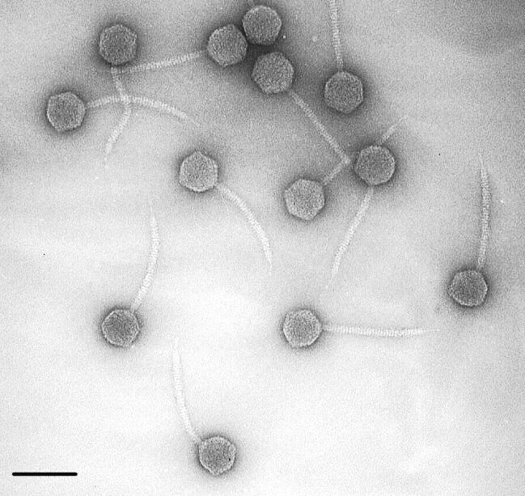

**Bacteriophage lambda**

**M13 bacteriophage**

**M13** is a [filamentous](http://en.wikipedia.org/wiki/Filamentous_phage) [bacteriophage](http://en.wikipedia.org/wiki/Bacteriophage) composed of circular single stranded DNA ([ssDNA](http://en.wikipedia.org/wiki/SsDNA)) which is 6407 [nucleotides](http://en.wikipedia.org/wiki/Nucleotides) long encapsulated [major coat protein](http://en.wikipedia.org/wiki/Phage_major_coat_protein). Infection with filamentous phages is not lethal; however, the infection causes turbid plaques in *E. coli*. It is a non-[lytic](http://en.wikipedia.org/wiki/Lytic) virus. However, a decrease in the rate of cell growth seen in the infected cells. M13 [plasmids](http://en.wikipedia.org/wiki/Plasmids) are used for many recombinant [DNA](http://en.wikipedia.org/wiki/DNA) processes, and the virus been studied for its uses in [nanostructures](http://en.wikipedia.org/wiki/Nanostructures) and [nanotechnology](http://en.wikipedia.org/wiki/Nanotechnology).

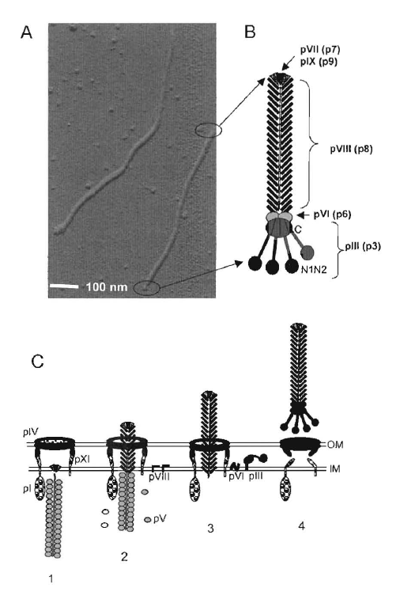

**Phi X 174**

The **phi X 174** (or **ΦX174**) [bacteriophage](http://en.wikipedia.org/wiki/Bacteriophage) was the first DNA-based [genome](http://en.wikipedia.org/wiki/Genome) to sequence. This work completed by [Fred Sanger](http://en.wikipedia.org/wiki/Fred_Sanger) and his team in 1977. The ΦX174 virus particle also successfully assembled *in vitro*. Recently, it was shown how its highly overlapping genome could be fully decompressed and remain functional. This [bacteriophage](http://en.wikipedia.org/wiki/Bacteriophage) has circular single-stranded [DNA](http://en.wikipedia.org/wiki/DNA) genome of 5386 [nucleotides](http://en.wikipedia.org/wiki/Nucleotide).

[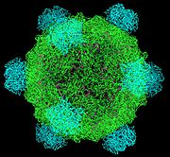](http://en.wikipedia.org/wiki/File:PhiX174.jpg)

**Structure of phage phi X 174 capsid**

**Enterobacteria phage T4**

A [bacteriophage](http://en.wikipedia.org/wiki/Bacteriophage) that infects [*Escherichia coli*](http://en.wikipedia.org/wiki/Escherichia_coli) [bacteria](http://en.wikipedia.org/wiki/Bacterium). The T4 phage is a member of the T-even phages, a group including the entero-bacteriophages [T2](http://en.wikipedia.org/wiki/Enterobacteria_phage_T2) and [T6](http://en.wikipedia.org/w/index.php?title=Enterobacteria_phage_T6&action=edit&redlink=1).

T4 is capable of undergoing only a [lytic lifecycle](http://en.wikipedia.org/wiki/Lytic) and not the [lysogenic lifecycle](http://en.wikipedia.org/wiki/Lysogeny).

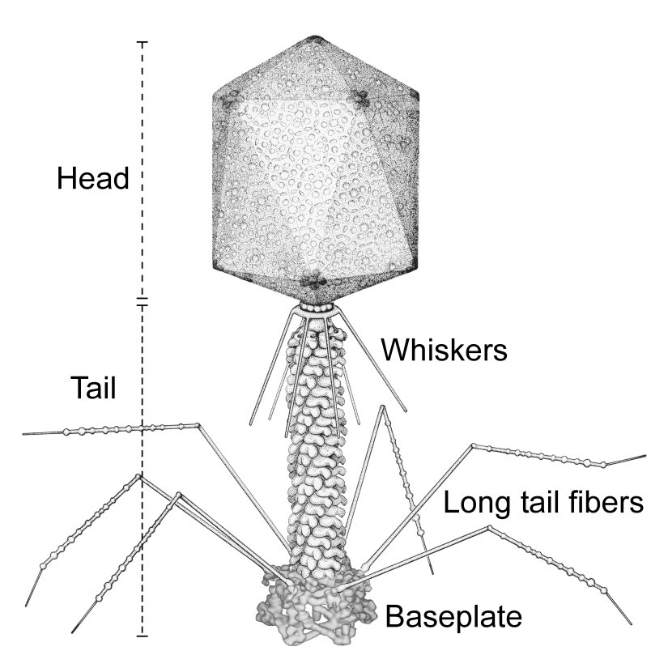

***Bacteriophage Qβ***

* is a single-stranded RNA bacteriophage which infects bacteria that have F-pili, most commonly [*Escherichia coli*](https://en.wikipedia.org/wiki/Escherichia_coli).
* Its linear genome is packaged into an [icosahedral](https://en.wikipedia.org/wiki/Icosahedral) [capsid](https://en.wikipedia.org/wiki/Capsid) with a diameter of 28 nm.
* Qβ enters its host cell after binding to the side of the [F-pilus](https://en.wikipedia.org/wiki/F_pilus).
* 