  - Hydrostatic Equilibrium

The atmosphere’s basic pressure structure is determined by the hydrostatic balance of forces. To a good approximation, every air parcel is acted on by three forces that are in balance, leading to no net force. Since they are in balance for any air parcel, the air can be assumed to be static or moving at a constant velocity

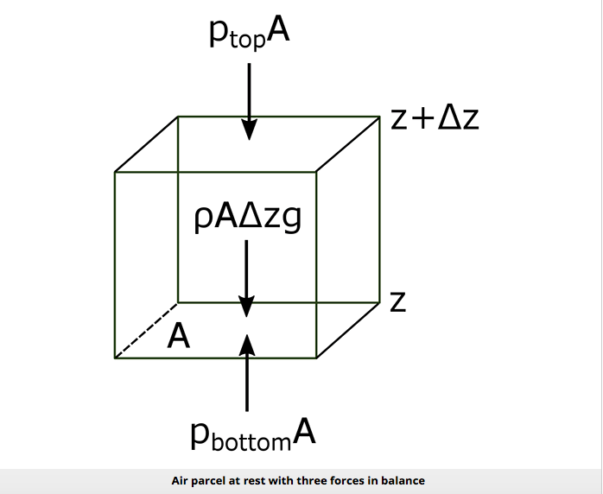

There are 3 forces that determine hydrostatic balance:
- One force is downwards (negative) onto the top of the cuboid from the pressure, p, of the fluid above it. It is, from the definition of pressure
$F_{top}=-P_{top}.A$ (1)
- Similarly, the force on the volume element from the pressure of the fluid below pushing upwards (positive) is:
$F_{bottom}=P_{bottom}.A$ (2)

- Finally, the weight of the volume element causes a force downwards. If the density is ρ, the volume is V, which is simply the horizontal area A times the vertical height, Δz, and g the standard gravity, then:
$$F_{gravity}=-mg$$
$$∴m=ρV$$
$$∴V=A∆z$$
so $F_{gravity}=-ρgA∆z$
$F_{gravity}=-ρVg=-ρgA∆z$ (3)

By balancing these forces, the total force on the fluid is:

$\sum{F}=F_{bottom}+F_{top}+F_{gravity}=P_{bottom}.A-P_{top}.A-ρgA∆z$ (4)

This sum equals zero if the air's velocity is constant or zero. Dividing by A,

$$0=P_{bottom}-P_{top}-ρg∆z (5)$$
or:
$$P_{top}-P_{bottom}=-ρg∆z (6)$$

$P_{top}-P_{bottom}$ is a change in pressure, and Δz is the height of the volume element – a change in the distance above the ground. By saying these changes are infinitesimally small, the equation can be written in differential form, where dp is top pressure minus bottom pressure just as dz is top altitude minus bottom altitude.

$$dp=-ρgdz (7)$$
The result is the equation:
$$\frac{dp}{dz}=-ρg (8)$$
This equation is called the Hydrostatic Equation.
Using the Ideal Gas Law, we can replace ρ and get the equation for dry air:
$$\frac{dp}{dz}=-g\frac{P}{R_{d}T} (9)$$
or
Prove??
$$\frac{dp}{p}=-\frac{g}{R_{d}T} dz=-\frac{Mg}{R^{*}T} dz (10)$$
We could integrate both sides to get the altitude dependence of p, but we can only do that if T is constant with height. It is not, but it does not vary by more than about ±20%. So, doing the integral,
$$p=p_{0}e^{-\frac{z}{H}} where p_{0}=surface pressure and H=\frac{R^{*}T}{M_{air }g}$$
H is called a scale height because when $z = H$, we have $e^{-1}$. If we use an average T of 250 K, with $M_{air} = 0.029 kg {mole}^{-1}$, then H = 7.2 km. The pressure at this height is about 360 hPa, close to the 300 mb surface that you have seen on the weather maps. of course, the forces are not always in hydrostatic balance and the pressure depends on temperature, thus the pressure changes from one location to another on a constant height surface.
From the hydrostatic equation, the atmospheric pressure falls off exponentially with height, which means that about every 7 km, the atmospheric pressure is about 1/3 less. At 40 km, the pressure is only a few tenths of a percent of the surface pressure. Similarly, the concentration of molecules is only a few tenths of a percent, and since molecules scatter sunlight, you can see in the picture below that the scattering is much greater near Earth's surface than it is high in the atmosphere.

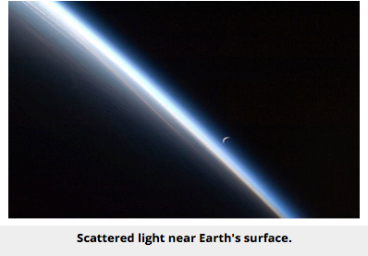

  - Snell’s law
A radio signal passing through the Earth’s atmosphere suffers a change in direction owing to refraction.
If we consider the neutral atmosphere to be horizontally stratified and neglect the ionospheric refraction, the total bending can be found by repeatly applying Snell’s law foe each layer (Smart,1936).

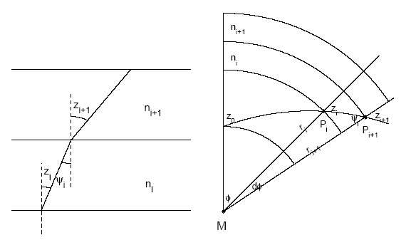

Snell’s law states:
$n_{i+1}{\sin{z}}_{i+1}=n_{i}\sin{z_{i}}=n_{i}\sin{ψ_{i}}$ (1)
where $z_{i}$ and $z_{i+1}$ are the zenith angle of the arriving radio signal in the layer i and are the corresponding refractive indexes.
$$n_{0}\sin{z_{0}}=n_{m}\sin{z_{m}} (2)$$
where the index $n_{0}$ denotes the lowest layer and the index $n_{m}$denotes the highest layer, when the refractive index reduces to 1. The formula (2) will be:
$$n_{0}\sin{z_{0}}=\sin{z_{m}} (3)$$
This formula (3) holds for any refractivity profile.
For a spherical Earth, we may formulate Snell’s law in spherical coordinates.

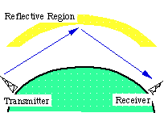

Application of sine rule in the triangle $MP_{i}P_{i+1}$ for this figure gives:
$$\frac{r_{i}}{\sin{ψ_{i}}}=\frac{r_{i+1}}{sin(π-{z_{i})}}=\frac{r_{i+1}}{\sin{z_{i}}} (4)$$

where $r_{i}$and $r_{i+1}$ are the distance $MP_{i}{ and MP}_{i+1} with M$ two center of mass of the Earth. Combining Eq. (1) and (4) gives Snell's law in spherical coordinates:

$n_{i+1 }r_{i+1}{\sin{z}}_{i+1}=n_{i}r_{i} sin{z_{i}}=n_{0}r_{0} sin{z_{0}}$ (5)
or simply

$$n_{0}\sin{z_{0}}=\sin{z_{m}} (6)$$

  - Virtual Temperature

Moist air has a smaller apparent molecular weight than dry air. Therefore, it follows from (eq. 13 in page 4)

$$R_{v}=1000\frac{R^{*}}{M_{w}}=1000\frac{8.3145}{18.016}=461.51 JK^{-1}{Kg}^{-1} \left(13\right)$$

that the gas constant for 1 kg of moist air is larger than that for 1 kg of dry air. However, rather than use a gas constant for moist air, the exact value of which would depend on the amount of water vapor in the air (which varies considerably), it is convenient to retain the gas constant for dry air and use a fictitious temperature (called the virtual temperature) in the ideal gas equation. We can derive an expression for the virtual temperature in the following way.
Consider a volume V of moist air at temperature T and total pressure p that contains mass md of dry air and mass mv of water vapor. The density of the moist air is given by
$$ρ=\frac{m_{d}+m_{v}}{V}=ρ_{d}^{'}+ρ_{v}^{'}$$

where $ρ_{d}^{'}$ is the density that the same mass of dry air would have if it alone occupied all of the volume V and $ρ_{v}^{'}$is the density that the same mass of water vapor would have if it alone occupied all of the volume V. We may call these partial densities. Because $ρ=ρ_{d}^{'}+ρ_{v}^{'}$ , it might appear that the density of moist air is greater than that of dry air. However, this is not the case because the partial density $ρ_{v}^{'}$ is less than the true density of dry air. Applying the ideal gas equation in the form of (eq. 2 in page 2, $P=ρRT$) to the water vapor and dry air in turn, we have
$$e=ρ_{v}^{'}R_{v}T$$
and
$$P_{d}^{'}=ρ_{d}^{'}R_{d}T$$
where e and $P_{d}^{'}$ are the partial pressures exerted by the water vapor and the dry air, respectively. Also, from Dalton’s law of partial pressures,
$$P=P_{d}^{'}+e$$
Combining the last four equations
$$ρ=\frac{p-e}{R_{d}T}+\frac{e}{R_{v}T}$$
or
Prove??
$$ρ=\frac{P}{R_{d}T} \left[1-\frac{e}{P}\left(1-ε\right) \right]$$
where $ε$ is defined by (eq.14 in page 4, $\frac{R_{d}}{R_{v}}=\frac{M_{w}}{M_{d}}=ε=0.622)$. The last equation may be written as
$$P=ρR_{d}T_{v}$$
where
$$T_{v}=\frac{T}{1-\frac{e}{P}\left(1-ε\right)}$$
T_{v} is called the virtual temperature.
The great advantage of introducing virtual temperature is that the total pressure and total density of the mixture are related by the ideal gas equation with the gas constant the same as that for dry air, R_{d}. The virtual temperature is the temperature that dry air must have in order to to have the same density as the moist air at the same pressure. Note that the virtual temperature is always greater than the actual temperature:
$$T_{v}≥T$$
Typically, the virtual temperature exceeds the actual temperature by only a few degrees.

