Lecture four
Simple life cycle the life cycle of organisms that don’t have a sexual process or it occurs without the formation of gametes.
Complex life cycle — is the alternation of generations of organisms with different structures and methods of reproduction.
Phylum Apicomplexa
- Have complex life cycles that are characterized by three processes: sporogony, merogony and gametogony. The life cycle consists of both asexually and sexual stages. In monoxenous species all three of these processes will be carried out in a single host and often in a single cell type or tissue. Whereas, in heteroxenous species the various processes will be carried out in different hosts and generally involve different tissues. Move by gliding.
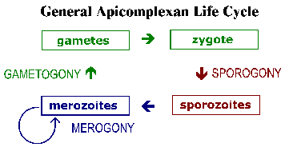
- All are obligate parasite, include the causative agents of malaria, toxoplasmosis, and cryptosporidiosis
NOTE: The group Apicomplexa was proposed for use in place of Sporozoa because the infective stage (sporozoite) is not always contained within a spore. While Apicomplexa and Sporozoa are often considered synonymous.
- Cryptosporidium species and Isospora species :They are microscopic parasites that causes the diarrheal disease cryptosporidiosis , Isosporiasis respectively.
They does not multiply outside of the host. They can complete its life cycle within a single host, including its asexual (merogony) and sexual (sporogony) reproductive cycles. Infection is initiated by ingestion of oocysts, which are activated in the stomach and upper intestines to release 4 infective sporozoites. These motile sporozoites bind to the receptors on the surface of the intestinal epithelial cells and are ingested into a parasitophorous vacuole near the surface of the epithelial cell, separated from the cytoplasm by a dense layer.
Exist in the form of oocyst, sporozoite, meront, merozoite, gametocyte, and zygote during its life-cycle. The meront, merozoite, and gametocytes are formed in the upper small intestine. Some of the merozoites formed after two or three cycles of merogony undergo gametocytogony which finally give rise 'the formation of oocyst. Oocyst passed in faeces are round, highly refractile, and measure 4-6 m in diameter. Oocysts are fully developed (contain four sporozoites _ without sporocyst) and are infective at the time of release. It is worldwide in distribution and has no host specificity (can infect man, cattle, horse, sheep, goat, rabbit, mice, chicken, and others including fishes and lizards). Infection in man takes place by ingestion of oocyst through contaminated food or drinks.
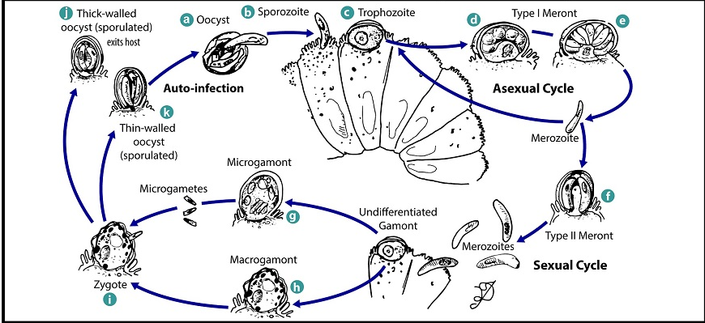
Laboratory diagnosis is done by faecal examination. Of the various techniques described, the sucrose centrifugal-floatation technique (observed under a phase contrast microscope) and modified AFB stains are commonly used for the detection of oocysts. Saline preparation is not useful in the diagnosis.
- Toxoplasma gondii is a protozoan parasite that infects most species of warm-blooded animals, including humans, and can cause the disease toxoplasmosis. Tachyzoites (trophozoites) are approximately 4-8 µm long by 2-3 µm wide, with a tapered anterior end, a blunt posterior end and a large nucleus. They may be found in various sites of the body. Cysts usually range in size from 5-50 µ in diameter. Cysts are usually spherical in the brain but more elongated in cardiac and skeletal muscles. They may be found in various sites throughout the body of the host, but are most common in the brain and skeletal and cardiac muscles.
Life cycle
The only known definitive hosts for Toxoplasma gondii are members of family Felidae (domestic cats and their relatives). Unsporulated oocysts are shed in the cat’s feces. Oocysts take 1-5 days to sporulate in the environment and become infective. Human infection may occur either from ingestion of sporulated oocysts, or ingestion of meat infected with trophozoites.Intermediate hosts in nature as humans or birds and rodents become infected after ingesting soil, water or plant material contaminated with oocysts, Oocysts transform into tachyzoites shortly after ingestion. These tachyzoites localize in neural and muscle tissue and develop into tissue cyst bradyzoites. Cats become infected after consuming intermediate hosts harboring tissue cysts. Cats may also become infected directly by ingestion of sporulated oocysts.
Sexual reproduction takes place in the intestinal epithelium of the cat host and cysts are shed unsporulated in the feces.
Transmission
Humans can become infected by any of several routes:
1- Eating undercooked meat of animals harboring tissue cysts.
2- Consuming food or water contaminated with cat feces.
3- Blood transfusion or organ transplantation.
4- Trans-placental from mother to fetus.
Pathogenesis and symptoms
In the human host, the parasites form tissue cysts, most commonly in skeletal muscle, myocardium, brain, and eyes; these cysts may remain throughout the life of the host. Symptoms of the infection vary. Most people who become infected have no symptoms at all. Sometimes they feel as if they have the “flu” with swollen lymph glands or muscle aches and pains that may last for a month or more.
Severe toxoplasmosis, causing damage to the brain, eyes, or other organs,
Signs and symptoms depend on the location of the infection.
Most infants who are infected while still in the womb have no symptoms at birth, but they may develop symptoms later in life. A small percentage of infected newborns have serious eye or brain damage at birth.
Diagnosis
1- Is usually achieved by serology, although tissue cysts may be observed in stained biopsy specimens
2- Diagnosis of congenital infections can be achieved by detecting T. gondii DNA in the amniotic fluid using PCR method.
Prevention
1- Avoid drinking untreated water, and cook food well.
2- Wear gloves when gardening, it might be contaminated with cat feces and wash hands.
3- Teach children the importance of washing hands to prevent infection.
4- Keep outdoor sandboxes covered and clean the litter box.
5- Feed cats only canned or dried commercial food or well-cooked table food, not raw or undercooked meats.
- Genus is Plasmodium from Family Plasmodidae Asexual reproduction of the parasite takes place in vertebrates; sexual reproduction in mosquitoes.
Humans are hosts for at least 6 species of Plasmodium: cause Malaria (bad air)
The morphological characteristics (size, shape and appearance) of the blood stages are characteristic for each Plasmodium spp. Microgametocytes have a larger more diffuse nucleus (ready for gamete production) while macrogametocytes have darker-staining cytoplasm (plentiful ribosomes for protein synthesis).
1) P. falciparum
- Most virulent of all species, with mortality rates as high as 25%.
- Restricted to tropics and sub-tropics.
- Also known as malignant tertian or sub-tertian malaria.
- It is non-relapsing.
2) P. vivax
- Most widespread and common.
- Found in most of the habitable places in the world, although rarely on the north side of the 42nd parallel (Chicago).
- It is relapsing and disabling though not normally fatal.
- Known as benign tertian malaria.
3) P. malariae
- Cosmopolitan parasite. Once in US.
- It is relapsing.
- Known as chronic quartan malaria.
4) P. ovale
- Rarest of the four species.
- Found in tropical Africa only.
- Known as tertian malaria.
5) P. cynomolgi - Simian malaria
6) P. knowlesi - “
Life cycle:
- There are three phases in the life cycle.
- 2 in vertebrate host (asexual) ---pre-erythrocytic and erythrocytic
- 1 in invertebrate “ (sexual)
Pre-erythrocytic schizogony (multiple fission):
- Infected mosquito (female Anopheles) bites human and inoculates into capillary along with salivary anticoagulants several sporozoites (slender, minute form with fusiform body that contains one or more chromatin masses, that create a bulge in the parasite.
- Sporozoites circulate in blood for up to 30 minutes, and then enter fixed macrophages in the liver (Kupffer cells). Here they remain for 4-5 days and undergo pre-erythrocytic schizogony or exo-erythrocytic schizogony to produce a schizont. (Individual organisms within called trophozoites).
- Cells rupture and release parasites. The progeny of the first generation of parasites released are called cryptozoites, while the following generations are called metacryptozoites.
- Parasites re-invade other Kupffer cells in the liver.
- Some parasites may become dormant for an indefinite period. These are called hypnozoites.
- After a time delay that is species-specific, the parasites begin spilling over into the blood.
P. falciparum - 8 days - no relapse because all of the parasites will be gone from the liver within 2 weeks after the initial invasion.
P. vivax - 6 days - relapse possible because some of the metacryptozoites remain indefinitely in the Kupffer cells.
- When the parasites enter the blood, they may show a predilection for certain RBCs.
P. vivax - attacks only reticulocytes (young RBCs), P. malariae – same, P. falciparum - attacks all cells - this accounts in part for its virulence - in some cases, up to 10% of all RBCs may be infected.
- There is some indication that even uninfected RBCs are eliminated with infected ones.
Erythrocytic schizogony:
- Metacryptozoites attack RBCs - after penetrating the cell membrane, they first appear as minute specks of chromatin surrounded by cytoplasm.
- As the parasites grow and develop, hemoglobin is metabolized, and the parasite produces a pigmented waste called hemozoin.
- Gradually, the parasite rounds up and is known as a trophozoite or ring stage.
P.v. & P.o. - Schuffner’s dots, P.m. - Zeiman’s dots, P.f. - Mauer’s dots
- Parasite begins to divide and produce a schizont via schizogony. When schizogony is complete, the schizont is called a mature segmenter.
- The RBC or blood cell then bursts and releases its contents into the bloodstream. The progeny are called merozoites. They penetrate new RBCs.
- All segmenters burst within a few hours of each other.
- The sudden and synchronous bursting of cells results in a bout of fever in which temperature rises rapidly.
- The combination of malarial symptoms is called a paroxysm. The symptoms first appear when the parasitemia reaches about 200 parasites/ml or about 1 million parasites/host.
- The length of the cell cycle is in multiples of 24 hours.
P.v. and P.o. - tertian - 48 hours, P.f. - sub-tertian - 36-48 hours, P.m. - quartan - 72 hours
- Early in infection, these paroxysms are quotidian (24 hrs.) because the metacryptozoites are constantly introduced into the blood.
- However, in falciparum malaria, there is less synchrony, and the attacks are drawn out.
- The freed merozoites invade other cells, and erythrocytic schizogony continues, lasting 20-40 days.
- About this time, the disease becomes patent (mature) and can be diagnosed using ordinary microscope procedures.
- Some of the merozoites on entering RBCs, become sexual forms called gametocytes (microgametocytes - male; macrogametocytes - female).
- Gametocytes are acquired by mosquitoes when they take a blood meal.
- Further maturation of the gametocytes occurs in the insect’s midgut. For males, this process is called exflagellation, but there is no special name given for the microgametocytes. Both undergo meiosis to produce microgametes and macrogametes.
- Two fuse to form a zygote, which 12-24 hrs. later changes into an ookinete.
- Ookinete penetrates midgut wall and forms an oocyst between epithelium and basement membrane.
- Within oocyst, there is sporogony to produce thousands of sporozoites.
- When sporozoites are mature, they break out of the oocyst and travel through the insect hemocoel to the salivary glands.
- Life cycle in mosquito host takes 10-14 days to complete, dependent upon parasite species and temperature.
Symptoms and pathology:
1. Usually due to (1) host inflammatory response, and (2) anemia that results from the destruction of RBCs when schizonts burst. Both infected and uninfected RBCs are phagocytized by cells in the spleen.
2. Each paroxysm beings with chills, convulsions, severe shaking, cyanosis and increasing fever. There are violent headaches, nausea, vomiting, rapid pulse. The person may be euphoric. Fever is followed by profuse sweating. Body temperature then falls and becomes normal 10 hours after the paroxysm begins.
3. Attacks normally occur between midnight and noon --> perfect for transmission to mosquito host.
4. It can develop multiple vascular thromboses in smaller blood vessels that also lead to both RBC and plasma loss.
5. At autopsy, both the spleen and liver will be black; white matter of brain will be slate grey due to phagocytosis of hemozoin by fixed macrophages. The pigment is also concentrated in the organs of the reticuloendothelial system, especially Kupffer cells and spleen. Spleen always becomes enlarged --> splenomegaly.
6. Capillary thromboses in P. falciparum: --> cerebral malaria
7. Most frequent and dangerous in brain.
8. Parasitized cells seem to become sticky (probably due to accumulation of surface antigens) and stick to endothelial cells of blood vessels and to each other --> clump and block small vessels. Following the occlusion, there is local hemorrhage and necrosis. Anoxia develops, followed by local cell death and convulsions. If thromboses (clots) are severe enough, the death of the host is likely.Blackwater fever
- Defined as acute and massive hemolysis during infection.
- Severe side effect associated with P. falciparum that results from repeated infection.
- Disease is characterized by intravenous hemolysis, hemoglobinemia, and hemoglobinuria.
- Also get dark urine with chills, fever, jaundice, and vomiting.
- Mortality rate is 20-50%.
- Control and Prevention:
- Massive chemotherapy.
- Mosquito control measures - destruction of breeding places or use of mosquito predators.
- Judicious use of insecticides.
- Vaccine development.

