Ribosomes
Ribosome: particle that is present in large numbers in all living cells and serves as the site of protein synthesis. Ribosomes occur both as free particles in prokaryotic and eukaryotic cells and as particles attached to the membranes of the endoplasmic reticulum in eukaryotic cells.
Ribosomes floating and on rough endoplasmic reticulum Ribosomes are special because they are found in both prokaryotes and eukaryotes. While a structure such as a nucleus is only found in eukaryotes, every cell needs ribosomes to manufacture proteins. Since there are no membrane-bound organelles in prokaryotes, the ribosomes float free in the cytosol.
Each ribosome is composed of two subunits, the small ribosomal subunits, which read the RNA, and the large subunits, which join amino acids to form a polypeptide chain. Each subunit comprises one or more ribosomal RNA (rRNA) molecules and a variety of ribosomal proteins (r-protein or rProtein). each of which has a characteristic shape.
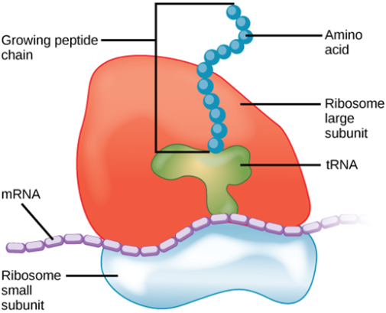
Figure (1): ribosome structure
The subunits typically are referred to in terms of their sedimentation rate, which is measured in Svedberg units (S), in a centrifugal field. Eukaryotes have 80S ribosomes, each consisting of a small (40S) and large (60S) subunit. Their 40S subunit has an 18S RNA (1900 nucleotides) and 33 proteins . The large subunit is composed of a 5S RNA (120 nucleotides), 28S RNA (4700 nucleotides), a 5.8S RNA (160 nucleotides) subunits and 46 proteins.
eukaryotic cytosolic ribosomes
ribosome | subunit | rRNAs | r-proteins
80S | 60S | 28S (4718 nt) | 49
 |  | 5.8S (160 nt)
 |  | 5S (120 nt)
 | 40S | 18S (1874 nt) | 33
While Prokaryotes have 70S ribosomes, each consisting of a small (30S) and a large (50S) subunit. Their small subunit has a 16S RNA subunit (consisting of 1540 nucleotides) bound to 21 proteins. The large subunit is composed of a 5S RNA subunit (120 nucleotides), a 23S RNA subunit (2900 nucleotides) and 31 proteins
prokaryotic ribosomes
ribosome | subunit | rRNAs | r-proteins
70S | 50S | 23S (2904 nt) | 31
 |  | 5S (120 nt)
 | 30S | 16S (1542 nt) | 21

Scientists have used this difference in ribosome structure to develop drugs that can kill prokaryotic microorganisms which cause disease. There are even structural differences between ribosomes found in the mitochondria and free ribosomes
The major differences between eukaryote and prokaryote ribosomes include:
- Prokaryotes have 70S ribosomes, singly made of a 30S and a 50S subunit. While the Eukaryotes have 80S ribosomes, singly made of a 40S and 60S subunit.
- 70S Ribosomes are relatively smaller than 80S while the 80S Ribosomes are relatively bigger than 70S ribosomes.
- Prokaryotes have 30S subunit with a 16S RNA subunit and comprise of 1540 nucleotides bound to 21 proteins. The 50S subunit gets produced from a 5S RNA subunit that involves 120 nucleotides, a 23S RNA subunit that contains 2900 nucleotides and 31 proteins.
- Eukaryotes have 40S subunit with 18S RNA and also 33 proteins and 1900 nucleotides. The big subunit contains 5S RNA and also 120 nucleotides, 4700 nucleotides and also 28S RNA, 5.8S RNA as well as 160 nucleotides subunits and 46 proteins.
- Eukaryotic cells have mitochondria and chloroplasts as organelles and those organelles additionally have ribosomes 70S. Hence, eukaryotic cells have different kinds of ribosomes (70S and 80S), while prokaryotic cells just have 70S ribosomes.

The ribosomes and associated molecules are also known as the translational apparatus:
Ribosomes are the sites at which information carried in the genetic code is converted into protein molecules. Ribosomal molecules of messenger RNA (mRNA) determine the order of transfer RNA (tRNA) molecules that are bound to nucleotide triplets (codons). The order of tRNA molecules ultimately determines the amino acid sequence of a protein. Molecules of rRNA catalyze the peptidyl transferase reaction, which forms peptide bonds between the amino acids, linking them together to form proteins. The newly formed proteins detach themselves from the ribosome site and migrate to other parts of the cell for use.
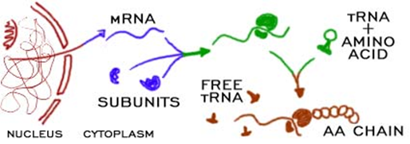
Figure (2): The role of ribosomes

