1. History of the Earth's Atmosphere

Earth is believed to have formed about 5 billion years ago. In the first 500 million years a dense atmosphere emerged from the vapor and gases that were expelled during degassing of the planet's interior. These gases may have consisted of hydrogen (H2), water vapor, methane (CH4) , and carbon oxides. Prior to 3.5 billion years ago the atmosphere probably consisted of carbon dioxide (CO2), carbon monoxide (CO), water (H2O), nitrogen (N2), and hydrogen.
The hydrosphere was formed 4 billion years ago from the condensation of water vapor, resulting in oceans of water in which sedimentation occurred.

The most important feature of the ancient environment was the absence of free oxygen. Evidence of such an anaerobic reducing atmosphere is hidden in early rock formations that contain many elements, such as iron and uranium, in their reduced states. Elements in this state are not found in the rocks of mid-Precambrian and younger ages, less than 3 billion years old.

One billion years ago, early aquatic organisms called blue-green algae began using energy from the Sun to split molecules of H2O and CO2 and recombine them into organic compounds and molecular oxygen (O2). This solar energy conversion process is known as photosynthesis. Some of the photosynthetically created oxygen combined with organic carbon to recreate CO2 molecules. The remaining oxygen accumulated in the atmosphere, touching off a massive ecological disaster with respect to early existing anaerobic organisms. As oxygen in the atmosphere increased, CO2 decreased.

High in the atmosphere, some oxygen (O2) molecules absorbed energy from the Sun's ultraviolet (UV) rays and split to form single oxygen atoms. These atoms combining with remaining oxygen (O2) to form ozone (O3) molecules, which are very effective at absorbing UV rays. The thin layer of ozone that surrounds Earth acts as a shield, protecting the planet from irradiation by UV light.

The amount of ozone required to shield Earth from biologically lethal UV radiation, wavelengths from 200 to 300 nanometers (nm), is believed to have been in existence 600 million years ago. At this time, the oxygen level was approximately 10% of its present atmospheric concentration. Prior to this period, life was restricted to the ocean. The presence of ozone enabled organisms to develop and live on the land. Ozone played a significant role in the evolution of life on Earth, and allows life as we presently know it to exist.

1-1 The First atmosphere:
The first of earth’s atmosphere, formed when the planet was still very young, was primarily hydrogen and helium (He). This atmosphere is about 4.57 billion years old, and was short-lived. Heat from the molten crust and solar wind dissipated this layer. Hydrogen and helium are not heavy enough to make up a stable atmosphere unless the planet is very massive. These elements are more likely to gain escape velocity during random thermal fluctuations. This is part of reason why hydrogen and helium are very rare in earth’s atmosphere’s atmosphere today.

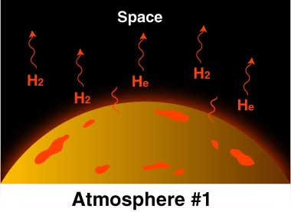

1-2 The Secondary Atmosphere:
Water related sediments have been found dating from as early as 3.8 billion years ago. About 3.4 billion years ago, nitrogen was the major part of the then stable “second atmosphere”. An influence of life has to be taken into account rather soon in history of the atmosphere, since hints of early life forms are to be found as early as 3.5 billion years ago. During this period, the rocks gave off large quantities of gases including nitrogen, ammonia, carbon monoxide and water vapor as well-a mixture similar to that given off by volcanoes and fumaroles today. Like modern volcanic gases, the primeval atmosphere is thought to have contained only the slightest trace of oxygen, so it would have been poisonous to almost all modern life forms.

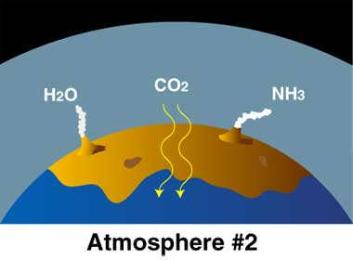

1-3 The Third Atmosphere:
This time span was the Phanerozoic Eon (time when abundant animal life existed and time when diverse hard-shelled animals first appeared), during which oxygen-breathing metazoan life forms began to appear. By 3.5 billion years ago, life had emerged, in the form of “Archaea”. Archaea are a major group of single celled organisms without nuclei. About 2.7 billion years ago, they were joined by microbes called cyanobacteria. Cyanobacteria were the first oxygen producing phototropic organism and slowly began to suck in carbon dioxide from the atmosphere and release oxygen.

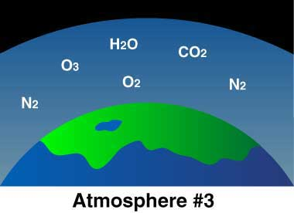

- The Present Composition of Atmosphere

Air is the name given to the atmosphere used in breathing and photosynthesis. Dry air contains roughly (by volume) :
78.09% nitrogen,
20.95% oxygen,
0.93% argon,
0.039% carbon-di-oxide, and small amounts of other gases like neon, helium, ozone and hydrogen.
Air also contains a variable amount of water vapor, which makes up 4% of the atmosphere by volume and 3% by weight. Many natural substances may be present in tiny amounts in an unfiltered air sample, including dust, pollen, salt, smoke and spores, sea spray and volcanic ash. Various industrial pollutants such as chlorine, fluorine, and elemental mercury and sulfur compounds may also be present. The composition of the atmosphere is relatively constant up to 50 km above the earth’s surface, with the exception of ozone and water vapor.
Table 1-1: Evolution of the Earth's atmosphere.
Name of Stage | Duration of Stage (Billions of Years Ago) | Main Constituents of the Atmosphere | Dominant Processes and Features
Early Atmosphere | 4.4 to 4.0 | H2O, hydrogen cyanide (HCN), ammonia (NH3), methane (CH4), sulfur, iodine, bromine, chlorine, argon | Lighter gases like hydrogen and helium escaped to space.  All water was held in the atmosphere as vapor because of high temperatures.
Secondary Atmosphere | 4.0 to 3.3 | At 4.0 billion H2O, CO2, and nitrogen (N) dominant. Cooling of the atmosphere causes precipitation and the development of the oceans.  By 3.0 billion CO2, H2O, N2 dominant. O2 begins to accumulate. | Continued release of gases from the lithosphere. Water vapor clouds common in the lower atmosphere. Chemosynthetic bacteria appear on the Earth sometime between 3.9 and 3.5 billion years ago. Life begins to modify the atmosphere.
Living Atmosphere | 3.3 to Present | N2 - 78%,  O2 - 21%,  Argon - 0.9%,  CO2 - 0.036% | Development, evolution and growth of life increases the quantity of oxygen in the atmosphere from <1% to 21%. 500 million years ago concentration of atmospheric oxygen levels off. Humans begin modifying the concentrations of some gases in the atmosphere beginning around the year 1700.
Table 1-2: Approximate origin time of the major plant and animal groups.
Organism Group | Time of Origin
Marine Invertebrates | 570 Million Years Ago
Fish | 505 Million Years Ago
Land Plants | 438 Million Years Ago
Amphibians | 408 Million Years Ago
Reptiles | 320 Million Years Ago
Mammals | 208 Million Years Ago
Flowering Plants (Angiosperms) | 140 Million Years Ago

