Lec.9: Bioseparation Technology
Gel Filtration Chromatography
Gel filtration chromatography, a type of size exclusion chromatography, can be used to either fractionate molecules and complexes in a sample into fractions with a particular size range, to remove all molecules larger than a particular size from the sample. Gel filtration chromatography can be used to separate compounds such as small molecules, proteins, polysaccharides, and nucleic acids when in aqueous solution.
Gel filtration chromatography can also be used for:
- Fractionation of molecules and complexes within a predetermined size range
- Size analysis and determination
- Removal of large proteins and complexes
- Desalting
- Removal of small molecules such as nucleotides, primers, dyes,
In size-exclusion chromatography (gel filtration) proteins are separated based on their size (molecular weight) .The resin used in size-exclusion chromatography is uncharged, but contains pores into which small proteins may be able to penetrate, the largest proteins move through the column the fastest, whereas small proteins are retained longer. Size exclusion chromatography in the presence of standards of known protein can be used to determine the approximate molecular weight of an unknown protein.
Gel Filtration Chromatography Mechanism:
In a gel filtration chromatography column, the stationary phase is composed of a porous matrix, and the mobile phase is the buffer that flows in between the matrix beads,the beads have a defined pore size range. Molecules and complexes that are too large to enter the pores stay in the mobile phase and move through the column with the flow of the buffer. Smaller molecules and complexes that are able to move into the pores enter the stationary phase and move through the gel filtration column by a longer path through pores of the beads.
Any molecule or complex that is above the fractionation range for a particular gel filtration chromatography column will move through the column faster than any molecule that can enter the stationary phase. Therefore, any constituent in the sample that is above the fractionation range will elute first before anything that is in the fractionation range.
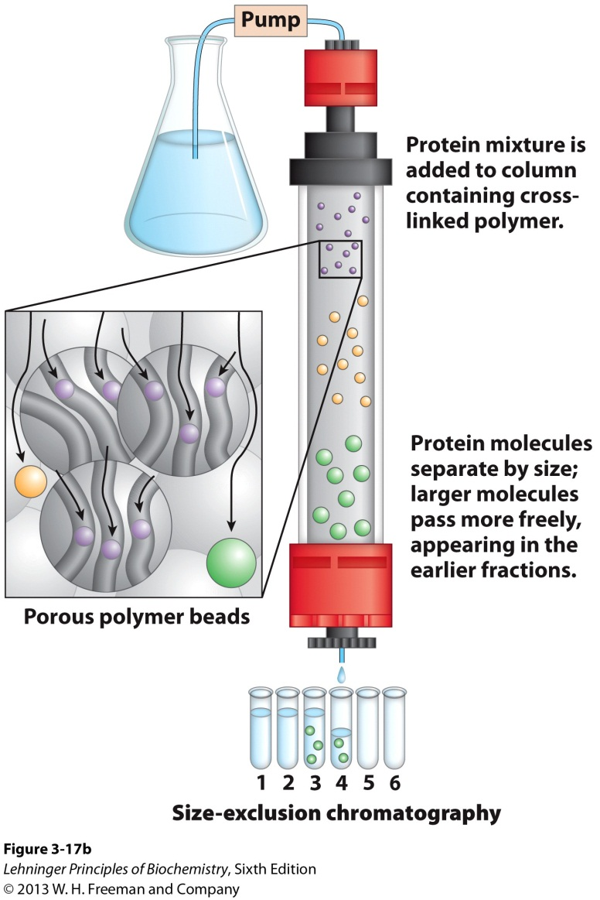
Molecules and complexes that can enter the stationary phase will be fractionated according to their sizes. Smaller molecules will migrate deep into the pores and will be retarded more than larger molecules that do not so easily enter the pores, and are thus eluted from the column more quickly. This difference in pore migration leads to fractionation of components by size with the largest eluting first.
Size exclusion, fractionation range, and elution rate are affected by buffer composition, ionic strength, and pH.

