Lec6:Bioseparation
Isolation methods of fermentative products(part2)
8- Reversed Micelle Extraction
Reversed micelles are aggregates of surfactant molecules in the organic solvents. These surfactant aggregates consist of a polar inner core and an inner layer made of the surfactant hydrophilic head.
A reversed micellar extraction cycle is basically composed of two steps: forward and back extraction. In the forward extraction process, biomolecules are transferred from the initial aqueous phase to the reversed micelles. In the back extraction process, biomolecules are transferred from the reversed micelles back to the aqueous stripping solution.

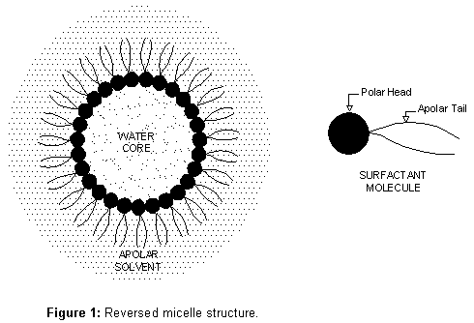
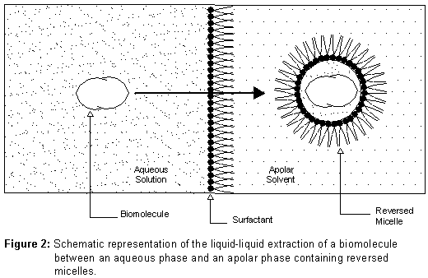

9- Chromatography
In many fermentation processes, chromatographic techniques are used to isolate and purify relatively low concentrations of metabolic products. Chromatographic methods separate solutes based on charge, polarity, size, and affinity.
10- Adsorption Chromatography
Adsorption can be a useful technique for the separation of a product from a dilute aqueous phase and the use of polymer absorbers for the recovery of small molecules. A range of polymers (eg, ion-exchangers) are available on a large scale. After extraction of the product onto the absorber, the product can then be recovered by solvent elution/extraction and the absorber can then be recycled.
11- Distillation (evaporation)
It is used for the separation of volatile products from less volatile materials such as ethanol (both alcoholic beverages and biofuel), flavors, and fragrances.
12- Ultrafiltration
Ultrafiltration is a process in which solutes of high molecular weight are retained when the solvent and low molecular weight solutes are forced under hydraulic pressure (between 2 and 10 atmospheres) through a membrane of a very fine pore size, typically between 0.001 and 0.1 µm. It is therefore used for product concentration and purification. A range of membranes made from a variety of polymeric materials, with different molecular weight cut-offs (500–500,000), for separation of macromolecules such as proteins, enzymes, hormones, and viruses.

