The blood volume of an adult correlates with his or her body mass and amounts to ca. 4-4.5L in women and 4.5-5 L in men of 70kg BW. The functions of blood include:

- The transport of various molecules (O_{2,} CO₂, nutrients, metabolites, vitamins, electrolytes)
- Regulation of body temperature.
- Transmission of signals (hormones).
- Buffering.
- Immune defense.

The blood consists of a fluid (plasma) and formed elements: Red blood cells (RBCs), White blood cells (WBCs), and platelets (thrompocytes). The formation of blood cells occurs in the red bone marrow of flat bone in adults and in the spleen and liver of the fetus. Hematopietic tissues contain pluripotent stem cells which, with the aid of hematopoietic growth factors, develop into myeloid, erythroid and lymphoid precursor cells.

Plasma physiology

Plasma is the fluid portion of the blood in which electrolytes, nutrients, metabolites, vitamins, hormones, gases, and proteins are dissolved. Plasma proteins are involved in humoral immune defense and maintain oncotic pressure, which helps to keep the blood volume constant. By binding to plasma proteins, compounds insoluble in water can be transported in blood, and many substances (e.g.,hem) can be protected from breakdown and renal excretion. The binding of small molecules to plasma protein reduces their osmotic efficacy, many plasma proteins are involved in blood cloting and fibrinolysis. Serum forms when fibrinogen separates from plasma in the process of of blood clotting.

RBCs physiology:

The major functions of erythrocytes are to carry oxygen taken in by the lungs and carbon dioxde produced by cells. RBCs contain a large amount of the protein hemoglobin with which O₂ and CO₂ reversibly combine. Hemoglobin also plays an important role in a buffering to keep the Acid-Base balance.

Erythrocytes have the shape of a biconcave disk, that is, a disk thicker at the edge than in the middle. This shape and their small size (7µm in diameter) impart to them a high surface-to-volume ratio, so that oxygen and carbon dioxide can diffuse rapidly to from the interior cell. The plasma membrane of erythrocytes contains specific polysaccharides and proteins that differ from person to person, and these confer upon the blood its so-called type, or group.

The site of erythrocyte production is the bone marrow, specifically the red bone marrow. With differentiation, the erythrocyte precursors produce hemoglobin but then they ultimately lose their nuclei and organelles-their machinery for protein synthesis. Young erythrocytes in the bone marrow still contain a few ribosome. These young erythrocytes called reticulocyte. Normally, only mature erythrocytes, which have lost these ribosome, leave the bone marrow and enter the general circulation. The average life span of an erythrocyte is approximately 120 days, which means that almost 1% of the body’s erythrocytes are destroyed and must be replaced every day. Erythrocyte destruction normally occurs in the spleen and the liver. Most of the iron released in the process is conserved. The major breakdown product of heme is bilirubin, which gives plasma its color.
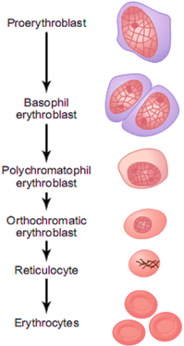

The production of erythrocytes requires the usual nutrients needed to synthesize any cell: amino acids, lipids, and carbohydrates. In addition, both iron and certain growth factors, including folic acid and vitamin B₁₂, are essential.

- Iron: is the element to which oxygen binds on a hemoglobin molecule within an erythrocyte, small amounts of iron are lost from the body via the urine, feces, sweat, and cells sloughed from the skin. In addition, women lose a similar amount via menstrual blood. In order to remain in iron balance, the amount of iron lost from the body must be replaced by ingestion of iron-containing foods; particularly rich sources are meat, liver, egg yolk, beans, nuts, and cereals. A significant upset of iron balance can result either in iron deficiency, leading to inadequate hemoglobin production, or in an excess of iron in the body, with serious toxic effects.

- Folic acid: a vitamin found in large amounts in leafy plants, yeast, and liver, is required for synthesis of the nucleotide bas thymine. It is, therefore, essential for the formation of DNA and hence for normal cell division. When this vitamin is not present in adequate amounts, impairment of cell division occurs throughout the body but is most striking in rapidly proliferating cell, including erythrocyte precursors. Thus, fewer erythrocytes are produced when folic acid is deficient.

- Vitamin B₁₂: production of normal erythrocyte numbers also requires extremely small quantities of a cobalt-containing molecule, vitamin B₁₂, since this vitamin is required for the action of folic acid. Vitamin B₁₂ is found only on animal products, and strictly vegetarian diets may be deficient in it. The absorption of vitamin B₁₂ from the gastrointestinal tract requires a protein called intrinsic factor, which is secreted by the stomach; lack of this protein also causes vitamin B₁₂ deficiency. Unlike folic acid, vitamin B₁₂ is also needed for myelin formation, so a variety of neurological symptoms may accompany the poor erythrocyte production when vitamin B₁₂ is deficient.
Regulation of Erythrocyte Production:

In a normal person, the total volume of circulating erythrocytes remains remarkably constant because of reflexes that regulate the bone marrow’s production of these cells. In the previous section, we stated that iron, folic acid, and vitamin B₁₂ must be present for normal erythrocyte production. Other factors regulates production rate are:
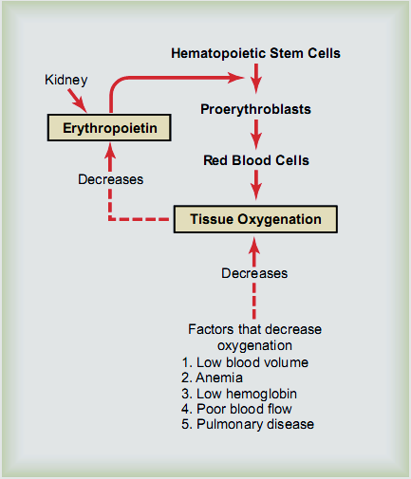
- Erythropoietin hormone: the direct control of erythrocyte production is exerted primarily by a hormone called erythropoietin, which is secreted into the blood mainly by a particular group of hormone-secreting connective tissue cells in the kidneys. It acts on the bone marrow to stimulate the proliferation of erythrocyte progenitor cells and their differentiation into erythrocytes.

- Tissue oxygenation: erythropoietin is normally secreted in relatively small amounts, which stimulate the bone marrow to produce erythrocytes at a rate adequate to replace the usual loss. This rate is increased above basal values when there is a decreased oxygen delivery to the kidneys. Situation in which this accurse include insufficient pumping of blood by the heart, lung disease, anemia, and exposure to high altitude.

- Testosterone: the male sex hormone stimulates the release of erythropoietin. This may account, at least in part, for the higher hemoglobin concentration in men than in women.

Formation of Hemoglobin
Synthesis of hemoglobin begins in the pro-erythroblasts and continues even into the reticulocyte stage of the red blood cells. Therefore, when reticulocytes leave the bone marrow and pass into the blood stream, they continue to form minute quantities of hemoglobin for another day or so until they become mature erythrocytes. the basic chemical steps in the formation of hemoglobin include:

- Succinyl-CoA, formed in the Krebs metabolic cycle and binds with glycine to form a pyrrole molecule .

- Four pyrroles molecule combine to form protoporphyrin.

- Protoporphyrin then combines with iron to form the heme molecule.

- Finally, each heme molecule combines with a long polypeptide chain, a globin synthesized by ribosomes, forming a subunit of hemoglobin called a hemoglobin chain. Each chain has a molecular weight of about 16,000; four of these in turn bind together loosely to form the whole hemoglobin molecule.

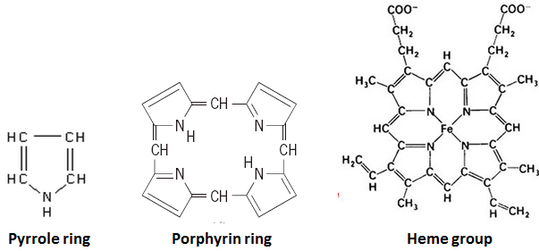

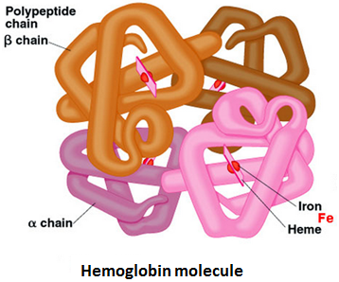

Anemia:
Is defined as a decrease in the ability of the blood to carry oxygen due to:

- A decrease in the total number of erythrocytes, each having a normal quantity of heamoglobin.
- A diminished concentration of hemoglobin per erythrocyte.
- A combination of both.

Laboratory evaluation of anemia starts with analysis of a blood sample for the concentration of hemoglobin, the number of erythrocytes, and the average erythrocytes size. Average cell size is particularly useful since it correlates well with several common types of anemia:

- Microcytosis (small cell) most common occurs in iron deficiency anemia.

- Normocytosis (normal size cell) a companies acute blood loss.

- Macrocytosis (large cell) is characterstic of vitamin B₁₂ or folic acid deficiency. This is due to delayed cell division because of the decrease in DNA caused by these vitamin deficiencies.

Some types of anemia and their physiologic causes

- Blood Loss Anemia. After rapid hemorrhage, the body replaces the fluid portion of the plasma in 1 to 3 days, but this leaves a low concentration of red blood cells. If a second hemorrhage does not occur, the red blood cell concentration usually returns to normal within 3 to 6 weeks. In chronic blood loss, a person frequently cannot absorb enough iron from the intestines to form hemoglobin as rapidly as it is lost. Red cells are then produced that are much smaller than normal and have too little hemoglobin inside them, giving rise to microcytic, hypochromic anemia.

- Aplastic Anemia. Bone marrow aplasia means lack of functioning bone marrow. For instance, a person exposed to gamma ray radiation from a nuclear bomb blast can sustain complete destruction of bone marrow, followed in a few weeks by lethal anemia. Likewise, excessive x-ray treatment, certain industrial chemicals, and even drugs to which the person might be sensitive can cause the same effect.

- Megaloblastic Anemia. Based on the earlier discussions of vitamin B12, folic acid, and intrinsic factor from the stomach mucosa, one can readily understand that loss of any one of these can lead to slow reproduction of erythroblasts in the bone marrow. As a result, the red cells grow too large, with odd shapes, and are called megaloblasts. Thus, atrophy of the stomach mucosa, as occurs in pernicious anemia, or loss of the entire stomach after surgical total gastrectomy can lead to megaloblastic anemia.

- Hemolytic Anemia. Different abnormalities of the red blood cells, many of which are hereditarily acquired, make the cells fragile. Even though the number of red blood cells formed may be normal, or even much greater than normal in some hemolytic diseases, the life span of the fragile red cell is so short that the cells are destroyed faster than they can be formed, and serious anemia results.

Sickle-cell anemia (polycythemia) : is due to a genetic mutation that alters one amino acid in globin chain. At the low oxygen concentrations existing in many capillaries, the abnormal hemoglobin molecules interact with each other to form fiber-like structures that distort the erythrocyte membrane and cause the cell to form sickle shapes or other bizarre forms. This results both in the blockage of capillaries, with consequent tissue damage and pain, and in the distraction of the deformed erythrocytes, with consequent anemia.

WBs physiology:

They are classified according to their structure and affinity for various dyes:
- Granulocytes: refers to the three types
- Eosinophils
- Basophils
- Neutrophis

- Agranulocytes: refers to the two types
- Monocyte
- Lymphocyte
These cells play an important role in the body’s defenses (Innate and Specific Immunity).

Platelets physiology:

The circulating platelets are colorless cell fragment that contain numerous granules and are much smaller than RBs. Platelets are produced when portions of large bone marrow cells, termed megakaryocytes, become pinched off and enter the circulation. Platelets functions in blood clotting by forms the platelet plug.

Destruction of Hemoglobin:

When red blood cells burst and release their hemoglobin, the hemoglobin is phagocytized almost immediately by macrophages in many parts of the body, but especially by the Kupffer cells of the liver and macrophages of the spleen and bone marrow. During the next few hours to days, the macrophages release iron from the hemoglobin and pass it back into the blood, to be carried by transferring either to the bone marrow for the production of new red blood cells or to the liver and other tissues for storage in the form of ferritin. The porphyrin portion of the hemoglobin molecule is converted by the macrophages, through a series of stages, into the bile pigment bilirubin, which is released into the blood and later removed from the body by secretion through the liver into the bile.

