About 40 per cent of the body is skeletal muscle, and perhaps another 10 per cent is smooth and cardiac muscle. Some of the same basic principles of contraction apply to all these different types of
muscle.
Skeletal Muscle

Physiologic Anatomy
All skeletal muscles are composed of numerous fibers ranging from 10 to 80 micrometers in diameter. Each of these fibers is made up of smaller subunits. In most skeletal muscles, each fiber extends the entire length of the muscle. Except for about 2 per cent of the fibers, each fiber is usually innervated by only one nerve ending, located near the middle of the fiber. Each muscle fiber contains several hundred to several thousand myofibrils. Each myofibril is composed of about 1500 adjacent myosin filaments and 3000 Actin filaments, which are large polymerized protein molecules that are responsible for the actual muscle contraction. The thick filaments in the muscle are myosin which consists of rod-shaped tail portion of each molecule aggregates in a regular parallel but staggered array, whereas the head portions project out in a regular helical pattern. The thin filaments are actin, Tropomyosin, and Troponin. Tropomyosin consists of a helix that run in the groove between the actin molecules. Troponin consists of a complex of three globular subunits. Each tropomyosin mplecule contains one troponin complex. Troponin-C (TnC) pinds Ca²⁺. Troponin-T(TnT) pinds to tropomyosin. Troponin-I (TnI) binds to actin.
The myosin and actin filaments partially Cross linking and thus cause the myofibrils to have alternate light and dark bands. The light bands contain only actin filaments and are called I bands because they are isotropic to polarized light. The dark bands contain myosin filaments, as well as the ends of the actin filaments where they overlap the myosin, and are called A bands because they are anisotropic to polarized light. A band is dissected by light region called the H band which has a narrow dense line called the M line. The ends of the actin filaments are attached to a so-called Z disc. From this disc, these filaments extend in both directions to Cross linking with the myosin filaments. These bands give skeletal and cardiac muscle their striated appearance. The portion of the myofibril (or of the whole muscle fiber) that lies between two successive Z discs is called a sarcomere.
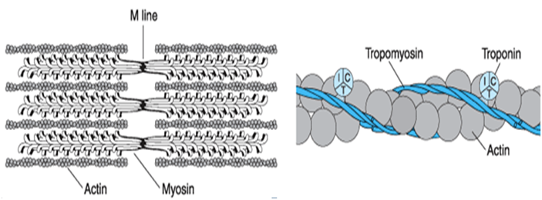
The side-by-side relationship between the myosin and actin filaments is difficult to maintain. This is achieved by a large number of filamentous molecules of a protein called titin. Each titin molecule has a molecular weight of about 3 million, which makes it one of the largest protein molecules in the body extend from the Z line to the M line. Also, because it is filamentous, it is very springy. These springy titin molecules act as a framework that holds the myosin and actin filaments in place so that the contractile machinery of the sarcomere will work.

Sarcoplasm. The many myofibrils of each muscle fiber are suspended side by side in the muscle fiber. The spaces between the myofibrils are filled with intracellular fluid called sarcoplasm, containing large quantities of potassium, magnesium, and phosphate, plus multiple protein enzymes. Also present are massive numbers of mitochondria that lie parallel to the myofibrils. These supply the contracting myofibrils with large amounts of energy in the form of adenosine triphosphate (ATP) formed by the mitochondria.

Sarcoplasmic Reticulum. Also in the sarcoplasm surrounding the myofibrils of each muscle fiber is an extensive reticulum, called the sarcoplasmic reticulum. This reticulum has a special organization (tubular network) that is extremely important in controlling muscle contraction with the T tubule, tubular invaginations of the plasma membrane. T tubule located between adjacent terminal cisternae at the A-I junction. The very rapidly contracting types of muscle fibers have especially extensive sarcoplasmic reticula.

General Mechanism of Muscle Contraction:
Neurons, or nerve cells, are stimulated when the polarity across their plasma membrane changes. The polarity change, called an action potential, travels along the neuron until it reaches the end of the neuron. A gap called a synapse or synaptic cleft separates the neuron from a muscle cell or another neuron. If a neuron stimulates a muscle, then the neuron is a motor neuron, and its specialized synapse is called a neuromuscular junction. Muscle contraction is stimulated through the following steps:

- An action potential travels along a motor nerve to its endings on muscle fibers (End feet). The nerve secretes a small amount of the neurotransmitter substance acetylcholine.

- The acetylcholine acts to open multiple “acetyl choline-gated” channels in the muscle fiber membrane. Opening of the acetylcholine-gated channels allows large quantities of sodium ions to diffuse to the interior of the muscle fiber membrane (T-tubule). This initiates an action potential at the membrane.

- The action potential travels along the muscle fiber membrane in the same way that action potentials travel along nerve fiber membranes. Here it causes to release large quantities of calcium ions from sarcoplasmic reticulum (terminal cisternae).
- The calcium ions initiate attractive forces between the actin and myosin filaments, causing them to slide alongside each other, which is the contractile process called a cross-bridge cycle.

- After a fraction of a second, the calcium ions are pumped back into the sarcoplasmic reticulum by a Ca++ membrane pump, and they remain stored in the reticulum until a new muscle action potential comes along.

Thus electrical events are ends by the release of calcium ions which is necessary for muscle contraction mechanism and therefore any defect occurs in this series will lead to muscle weakness and disease , including:

1- Myasthenia Gravis: is an autoimmune or congenital neuromuscular disease that leads to fluctuating muscle weakness and fatigue. In the most common cases, muscle weakness is caused by circulating antibodies that block acetylcholine receptors at the postsynaptic neuromuscular junction .

2- Lambert-Eaton:- is a rare autoimmune disorder that is characterized by muscle weakness of the limbs. It is the result of an autoimmune reaction in which antibodies are formed against presynaptic voltage-gated calcium channels,

As to stop nervous stimulation hurt muscles , the persistence of neural stimulation also hurt them because it will keep the muscle in a state of constant contraction of the so-called Tetanus which occurs when a muscle's motor unit is stimulated by multiple impulses at a sufficiently high frequency.

Molecular Mechanism of Muscle Contraction

In the relaxed state, the ends of the actin filaments extending from two successive Z discs barely begin to overlap one another. Conversely, in the contracted state, these actin filaments have been pulled inward among the myosin filaments, so that their ends overlap one another to their maximum extent. Also, the Z discs have been pulled by the actin filaments up to the ends of the myosin filaments. Thus, muscle contraction occurs by a sliding filament mechanism.The sliding filament theory of muscle contraction can be broken down into four distinct stages, these are;

- Muscle activation: The motor nerve stimulates an action potential (impulse) to pass down a neuron to the neuromuscular junction. This stimulates the sarcoplasmic reticulum to release calcium into the muscle cell.

- Muscle contraction: Calcium floods into the muscle cell binding with C-troponin allowing actin and myosin to bind by move the molecules. The actin and myosin cross bridges bind and contract using ATP as energy.
- Recharging: ATP is re-synthesised (re-manufactured) bind with the active myosine site in the head which allowing actin slid on myosin as a cross bridge.

- Relaxation: Relaxation occurs when stimulation of the nerve stops. Calcium is pumped back into the sarcoplasmic reticulum breaking the link between actin and myosin. Actin and myosin return to their unbound state causing the muscle to relax. Alternatively relaxation (failure) will also occur when ATP is no longer available.

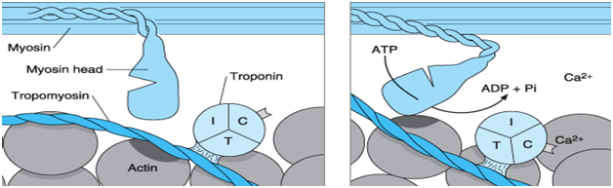

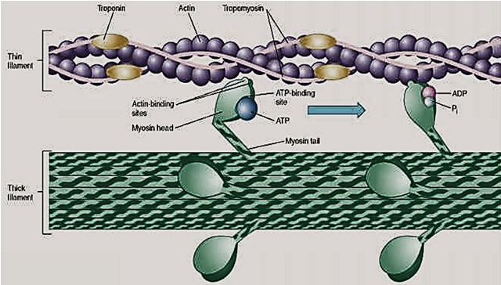

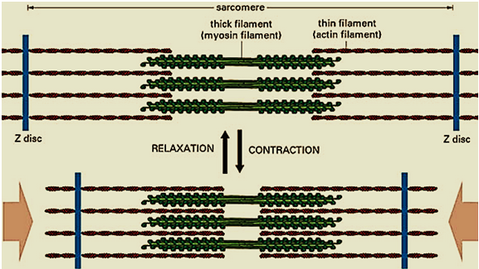

Contractile Response of Skeletal Muscle
Muscle contraction is easily investigated in the laboratory using an isolated muscle. The muscle is attached to an apparatus that produces a myogram, a graphic recording of contractile activity. The response of a motor unit to a single action potential of its motor neuron is called a muscle twitch. The muscle fibers contract quickly and then relax. Every twitch myogram has three distinct phases:-

- Latent period. The latent period is the first few milliseconds following stimulation when excitation contraction coupling is occurring. During this period, muscle tension is beginning to increase but no response is seen on the myogram.

- Period of contraction. This period lasts 10–100ms. If the tension (pull) becomes great enough to overcome the resistance of a load, the muscle shortens.

- Period of relaxation. The period of contraction is followed by the period of relaxation. This final phase, lasting 10–100 ms, the muscle tension decreases to zero and the tracing returns to the baseline. If the muscle shortened during contraction, it now returns to its initial length.

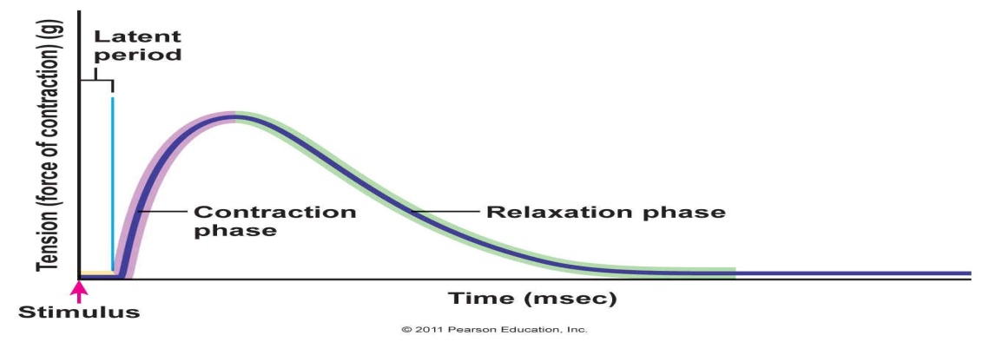

Twitch contractions of some muscles are rapid and brief, as with the muscles controlling eye movements. In contrast, the fibers of fleshy calf muscles (gastrocnemius and soleus) contract more slowly and remain contracted for much longer periods. These differences between muscles reflect metabolic properties of the myo- fibrils and enzyme variations. If two identical stimuli (electrical shocks or nerve impulses) are delivered to a muscle in rapid succession, the second twitch will be stronger than the first. This phenomenon, called wave summation, occurs because the second contraction occurs before the muscle has completely relaxed. Summation requires increasing stimulus frequency. At low frequency, the muscle fiber will relax before the next stimulus impulse occurs. As the stimulus frequency increases and the time between the stimuli decreases, the muscle fiber cannot fully relax before the next stimulus occurs. This loss of relaxation between stimuli is called tetanus which is divided to:

- Complete Tetanus: there is no relaxation in the muscle fiber at all between stimulus impulses.
- Incomplete Tetanus: the muscle fiber is able to partially relax between stimulus impulses.

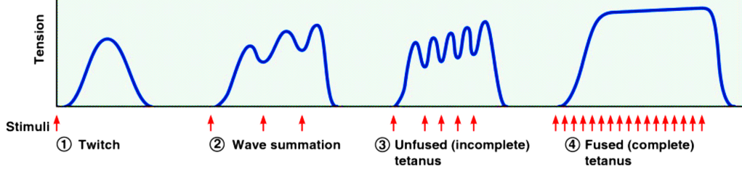
Prolonged and strong contraction of a muscle leads to the well-known state of muscle Fatigue. fatigue results mainly from inability of the contractile and metabolic processes of the muscle fibers to continue supplying the same work output.

Types of Contraction:
There are two main categories of contractions:
- Isotonic contractions: when the muscle shortens or lengthen while the tension on the muscle remanies constant.

- Isometric contractions: when the muscle dose not sortent during contraction while tension is incrasing .

Types of skeletal muscle:-

The muscles that react rapidly are composed mainly of “fast” fibers with only small numbers of the slow variety. Conversely, the muscles that respond slowly but with prolonged contraction are composed mainly of “slow” fibers. The differences between these two types of fibers are as follows.

- Fast Fibers. (1) Large fibers for great strength of contraction. (2) Extensive sarcoplasmic reticulum for rapid release of calcium ions to initiate contraction. (3) Large amounts of glycolytic enzymes for rapid release of energy by the glycolytic process. (4) Less extensive blood supply because oxidative metabolism is of secondary importance. (5) Fewer mitochondria, also because oxidative metabolism is secondary.

- Slow Fibers. (1) Smaller fibers. (2) More extensive blood vessel system and capillaries to supply extra amounts of oxygen. (3) Greatly increased numbers of mitochondria, also to support high levels of oxidative metabolism. (4) Fibers contain large amounts of myoglobin, an iron containing protein similar to hemoglobin in red blood cells. The myoglobin gives the slow muscle a reddish appearance and the name Red muscle, whereas a deficit of red myoglobin in fast muscle gives it the name White muscle.

Energy of Contraction:-
Skeletal muscle depends on several sources of energy to carry out its activities and contraction that can be identified as follows:

- High energy phosphate compounds: Muscles need energy to produce contractions. The energy is derived from adenosine triphosphate (ATP) present in muscles. Muscles tend to contain only limited quantities of ATP. When depleted, ATP needs to be resynthesized from other sources, namely creatine phosphate (CP) and muscle glycogen. Other supplies of glycogen are stored in the liver and the human body is also able to resynthesize ATP from lipids, i.e. free fatty acids. Different modes of energy coverage are used depending on intensity and duration of the workload put on the organism.

- Aerobic metabolism of glucose (Oxydative system): This is a chemical process during which the ATP resynthesis takes place through an aerobic way (with access to oxygen). Both glycogen or glucose and free fatty acids act here as sources of energy. Aerobic glycolysis takes place in the cytoplasm of the cell where 34 ATP molecules are generated from the glycogen, i.e. glucose with oxygen present

- Anaerobic Mechanism (Glycolysis ): It is a chemical process during which ATP gets renewed from glycogen, i.e. glucose in an anaerobic way (without access to oxygen). In these processes lactate, i.e. salt of the lactic acid is generated in muscles. This pathway occurs in both the presence and the absence of oxygen, but because it does not use oxygen, it is an anaerobic pathway. During glycolysis, glucose is broken down to two pyruvic acid molecules, releasing enough energy to form small amounts of ATP (2 ATPs per glucose).

Cardiac Muscle:

The contract mechanism in the cardiac muscle is same in the skeletal only there are functional differences between cardiac muscle and skeletal muscle:

- Since skeletal muscle is more extensible than the cardiac muscle, the passive extension force of cardiac muscle at rest is greater than that of skeletal muscle.

- Action potentials in cardiac muscle are of much longer duration than those in skeletal because K temporarily decreases and Ca increases after rapid in activation of Na channels. This allows the slow influx of Ca²⁺, causing the action potential. As a result, the refractory period does not end until a contraction has almost subsided, therefore, tetanus cannot be evoked in cardiac muscle.

- Unlike skeletal muscle, cardiac muscle has no motor units. Instead, the stimulus spreads across all myocardial fibers of atria and subsequently of the ventricles generating an all-or-none contraction of both atria and, thereafter, both ventricles.

- In cardiac muscle but not in skeletal muscle, the duration of an action potential can change the force of contraction, which is controlled by the variable influx of Ca²⁺ into the cell.

Smooth muscle:

There are significant differences between the two types of muscles, smooth and skeletal, in the way in which Ca⁺²exerts its effects on cross-bridge activity and in the mechanisms by which stimulation leads to alterations in Ca⁺² concentration:
- The thin filaments in smooth muscle do not have the Ca⁺²-binding protein troponin but they have calmodulin, Ca-binding protein.

- Cross-bridge cycle in smooth muscle is controlled by a Ca⁺²-regulated enzyme that phosphorylates myosin.

- Only the phosphorylated form of smooth muscle myosine is able to bind to actine and undergo cross-bridge cycling.

The following sequence of events occurs after a rise in cytosolic Ca⁺² in smooth muscle fiber:
- Ca⁺² binds to calmodulin
- The Ca⁺²-calmodulin complex binds to a protein kinase, myosin light-chain kinase, thereby activating the enzyme.

- The activate protein kinase then uses ATP to phosphorylate myosin light chain in the globular head of myosin. Hense, cross-bridge activity in smooth muscle is turned on by calcium-mediated changes in the thick filaments, whereas in striated muscle, calcium mediates changes in the thin filaments.

Type of smooth muscle:
Many smooth muscles can be placed, however, into one of two groups, based on electrical characteristics of their plasma membrane:

- Single-unit smooth muscle, whose membranes are capable of propagating action potentials from cell to cell through gab junctions and may manifest spontaneous action potentials. Such as, intestinal tract, uterus, and small-diameter blood vessels.

- Multiunit smooth muscle, which exhibit little, if any, propagation of electrical activity from fiber and do not have spontaneous activity. Such as, large airway to the lungs, large arteries, and attached to the hairs in the skin

