Nerves Physiology
The nervous system consists of nerve cells (neurons) and supporting cells. Neuron is the structural and functional unit of the nervous system. A typical neuron consists of the soma or cell body and two types of processes: the axon and dendrites. These cells functionally divided to four zones:
- Receptor Zone: It is the body cell and its dendrites. Dendrites provide a receptive area that transmits electrical impulses to the cell body.
- Impulse origin one: it is the axon hillock, the origin of the axon near the cell body. Here, the nerve impulses originate.
- Impulse transmission zone: it is the reign extends from the axon hillock to the telodendria, the nerve ending. The nerve impulses transmit to synaptic buttons.
- Neurotransmitter secretion zone: it is telodendria and its synaptic buttons which responsible to transmit the impulses to other cell by secret the neurotransmitters.
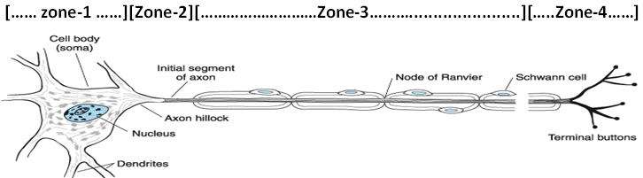

Nerve fibers:
The nerve fibers divided to myelinated and unmyelinated. The myelin sheath formed by oligo dendrocytes. All myelinated axons are surrounded by myelin sheath except Ranvier’s nodes, which have 2000-12000 Na⁺ chanal/µm² axolemma, while in the first one of axone 350-500, in the cell body 50.75, in the myelin sheath 25, in the end of axon 20-75, and in the unmyelinated axons 110. Unmyelinated are smaller than 2µm in diameter, whereas those that are larger are likely to by myelinated. Myelinated axons conduct impulses more rapidly than unmyelinated.

Resting membrane potential (RMP):
An electrical potential difference, or membrane potential, can be recorded across the plasma membrane of living cells. The potential of unstimulated cells, or resting potential, amounts to -9 to 100mV depend of the type of cell. A resting potential is caused by a slightly unbalanced distribution of ions between intracellular fluid (ICF) and extracellular fluid (ECF). The following factors are involved in establishing the membrane potential:
- High K⁺ conductance: it is relatively easy for K⁺ ions to diffuse across the cell membrane. Because of the steep concentration gradient, K⁺ ions diffuse from the ICF to the ECF.

- Maintenance of an unequal distribution of ions: the Na⁺-K⁺ ATPase continuously pumps Na⁺ out of the cell and K⁺ into it by active transport. As a result, the intracellular K⁺ concentration is around 35 times higher and the intracellular Na⁺ concentration is roughly 20 times lower than the extracellular concentration.

- Cl⁻ distribution: a passive distribution of Cl⁻ between intra- and extra- cellular spaces exists only as long as there is no active Cl⁻ uptake into the cell.
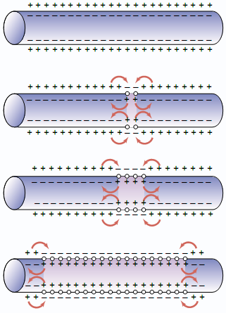

Membrane Action Potential (MAP):
An action potential is a signal passed on through an axon that influences other neurons or induces somatic cell. Excitation of a neuron occurs if the membrane potential on the axon hillock changes from its resting value -70mV to a less negative value -55mV, which called threshold potential. This depolarization may be caused by neurotransmitter-induced opening of postsynaptic action channels or by the transmission of stimuli from the surrounding. If the membrane potential of a stimulated cell comes close to threshold potential, rapid voltage-gated Na⁺ channels are activated. This results in increased Na⁺ conductance, and higher of Na⁺ into the cell. This is resulted a high potential value +35mV called Action potential.
To understand the changes in the membrane potential, Cathode RAY Oscilloscope (CRO) was used to record the electric evidences happened in nerve fiber by microelectrodes. One of microelecrtodes was put on the extra-surface of cell membrane of nerve fiber and the other was put in intra-surface. The excitation of nerve was begun by electric excitation. This instrument records the changes by scheme. The excitation of nerve has four periods:

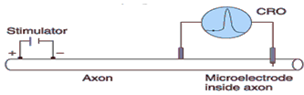

- Latent (resting) period: in this period the membrane potential is stile -70mV (resting potential) to a short or long time according the microelectrodes position.

- Depolarization period: large numbers of Na⁺ channels are activated, and the influxing Na⁺ accelerates depolarization. As a result, the membrane potential is slowly decreased from -70 to -55mV, which called threshold or firing level. After that, the membrane potential is rapidly decreased to (0mV), which called isopotential. The membrane potential temporarily reaches positive levels (+35mV).

There are two types of stimuli:
- Threshold stimuli: it is successful to produce active potential, which its intensity is more than 15mV (-70mV, RMB, -55, threshold=15)
- Sub-threshold stimuli: its intensity is less than 15mV, which cannot reach the threshold so it cannot produce active potential.

- Repolarization period: because the Na⁺ channels are inactivated, the potential reverses, and restoration of the resting potential, the repolarization phase of the action potential, begins. Depolarization has increased the open-probability of voltage gated K⁺ channels. This has increased the potassium conductance, thereby accelerating repolarization.

- Hyperpolarization period: in many cases, potassium conductance is still increased after the original resting potential has been restored, resulting in a hyperpolarization afterpotential. Increased Na⁺-K⁺ ATPase pumping rates can contribute to this afterpotential.

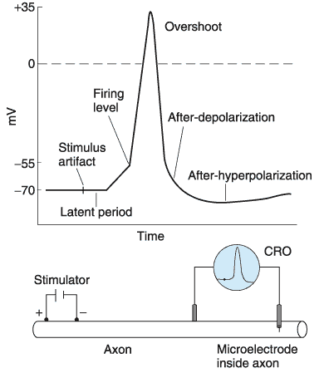

Nerve Impulse: Nerve impulse is an electrochemical phenomenon which includes:
- Electrical, The movement of active potential by stimuli from stimulation point on the long nerve fiber. This is like electrical flows through a cable when voltage is applied.

- Chemical, neurotransmitter is released by regulated exocytosis of synaptic vesicles when the action potential reached it to stimulate the adjacent cells.
Nerve impulse characteristics are:
- All or None Low:
Action potential producing depends on intensity of stimulus and duration of stimulation. All stimuli, which have threshod intensity and enough duration of stimulation, are success to produce action potential. But none, which its intensity is less than threshold, can produce action potential whatever its duration.

- Refractory period:
During an action potential, the cell remains unresponsive to further stimuli. In absolute refractory period, from firing point to repolarization period no other action potential can be triggered, even by extremely strong stimuli, since Na⁺ channels in depolarized membranes cannot be activated. This is flowed by a relative refractory period during which only action potentials of smaller amplitudes and rates or rise can be generated, even by strong stimuli. The refractory period ends once the membrane potential returns to its resting value.
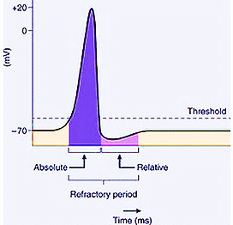
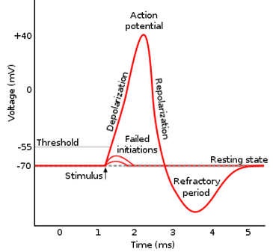

- Impulse conduction:
The start of an action potential is accompanied by a brief influx of Na⁺ into the nerve fiber. The cell membrane that previously was inside negative now becomes positive, thus a longitudinal potential difference with respect to adjacent, still unstimulated nerve segments. This is followed by a passive electrotonic withdrawal of charge from the adjacent segment of the nerve fiber, causing its depolarization. If it exceeds threshold, another action potential is created in the adjacent segment dissipates.

Action potential normally run forward (thodromic conduction) because each segment of nerve fiber becomes refractory when an action potential passes. If, however, the impulse are conducted backwards (antidromic conduction) due, for example, to stimulation of nerve fibers from an external source, they will terminate at the next synapse. Although the continuous generation of action potentials in the immediately adjacent fiber segment guarantees a refreshed signal, this process is rather time-consuming. The continuous conduction or velocity conduction, in unmyelinated nerve fibers is only around 1m/s. myelinated nerve fibers conduct much faster (up to 80m/s). In the Ranvier’s nodes, a myelin sheath insulates the nerve fiber from the surroundings; thus, longitudinal current strong enough to generate action potential can travels further down the axon. This results in more rapid conduction because the action potential is generated only at the Ranvier’s nodes, where there is a high density of Na⁺ channel. This results in rapid, jump-like passage of the action potential from node to node (salutatory conduction).
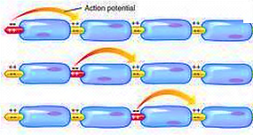
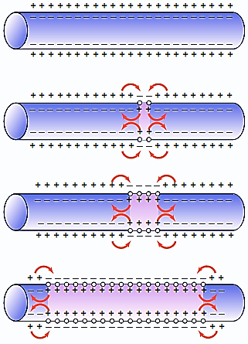

- Velocity of conduction: The conduction velocity depends on:
- Myelination: the conduction velocity of such myelinated nerve fiber is much higher than that of unmyelinated nerve fibers.

- Diameter: the conduction velocity increases with the diameter of nerve fiber.
Classification of nerve fiber according its conduction velocity:
- Type-A-nerve fiber:

Its conduction velocity is very high (2-80m/s) because it is myelinated and big diameter (1-16µm). It is called fast fiber such as somatic nerve fiber which pressure and touch sensation. It is can triggered the nerve impulse under anesthesia because of myeline sheath, but cannot triggered the nerve impulse under compression because of the big diameter which cause the paralysis.

- Type-B-nerve fiber:

Their conduction velocity is less than types-A (3-15m/s) because it is myelinated but smaller diameter (3µm). It is called moderate fiber such as visceral nerve fibers which pressure and touch sensation like type A.

- Type-C-nerve fiber:

Its conduction velocity is very low (0.25-1.5m/s) because it is unmyelinated and small diameter (0.5-1.5µm).it is called slow fibers such as all nerve fiber which pain and temperature sensation. It is cannot triggered the nerve impulse under anesthesia, because it is unmyelinated; and under compression, because of the small diameter.

- Compound action potential:

Synaptic transmission:

At the chemical synapse, the arrival of an action potential in the axon triggers the release of transmitter form the presynaptic axon terminals (presynaptic membrane). The transmitter then diffuses across the narrow synaptic cleft to bind postsynaptically to receptors in the subsynaptic or postsynaptic membrane of a neuron or of glandular or muscle cell. Depending on the type of transmitter and receptor involved, the effect on the postsynaptic membrane may either be excitatory or inhibitory. Excitatory neurotransmitters such as Acetyl choline (Ach) and Norepinephrine (NE) open Ca²⁺ channels leading to an increase in the cytosolic Ca²⁺ concentration, which increases the action potential. Inhibitory neurotransmitters such as Glycine and Gamma Amino Butyric Acid (GABA) open K⁺ or Cl⁻ channels, as a result, excitatory postsynaptic potential related depolarization is reduced and stimulation of postsynaptic neurons is inhibited.
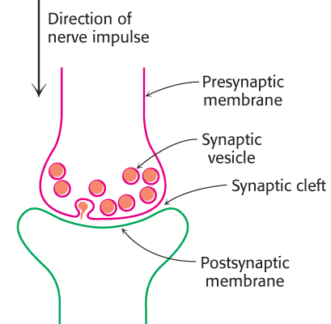

A signal excitatory postsynaptic potential normally is not able to generate a postsynaptic (axonal) action potential, but requires the triggering of a large number of local depolarizations in the dendrites. Their depolarizations are transmitted electrotonically across the soma and summed on the axon hillock (spatial summation). Should the individual stimuli arrive at different times, the prior depolarization will not have dissipated before the next one arrives, and summation will make it easier to reach threshold. This type of temporal summation therefore increases the excitability of the postsynaptic neuron.

