Membranous Structures of the Cell
Most organelles of the cell are covered by membranes composed primarily of lipids and proteins. These membranes include the cell membrane, nuclear membrane, membrane of the endoplasmic reticulum, and membranes of the mitochondria, lysosomes, and Golgi apparatus.

The Cell Membrane
The cell membrane (also called the plasma membrane), which envelops the cell, is a thin, pliable, elastic structure only 7.5 to 10 nanometers thick. It is composed almost entirely of proteins and lipids. The approximate composition is proteins, 55 %; phospholipids, 25 %; cholesterol, 13% other lipids, 4 %; and carbohydrates, 3 %. Cell membranes are selectively permeable semipermeable (some things can pass through and some can’t).

1) Lipid Barrier of the Cell Membrane

Its basic structure is a lipid bilayer, which is a thin, double-layered film of lipids—each layer only one molecule thick that is continuous over the entire cell surface. Interspersed in this lipid film are large globular protein molecules. The basic lipid bilayer is composed of phospholipid molecules. One end of each phospholipid molecule is soluble in water; that is, it is hydrophilic. The other end is soluble only in fats; that is, it is hydrophobic. Because the hydrophobic portions of the phospholipid molecules are repelled by water but are mutually attracted to one another, they have a natural tendency to attach to one another in the middle of the membrane, as shown in Figure. The hydrophilic phosphate portions then constitute the two surfaces of the complete cell membrane, in contact with intracellular water on the inside of the membrane and extracellular water on the outside surface.

The lipid layer in the middle of the membrane is impermeable to the usual water-soluble substances, such as ions, glucose, and urea. Conversely, fat-soluble substances, such as oxygen, carbon dioxide, and alcohol, can penetrate this portion of the membrane with ease.
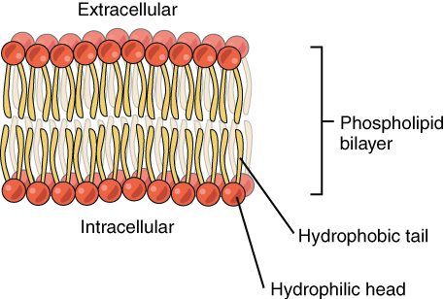

2) Cell Membrane Proteins
Most of the cell membrane are glycoproteins. Two types of proteins occur: integral proteins that protrude all the way through the membrane, and peripheral proteins that are attached only to one surface of the membrane and do not penetrate all the way through. Many of the integral proteins provide structural channels (or pores) through which water molecules and water-soluble substances, especially ions, can diffuse between the extracellular and intracellular fluids. These protein channels also have selective properties that allow diffusion of some substances over others. Other integral proteins act as carrier proteins for transporting substances that otherwise could not penetrate the lipid bilayer. Sometimes these even transport substances in the direction opposite to their natural direction of diffusion, which is called “active transport.” Still others act as enzymes.

Integral membrane proteins can also serve as receptors for water-soluble chemicals, such as peptide hormones, that do not easily penetrate the cell membrane. Interaction of cell membrane receptors with specific ligands that bind to the receptor causes conformational changes in the receptor protein. This, in turn, enzymatically activates the intracellular part of the protein or induces interactions between the receptor and proteins in the cytoplasm that act as second messengers, thereby relaying the signal from the extracellular part of the receptor to the interior of the cell. In this way, integral proteins spanning the cell membrane provide a means of information about the environment to the cell interior.

Peripheral protein molecules are often attached to the integral proteins. These peripheral proteins function almost entirely as enzymes or as controllers of transport of substances through the cell membrane “pores.”

3) Membrane Carbohydrates—The Cell “Glycocalyx.”
Membrane carbohydrates occur almost invariably in combination with proteins or lipids in the form of glycoproteins or glycolipids. In fact, most of the integral proteins are glycoproteins, and about one tenth of the membrane lipid molecules are glycolipids. The “glyco” portions of these molecules almost invariably protrude to the outside of the cell, dangling outward from the
cell surface. The carbohydrate have several important functions:

(1) Many of them have a negative electrical charge, which gives most cells an overall negative surface charge that repels other negative objects.

(2) The glycocalyx of some cells attaches to the glycocalyx of other cells, thus attaching cells to one another.

(3) Many of the carbohydrates act as receptor substances for binding hormones, such as insulin; when bound, this combination activates attached internal proteins that, in turn, activate a cascade of intracellular enzymes.

(4) Some carbohydrate enter into immune reactions.

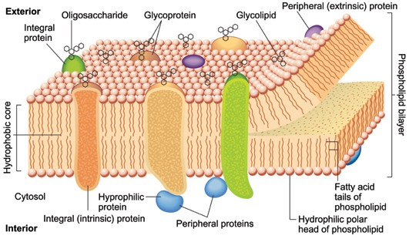

Mechanism of Solutes Transport

All cells need to import oxygen, sugars, amino acids, and some small ions and to export carbon dioxide, metabolic wastes, and secretions. At the same time, specialized cells require mechanisms to transport molecules such as enzymes, hormones, and neurotransmitters. The movement of large molecules is carried out by Endocytosis and Exocytosis, the transfer of substances into or out of the cell, respectively, by vesicle formation and vesicle fusion with the plasma membrane. Cells also have mechanisms for the rapid movement of ions and solute molecules across the plasma membrane. These mechanisms are of two general types: Passive movement (Passive Transport), which requires no direct expenditure of metabolic energy, and Active movement (Active transport), which uses metabolic energy to drive solute transport.

Macromolecules Cross the Plasma Membrane by Vesicle Fusion

A) Endocytosis – is a general term for the process in which a region of the plasma membrane is pinched off to form an endocytic vesicle inside the cell. During vesicle formation, some fluid, dissolved solutes, and particulate material from the extracellular medium are trapped inside the vesicle and internalized by the cell , three main types of endocytosis can be distinguished :-

1- Phagocytosis – is the ingestion of large particles or microorganisms, usually occurring only in specialized cells such as macrophages. An important function of macrophages in human is to remove invading bacteria. The phagocytic vesicle is almost as large as the phagocytic cell itself. Phagocytosis requires a specific stimulus. It occurs only after the extracellular particle has bound to the extracellular surface. The particle is then enveloped by expansion of the cell membrane around it.

2- Pinocytosis: is the nonspecific uptake of the extracellular fluid and all its dissolved solutes. The material is trapped inside the endocytic vesicle as it is pinched off inside the cell. The amount of extracellular material internalized by this process is directly proportional to its concentration in the extracellular solution.

3- Receptor mediated Endocytosis is a more efficient process that uses receptors on the cell surface to bind specific molecules. These receptors accumulate at specific depressions known as coated pits, so named because the cytosolic surface of the membrane at this site is covered with a coat of several proteins. The coated pits pinch off continually to form endocytic vesicles, providing the cell with a mechanism for rapid internalization of a large amount of a specific molecule without the need to endocytose large volumes of extracellular fluid. Receptor-mediated endocytosis is the mechanism by which cells take up a variety of important molecules, including hormones; growth factors; and serum transport proteins, such as transferrin (an iron carrier). Foreign substances, such as diphtheria toxin and certain viruses, also enter cells by this pathway.

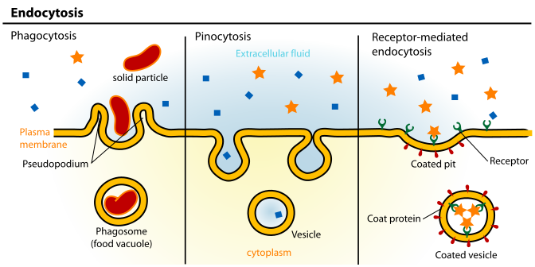
Almost immediately after a pinocytotic or phagocytic vesicle appears inside a cell, one or more lysosomes become attached to the vesicle and empty their acid hydrolases to the inside of the vesicle. Thus, a digestive vesicle is formed inside the cell cytoplasm in which the vesicular hydrolases begin hydrolyzing the proteins, carbohydrates, lipids, and other substances in the vesicle. The products of digestion are small molecules of amino acids, glucose, phosphates, and so forth that can diffuse through the membrane of the vesicle into the cytoplasm. Thus, the pinocytotic and phagocytic vesicles containing lysosomes can be called the digestive organs of the cells.

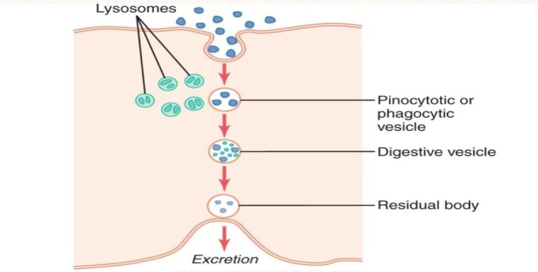

B) Exocytosis
Many cells synthesize important macromolecules that are destined for Exocytosis or export from the cell. These molecules are synthesized in the endoplasmic reticulum, modified in the Golgi apparatus, and packed inside transport vesicles. The vesicles move to the cell surface, fuse with the cell membrane, and release their contents outside the cell. There are two exocytic pathways constitutive and regulated. Some proteins are secreted continuously by the cells that make them. Secretion of mucus by goblet cells in the small intestine is a specific example. In this case, exocytosis follows the constitutive pathway, which is present in all cells. In other cells, macromolecules are stored inside the cell in secretary vesicles. These vesicles fuse with the cell membrane and release their contents only when a specific extracellular stimulus arrives at the cell membrane. This pathway, known as the regulated pathway, is responsible for the rapid “on-demand” secretion of many specific hormones, neurotransmitters, and digestive enzymes.

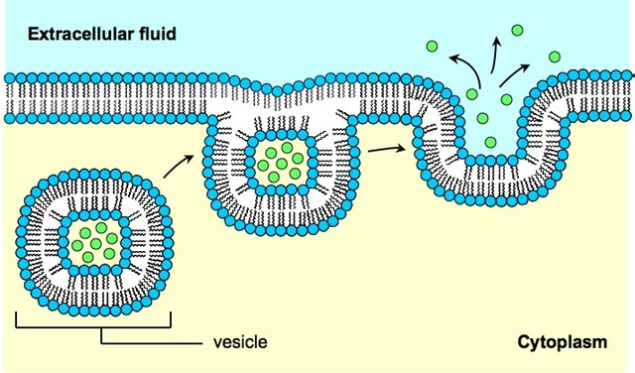

C) Diffusion (Passive Transport)

It’s means random molecular movement of substances molecule by molecule, either through intermolecular spaces in the membrane or in combination with a carrier protein. The energy that causes diffusion is the energy of the normal kinetic motion of matter. Diffusion is a passive process: The solutes move down the concentration gradient and don't use extra cellular energy to move. [Material movement from an area of high concentration to an area with lower concentration. The difference of concentration between the two areas is often termed as the concentration gradient ]. Diffusion through the cell membrane is divided into three subtypes called simple diffusion, facilitated diffusion. and Filtration.

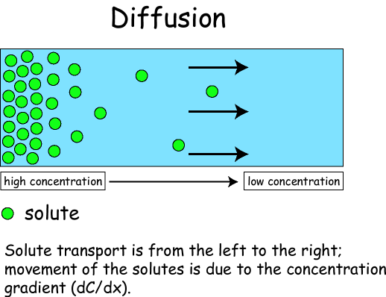

- Simple diffusion: means that kinetic movement of molecules or ions occurs through a membrane opening or through intermolecular spaces without any interaction with carrier proteins in the membrane. In simple diffusion the solute is movement from a high concentration to a lower concentration until the concentration of the solute is uniform throughout and reaches equilibrium. The rate of diffusion is determined by the amount of substance available, the velocity of kinetic motion, and the number and sizes of openings in the membrane through which the molecules or ions can move.

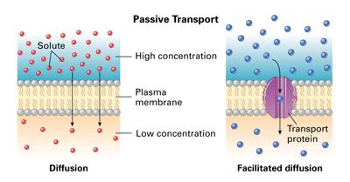

Computerized three-dimensional reconstructions of protein channels have demonstrated tubular pathways all the way from the extracellular to the intracellular fluid. Therefore, substances can move by simple diffusion directly along these channels from one side of the membrane to the other. The protein channels are distinguished by two important characteristics: (1) they are often selectively permeable to certain substances, and (2) many of the channels can be opened or closed by gates.

Many of the protein channels are highly selective for transport of one or more specific ions or molecules. This results from the characteristics of the channel itself, such as its diameter, its shape, and the nature of the electrical charges and chemical bonds along its inside surfaces. To give an example, one of the most important of the protein channels, the so-called sodium channel, is only 0.3 by 0.5 nanometer in diameter, but more important, the inner surfaces of this channel are strongly negatively charged. These strong negative charges can pull small
dehydrated sodium ions into these channels, actually pulling the sodium ions away from their hydrating water molecules. Once in the channel, the sodium ions diffuse in either direction according to the usual laws of diffusion. Thus, the sodium channel is specifically selective for passage of sodium ions. Conversely, another set of protein channels is selective for potassium transport. These channels are slightly smaller than the sodium channels, only 0.3 by 0.3 nanometer, but they are not negatively charged, and their chemical bonds are different. The hydrated form of the potassium ion is considerably smaller than the hydrated form of sodium because the sodium ion attracts far more water molecules than does potassium. Therefore, the smaller hydrated potassium ions can pass easily through this small channel, whereas the larger hydrated sodium ions are rejected, thus providing selective permeability for a specific ion.

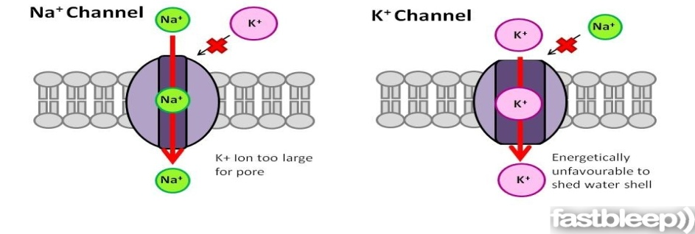

Osmosis is the diffusion of water molecules across a selectively permeable membrane. The net movement of water molecules through a partially permeable membrane from a solution of high water potential to an area of low water potential. A cell with a less negative water potential will draw in water but this depends on other factors as well such as solute potential (pressure in the cell e.g. solute molecules) and pressure potential (external pressure e.g. cell wall). The Osmotic Pressure is defined to be the minimum pressure required to maintain an equilibrium, with no net movement of solvent.
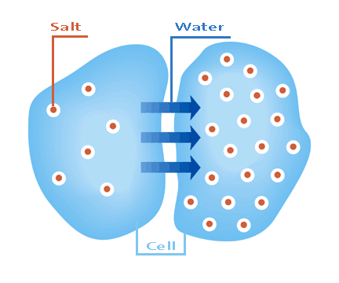
Osmosis: the diffusion of water

- Facilitated diffusion: also called carrier-mediated diffusion, is the movement of molecules across the cell membrane via special transport proteins that are embedded within the cellular membrane. Many large molecules, such as glucose, are insoluble in lipids and too large to fit through the membrane pores. Therefore, it will bind with its specific carrier proteins, and the complex will then be bonded to a receptor site and moved through the cellular membrane. Facilitated diffusion is a passive process: The solutes move down the concentration gradient and don't use extra cellular energy to move. Facilitated diffusion differs from simple diffusion in the following important way: Although the rate of simple diffusion through an open channel increases proportionately with the concentration of the diffusing substance, in facilitated diffusion the rate of diffusion approaches a maximum, called V_{max}, as the concentration of the diffusing substance increases.

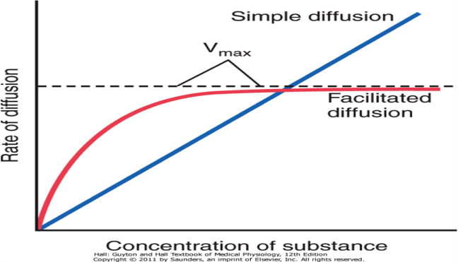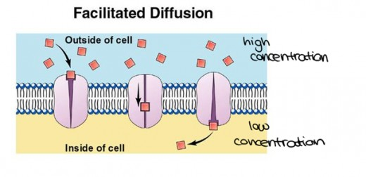

- Filtration is movement of water and solute molecules across the cell membrane due to hydrostatic pressure generated by the cardiovascular system. Depending on the size of the membrane pores, only solutes of a certain size may pass through it. For example, the membrane pores of the Bowman's capsule in the kidneys are very small, and only albumins, the smallest of the proteins, have any chance of being filtered through. On the other hand, the membrane pores of liver cells are extremely large, to allow a variety of solutes to pass through and be metabolized.

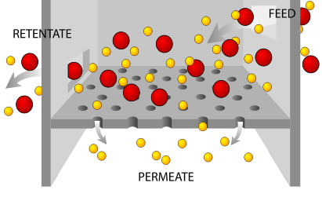 Filtration

D) Active Transport
is the movement of molecules across a cell membrane in the direction against their concentration gradient, i.e. moving from an area of lower concentration to an area of higher concentration. Active transport is usually associated with accumulating high concentrations of molecules that the cell needs, such as ions, glucose and amino acids. Active transport uses cellular energy, unlike passive transport, which does not use cellular energy. Active transport is a good example of a process for which cells require energy. Examples of active transport include the uptake of glucose in the intestines in humans. Active transport is divided into two types according to the source of the energy used to cause the transport: primary active transport and secondary active transport. In both instances, transport depends on carrier proteins that penetrate through the cell membrane, as is true for facilitated diffusion. However, in active transport, the carrier protein functions differently from the carrier in facilitated diffusion because it is capable of imparting energy to the transported substance to move it against the electrochemical gradient.

- Primary Active transport :
Primary active transport, also called direct active transport, directly uses metabolic energy which is derived from breakdown of adenosine triphosphate (ATP) or of some other high-energy phosphate compound. The active transport mechanism that has been studied in greatest detail is the sodium-potassium (Na+-K+) pump, which helps to maintain the cell potential. Active transport is responsible for the fact that cells contain a relatively high concentrations of potassium ions but low concentrations of sodium ions. The mechanism responsible for this is the sodium-potassium pump, which moves these two ions in opposite directions across the plasma membrane. This was investigated by following the passage of radioactively labeled ions across the plasma membrane of certain cells. It was found that the concentrations of sodium and potassium ions on the two sides of the membrane are interdependent, suggesting that the same carrier transports both ions. It is now known that the carrier is an ATP-ase and that it pumps three sodium ions out of the cell for every two potassium ions pumped in. The Na+-K+ pump has three specific features that are important for the functioning of the pump:

1. It has three receptor sites for binding sodium ions on the pump of the protein that protrudes to
the inside of the cell.
2. It has two receptor sites for potassium ions on the outside.
3. The inside portion of this pump near the sodium binding sites has ATPase activity.

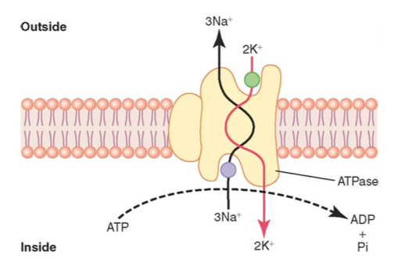

- Secondary Active Transport
In secondary active transport, also known as coupled transport or co-transport, energy is used to transport molecules across a membrane; however, in contrast to primary active transport, there is no direct coupling of ATP; instead it relies upon the electrochemical potential difference created by pumping ions in/out of the cell. Permitting one ion or molecule to move down an electrochemical gradient, but possibly against the concentration gradient where it is more concentrated to that where it is less concentrated increases entropy and can serve as a source of energy for metabolism (e.g. in ATP synthase).

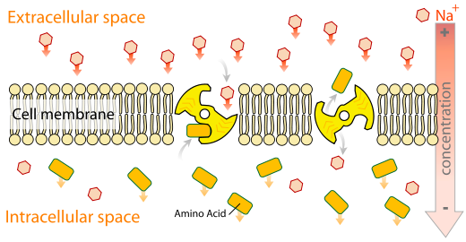

In August 1960, in Prague, Robert K. Crane presented for the first time his discovery of the sodium-glucose cotransport as the mechanism for intestinal glucose absorption. Cotransporters can be classified as Syn-cotransport and Anti-cotransport depending on whether the substances move in the same or opposite directions.

1) Syn-Cotransport
Syn-Cotransport uses the downhill movement of one solute species from high to low concentration to move another molecule uphill from low concentration to high concentration (against its electrochemical gradient). Both molecules are transported in the same direction. An example is the glucose symporter , which co-transports one glucose (or galactose) molecule into the cell for every two sodium ions it imports into the cell.

2) Antiport (Anti-Cotransport)
In an antiport two species of ion or other solutes are pumped in opposite directions across a membrane. One of these species is allowed to flow from high to low concentration which yields the entropic energy to drive the transport of the other solute from a low concentration region to a high one. An example is the sodium-calcium exchanger or antiporter, which allows three sodium ions into the cell to transport one calcium out.

