SUBNETTING:

QUESTION 1

The Certkiller Texas branch network is displayed in the following diagram:

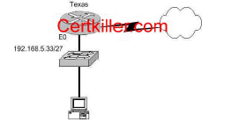

Of the following choices, which IP address should be assigned to the PC host?

A. 192.168.5.5
B. 192.168.5.32
C. 192.168.5.40
D. 192.168.5.63
E. 192.168.5.75

QUESTION 2

Which address represents a unicast address?

A. 224.1.5.2
B. FFFF. FFFF. FFFF.
C. 192.168.24.59/30
D. 255.255.255.255
E. 172.31.128.255/18

QUESTION 3

If a host on a network has the address 172.16.45.14/30, what is the address of the
subnetwork to which this host belongs?

A. 172.16.45.0
B. 172.16.45.4
C. 172.16.45.8
D. 172.16.45.12
E. 172.16.45.18

QUESTION 4

Which one of the binary number ranges shown below corresponds to the value of the first
octet in Class B address range?

A. 10000000-11101111
B. 11000000-11101111
C. 10000000-10111111
D. 10000000-11111111
E. 11000000-10111111

QUESTION 5

Which two of the addresses below are available for host addresses on the subnet
192.168.15.19/28? (Select two answer choices)

A. 192.168.15.17
B. 192.168.15.14
C. 192.168.15.29
D. 192.168.15.16
E. 192.168.15.31
F. None of the above

QUESTION 6

You have a Class C network, and you need ten subnets. You wish to have as many
addresses available for hosts as possible. Which one of the following subnet masks
should you use?

A. 255.255.255.192
B. 255.255.255.224
C. 255.255.255.240
D. 255.255.255.248
E. None of the above

QUESTION 7

Which of the following is an example of a valid unicast host IP address?

A. 172.31.128.255./18
B. 255.255.255.255
C. 192.168.24.59/30
D. FFFF.FFFF.FFFF
E. 224.1.5.2
F. All of the above

QUESTION 8

How many subnetworks and hosts are available per subnet if you apply a /28 mask
to the 210.10.2.0 class C network?

A. 30 networks and 6 hosts.
B. 6 networks and 30 hosts.
C. 8 networks and 32 hosts.
D. 32 networks and 18 hosts.
E. 14 networks and 14 hosts.
F. None of the above

QUESTION 9

The Certkiller network was assigned the Class C network 199.166.131.0 from the
ISP. If the administrator at Certkiller were to subnet this class C network using the
255.255.255.224 subnet mask, how may hosts will they be able to support on each
subnet?

A. 14
B. 16
C. 30
D. 32
E. 62
F. 64

QUESTION 10

What is the subnet for the host IP address 172.16.210.0/22?

A. 172.16.42.0
B. 172.16.107.0
C. 172.16.208.0
D. 172.16.252.0
E. 172.16.254.0
F. None of the above

QUESTION 11

What is the subnet for the host IP address 201.100.5.68/28?

A. 201.100.5.0
B. 201.100.5.32
C. 201.100.5.64
D. 201.100.5.65
E. 201.100.5.31
F. 201.100.5.1

QUESTION 13

What is the IP address range for the first octet in a class B address, in binary form?

A. 00000111-10001111
B. 00000011-10011111
C. 10000000-10111111
D. 11000000-11011111
E. 11100000-11101111
F. None of the above

QUESTION 14

Which one of the binary bit patterns below denotes a Class B address?
A. 0xxxxxxx
B. 10xxxxxx
C. 110xxxxx
D. 1110xxxx
E. 11110xxx

QUESTION 15

The Certkiller network consists of 5 different departments as shown below:

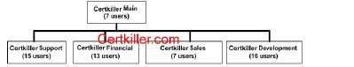

You are a systems administrator at Certkiller and you've just acquired a new Class
C IP network. Which of one of the subnet masks below is capable of providing one
useful subnet for each of the above departments (support, financial, sales &
development) while still allowing enough usable host addresses to meet the needs of
each department?

A. 255.255.255.128
B. 255.255.255.192
C. 255.255.255.224
D. 255.255.255.240
E. 255.255.255.248
F. 255.255.255.252

QUESTION 16

Your network uses the172.12.0.0 class B address. You need to support 459 hosts per
subnet, while accommodating the maximum number of subnets. Which mask would
you use?

A. 255.255.0.0.
B. 255.255.128.0.
C. 255.255.224.0.
D. 255.255.254.0.

QUESTION 17

Using a subnet mask of 255.255.255.224, which of the IP addresses below can you
assign to the hosts on this subnet? (Select all that apply)

A. 16.23.118.63
B. 87.45.16.159
C. 92.11.178.93
D. 134.178.18.56
E. 192.168.16.87
F. 217.168.166.192

QUESTION 18

Your ISP has assigned you the following IP address and subnet mask:
IP address: 199.141.27.0
Subnet mask: 255.255.255.240
Which of the following addresses can be allocated to hosts on the resulting subnet?
(Select all that apply)

A. 199.141.27.2
B. 199.141.27.175
C. 199.141.27.13
D. 199.141.27.11
E. 199.141.27.208
F. 199.141.27.112

QUESTION 19

The IP network 210.106.14.0 is subnetted using a /24 mask. How many usable
networks and host addresses can be obtained from this?

A. 1 network with 254 hosts
B. 4 networks with 128 hosts
C. 2 networks with 24 hosts
D. 6 networks with 64 hosts
E. 8 networks with 36 hosts

QUESTION 20

Given that you have a class B IP address network range, which of the subnet masks
below will allow for 100 subnets with 500 usable host addresses per subnet?

A. 255.255.0.0
B. 255.255.224.0
C. 255.255.254.0
D. 255.255.255.0
E. 255.255.255.224

QUESTION 21

You have a class C network, and you need to design it for 5 usable subnets with each
subnet handling a minimum of 18 hosts each. Which of the following network masks
should you use?

A. 225.225.224.0.
B. 225.225.240.0.
C. 225.225.255.0.
D. 255.255.255.224
E. 225.225.255.240

QUESTION 22

The 213.115.77.0 network was subnetted using a /28 subnet mask. How many
usable subnets and host addresses per subnet were created as a result of this?

A. 2 networks with 62 hosts
B. 6 networks with 30 hosts
C. 16 networks and 16 hosts
D. 62 networks and 2 hosts
E. 14 networks and 14 hosts
F. None of the above

QUESTION 23

The 201.145.32.0 network is subnetted using a /26 mask. How many networks and
IP hosts per network exists using this subnet mask?

A. 4 networks with 64 hosts
B. 64 networks and 4 hosts
C. 2 networks and 62 hosts
D. 62 networks and 2 hosts
E. 6 network and 30 hosts

QUESTION 24

You have a class B network with a 255.255.255.0 mask. Which of the statements
below are true of this network? (Select all valid answers)

A. There are 254 usable subnets.
B. There are 256 usable hosts per subnet.
C. There are 50 usable subnets.
D. There are 254 usable hosts per subnet.
E. There are 24 usable hosts per subnet.
F. There is one usable network.

QUESTION 25
How many usable IP addresses can you get from a conventional Class C address?
A. 128
B. 192
C. 254
D. 256
E. 510

QUESTION 26

Your ISP assigned you a full class B address space. From this, you need at least 300
sub-networks that can support at least 50 hosts each. Which of the subnet masks
below are capable of satisfying your needs? (Select two).

A. 255.255.255.0
B. 255.255.255.128
C. 255.255.252.0
D. 255.255.255.224
E. 255.255.255.192
F. 255.255.248.0

QUESTION 27

Your work PC has the IP address 172.16.209.10 /22. What is the subnet of this
address?

A. 172.16.42.0
B. 172.16.107.0
C. 172.16.208.0
D. 172.16.252.0
E. 172.16.254.0

QUESTION 28

You've been assigned the CIDR (classless inter domain routing) block of
115.64.4.0/22 from your ISP. Which of the IP addresses below can you use for a
host? (Select all valid answers)

A. 115.64.8.32
B. 115.64.7.64
C. 115.64.6.255
D. 115.64.3.255
E. 115.64.5.128
F. 115.64.12.128

QUESTION 29

The Certkiller network is shown in the following diagram:

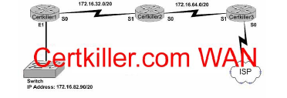

In the above network diagram,what are the broadcast addresses of the subnets?
(Select three)

A. 172.16.82.255
B. 172.16.95.255
C. 172.16.64.255
D. 172.16.32.255
E. 172.16.47.255
F. 172.16.79.255

QUESTION 30

You have a single Class C IP address and a point-to-point serial link that you want
to implement VLSM on. Which subnet mask is the most efficient?

A. 255.255.255.0
B. 255.255.255.240
C. 255.255.255.248
D. 255.255.255.252
E. 255.255.255.254

QUESTION 30

You have a network that supports VLSM and you need to reduce IP address waste
in your point to point WAN links. Which of the masks below would you use?

A. /38
B. /30
C. /27
D. /23
E. /18
F. /32

QUESTION 31

Which of the following IP hosts would be valid for PC users, assuming that a /27
network mask was used for all of the networks? (Choose all that apply.)

A. 15.234.118.63
B. 83.121.178.93
C. 134.178.18.56
D. 192.168.19.37
E. 201.45.116.159
F. 217.63.12.192

QUESTION 33

Certkiller has three locations and has plans to redesign the network accordingly. The
networking team received 192.168.126.0 to use as the addressing for entire network
from the administrator. After subnetting the address, the team is ready to assign the
address.
The administrator plans to configure ip subnet-zero and use RIP v2 as the routing
protocol. As a member of the networking team, you must address the network and
at the same time converse unused addresses for future growth.
Being mindful of these goals, drag the host addresses on the left to the correct router
interface. One of the routers is partially configured. Move the mouse over a router
to view its configuration. Not all of the host addresses on the left will be used.
Drag and drop

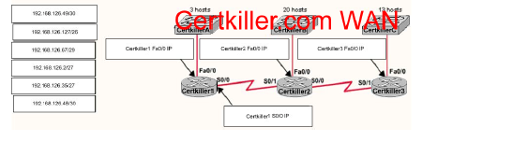
QUESTION 34

The Certkiller network has been divided into 5 separate departments as displayed

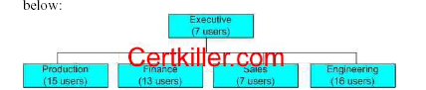

Using a Class C IP network, which subnet mask will provide one usable subnet per
department while allowing enough usable host addresses for each department
specified in the graphic?

A. 255.255.255.0
B. 255.255.255.192
C. 255.255.255.224
D. 255.255.255.240
E. 255.255.255.248
F. 255.255.255.252

QUESTION 35

Certkiller has three locations and has plans to redesign the network accordingly. The
networking team received 192.168.55.0 to use as the addressing for entire networkinterface. One of the routers is partially configured. Not all of the host addresses on

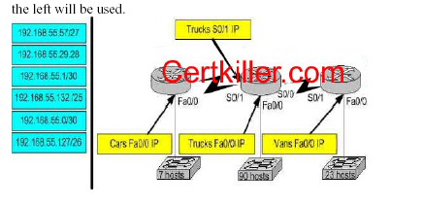

The administrator plans to configure ip subnet-zero and use RIP v2 as the routing
protocol. As a member of the networking team, you must address the network and
at the same time converse unused addresses for future growth.
Being mindful of these goals, drag the host addresses on the left to the correct router
interface. One of the routers is partially configured. Not all of the host addresses on
the left will be used.

QUESTION 36

You are the network administrator at Certkiller . Certkiller has been assigned the
class C IP address 189.66.1.0 by its Internet Service Provider. If you divide the
network range by using the 255.255.255.224 subnet mask, how many hosts can be
supported on each network?

A. 14
B. 16
C. 30
D. 32
E. 62
F. 64

QUESTION 37

Which of the following are true regarding a network with a subnet mask of
255.255.248.0. Choose three

A. It corresponds to a Class A address with 13 bits borrowed.
B. It corresponds to a Class B address with 4 bits borrowed.
C. The network address of the last subnet will have 248 in the 3rd octet.
D. The first 21 bits make the host portion of the address.
E. This subnet mask allows for 16 total subnets to be created.
F. The subnetwork numbers will be in multiples of 8.

QUESTION 38

Which of the following IP addresses is a private IP address?

A. 12.0.0.1
B. 168.172.19.39
C. 172.20.14.36
D. 172.33.194.30
E. 192.168.42.34

QUESTION 39

What is the subnetwork address for a host with the IP address 201.100.5.68/28?

A. 201.100.5.0
B. 201.100.5.32
C. 201.100.5.64
D. 201.100.5.65
E. 201.100.5.31
F. 201.100.5.1

QUESTION 40

Which of the following IP addresses fall into the CIDR block of 115.54.4.0/22? Select
three

A. 115.54.8.32
B. 115.54.7.64
C. 115.54.6.255
D. 115.54.3.32
E. 115.54.5.128
F. 115.54.12.128

QUESTION 41

If an Ethernet port on router was assigned an IP address of 172.16.112.1/20, what is
the maximum number of hosts allowed on this subnet?

A. 1024
B. 2046
C. 4094
D. 4096
E. 8190

QUESTION 42

You work as network consultant. Your customer, Certkiller Inc, has a class C
network license. Certkiller wants you to subnet the network to provide a separate
subnet for each of its 5 departments. Each subnet must support at least 24 hosts.
Which subnet mask should you use?
Which network mask should you use?

A. 255.255.255.192
B. 255.255.255.224
C. 255.255.255.240
D. 255.255.255.248
E. 255.255.255.252
F. 255.255.255.254

QUESTION 43

Your Certkiller trainee Bob asks you what 11111001 binary is in decimal. What
should you tell him?

A. 6
B. 193
C. 225
D. 241
E. 249
QUESTION 44

What is the maximum number of IP addresses that can be assigned to hosts on a
local subnet that use the 255.255.255.224 subnet mask?

A. 14
B. 15
C. 16
D. 30
E. 31
F. 32

QUESTION 45

Which of the following IP addresses for the network 27.35.16.32/28 can be assigned
to hosts? Choose three

A. 27.35.16.32
B. 27.35.16.33
C. 27.35.16.48
D. 27.35.16.47
E. 27.35.16.45
F. 27.35.16.44
QUESTION 46

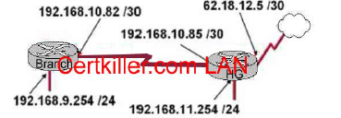

After the router interfaces shown in the diagram have been configured, it is
discovered that hosts in the Branch LAN cannot access the Internet.
Further testing reveals additional connectivity issues.
What will fix this problem?

A. Change the address of the Branch router LAN interface.
B. Change the address of the Branch router WAN interface.
C. Change the subnet mask of the HQ router LAN interface.
D. Change the address of the HQ router LAN interface.
E. Change the address of the HQ router interface to the Internet.
F. Change the subnet mask of the HQ router interface to the Internet.

QUESTION 47

A portion of he Certkiller network is shown in the diagram below:

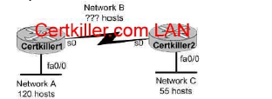

Consider the 192.1.1.0/24 network in this exhibit. This network uses RIP v2.
Which combination of subnetwork assignments will satisfy the requirements for
networks A, B, and C of this design? (Select three)

A. Network A = 192.1.1.128/25
B. Network A = 192.1.1.0/25
C. Network B = 192.1.1.252/30
D. Network B = 192.1.1.4/30
E. Network C = 192.1.1.64/26
F. Network C = 192.1.1.224/27
QUESTION 48

The Certkiller network topology is displayed in the following diagram:

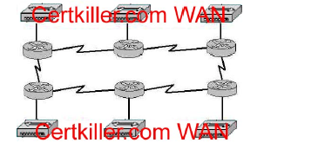

Assume that RIP v1 is the only routing protocol in use. What is the Maximum
number of usable IP address that can be supported on each LAN if the Certkiller
network is using one Class C address block?

A. 14
B. 16
C. 30
D. 32
E. 62
F. 64

QUESTION 49

You are a systems administrator and you are about to assign static IP addresses to
various servers on your network. For the network 192.168.20.24/29 the router is
assigned to the first usable host address, while the last usable host address goes to
your Sales server.
Which one of the following commands would you enter into the IP properties box of
the sales server?

A. IP address: 192.168.20.14 Subnet Mask: 255.255.255.248 Default Gateway:
192.168.20.9
B. IP address: 192.168.20.254 Subnet Mask: 255.255.255.0 Default Gateway:
192.168.20.1
C. IP address: 192.168.20.30 Subnet Mask 255.255.255.248 Default Gateway:
192.168.20.25
D. IP address: 192.168.20.30 Subnet Mask 255.255.255.240 Default Gateway:
192.168.20.17
E. IP address: 192.168.20.30 Subnet Mask 255.255.255.240 Default Gateway:
192.168.20.25

QUESTION 50

You've been assigned a single Class C address. From this, you need 8 subnets, and
your subnet mask is 255.255.255.224. Which one of the following configuration
commands would you have to use before you begin?

A. Router(config)# ip classless
B. Router(config)# ip subnet-zero
C. Router(config)# ip version 6
D. Router(config)# no ip classful
E. Router(config)# ip unnumbered
F. Router(config)# ip all-nets

QUESTION 51

Study the following exhibit:

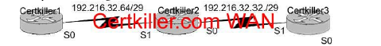

Taking the information from the above exhibit; which command line below would
correctly configure serial port0 on the Certkiller 2 router with the LAST usable host
addresses on the 192.216.32.32 subnet?

A. Certkiller 2(config-if)# ip address 192.216.32.63 255.255.255.248
B. Certkiller 2(config-if)# ip address 192.216.32.38 255.255.255.240
C. Certkiller 2(config-if)# ip address 192.216.32.39 255.255.255.248
D. Certkiller 2(config-if)# ip address 192.216.32.63 255.255.255.248 no shut
E. Certkiller 2(config-if)# ip address 192.216.32.39 255.255.255.248 no shut
F. Certkiller 2(config-if)# ip address 192.216.32.38 255.255.255.248

QUESTION 52

The Certkiller Network is displayed as follows:
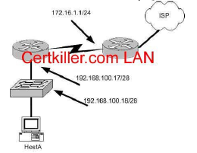

What is a valid possible IP address configuration for Host A?

A. IP 192.168.100.31 255.255.255.240 default-gateway 192.168.100.18
B. IP 192.168.100.30 255.255.255.240 default-gateway 172.16.1.1
C. IP 192.168.100.20 255.255.255.240 default-gateway 192.168.100.17
D. IP 192.168.100.21 255.255.255.248 default-gateway 192.168.100.17
E. IP 192.168.100.19 255.255.255.248 default-gateway 172.16.1.1

QUESTION 53

Study the exhibit below:
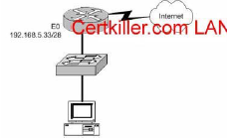

Which of the following would be a valid IP address of the PC?

A. 192.168.5.55
B. 192.168.5.47
C. 192.168.5.40
D. 192.168.5.32
E. 192.168.5.14

QUESTION 54

You are on the Certkiller network design team and have the task of networking
three Certkiller locations together. Your team will be using the address range
192.168.55.0. RIP v2 will be used as the routing protocol, and "ip subnet-zero" will
be configured. Your goal is to fulfill the address needs of the network while
conserving unused addresses for potential future growth.
With these goals in mind, drag the host addresses on the left side to the correct
router interface on the right side. Not all the addresses are going to be used, and one
of the routers is already partially configured.

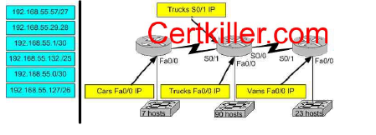

QUESTION 55

The Certkiller network is shown in the following exhibit:

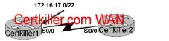

What command would you use to configure the correct IP address and subnet mask
on Certkiller 2's serial interface?

A. Certkiller 2(config-if)# ip address 172.16.17.1 255.255.255.0
B. Certkiller 2(config-if)# ip address 172.16.18.2 255 255. 252.0
C. Certkiller 2(config-if)# ip address 172.16.17.2 255.255.255.252
D. Certkiller 2(config-if)# ip address 172.16.16.0 255.255.255.0

QUESTION 56

The Certkiller connection between the BMW and ATL routers are displayed below:
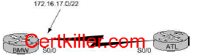

Based on the information above, which of the following commands can be used to
configure the address on the ATL serial 0/0 interface?

A. ATL(config-if)# ip address 172.16.17.1 255.255.255.0
B. ATL(config-if)# ip address 172.16.18.255. 255.255.252.0
C. ATL(config-if)# ip address 172.16.17.2 255.255.255.252
D. ATL(config-if)# ip address 172.16.16.0 255.255.255.0
E. None of the above

QUESTION 57

Which of the following addresses can be assigned to a host when using a subnet
mask of 255.255.254.0? (Select three)

A. 113.10.4.0
B. 186.54.3.0
C. 175.33.3.255
D. 26.35.3.255
E. 152.135.7.0
F. 17.35.36.0

QUESTION 58

Which command will assign the last usable IP address from the 192.168.32.128/28
subnetwork to a router interface?

A. Certkiller A(config-if)# ip address 192.168.32.142 255.255.255.240
B. Certkiller A(config-if)# ip address 192.168.32.143 255.255.255.240
C. Certkiller A(config-if)# ip address 192.168.32.158 255.255.255.240
D. Certkiller A(config-if)# ip address 192.168.32.145 255.255.255.240
E. Certkiller A(config-if)# ip address 192.168.32.144 255.255.255.240
F. Certkiller A(config-if)# ip address 192.168.32.158 255.255.255.240

QUESTION 59

Network topology exhibit

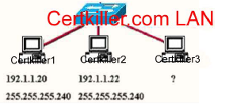

A Certkiller .com network administrator is adding host Certkiller 3 to the network
shown in the exhibit.
Which IP address can be assigned this host on this network?

A. 192.1.1.14
B. 192.1.1.18
C. 192.1.1.20
D. 192.1.1.30
E. 192.1.1.31
F. 192.1.1.36

QUESTION 59

Study the exhibit below:

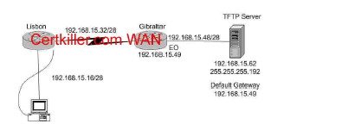

A systems administrator in Lisbon configured a new router to connect with his
company's head office in Gibraltar. He attempted to create and save an image file
of the new router on the TFTP server in Gibraltar but failed. Based on the
information given by above exhibit, what is the underlying problem?

A. The IP address if the TFTP server not correct.
B. There is an incorrect subnet mask of the TFTP server.
C. The default gateway of the TFTP server not properly set.
D. The subnet mask on the Lisbon router not correct
E. There is an incorrect IP address configured on E0 of the Gibraltar router
QUESTION 60

The Certkiller router is running RIP as the routing protocol, and the IP routing table
is displayed below:
Gateway of last resort is 10.1.2.2 to network 0.0.0.0
10.0.0.0/24 is subnetted, 2 subnets
R 10.1.3.0 [120/1] via 10.1.2.2, 00:00:00, Serial0/0
C 10.1.2.0 is directly connected, Serial0/0
C 10.1.5.0 is directly connected, Serial0/1
C 10.1.6.0 is directly connected, FastEthernet0/0
R* 0.0.0.0/0 [120/1] via 10.1.5.5, 00:00:00, Serial0/1
Based on the output above, if an administrator pings host 10.1.8.5 from host
10.1.6.100, how will the router Certkiller A process the ICMP packets?

A. The packets will be discarded.
B. The packets will be routed out the S0/0 interface.
C. The packets will be routed out the S0/1 interface.
D. The packets will be routed out the Fa0/0 interface.
E. The packets will be routed through the 10.1.2.2 gateway.

QUESTION 60

You work as a network engineer at Certkiller .com. Certkiller .com is redesigning the
network that connects its three locations. You are give the 192.168.9.1 addressing to
be used for the entire network. After the subnetting the address, you are ready to
assign the addresses. You place to configure ip subnet-zero and use RIP v2 as the
routing protocol. Now you must address the network and at the same time conserve
unused addresses for future growth. You are required to place the host addresses to
the correct interface. On of the routers is partially configured. You can view the
configuration by placing the mouse over the router. Not all host addresses will be
used.
Drag and Drop
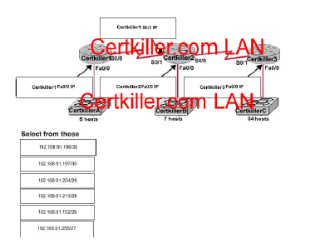

QUESTION 61

Certkiller has three locations and has plans to redesign the network accordingly. The
networking team received 192.168.132.0 to use as the addressing for entire network
from the administrator. After subnetting the address, the team is ready to assign the
address.
The administrator plans to configure ip subnet-zero and use RIP v2 as the routing
protocol. As a member of the networking team, you must address the network and
at the same time converse unused addresses for future growth.
Being mindful of these goals, drag the host addresses on the left to the correct router
interface. One of the routers is partially configured. Move the mouse over a router
to view its configuration. Not all of the host addresses on the left will be used.
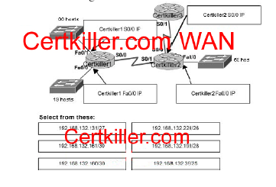

QUESTION 62

In network that support VLSM, which network mask should be used for point-topoint
WAN links in order to reduce waste of IP addresses?

A. /24
B. /30
C. /27
D. /26
E. /32

QUESTION 63

The network 172.25.0.0 has been divided into eight equal subnets. Which of the
following IP addresses can be assigned to hosts in the third subnet if the ip subnetzero
command is configured on the router? (Choose three)

A. 172.25.78.243
B. 172.25.98.16
C. 172.25.72.0
D. 172.25.94.255
E. 172.25.96.17
F. 172.25.100.16

QUESTION 64

Certkiller has three locations and has plans to redesign the network accordingly. The
networking team received 192.168.199.0 to use as the addressing for entire network
from the administrator. After subnetting the address, the team is ready to assign the
address.
The administrator plans to configure ip subnet-zero and use RIP v2 as the routing
protocol. As a member of the networking team, you must address the network and
at the same time converse unused addresses for future growth.
Being mindful of these goals, drag the host addresses on the left to the correct router
interface. One of the routers is partially configured. Move the mouse over a router
to view its configuration. Not all of the host addresses on the left will be used.
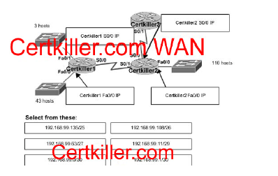
QUESTION 65

Certkiller has three locations and has plans to redesign the network accordingly. The
networking team received 192.168.197.0 to use as the addressing for entire network
from the administrator. After subnetting the address, the team is ready to assign the
address.
The administrator plans to configure ip subnet-zero and use RIP v2 as the routing
protocol. As a member of the networking team, you must address the network and
at the same time converse unused addresses for future growth.
Being mindful of these goals, drag the host addresses on the left to the correct router
interface. One of the routers is partially configured. Move the mouse over a router
to view its configuration. Not all of the host addresses on the left will be used.
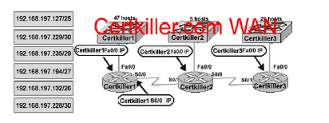
QUESTION 66

Certkiller has three locations and has plans to redesign the network accordingly. The
networking team received 192.168.15.0 to use as the addressing for entire network
from the administrator. After subnetting the address, the team is ready to assign the
address.
The administrator plans to configure ip subnet-zero and use RIP v2 as the routing
protocol. As a member of the networking team, you must address the network and
at the same time converse unused addresses for future growth.
Being mindful of these goals, drag the host addresses on the left to the correct router
interface. One of the routers is partially configured. Move the mouse over a router
to view its configuration. Not all of the host addresses on the left will be used.

