CHAPTER TWO

Mobile IP

2.1 Introduction

Mobile Computing is becoming increasingly important due to the rise in the number of portable computers and the desire to have continuous network connectivity to the Internet irrespective of the physical location of the node. The Internet infrastructure is built on top of a collection of protocols, called the TCP/IP protocol suite. Transmission Control Protocol (TCP) and Internet Protocol (IP) are the core protocols in this suite.
IP requires the location of any host connected to the Internet to be uniquely identified by an assigned IP address. This raises one of the most important issues in mobility, because when a host moves to another physical location, it has to change its IP address. However, the higher level protocols require IP address of a host to be fixed for identifying connections. The Mobile Internet Protocol (Mobile IP) is an extension to the Internet Protocol proposed by the Internet Engineering Task Force (IETF) that addresses this issue. It enables mobile computers to stay connected to the Internet regardless of their location and without changing their IP address. More precisely, Mobile IP is a standard protocol that builds on the Internet Protocol by making mobility transparent to applications and higher level protocols like TCP [6].

2.2 The TCP/IP Protocol Suite
TCP/IP protocol suite is a four-layer system. Each layer is responsible for a specific task . The four layers, from top to bottom, are application layer, transport layer, network layer, and link layer. The application layer handles the details of the particular application (e.g., FTP, TELNET, HTTP etc.). The transport layer provides a flow of data between two Internet nodes. There are two widely used transport layer protocols on the Internet: TCP (Transmission Control Protocol) and UDP (User Datagram Protocol). TCP provides a reliable flow of data between two nodes by maintaining a connection-oriented environment. On the other hand, UDP provides an unreliable and connectionless datagram service. The network layer handles the movement of packets around the network by implementing efficient routing algorithms. IP (Internet Protocol) , the default network layer protocol on the Internet, is described in detail in the next section. The link layer provides interfaces to the network hardware devices in the form of device drivers.
The overall protocol stack is also a tightly-coupled system. Each layer provides some services that the upper layers use. Thus, support for mobility is likely to affect all the layers. Mobile IP extends IP to support mobile computing. The next section gives an overview of IP, as a preamble to Mobile IP.

2.3 Brief Overview of IPv4
At the network layer, the Internet is viewed as a set of networks or autonomous systems connected together in a hierarchical manner. IP is the mechanism that connects these networks together. Its basic function is to deliver data from a source to a destination independent of the physical location of the two.
IP identifies each node uniquely, using an IP address that designates its physical attachment to the Internet. IP addresses are 32-bit long integers and are represented in a dotted decimal format (e.g., 128.55.44.1), for ease of use. Every IP packet consists of an IP header and an IP payload. The header contains the IP addresses of the sending node and the receiving node along with some other information. To correctly deliver these packets, IP executes two major steps: packet routing and packet forwarding. Packet routing involves use of protocols like BGP, RIP, and OSPF to decide the route that each packet has to travel. The route is decided using a routing table of < destination address, next hop > pairs at each router. Destination addresses are paired with a pair contained in the routing table. Packet forwarding involves use of protocols like ARP etc. to deliver the packet to the end node once it has arrived at the destination network. This is typically done by discovering the hardware address of the host corresponding to its IP address.
2.4 Motivation for the Mobile IP design
The IP address of a host consists of two parts :
1) The higher order bits of the address determine the network on which the host resides;
2) The remaining low-order bits determine the host number.
IP decides the next-hop by determining the network information from the destination IP address of the packet. Thus, while trying to support mobility on the Internet under the existing protocol suite, we are faced with two mutually conflicting requirements:
(1) a mobile node has to change its IP address whenever it changes its point of attachment, so that packets destined to the node are routed correctly,
(2) to maintain existing TCP connections, the mobile node has to keep its IP address the same. Changing the IP address will cause the connection to be disrupted and lost.
Mobile IP, the standard proposed by IETF, is designed to solve the problem by allowing each mobile node to have two IP addresses and by transparently maintaining the binding between the two addresses [9]. One of the IP addresses is the permanent home address that is assigned at the home network and is used to identify communication endpoints. The other is a temporary care-of address that represents the current location of the host. The main goals of Mobile IP are to make mobility transparent to the higher level protocols and to make minimum changes to the existing Internet infrastructure.

2.5 Mobile IP Entities :
Mobile IP is consisting of the following entities:
Mobile Node (MN): A host or router that may change its point of attachment from one network or sub network to another through the internet. This entity is pre-assigned a fixed home address on a home network, which other correspondent hosts will use to address their packets to, regardless of its current location.
Home Agent (HA): A router that maintains a list of registered mobile nodes in a visitor list. It is used to forward mobile node-addressed packets to the appropriate local network when the mobile nodes are away from home. After checking with the current mobility bindings for a particular mobile node, it encapsulates (see below) datagrams and sends it to the mobile host's current temporary address when the mobile node.
Foreign Agent (FA): A router that assists a locally reachable mobile node that is away from its home network. It delivers information between the mobile node and the home agent.
Care-of-address (COA): An address which identifies the mobile node's current location. It can be viewed as the end of a tunnel (see below) directed towards a mobile node. It can be either assigned dynamically or associated with its foreign agent.
Correspondent Node (CN): This node sends the packets which are addressed to the mobile node.

Home Address: A permanent IP address that is assigned to a mobile node. It remains unchanged regardless of where the mobile node is attached to the internet.
Mobility Agent: An agent which supports mobility. It could be either a home agent or a foreign agent.
Tunnel: The path which is taken by encapsulated packets. It is the path which leads packets from the home agent to the foreign agent.

2.6 Overview of the Protocol:
As discussed in the last section, Mobile IP supports mobility by transparently binding the home address of the mobile node with its care-of address. This mobility binding is maintained by some specialized routers known as mobility agents. Mobility agents are of two types - home agents and foreign agents. The home agent, a designated router in the home network of the mobile node, maintains the mobility binding in a mobility binding table where each entry is identified by the tuple <permanent home address, temporary care-of address, association lifetime>. Figure 1 shows a mobility binding table. The purpose of this table is to map a mobile node's home address with its care-of address and forward packets accordingly.
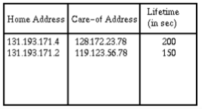

Figure 1: Mobility Binding Table
Foreign agents are specialized routers on the foreign network where the mobile node is currently visiting. The foreign agent maintains a visitor list which contains information about the mobile nodes currently visiting that network. Each entry in the visitor list is identified by the tuple: < permanent home address, home agent address, media address of the mobile node, association lifetime>. Figure 2 shows an instance of a visitor list.
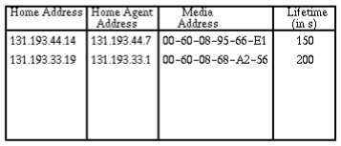
In a typical scenario, the care-of address of a mobile node is the foreign agent's IP address. There can be another kind of care-of address, known as colocated care-of address, which is usually obtained by some external address assignment mechanism.

Figure 2 : instance of a visitor list.
The basic Mobile IP protocol has four distinct stages. These are:
- Agent Discovery: Agent Discovery consists of the following steps:
- Mobility agents advertise their presence by periodically broadcasting Agent Advertisement messages. An Agent Advertisement message lists one or more care-of addresses and a flag indicating whether it is a home agent or a foreign agent.
- The mobile node receiving the Agent Advertisement message observes whether the message is from its own home agent and determines whether it is on the home network or a foreign network.
- If a mobile node does not wish to wait for the periodic advertisement, it can send out Agent Solicitation messages that will be responded by a mobility agent.
- Registration: Registration consists of the following steps:
- If a mobile node discovers that it is on the home network, it operates without any mobility services.
- If the mobile node is on a new network, it registers with the foreign agent by sending a Registration Request message which includes the permanent IP address of the mobile host and the IP address of its home agent.
- The foreign agent in turn performs the registration process on behalf of the mobile host by sending a Registration Request containing the permanent IP address of the mobile node and the IP address of the foreign agent to the home agent.
- When the home agent receives the Registration Request, it updates the mobility binding by associating the care-of address of the mobile node with its home address.
- The home agent then sends an acknowledgement to the foreign agent.
- The foreign agent in turn updates its visitor list by inserting the entry for the mobile node and relays the reply to the mobile node.
Figure 3 illustrates the registration process.
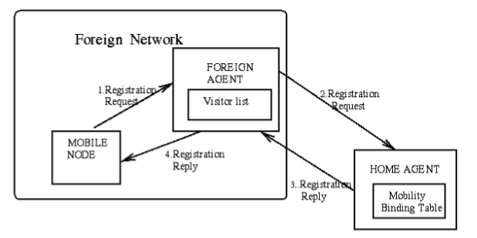
Figure 3: Registration process in Mobile IP
- In Service: This stage can be subdivided into the following steps:
- When a correspondent node wants to communicate with the mobile node, it sends an IP packet addressed to the permanent IP address of the mobile node.
- The home agent intercepts this packet and consult the mobility binding table to find out if the mobile node is currently visiting any other network.
- The home agent finds out the mobile node's care-of address and constructs a new IP header that contains the mobile node's care-of address as the destination IP address. The original IP packet is put into the payload of this IP packet. It then sends the packet. This process of encapsulating one IP packet into the payload of another is known as IP-within-IP encapsulation ,or tunneling.
Figure 4 illustrates the tunneling operation.
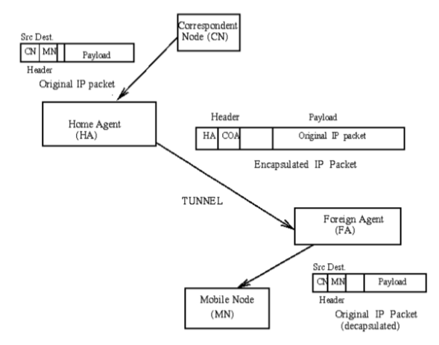
Figure 4: Tunneling operation in Mobile IP
- When the encapsulated packet reaches the mobile node's current network, the foreign agent decapsulates the packet and finds out the mobile node's home address. It then consults the visitor list to see if it has an entry for that mobile node.
- If there is an entry for the mobile node on the visitor list, the foreign agent retrieves the corresponding media address and relays it to the mobile node.
- When the mobile node wants to send a message to a correspondent node, it forwards the packet to the foreign agent, which in turn relays the packet to the correspondent node using normal IP routing.
- The foreign agent continues serving the mobile node until the granted lifetime expires. If the mobile node wants to continue the service, it has to reissue the Registration Request.

- Deregistration: If a mobile node wants to drop its care-of address, it has to deregister with its home agent. It achieves this by sending a Registration Request with the lifetime set to zero. There is no need for deregistering with the foreign agent as registration automatically expires when lifetime becomes zero. However if the mobile node visits a new network, the old foreign network does not know the new care-of address of the mobile node. Thus datagrams already forwarded by the home agent to the old foreign agent of the mobile node are lost.

