Protoplast isolation and regeneration
1. Introduction
The term protoplast was introduced by Hanstein in 1880. It refers to the cellular content excluding cell wall or can also be called as naked plant cell. It is described as living matter enclosed by a plant cell membrane. Protoplast isolation for the first time was carried out by Klercker in 1892 using mechanical method on the plasmolysed cells. The application of protoplast technology for the improvement of plants offers fascinating option to complement conventional breeding programs. The ability of isolated protoplasts to undergo fusion and take up macromolecules and cell organelles offers many possibilities in genetic engineering and crop improvement (Bhojwani et al . 1977). The experiments involving protoplasts consist of three stages –
i. protoplast isolation
ii. protoplast fusion (leading to gene uptake)
iii. development of regenerated fertile plants from the fusion product (Hybrid).
Depending upon the species and culture conditions, the protoplasts may have the potential to:
i. regenerate a cell wall
ii. dedifferentiate to form callus
iii. divide mitotically and proliferate clonally
iv redifferentiate into shoots, roots or embryos and produce a complete plantlet.
However, to fully explore the potentials for protoplast-technology, efficient and reproducible methods for protoplast isolation and purification must first be established. Since leaf tissue is a readily accessible source of genetically uniform cells, it is often desirable to use mesophyll protoplasts in somatic hybridization studies, but, leaf tissues, in general, do not yield large number of protoplasts owing to the difficulty in removing the lower epidermis (Chaturvedi 2003). An alternative, therefore, is the cultured cell material where protoplasts can show greater potential to divide (Bhojwani and Razdan 1996).

2. Protoplast isolation
Protoplast isolation may be carried out by Mechanical disruption method or enzymatic method. Out of these two methods, enzymatic method is preferred as it provides better protoplast yield with low tissue damage while mechanical method causes maximum tissue chopping with lower protoplast yields. Both of these methods are described below:

i. Mechanical method
Klercker in 1892 pioneered the isolation of protoplasts by mechanical methods. In this method, the cells were kept in suitable plasmolyticum, for example CPW containing 13% w/v mannitol. Once the plasmolysis is complete, while remaining in the osmoticum, the leaf lamina would be cut with a sharp-edged knife. In this process some of the plasmolyzed cells were cut only through the cell wall, releasing intact protoplasts while some of the protoplasts may be damaged inside many cells. Protoplasts that were trapped in a cell and only the corner had been cut off could be encouraged to come out by reducing the osmolarity slightly to force the protoplasts swell to force their way out of the cut surface. The released protoplasts then have to be separated from damaged ones and cell debris.
Disadvantages
• Lower protoplast yield.
• Labour intensive method.
• Protoplast obtained has low viability.
• Method is applicable only to vacuolated cells.
1
ii. Enzymatic method
In 1960, E.C. Cocking demonstrated the possibility of enzymatic isolation of a large number of protoplasts from cells of higher plants. This method involves leaf sterilization followed by peeling of the lower epidermis to release cells which are plasmolyzed and added to enzyme mixture followed by harvest of protoplast as shown in (Figure 12.1). Either of the procedures for enzymatic isolation can be used: sequential enzymatic hydrolysis or mixed enzymatic hydrolysis.
In the sequential isolation, firstly, cells are separated by the use of a maceration enzyme – a pectin hydrolyzing enzyme such as, macerozyme or Pectolyase. Once the cells are separated, they are washed in CPW solution free of enzymes but containing plasmolyticum by gentle centrifugation (100g). The pellet is retained and resuspended in the second enzyme like, cellulases and hemicellulases, used to hydrolyse the remaining cell was component. Once the protoplasts are released they are washed with CPW to remove the debris.
In the mixed enzymatic approach, Plant tissues are plasmolyzed in the presence of a mixture of pectinases and cellulases, thus, inducing simultaneous separation of cells and degradation of their walls to release the protoplasts directly in a single step.

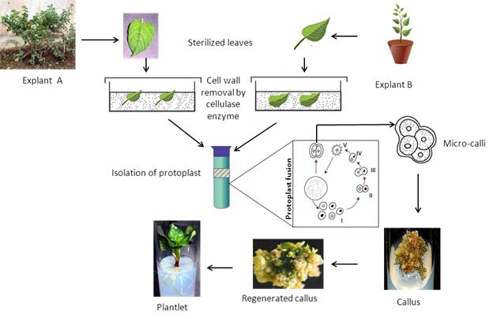
Figure 12.1: Steps involved in protoplast isolation, fusion and regeneration
Conditions required for enzyme activity :
Enzymes are pH and temperature dependent, thus, for enzymatic release of protoplast an enzyme showing activity at pH range 4.7-6.0 and temperature range of 25-30°C is used
• Duration of enzyme pretreatment and condition of light presence required for incubation may also be determined.
• Enzyme mixture used should essentially consist of cellulose, hemicellulase and pectinase which facilitate the degradation of cellulose, hemicelluloses and pectin, respectively.
• The concentration of sugar alcohols used as osmoticum (mannitol) must be empirically defined.
2.1. Factors affecting yield and viability of protoplasts
i. Source of material : Leaves were the most convenient source of the plant protoplasts because it allows the isolation of a large number of relatively uniform cells without killing the plants. Moreover the mesophyll cells are loosely arranged, the enzymes have an easy access to the cell wall. The parent plant age and the conditions in which it is growing have profound effect on the yield of protoplast. Due to the difficulty in isolating culturable protoplast from leaf cells of cereals and some other species their cultured cells can be used as a source material. The yield of protoplasts depends upon the growth rate and growth phase of the cells. Generally embryogenic suspension cultures are used to obtain totipotent protoplasts .
ii. Pre-enzyme treatments : To facilitate the penetration of enzyme solution into the intercellular spaces of leaf, which is essential for effective digestion, various methods are followed. The most commonly used method is to peel the lower epidermis and float the stripped pieces of leaf on the enzyme solution in a manner that the peeled surface is in a contact with the solution. Most of the time it is not convenient to peel the epidermis, in such cases cutting the leaf or tissue into small strips (1- 2 mm wide) has been found useful. When combined with vacuum infiltration the latter approach has proved very effective. Brushing of leaves with a soft brush or with the cutting edge of a scalpel may also improve the enzymatic action. Large calli are chopped into pieces and can be transferred to enzyme mixture. Agitation of incubation mixture during enzyme treatment improves protoplast yield from cultured cells.
iii. Enzyme treatment : The release of protoplast is very much dependent on the nature and concentration of the enzymes used. The two major enzymes required for the isolation of protoplast are cellulase and pectinase. The cellulase is required to digest the cellulosic cell walls and the pectinase mainly degrades the middle lamella. Some of the tissues may require other enzymes like, hemicellulase, driselase, macerozyme and pectolyase. The activity of enzyme is pH dependent. The pH of the enzyme solution is adjusted somewhere between 4.7 to 6.0.
2.2. Choice of plasmolyticum
The two most commonly used compounds are the sugar alcohols - mannitol and sorbitol. Of these, mannitol is the most preferred since it is not metabolized by the plant cells. Once the protoplast divides and regenerates the cell wall, no more osmoticum is required. It is, therefore, should be removed gradually from the medium otherwise cell division stops. To slowly remove the osmoticum from the medium, the protoplast can be isolated in a high osmoticum mixture consisting of both mannitol and sucrose, the sucrose will be metabolized by the dividing protoplasts and thus, will reduce the osmolarity of the medium. Normally, mannitol is used at concentration range of 11-13%. A solution into which the osmoticum is often, but not always, added is called CPW salts mix or CPW for short. This has been observed much more beneficial than using distilled water as a solvent in obtaining high yields of viable protoplasts:
Although CPW is most widely used solution into which osmoticum or enzymes are added, some times culture medium used to grow cells or plants can also be utilized for protoplast isolation at one tenth concentration. Low concentration of culture medium is much more advantageous when compared with CPW.

Table 12.1: Salt mix of protoplast washing media solution (Cocking, Peberdy and White - CPW)
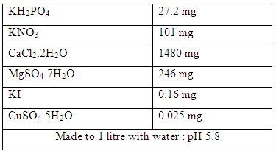
2.3. Protoplast purification
Enzyme treatment results in suspension of protoplast, undigested tissues and cellular debris. This suspension is passed through a metal sieve or a nylon mesh (50-100 µm) in order to remove undigested cellular clumps. The filtered protoplast-enzyme solution is mixed with a suitable volume of osmoticum, solution is centrifuged to pellet the protoplasts, pellet of protoplast is resuspended in osmoticum of similar concentration as used in enzyme mixture. The protoplast band is sucked in Pasteur pipette and is put into other centrifuge and finally suspended in culture medium at particular density; this is explained by the Figure 12. 2.

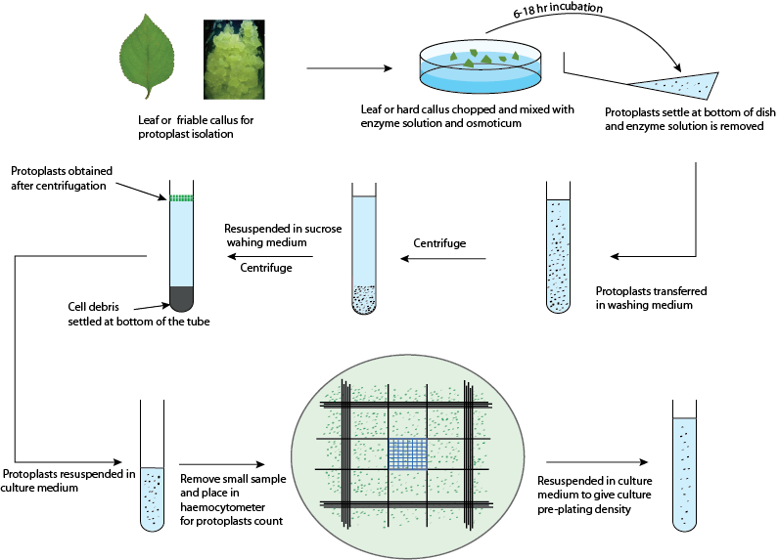

Figure 12.2: schematic diagram of protoplast purification
2.4. Protoplast viability : The isolated protoplast must have a spherical shape when observed by a light microscope, protoplast can be stained using following stain:
• Fluorescein diacetate staining method: FDA accumulates inside the plasmalemma of viable protoplasts. Live protoplasts contain esterases which cleave FDA to release fluorescein which fluoresces yellowish-green using fluorescence microscopy within 5 min. FDA dissociates from membrane after about 15 min. It is used at a concentration of 0.01% dissolved in acetone.
• Calcofluor White staining: This staining method assures protoplast viability by detecting onset of cell wall formation. Calcofluor binds to beta linked glucosides in newly synthesized cell wall which can be observed as a fluorescent ring around the membrane. Optimum staining is achieved when 0.1 ml of protoplast is mixed with 5.0 μl of 0.1% w/v solution of CFW.
• Protoplast viability can also be detected by monitoring oxygen uptake of cells by oxygen electrode, which shows respiration.

• Variation of protoplast size with changing osmotic concentration also enables viability of protoplast.
3. Protoplast culture
3.1. Protoplasts culture techniques
The culture requirements and the culture methods are same for both protoplasts and single cells. The main difference is the requirement of suitable osmoticum for protoplasts until they regenerate a strong wall. Isolated protoplasts are either cultured in liquid or semisolid agar or agarose media plates, sometimes the protoplast is first grown in liquid media and then transferred into the agar media plates. The following techniques have been adopted in order to maintain number of protoplast population between minimum and maximum effective densities after plating up:
i. Liquid method : This method is preferred in earlier stages of culture as it provides (a) easier dilution and transfer, (b) the osmotic pressure of liquid media can be effectively reduced after a few days of culture (c) the cell density can be reduced or cells of special interest can be isolated easily. In Liquid medium, the protoplast suspension is plated as a thin layer in petriplates, incubated as static culture in flasks or distributed in 50-100 μl drops in petriplates and stored in a humidifier chamber.
ii. Embedded in Agar/ Agarose : Agarose is a preferred choice in place of agar and this has improved the culture response. This method of agar culture keeps protoplast in fixed position, thus, prevents it from forming clumps. Immobilized protoplasts give rise to clones which can then be transferred to other media. In practice, the protoplasts suspended in molten (40°C) agarose medium (1.2% w/v agarose) are dispensed (4ml) into small (3.5-5cm diameter) plates and allowed to solidify. The agarose layer is then cut into 4 equal sized blocks and transferred to larger dishes (9 cm diameter) containing liquid medium of otherwise the same composition. Alternatively, protoplasts in molten agarose medium are dispensed as droplets (50-100 μl) on the bottom of petri plates and after solidification the droplets are submerged in the same liquid medium.
iii. Feeder layer : In order to culture protoplast at low density, a feeder layer technique is adopted. A feeder layer of X-ray irradiated non-dividing but metabolically active protoplasts after washing are plated in soft agar medium. Non-irradiated protoplasts of low density are plated over this feeder layer. The protoplasts of the same species or different species can be used as a feeder layer.
iv. Co-culturing : This method involves co-culture of protoplasts from two different species to promote their growth or that of the hybrid cells. Metabolically active and dividing protoplasts of two types - slow and fast growing are cultured together, the fast growing protoplast provide other species with diffusible chemicals and growth factors which helps in cell wall formation and cell division. The co-culture methods is generally used where calli arising from two types of protoplasts can be morphologically distinguished. For example, protoplasts isolated from albino plants and green plants are easily distinguishable based on color where albino protoplast will develop non green colonies.

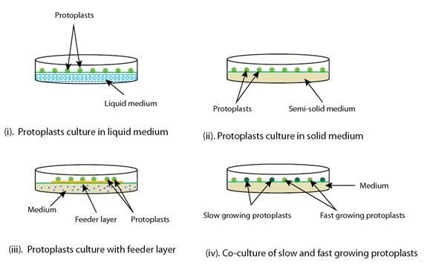
Figure 12.3: protoplast culture techniques

3.2. Culture medium
The nutritional requirement of protoplast is almost similar to that of the cultured plant cells. Mostly the salts of MS (Murashige and Skoog, 1962) and B₅ (Gamborg et al. 1968) media and their modifications have been used. Ammonium salts have been found detrimental to protoplasts survival of many species, and media have been devised that either have a reduced concentration of ammonium or lack it. Concentration of zinc is reduced while the concentration of calcium is increased as it enhances the membrane stability. Osmolarity is maintained by addition of sorbitol, mannitol, glucose or sucrose and mannitol being widely used osmoticum as it is not used by the dividing cells, thus, maintains the osmolarity of the medium. Glucose is preferred carbon source as sucrose do not satisfy protoplast culture. One or two amino acids are added at low concentration. Growth regulators are required essentially in protoplast culture generally high concentration of auxins (NAA, 2,4-D) along with lower concentration of cytokinins (BAP, Zeatin ) is used. Environmental conditions: High light intensity inhibits growth of protoplast hence initially protoplast is grown in dim light for few days and then transferred to light of about 2000-5000 lux. However, better results are obtained when cultured in darkness.

3.3. Plating density
Like cell cultures, the initial plating density of protoplasts has profound effect on plating efficiency. Protoplasts are cultured at a density of 1 x 10⁴ to 1 x 10⁵ protoplasts ml⁻¹ of the medium. At high density the cell colonies arising from individual protoplasts tend to grow into each other resulting into chimera tissue if the the protoplast population is genetically heterogeneous. Cloning of individuals cells, which is desirable in somatic hybridization and mutagenic studies, can be achieved if protoplasts or cells derived from them can be cultured at a low density.
4. Protoplast development and regeneration
Protoplast starts to regenerate a cell wall within few days (2-4 days) of culture and during this process, protoplasts lose their characteristic spherical shape which has been taken as an indication of new wall regeneration. Cell wall regeneration can be confirmed by Calcofluor White staining method. There is direct relationship between wall formation and cell division. Protoplasts which are not able to regenerate a proper wall fail to undergo normal mitosis. Protoplasts with a poorly developed wall often show budding and may enlarge several times their original volume. They may become multinucleate because karyokinesis is not accompanied by cytokinesis. Among other reasons, inadequate washing of the protoplasts prior to culture leads to these abnormalities. And completes process when provided with suitable condition of light, pH and temperature newly synthesized protoplast can be visualized by staining. Once the cell wall formation is completed, cells undergo division resulting in increase size of cells. After an interval of 3 weeks, small cell colonies appear, these colonies are transferred to an osmotic-free callus induction medium. This is followed by introduction into organogenic or embryogenic medium leading to plantlet development.

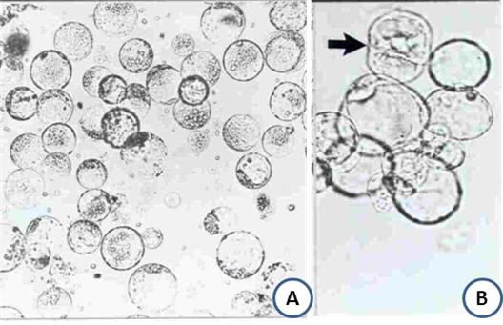

Figure 12.4: Protoplast isolation and cell wall regeneration. A. Isolated protoplast showing spherical structure; B. Wall is regenerated around the protoplast and one of the protoplasts showing cell division (arrow marked)

