Lec 3
Division:Chlorophyta(Green algae)
The principal Characteristics of the Chlorophyta:
1- flagellate cells are isokont. Which means that the flagella are similar in structure . there are usually tow flagella per cell or four .
2-the chlorophyll a and b present , also have accessory pigments , including B-carotene and Xanthophylls .
3-Pyrenoids, where present ,are embedded within the chloroplast , Each is surrounded starch grains.
4- Food stores as starch , is similar in the seed plants
5-Chloroplast vary in shape ,size , and number ,in unicellular species they tend to be cup-shaped but in filamentous form may be annular ,reticulate ,discoid or ribbon-like .
6- motile species an eyespot is frequently present,
7- Cell walls mainly cellulose, but some marine forms add CaCO₃
8- May live symbiotically as lichens
9- Habitat may be freshwater, moist surfaces, or marine environments
Chlorophyta includes two classes:
  - Class:Chlorophyceae 2) Class:Charaphyceae

Class:chlorophyceae
The Chlorophyceae are a large and important group of freshwater. They include some of the most common species, as well as many members that are important both ecologically and scientifically.
Most famous and important chlorophyceans:
- Chlamydomonas:is a genus of green alga consisting of unicellular flagellates. occurring in stagnant water and on damp soil, in freshwater, seawater, and even in snow as "snow algae". Chlamydomonas is used as a model organism for molecular biology, especially studies of flagellar motility and chloroplast dynamics, biogeneses, and genetics e.x: Chlamydomonas nivalis.
It is generally found in habitat rich in ammonium salt. Chlamydomonas possesses red eye spots for photosensitivity and reproduces by both asexual and sexual means.
Chlamydomonas's asexual reproduction goes through Zoospores, Palmella stage, Alpanospores and Hypnospores (resting spore ,thick walled ) sexual reproduction through isogamy, anisogamy or oogamy.

Morphology
- Motile unicellular algae.
- Generally oval in shape.
- Cell wall is made up of glycoprotein
- Two anteriorly flagella. Flagella originate from a basal granule located in the anterior papillate or non-papillate region of the cytoplasm.
- Contractile vacuoles found at near the bases of flagella.
- Cup or bowl shaped chloroplast is present. Which has a single large pyrenoid where starch is formed from photosynthetic products.
- Eye spot present in the anterior portion of the chloroplast
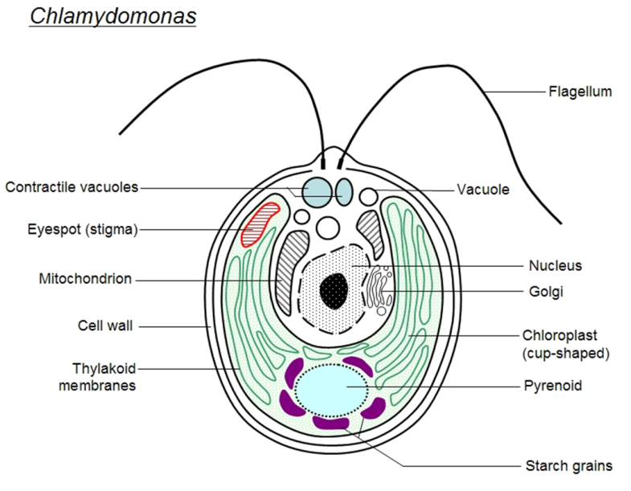
Reproduction:
a sexaul reproduction
1- reproduce by cell division, The flagella are withdrawn, the cytoplasm shrinks slightly within the cell wall, the nucleus and then the cytoplasm divide once, twice, or occasionally three times,
2- Each of these units forms a new cell wall and a pair of flagella. The parent cell wall bursts open and releases the daughter individuals.
This fission may occur once a day, so that great numbers of Chlamydomonas may appear very rapidly, when they usually make the water look green.

Sexual reproduction
Division as described above takes place but produces up to sixteen new individuals which do not develop cell walls. On release from the parental cell they swim about and may meet other individuals and fuse in pairs to form a zygote.
The zygote eventually rounds off, with draws the flagella, secretes a thick wall round the cytotoplasm so forming a zygospore which sinks to the bottom of the pond.As a zygospore,. The cytoplasm in the zygospore will divide, usually into four units, which are released as new chlamydomonas individuals.

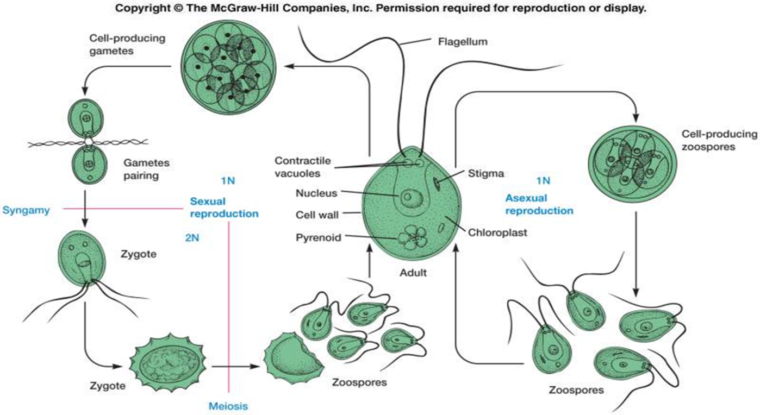

Volvox: is that form spherical colonies Each mature Volvox colony is composed of numerous flagellate cells similar to Chlamydomonas, up to 50,000 in total, and embedded in the surface of a hollow sphere. The cells have eyespots, more developed near the anterior, which enable the colony to swim towards light. Volvox colony consist from : 1) Chlamydomonas-like cell, 2) Daughter colony, 3) Cytoplasmic bridges, 4) Intercellular gel, 5) Reproductive cell, 6) Somatic cell.

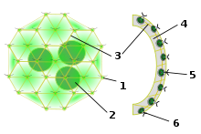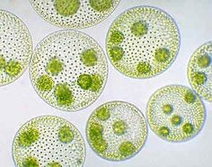

Reproduction
A) asexual reproduction: colony includes both somatic (vegetative) cells, which do not reproduce, and gonidia near the posterior, which produce new colonies through repeated division. The daughter colonies are initially held within the parent coenobium and have their flagella directed inwards. Later, the parent disintegrates and the daughters invert.
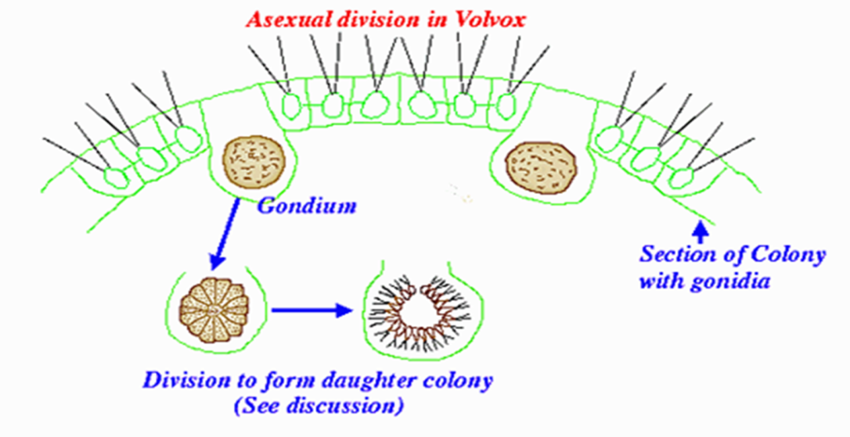

B). Sexual reproduction :two types of gametes are produced . fusion of sperms and egg cells. It is necessary to note that volvox can be monoecious or dioecious. The fertilization of male and female gametes in sexual reproduction leads to the formation of zygotes.
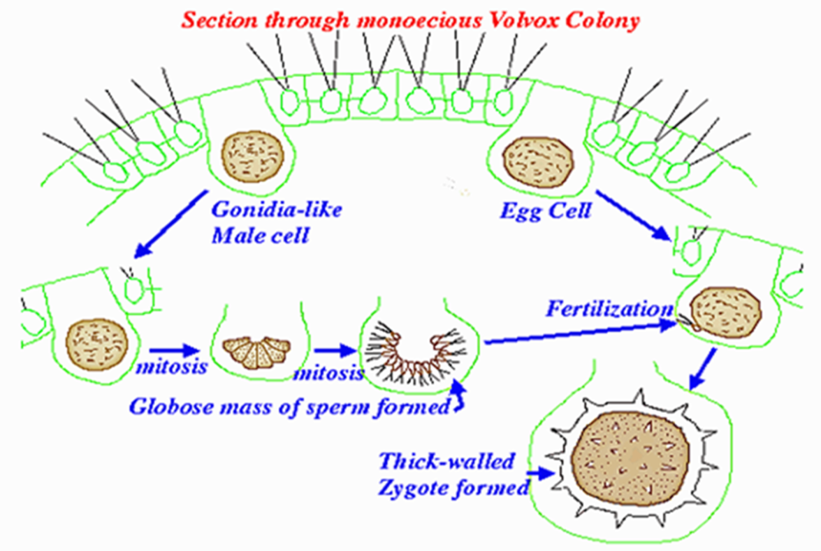

Chlorella.:
it plays an important role as endosymbionts inside the tissues of other organisms. Sponges, polyps, ciliates, and forams all may house Chlorella internally, providing a home for the alga in exchange for its photosynthates. More recently, this tiny alga has become popular as a "health food" for its concentrated proteins and chlorophyll, and is now raised commercially in large numbers, especially in Asia.
Chlorella is a genus of single-cell green algae,. It is spherical in shape, about 2 to 10 μm in diameter, and is without flagella. Chlorella contains the green photosynthetic pigments chlorophyll a and b in its chloroplast. Through photosynthesis, it multiplies rapidly, requiring only carbon dioxide, water, sunlight, and a small amount of minerals to reproduce.^{[1]}
. In recent years, researchers have use of Chlorella as an experimental organism because it lacks a sexual cycle ,the research advantages of genetics and source of food .
Oedogonium.
Oedogonium: is epiphytic on other aquatic algae or water plants. it may also be attached to stones or free floating objects. It is usually found in small permanent bodies of water like pools and ponds. The filaments may also occur as free floating masses.
Reproduction
Vegetative reproduction is by fragmentation of the filaments.
Asexual reproduction is through zoospores, formed singly within a cell. The zoospores are ovoid to pyriform, each with a ring of flagella at the anterior end. On germination, the zoospore gives rise to a 1-celled structure that anchors itself to the substratum and begins to divide and subdivide into a filament. Asexual reproduction may also take place through aplanospores and akinetes.
Sexual reproductionSexual reproduction :is oogamous. Thalli are monoecious or dioecious forming antheridium and/or oogonium. Some dioecious species produce androspores that attache and form small male gametophytes (dwarf males) near oogonium (nannandrous). Other dioecious species have the male gametophytes simillar to female in size (macrandrous). The zygote becomes resting oospore and usually releases four zoospore via meiosis. Zoospores undergo meiosis so one cell attaches to the bottom & develops a holdfast while the other zoospores divide & form a filament

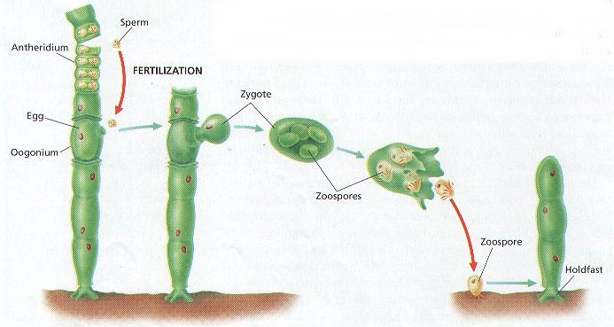

Cladophora
Cladophora, genus of green algae found growing attached to rocks . in appearance regular-branching filaments that have cross walls separating multinucleate segments, Cladophora grows in the form of a tuft or ball with filaments that may range up to 13 cm (5 inches) in length. Asexual reproduction involves small, motile spores (zoospores) with four flagella; in sexual reproduction the biflagellate gametes normally unite, although they sometimes develop into new plants without union.
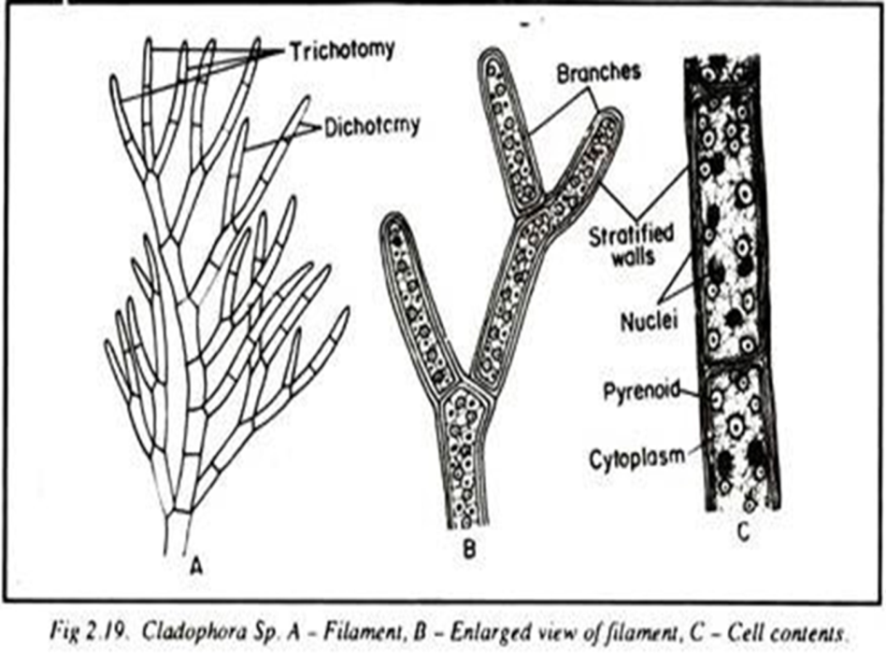

Order :Zygnematales
1-family : Zygnemaceae
1-The family Zygnemaceae comprising several thousand different species in genera such as Zygnema and Spirogyra.
2- All the members of this group develop into unbranched filaments, one cell thick,
3-which grow longer through normal cell division.
4-Most live in freshwater, and form an important component of the algal scum that grows on or near plants, rocks, and various debris.
5-Systematically they fall within the Charophyta (Streptophyta) Division,
6- which includes algae that are closer related to the higher plants than they are to most of the other algae (and including land plants themselves in Streptophyta classification). Recently they were discovered to be the Algal order most closely related to the land plants (Embryophyta)
Sexual reproduction in Zygnematales takes place through a process called conjugation.
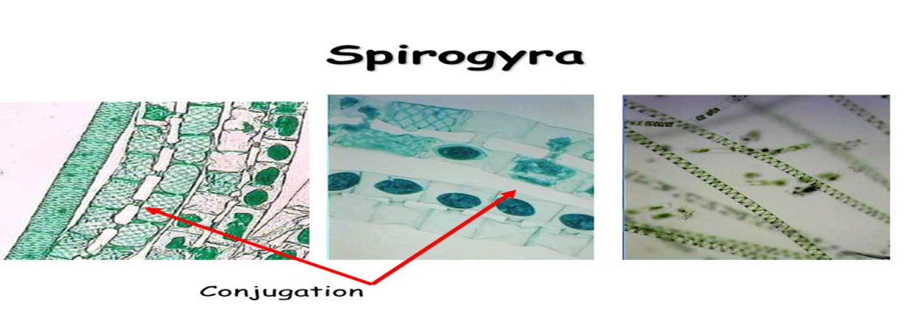
2-Family: Desmidiales
1-Mostly freshwater such as ponds, rivers, and lakes.
2- Most desmids are unicellular, some species grow as long filamentous colonies.
3- No flagella
4-Two, semi-cells are joined by a narrow connection called the isthmus. The shape of the half-cells (semi cells) is most various: ranging from more or less globular to disc- or spindle-like
5-the spherical nucleus is situated. Each semi-cell houses a large, often folded chloroplast. One or more pyrenoids can be found
6-Reproduction: Asexual: division along the isthmus, each new cell regrows its sister semicell. Sexual: conjugation, with dormant zygote
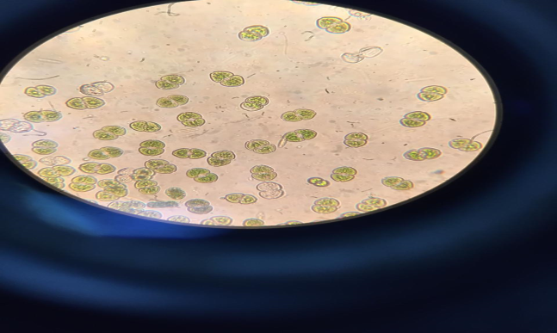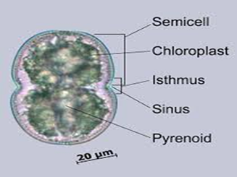
Cosmarium spp.
e.x.;Micrasterias:
Commonly known as green alga, this unicellular organism’s nucleus sits on a narrow isthmus linking its two mirror image “semi-cells.” A single large, space-filling chloroplast is housed within each semi-cell

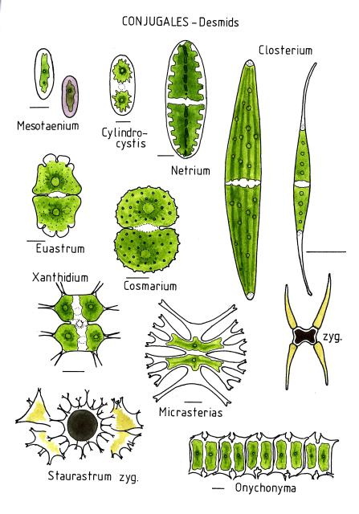
2)Class: Charaphycae (stonewort)
The members of this class of algae greens link between the rest of the algae and mosses
And differs from the class algae greens with features the following: -
1-consist of erect axis is divided into nodes and internodes, the provider side branched
- Members of reproduction complex is surrounded by sterile tissue
- Vary the male gametes swimming in the shape of the male in class green algae .
- Zygote grow to give Protonemal stage then grows into an adult plant.

The principal Characteristics of the Charophyceae

1-These algae can occur in fresh or brackish waters, and they have cell walls that contain large concentrations of calcium carbonate.
2- Cells of this class are asymmetrical.
3- Unlike in the other two common classes of green algae, but as with plants, the nuclear envelope disintegrates when mitosis begins. During cell division the mitotic spindle is present; in some a phragmoplast similar to those seen in plants aids in the formation of a cell plate. Plants are thought to have evolved from early species of Charophyceae.
4-Most stonewort generally occur in fresh water.
5- Some are calcified (Chara) and may accumulate as calcium carbonate deposits..
6-Superficially resembling the structures of some higher plants,
7-Stonewort structures include root like( rhizoids), whorls of branches at regular intervals, and an erect cylindrical axis, which may be surrounded by a sheath of small cells.
Charophytes are also the only algae that develop multicellular sex organs, although these are not comparable to those of the higher plants.

8- In sexual reproduction each female sex organ (oogonium) contains one large, immobile egg, and each male sex organ (antheridium) produces one small, biflagellate sperm. An envelope of sterile cells surrounds the reproductive structures. No motile spores are formed.
Chara sp.
Chara is a genus of charaphyta , The branching system of Chara species is complex with branches derived from apical cells which cut off segments at the base to form nodal and internodal cells alternately. They are typically anchored to the littoral substrate by means of branching underground rhizoids. Chara plants are rough to the touch because of deposited calcium salts on the cell wall. The metabolic processes associated with this deposition often give Chara plants a distinctive and unpleasant smell of hydrogen sulfide.

Morphology
The plant body is a gametophyte. It consists of a main axis (differentiated into nodes and internodes), dimorphic branches (long brach of unlimited growth and short branches of limited growth), rhizoids (multicellular with oblique septa) and stipulodes (needle shaped structures at the base of secondary laterals.

Reproduction
The sex organs can be readily identified by their shape and color. The sperm-bearing antheridia are bright orange, while the egg-bearing oogonium is green with a distinctive crown of cells. This is an excellent alga for studying life cycles in general biology and botany classes.

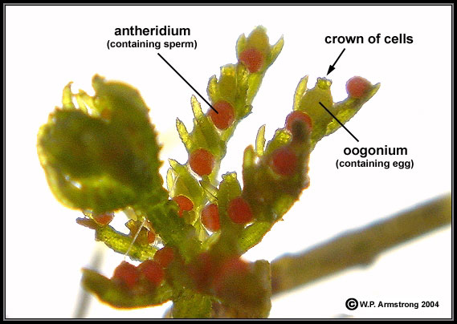

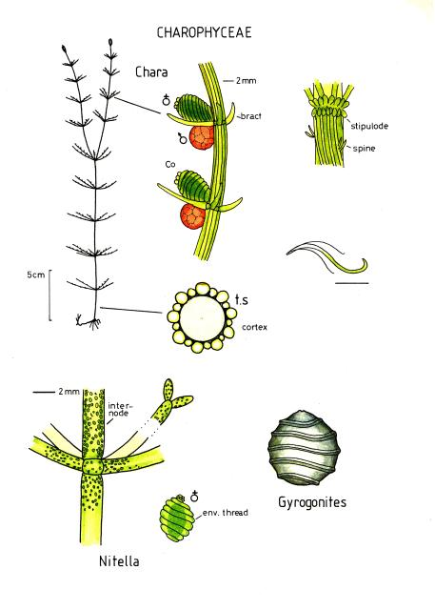
Nitella Chara
•Light to dark green color •Grey-green color
•Less than 8 cm to 2 m long •5 cm to 1 m long
•Forked bushy branches •Cylindrical whorled branches
•Soft to touch •Crunchy texture (Calcium deposits)
•No odor •Musty, garlic, or skunk like odor
•Fresh water •Fresh to brackish water
•Prefers slightly acidic water •Prefers slightly alkaline water

