Examination of bacteria in clinical samples
Blood
Introduction
Blood is cultured to detect and identify bacteria or other cultivable microorganisms (yeasts, filamentous fungi). The presence of such organisms in the blood is called bacteraemia or fungaemia, and is usually pathological. In healthy subjects, the blood is sterile. However, there are a few exceptions: transient bacteraemia often occurs shortly after a tooth extraction or other dental or surgical manipulation of contaminated mucous membranes, bronchoscopy, or urethral catheterization. This type of transient bacteraemia is generally due to commensal bacteria and usually resolves spontaneously through phagocytosis of the bacteria in the liver and spleen. Septicaemia is a clinical term used to describe bacteraemia with clinical manifestations of a severe infection, including chills, fever, malaise, toxicity, and hypotension, the extreme form being shock. Shock can be caused by toxins produced by Gram-negative rods or Gram-positive cocci.
When and where bacteraemia may occur
Bacteraemia is a feature of some infectious diseases, e.g. brucellosis, leptospirosis and typhoid fever. Persistent bacteraemia is a feature of endovascular infections, e.g. endocarditis, infected aneurysm and thrombophlebitis. Transient bacteraemia often accompanies localized infections such as arthritis, bed sores, cholecystitis, enterocolitis, meningitis, osteomyelitis, peritonitis, pneumonia, pyelonephritis, and traumatic or surgical wound infections.
It can arise from various surgical manipulations, but usually resolves
Spontaneously in healthy subjects.
Bacteraemia and fungaemia may result from the iatrogenic introduction of microorganisms by the intravenous route: through contaminated intravenous fluids, catheters, or needle-puncture sites. Both types of infection may develop in users of intravenous drugs and in immunosuppressed subjects, including those with human immunodeficiency virus/the acquired immunodeficiency syndrome (HIV/AIDS). They are often caused by “opportunistic” microorganisms
and may have serious consequences. Table 5 shows the most common
causes of bacteraemia or fungaemia.

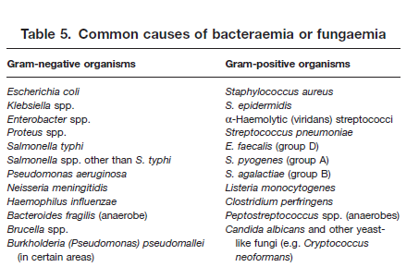

Considering aerobic or anaerobic culture for blood:
We could expect the type of blood culture depending on the infection referred for blood culture as below table summarizes:

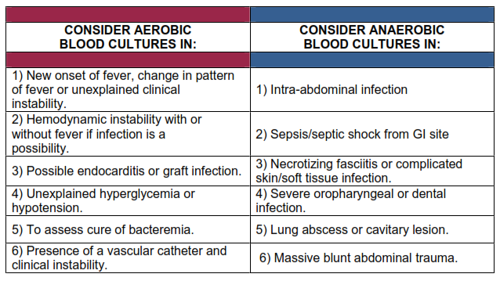

Blood collection
Timing of blood collection
Whenever possible, blood should be taken before antibiotics are administered. The best time is when the patient is expected to have chills or a temperature spike. It is recommended that two or preferably three blood cultures be obtained, separated by intervals of approximately 1 hour (or less if treatment cannot be delayed). More than three blood cultures are rarely indicated.
The advantages of repeated cultures are as follows:
— the chance of missing a transient bacteraemia is reduced;
— the pathogenic role of “saprophytic” isolates (e.g. Staphylococcus epidermidis) is confirmed if they are recovered from multiple venipunctures.

It is important that blood specimens for culture are collected before initiating empirical antimicrobial therapy. If necessary, the choice of antimicrobial can be adjusted when the results of susceptibility tests become available.

Quantity of blood
Because the number of bacteria per millilitre of blood is usually low, it is
important to take a reasonable quantity of blood: 10 ml per venipuncture for adults; 2–5 ml may suffice for children, who usually have higher levels of bacteraemia; for infants and neonates, 1–2 ml is often the most that can be obtained. Two tubes should be used for each venipuncture: the first a vented tube (أنبوب تهوية) for optimal recovery of strictly aerobic microorganisms, the second a non-vented tube for anaerobic culture.
Skin disinfection
The skin at the venipuncture site must be meticulously prepared using a bactericidal disinfectant: 2% tincture of iodine, 10% polyvidone iodine, 70% alcohol, or 0.5% chlorhexidine in 70% alcohol. The disinfectant should be allowed to evaporate on the skin surface before blood is withdrawn. If tincture of iodine is used, it should be wiped off with 70% alcohol to avoid possible skin irritation.
Even after careful skin preparation, some bacteria persist in the deeper skin layers and may gain access to the blood, e.g. S. epidermidis, Propionibacterium acnes, and even spores of Clostridium. Pseudobacteraemia (false-positive blood culture) may result from the use of contaminated antiseptic solutions, syringes, or needles. The repeated isolation of an unusual organism (e.g. Burkholderia (Pseudomonas) cepacia, Pantoea (Enterobacter) agglomerans, or Serratia spp.) in the same hospital must raise suspicion of a nosocomial infection and
promote an investigation. Another source of contamination is contact of the needle with non-sterile vials (or solutions), if the same syringe is first used to provide blood for chemical analysis or measurement of the erythrocyte sedimentation rate.

Anticoagulant
The use of sodium polyanethol sulfonate (SPS) as an anticoagulant is recommended because it also inhibits the antibacterial effect of serum and phagocytes.
If the blood is immediately added to a sufficient volume (50 ml) of broth and thoroughly mixed to prevent clotting, no anticoagulant is needed. It is recommended that blood-culture bottles be available at all hospitals and major health centers. If blood-culture bottles are not available, blood may be transported to the laboratory in a tube containing a sterile anticoagulant solution
(citrate, heparin, or SPS). Upon receipt in the laboratory, such blood samples must be transferred immediately to blood-culture bottles using a strict aseptic technique. Where blood is taken without anticoagulant, the clot can be aseptically transferred to broth in the laboratory and the serum used for certain serological tests (e.g. Widal).
Blood-culture media
Choice of broth medium
The blood-culture broth and tryptic soy broth (TSB) should be able to support growth of all clinically significant bacteria.
Quantity of broth
Ideally, the blood should be mixed with 10 times its volume of broth (5 ml of blood in 50 ml of broth) to dilute any antibiotic present and to reduce the bactericidal effect of human serum.
Blood-culture bottles
Blood-culture bottles (125 ml) with a pre-perforated screw-cap and a rubber diaphragm must be used. Fill the bottle with 50 ml of medium and then loosen the screw-cap half a turn. Cover the cap with a square piece of aluminium foil, and autoclave the bottle for 20 minutes at 120 ᵒC. Immediately after autoclaving, while the bottle and the medium are still hot, securely tighten the cap without removing the aluminium foil (otherwise the cap will not be sterile). As the medium cools, a partial vacuum will be created in the bottle, which will facilitate injection of a blood specimen through the diaphragm.
The top of the cap must be carefully disinfected just before the bottle is
inoculated.
Prior to distribution and before use, all blood-culture bottles should be
carefully examined for clarity. Any medium showing turbidity should not be used.
If strictly aerobic bacteria (Pseudomonas, Neisseria) or yeasts are suspected, the bottle should be vented as soon as it is received in the laboratory, by inserting a sterile cotton-wool-plugged needle through the previously disinfected diaphragm. The needle can be removed once the pressure in the bottle reaches atmospheric pressure. Commercial blood-culture bottles often also contain carbon dioxide, which has a stimulating effect on growth.
BLOOD
In countries where brucellosis is prevalent, the use of a diphasic blood-culture bottle, with a broth phase and a solid-slant phase on one of the flat surfaces of the bottle (Castaneda bottle), is recommended for the cultivation of Brucella spp. The presence of carbon dioxide is needed for the isolation of most strains of B. abortus.

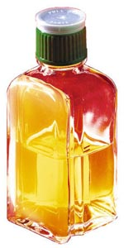

Vials of anaerobic culture
Two types of vials are commercially available for anaerobic culturing (Fig. 1): The Hungate-type tubes are closed with a flange-type butyl rubber septum and a screw cap with 9 mm opening to allow puncturing of the septum with injection needles. Balch-type tubes are more stable than Hungate-type tubes and recommended if an overpressure of 2 to 3 bar can be expected during culturing. They are closed with a thick butyl rubber stopper which is hold in place by sealing with an aluminum crimp. For sealing and removing of the aluminum crimp special devices (crimper/decapper) are necessary. Serum bottles which are available in various sizes can be used alternatively to Balch-type tubes. However, serum bottles are less stable than Blach tubes and should be handled with special care when strains are cultured that are expected to produce significant amounts of gas during incubation (see below). Pre-reduced media can be stored in both types of vials at room temperature in the dark for several weeks without becoming oxidized.

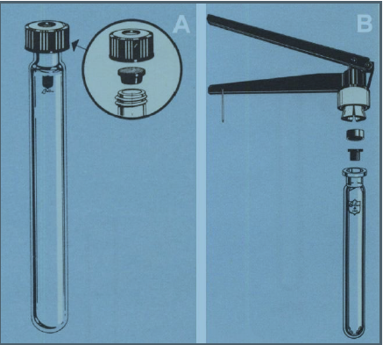

Fig 1. Suitable vials for culturing strict anaerobes. (A) Hungate-type tube with screw cap and butyl rubber septum. (B) Balch-type tube with butyl rubber stopper and aluminum crimp seal to hold stopper in place. A crimper is necessary for sealing the vial. Figures are courtesy of Bellco glass Inc.

Gassing of media and cultures with oxygen-free gas
When vials of pre-reduced media or anaerobic cultures are opened a constant flow of oxygen-free gas over the surface of the medium is necessary to avoid exposure to oxygen. The used oxygen-free gas should have the same composition as that used for medium preparation. We recommend to use oxygen-free gasses of high purity (containing less than 5 ppm oxygen), that are delivered as compressed gas cylinders

The Hungate technique is based on the use of Gassing cannulas. Usually, several cannulas are connected by butyl rubber tubing to a manifold supplying oxygen-free gas with an overpressure that should be adjusted to approx. 0.5 bar. At least two cannulas are needed: one for the vessel to be inoculated or filled with medium and one for the vessel containing the inoculum or the medium to be dispensed. When an aseptic gassing of media or cultures is necessary a barrel of a glass syringe is packed with cotton and fitted between the gassing needle and the butyl rubber tubing. (Fig. 2).

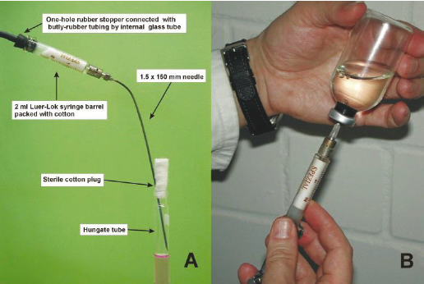

Fig 2. Assembly of cannulas used in the Hungate technique for aseptic gassing.
(A) Cannula used for aseptic gassing of opened vials with oxygen-free gas. (B) Overpressurizing of anaerobic cultures with sterile gas mixtures.

Processing of blood cultures
Incubation time
Blood-culture bottles should be incubated at 35–37 ᵒC and routinely inspected twice a day (at least for the first 3 days) for signs of microbial growth. A sterile culture usually shows a layer of sedimented red blood covered by a pale yellow transparent broth. Growth is evidenced by:
— a floccular deposit on top of the blood layer
— uniform or subsurface turbidity
— haemolysis
— coagulation of the broth
— a surface pellicle
— production of gas
— white grains on the surface or deep in the blood layer.
Whenever visible growth appears, the bottle should be opened aseptically, a small amount of broth removed with a sterile loop or Pasteur pipette, and a Gram-stained smear examined for the presence of microorganisms.
Subcultures are performed by streaking a loopful on appropriate media:
— for Gram-negative rods: MacConkey agar, Kligler iron agar, motility indole– urease (MIU) medium, Simmons citrate agar;
— for small Gram-negative rods: blood agar;
— for staphylococci: blood agar, mannitol salt agar;
— for streptococci: blood agar with optochin, bacitracin, and tellurite discs, sheep blood agar for the CAMP test, and bile–aesculin agar.
For routine examinations, it is not necessary to incubate blood cultures beyond 7 days. In some cases, incubation may be prolonged for an additional 7 days, e.g. if Brucella or other fastidious organisms are suspected, in cases of endocarditis, or if the patient has received antimicrobials.
Blind subcultures and final processing
Some microorganisms may grow without producing turbidity or visible
alteration of the broth. Other organisms, e.g. pneumococci, tend to undergo autolysis and die very rapidly. For this reason some laboratories perform routine subcultures on chocolate agar after 18–24 hours of incubation. A blind subculture may be made at the end of 7 days of incubation, by transferring several drops of the well-mixed blood culture (using a sterile Pasteur pipette) into a tube of thioglycollate broth, which in turn is incubated and observed for 3 days.

Antibiogram
When staphylococci or Gram-negative rods are suspected, precious time can be saved by performing a direct, non-standardized antibiogram using the positive broth as an inoculum. A sterile swab is dipped into the turbid broth, excess fluid is expressed, and the swab is used to inoculate Mueller–Hinton medium as in the standard method. A provisional reading can often be made after 6–8 hours of incubation. In 95% of cases the results obtained with this method are in agreement with the standardized test.
Contaminants
Contamination of blood cultures can be avoided by meticulous skin preparation and by adherence to strict aseptic procedures for inoculation and subinoculation.
However, even in ideal conditions, 3–5% of blood cultures grow “contaminants” originating from the skin (S. epidermidis, P. acnes, Clostridium spp., diphtheroids) or from the environment (Acinetobacter spp., Bacillus spp.).
Such organisms, however, may occasionally behave as pathogens and even cause endocarditis.
Inspection of true infection
A true infection should be suspected in the following situations:
— if the same organism grows in two bottles of the same blood specimen;
— if the same organism grows in cultures from more than one specimen;
— if growth is rapid (within 48 hours);
— if different isolates of one species show the same biotypes and antimicrobial- susceptibility profiles.
All culture results should be reported to the clinician, including the presumed contaminants. However, for the latter no antibiogram need be performed and appropriate mention should be made on the report slip, e.g. Propionibacterium acnes (skin commensal), Staphylococcus epidermidis (probable contaminant).
It is to the advantage of all concerned to establish good communication between physicians and laboratory personnel.
The identification of two or more agents may indicate polymicrobial bacteraemia, which can occur in debilitated patients, but may also be due to contamination.
“Anaerobic” bacteraemia is often caused by multiple pathogens; for example, one or more anaerobes may be associated with one or more aerobes in severe fulminating bacteraemia associated with severe trauma or surgery involving the large intestine.

Steps of blood sampling and culture

