Chapter One

Climate change

1.General consideration
In many parts of the world, the climate has varied sufficiently within the past few thousand years to affect patterns of agriculture and settlement(استيطان). As will become clear, the evidence is now overwhelming (غامر ) that human activities have begun to influence climate.
Realization that climate is far from being constant came only during the 1840s, when indisputable (لا يقبل الجدل) evidence of former (من السابق )Ice Ages was obtained. Studies of past climate began with a few individuals
(
شخص
) in the 1920s and gained momentum in the 1950s. Instrumental(دور فعال )records for most parts of the world span(امتداد) only the past 100 to 150 years, and are typically assembled at monthly, seasonal or annual time resolution.
However, proxy indicators (مؤشرات الوكيل ) from tree rings(حلقات جذوع الأشجار), pollen (حبوب لقاح )in bog( في المستنقع )and lake sediments(وترسبات البحيرة), ice core records (سجلات الجليد الأساسية ) of physical and chemical parameters, and ocean foraminifera(Microscopic, single-celled organisms called foraminifera have a fossil record that extends from today to more than 500 million years ago) in sediments provide a wealth of paleoclimatic data. Tree rings ( جذوع الأشجار ) and ice cores can give seasonal or annual records. Peat bog( نسيج نباتات المستنقع) and ocean sediments may provide records with 100 to 1000-year time resolution.
In any study of climate variability and change, one must pay careful attention to possible artifacts (الآثار ) in the records. For instrumental records, these include changes in instrumentation (e.g., rain gauge types), observational practices, station location, or the surroundings of the instrumental site, or even errors in transcribed (نسخت) data. Proxy records may suffer from errors in dating or interpretation. Even when climate signals are real, it may be difficult to ascribe (لكسبهم) them to unique causes owing to the complexity of the climate system, a system which is characterized by myriad(وافر) interactions between its various components on a suite of spatial(مكاني )and temporal(زمني )scales (Figure 1).
What is the distinction ( التمييز )between climate variability and change? Climate variability, as defined by the Intergovernmental Panel (فريق )on Climate Change (IPCC), refers to fluctuations in the mean state and other statistics (such as the standard deviation, extremes, or shape of frequency distribution, see Note 1) of climate elements on all spatial and temporal scales beyond those of individual (فرد )weather events. Variability can be associated with either natural internal(داخلي) processes within the climate system, or with variations in natural or anthropogenic(الصنعية) climate forcing. Climate change, by contrast, is viewed by the IPCC as a statistically significant variation in the mean state of the climate or in its variability persisting(استمرار) over an extended period, typically decades or longer.
Climate change may be due to natural internal processes, natural external forcings, or persistent(استمرار) anthropogenic-induced changes in atmospheric composition or land use.
Given that climate variability as viewed by the IPCC includes fluctuations on all spatial and temporal scales beyond synoptic weather events, one could legitimately(قانوني) view all of the behaviors in the figure as expressions of variability.

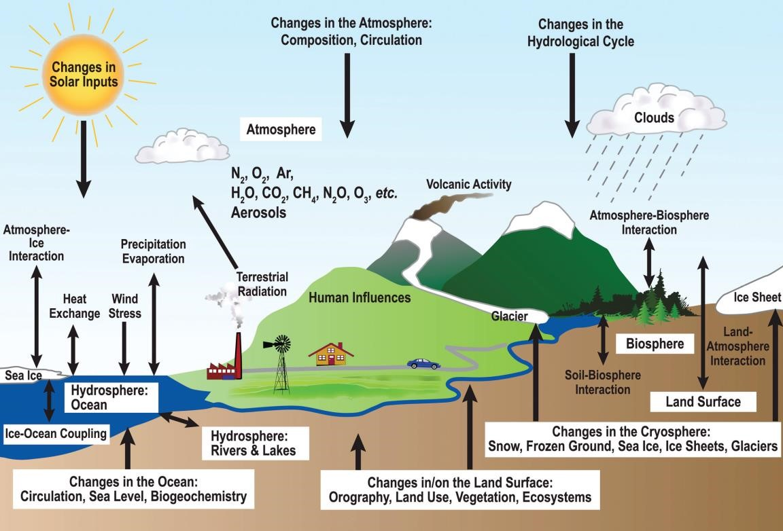

Figure(1): A schematic of processes driving variability and change in the climate system.
The United Nations Framework(هيئة) Convention (اتفاقية )on Climate Change
(UNFCCC) offers a different definition that can help to resolve some of these problems. They define climate change as ‘a change of climate which is attributed(ينسب) directly or indirectly to human activity that alters(يغير )the composition of the atmosphere and which is in addition to natural climate variability observed over comparable(مشابه) timescales’. This definition is useful in that it makes a clear distinction(تميز) between natural processes and anthropogenic influences. The remainder(بقية) of this chapter will view climate change in this context(سياق الكلام) Variability, in turn, will be viewed as associated with natural processes.

2.Climate forcing, Feedback and Response
The most fundamental measure of the earth’s climate state is the global mean, annually averaged surface air temperature. Year-to-year and even decadal-scale variations in this value can occur due to processes purely internal to the climate system. When considering timescales of decades or longer, thinking must turn to climate forcings and attendant(المصاحبة) feedbacks. Forcing factors represent imposed( مفروض) perturbations(الاضطرابات )to the global system, and are defined as positive when they induce(يحثون) an increase in global mean surface temperature, and negative when they induce a decrease. Forcing factors may in turn be of natural or anthropogenic origin. The magnitude (أهمية ) of the global temperature response to forcing depends on the feedbacks. Positive feedbacks amplify the temperature change while negative feedbacks dampen (إخماد )the change.
A. Climate forcing
Many different types of climate forcing can be identified( محدد )Key forcing are associated with the following processes:
- Plate Tectonics. On geological timescales, plate tectonics have resulted in great changes in continental positions and sizes, the configuration ( ترتيب ) of ocean basins and (through associated phases in volcanic activity) atmospheric composition. While there is little doubt (شك) that such changes altered (تغيير ) the globally averaged surface albedo and greenhouse gas concentrations, plate movements have also altered the size and location of mountain ranges and plateaus ( الهضاب ). As a result, the global circulation of the atmosphere and the pattern of ocean circulation were modified. In 1912, Alfred Wegener proposed continental drift (الانجراف )as a major determinant (مقرر) of climates and biota, but this idea remained (ظلت ) controversial (مثيرة للجدل) until the motion of crustal (القشرة الأرضية) plates was identified (محدد) in the 1960s.
- Astronomical periodicities.( دوريات) the earth’s orbit around the sun is subject to long-term variations, leading to changes in the seasonal and spatial distribution of solar radiation incident (حادث) to the surface. These are known as Milankovich forcings after the astronomer Milutan Milankovich, whose careful calculations of their effects built upon the work of nineteenth- century astronomers and geologists. There are three principal effects: the eccentricity (الانحراف) (or stretch) (تمتد) of the orbit influencing the strength of the contrast in solar radiation received at perihelion (الحضيض الشمسي ) (closest to sun) and aphelion (the point in the orbit of a planet or a comet (المذنب ) at which it is farthest from the sun ) (furthest from sun), ( أبعد من الشمسwith periods of approximately 95,000 years and 410,000 years; the tilt (الميل) of the earth’s axis (approximately 41,000 years) influencing the strength of the seasons; and a wobble (تمايل) in the earth’s axis of rotation, which causes seasonal changes in the timing of perihelion (الحضيض الشمسي) and aphelion (Figure 2). The range of variation of these three components and their consequences (نتيجة )are summarized in Table 1. Astronomical periodicities (دوريات) are associated with global temperature fluctuations of ±2–5°C per 10,000 years. The timing of orbital forcing is clearly represented in glacial–interglacial fluctuations with the last four major glacial cycles spanning roughly 100,000 years (or 100ka). The astronomical theory of glacial cycles became widely accepted in the 1970s after Hays,( حشائش جافة) (Imbrie and Shackleton) provided convincing(مقنع) evidence from ocean core records.
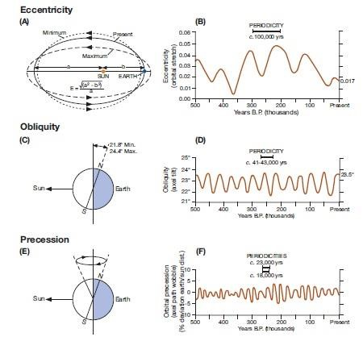
Figure (2): Summary of astronomical (orbital) effects on solar irradiance and their relevant timescales over the past 500,000 years. A and B: Eccentricity or orbital stretch; C and D: Obliquity or axial tilt; E and F: Precession or axial path wobble.

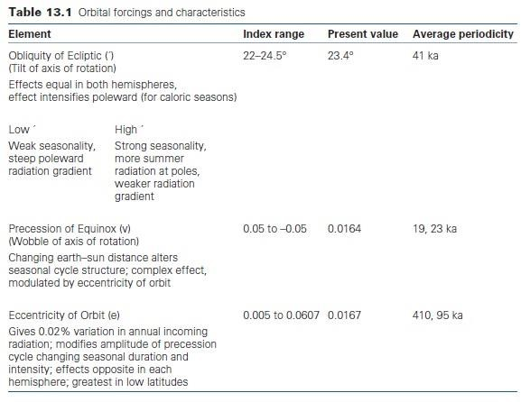
- Solar variability. The sun is a variable star. The approximately 11-year solar (sunspot) cycle (and 22-year magnetic field cycle) are well known. The 11-year sunspot cycle is associated with ±1W m–2 fluctuations in solar irradiance
- (the flux of radiant energy per unit area (normal to the direction of flow of radiant energy through a medium).
- (i.e., a departure from the solar constant; in terms of radiation receipts globally averaged over the top of the atmosphere, the effective value is only 0.25W m–2). Effects on ultraviolet radiation are proportionally ( نسبيا ) larger in terms of percent change. There is also evidence for longer-term variations. Intervals when sunspot and solar flare (توهج ) activity were much reduced (especially the Maunder Minimum of AD 1645– 1715) (( The Maunder Minimum, also known as the "prolonged sunspot minimum", is the name used for the period around 1645 to 1715 during which sunspots became exceedingly rare, as was then noted by solar observers. The term was introduced after John A. Eddy published a landmark 1976 paper in Science.)) may have been associated with global temperature decreases of about 0.5°C. Solar variability also seems to have played a role in decadal scale variations of global temperature until the latter part of the twentieth century, when anthropogenic effects became dominant. Turning to the distant past, it is known that solar irradiance three billion years ago (during the Archean) (( The Archean Eon (Archean عصر) marked a time when the Earth had a more stable climate. From 4.6 to 4.0 billion years ago, the Hadean ( الحاضن )Eon was a violent (عنيف) time in Earth's geologic history. But in the Archean Eon, Earth finally starts to cool down from its molten(مصهور) state. )) was about 80 percent of the modern value.
Interestingly, the effect of this faint (باهت ) early sun was offset,( تأثير معاكس most likely, by a concentration of carbon dioxide that was perhaps 100 times higher than now, and perhaps also by the effects of a largely water-covered earth (meaning lots of water vapor in the atmosphere)

From second

now, and perhaps also by the effects of a largely water-covered earth (meaning lots of water vapor in the atmosphere).
- Volcanic eruptions. Major individual explosive eruptions inject dust and sulfur gases (especially sulfur dioxide) into the stratosphere, the latter forming sulfuric acid droplets.
Equatorial eruption plumes spread into both hemispheres, whereas plumes from eruptions in mid-to high latitudes are confined to that hemisphere. Observational evidence from the past 100 years emonstrates that major eruptions can be associated with global averaged cooling of several tenths of a degree C in the year following the event and much larger changes on a regional to hemispheric basis.
The cooling is primarily from the sulfuric acid droplets which reflect solar radiation. Dust also causes surface cooling by absorbing solar radiation in the stratosphere, but compared to the sulfuric acid these effects are short-lived (weeks to months) Stratospheric aerosols may also cause brilliant sunsets
- Human-induced changes in atmospheric composition and land cover. The effect of greenhouse gases such as carbon dioxide and methane on the radiation budget has already been introduced. The observed buildup of these gases since the dawn of the industrial age represents a positive forcing. Human activities have also led to a buildup of tropospheric aerosols, which induce a partly compensating cooling. Changes in land use and land cover have also led to a small increase in surface albedo that promotes cooling.

