Lab Two :.
Dilutions:
For many years, scientists have used a serial dilution method to control sample size. This is important to many diagnostic and enumeration methods.
Serial dilution is a common technique used in many immunologic procedures and many laboratory test. A small amount of serum or solute can be serially diluted by transferring aliquots to diluent. One of the most common series doubles the dilution factor with each transfer (1:2, 1:4, 1:8 ...). These dilutions can be done in microtiter plates or test tubes depending on the volumes of sample and diluent used.
Sample: refers to the original liquid that will be tested
Diluent: the solution that is mixed with the sample (often-purified water).
Concentration: refers to how much of the sample is in a given test. For
example, “40 to 1” (1/40) dilution means that for every 40 parts of water,
there is 1 part of sample.
Type of dilutions:
- Decimal Dilution Method or One – Ten D.M. : We transfer 1 ml of the original solution into the tube with 9ml of water, to become one part to 9 part

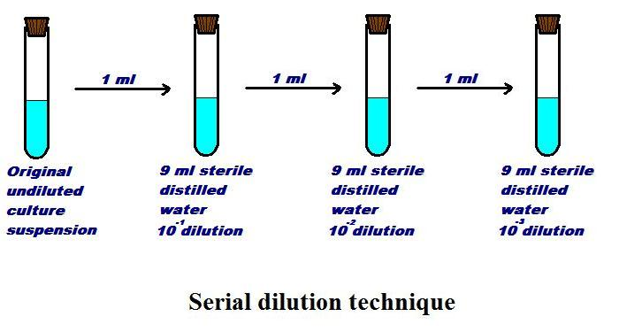
Always Remember:
- Concentration ≠ Volume
- Follow the formula
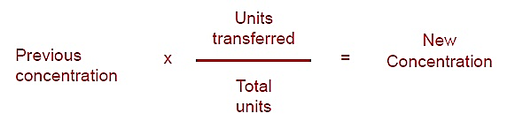
What is the concentration in tube #3?
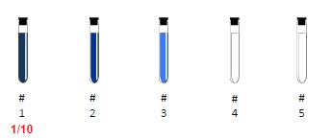

- Two – fold Dilution method: it's called One –Two D.M.( 1/2(
We transfer 1 ml of the original solution into the tube with 1ml of water, to become one part to 2 part.

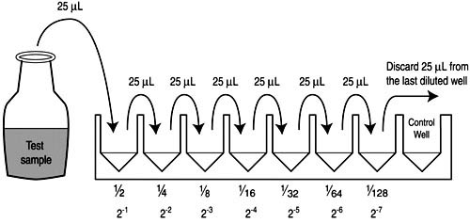

Times dilution:
If you want to determine the No. of times dilution of a substance,
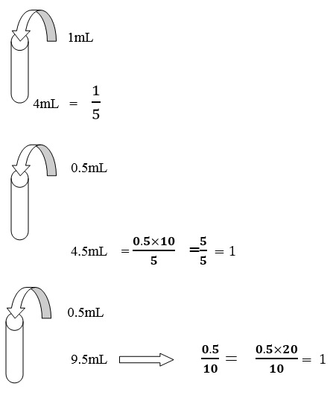
- Dilution 5 times
$\frac{1×5}{5}$=5

- Dilution 10 times

- Dilution 20 times

Sometime do not need the primary dilution, so depend on the double dilution of material or antibiotics Where added 0.1 mL to 9.9 mL from material diluted.

0.1 mL

$1$ $=$ $\frac{0.1×100}{10}$ $\frac{0.1}{10}=$ 9.9 mL

Where dilution = 100 times
- Sometimes use C1V1 = C2V2 to find different dilutions.
- Stock = $\frac{W.}{V. }$
- 1g = 1000mg
- 1mg = 1000 μg
- 1L = 1000mL
- 1mL = 1000 μL

Ex: prepare antibiotic with concentration 100 μg/mL from concentration 5000 μg/mL in volume 10mL.
C1V1 = C2V2
5000* V1=100*10 = V1=$\frac{1000}{5000}$ = 0.2 mL
H.W.: Why we dilution antibiotic??
H.W.: Prepare the serial dilution (2000, 1000, 700, 100, 25, 10, 2 μg/mL) from capsule ampicillin 250mg.

