Lab Five:.
Minimal Inhibitory Concentration (MIC):
The lowest concentration of antibiotic that inhibit growth of bacteria also called tube dilution method, The lowest concentration (highest dilution) of test agent preventing appearance of turbidity (growth) is considered to be the minimal / minimum inhibitory concentration (MIC). At this dilution, the test agent is bacteriostatic, and this Achieved by:
- Tube dilution methods.
- Agar dilution method.
Advantages of MIC:
- Dose to inhibit MIC is a better predictor of appropriate drug.
- Use a lower concentration which reach to the body fluid, able to use a less expensive but still effective antibody
- Decrease chance of toxic effects on the patient's systems/organs.

Antibacterial susceptibility breakpoints
What are the antibacterial susceptibility breakpoints? They are a set of values through which scientists define susceptibility and resistance of bacterial strains to various antibacterial agents. These breakpoints had expressed either in concentration (mg/liter or µg/ml) or in a zone diameter (mm), and had established by many international organizations and by using different methods. Setting the antibacterial breakpoints depends usually on four different data sources that have to be taken into consideration, while the final goal of every breakpoint is classify tests results as susceptible, intermediate, or resistant. The huge variety among breakpoints have made it possible that the same pathogenic strain causing the same damage to body tissues can be identified resistant in one country and susceptible in another to the same antibacterial agent. The fact that the data sources might be collected using experimental procedures that does not resemble the in “vivo” environment questions the validity of these breakpoints. Problems with susceptibility breakpoints extended toward reliability and even toward the economic impact of wrong breakpoints.
Principle:
The lowest concentration of antimicrobial agent that inhibits the growth of the microorganism is the minimal inhibitory concentration (MIC). The MIC and the zone diameter of inhibition are inversely correlated. In other words, the more susceptible the microorganism is to the antimicrobial agent, the lower the MIC and the larger the zone of inhibition. Conversely, the more resistant the microorganism, the higher the MIC and the smaller the zone of inhibition.
- The tube dilution test is the standard method for determining levels of resistance to an antibiotic.
- Serial dilutions of the antibiotic are made in a liquid medium, which is inoculated with a standardized number of organisms and incubated for a prescribed time.
- The lowest concentration of antibiotic preventing appearance of turbidity had considered the minimal inhibitory concentration (MIC).
For the detection MIC: you should do a series of broths had mixed with serially diluted antibiotic solutions and a standard inoculum is applied and unify the sizes in all the tube according to the less size. After incubation (10 ³- 10 ⁶ cell\mL), the MIC is the first broth in which growth of the organism has been inhibited. The more resistant an organism is, then the higher will be the MIC.
Clinicians use MIC scores to choose which antibiotics to administer to patients with specific infections and to identify an effective dose of antibiotic. This is important because populations of bacteria exposed to an insufficient concentration of a particular drug or to a broad-spectrum antibiotic (one designed to inhibit many strains of bacteria) can evolve resistance to these drugs. Therefore, MIC scores aid in improving outcomes for patients and preventing evolution of drug-resistant microbial strains.
Tube dilution methods:
- In this method, we use sterile Müeller-Hinton broth.
- We make 2-folds dilution of antibiotics in the broth i.e. 2µg/ml, 4µg/ml, 8µg/ml, 16µg/ml and so on.
- Then we add broth culture (0.1ml) of test organism to the prepared dilutions.
Procedure:
- Arrange sterile test tubes in a rack and dispense 1 ml of sterile Müeller-Hinton broth into each tube.
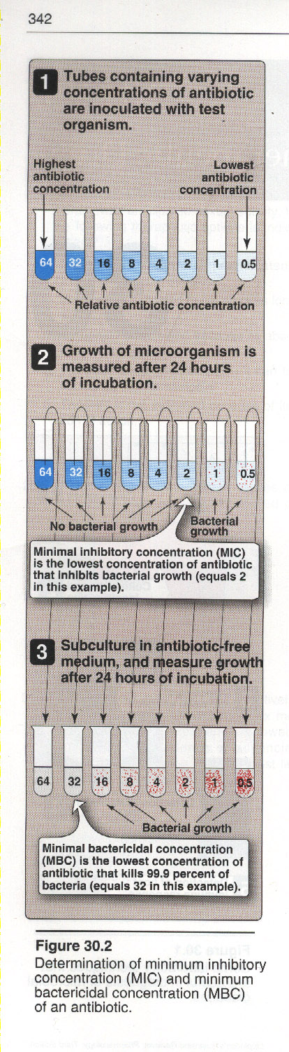
- Prepare a stock solution of the antimicrobial agent and diluted according to your serial dilution to your test. The value of MIC according to CLSI is : (0.5,1,2,4,8,16,32,64,128,256,512,1024).
- Start to do the serial dilution according to your value. Make two-fold dilution of the antimicrobial agent by transferring 1 ml of the solution from the solution from the first tube to the second one.
- Continue to make serial dilution till the entire range is covered. The last tube concentration is 0.5μg/ml and let two tube one of them without add anything as it act as growth control (positive control). In addition, the second just broth and antibiotic without inoculated by bacteria (negative controle).
- Adjust the turbidity of bacterial suspension overnight growth by 0.5 McFarland standard.
- Unify the sizes in all the tube according to the less size of tubes.
- Add 0.1 mL of this suspension to each dilution and control tube.
- Incubate the tubes in 16-18hr at 37 ºC.
- Results by compare with the control tube read all tubes for visible growth record the result. The lowest concentration with no visible growth is the MIC for the test organism.
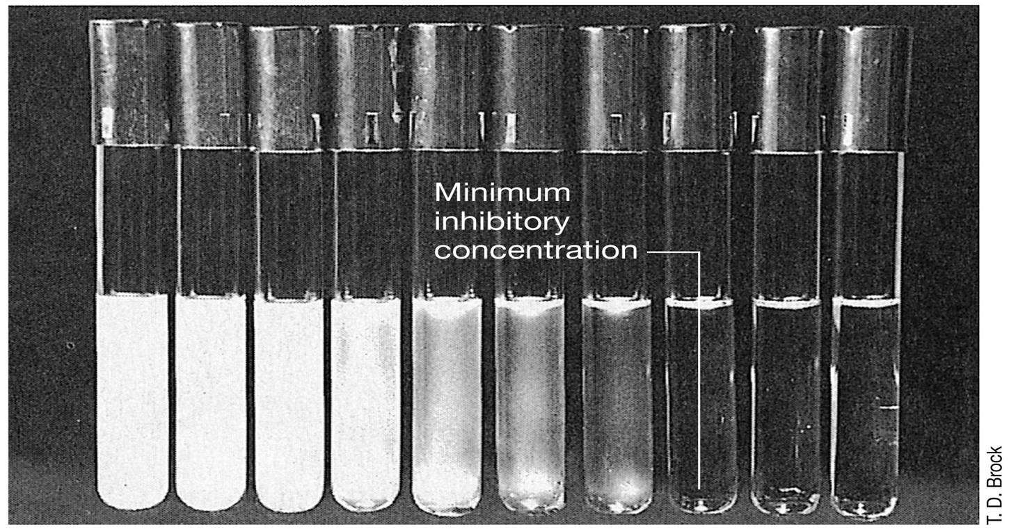

H.W.: what is the best method to do MIC in broth or in agar plates??
Why we do serial dilution of antibiotics in MIC??
Why we add the same size of bacteria to all tubes??
Epsilometer test or E-test or MIC Test Strip: It is a quantitative assay for determining the MIC of antimicrobial agents against microorganisms and for detecting the resistance mechanisms, Plastic strips with a predefined gradient of one antibiotic. Paper strips with special features that are impregnated with a predefined concentration gradient of antibiotic, On one side of the strip is indicated a MIC scale in μg/ml and a code that identify the antimicrobial agent. E-test is based on arraying a concentration gradient of each antibiotic on a polymer strip. Concentration values are marked on the other side of the strip so that one can easily locate corresponding concentrations
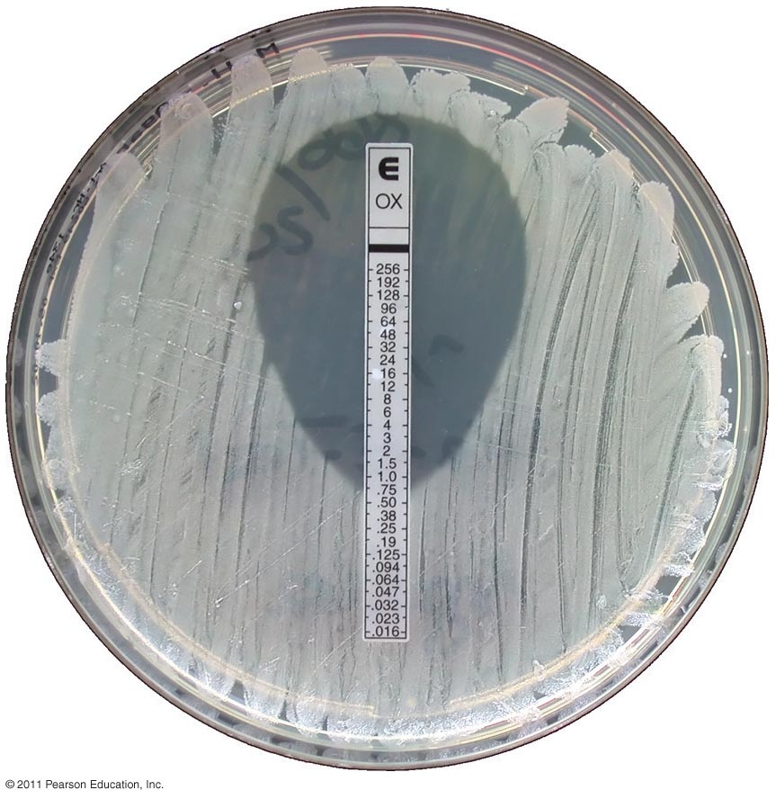
The exponential gradient of antimicrobial agent is immediately transferred to the agar matrix. After 16-18 hours incubation or longer, a symmetrical inhibition ellipse centered along the strip is formed. The MIC is read directly from the scale in terms of μg/ml at the point where the edge of the inhibition ellipse intersects the MIC Test Strip, and its have Wide range of antibiotics, Easy to use, Storage at -20°C, Short shelf life, expensive, Simple, Active.

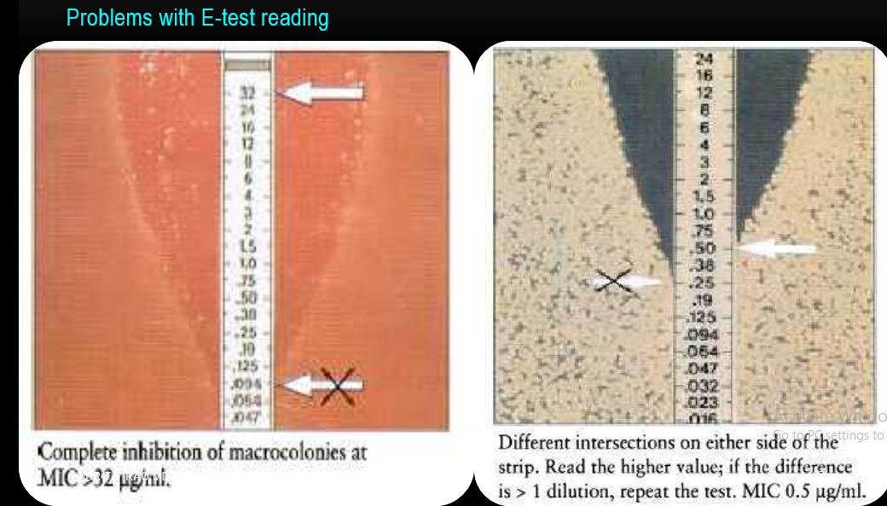
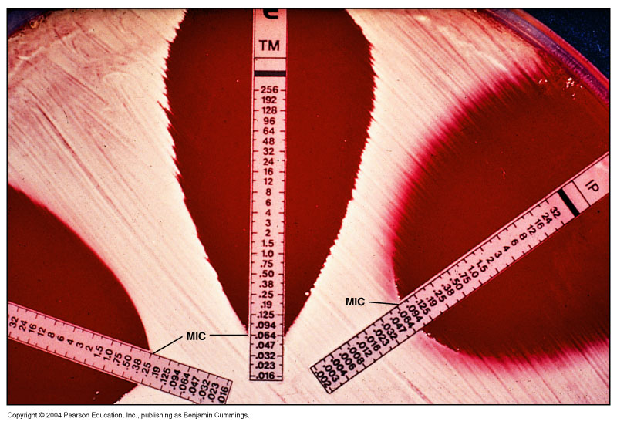

Reading Plates and Interpreting Results in sensitivity test:
- Ordinarily, no more than 12 discs should be placed on one 150 mm plate or more than 5 discs on a 100 mm plate.
- Because some of the drug diffuses almost instantaneously, a disc should not be relocated once it has come into contact with the agar surface. Instead, place a new disc in another location on the agar.
- After 16 to 18 hours of incubation, each plate is examined.
- If individual colonies are apparent, the inoculum was too light and the test must be repeated.
- The diameters of the zones of complete inhibition (as judged by the unaided eye) are measured, including the diameter of the disc.
- Zones are measured to the nearest whole millimeter, using a ruler, which is held on the back of the inverted Petri plate.
- The Petri plate is held a few inches above a black, nonreflecting background and illuminated with reflected light.
- If blood was added to the agar base (as with streptococci), the zones are measured from the upper surface of the agar illuminated with reflected light, with the cover removed.
- The zone margin should be taken as the area showing no obvious, visible growth that can be detected with the unaided eye.
- Faint growth of tiny colonies, which can be detected only with a magnifying lens at the edge of the zone of inhibited growth, is ignored.
- However, discrete colonies growing within a clear zone of inhibition should be subcultured, re-identified, and retested.
- Strains of Proteus spp. may swarm into areas of inhibited growth around certain antimicrobial agents. With Proteus spp., the thin veil of swarming growth in an otherwise obvious zone of inhibition should be ignored.
- When using blood-supplemented medium for testing streptococci, the zone of growth inhibitio n should be measured, not the zone of inhibition of hemolysis.

