Specific immunity is developed as a result of exposure to a variety of agents capable of inducing an immune response (immunogens) such as:
1- Vaccines.
2- Microbes that colonize the body.
3- Macromolecules in the diet.
Specific Immune responses:
I- Antibody mediated (Humoral) immune responses:
a. Primary immune response.
b. Secondary immune response.
S.N. | Primary immune response | Secondary immune response
1. | This occurs as a result of primary contact with an antigen. | This occurs as a result of second and subsequent exposure of the same antigen
2 | Responding cell is naïve B-cell and T-cell. | Responding cell is memory cell.
3 | Lag phase is often longer (4-7 days), sometimes as long as weeks or months. | Lag phase is shorter (1-4 days) due to the presence of memory cell.
4 | Level of antibody reaches peak in 7 to 10 days. | Level of antibody reaches peak in 3 to 5 days.
5 | It takes longer time to establish immunity. | Takes shorter time to establish immunity.
6 | First antibody produced is mainly IgM. Although small amount of IgG are also produced. | Mainly IgG antibody is produced. Although sometimes small amount of IgM are produced. Other immunoglobulins such as IgA and in the case of allergy IgE are produced.
7 | Amount of antibody produced depends on nature of antigen. Usually produced in low amount. | Usually 100-1000 times more antibodies are produced.
8 | Antibody level declines rapidly. | Antibody level remain high for longer period.
9. | Affinity of antibody is lower for its antigen. | Antibodies have greater affinity for antigen.
10 | Primary response appears mainly in the lymph nodes and spleen. | Secondary response appears mainly in the bone marrow, followed by the spleen and lymph nodes.
11 | Both Thymus dependent and Thymus independent antigen gives primary immune response. | Only Thymus-dependent antigen gives secondary immune response.
The primary immune response occurs when an antigen comes in contact to the immune system for the first time. During this time the immune system has to learn to recognize antigen and how to make antibody against it and eventually produce memory lymphocytes.
- Following the first exposure to a foreign antigen, a lag phase occurs in which no antibody is produced, but activated B cells are differentiating into plasma cells. The lag phase can be as short as 2-3 days, but often is longer, sometimes as long as weeks or months.
- The amount of antibody produced is usually relatively low.
- Over time, antibody level declines to the point where it may be undetectable.
- The first antibody produced is manily IgM (although small amounts of IgG are usually also produced).
- No detectable antibodies for several days (long lag period).
- Antibodies become detectable after one week, they climb for 10-14 days.
- Antibodies decline and disappear within a few weeks.
- Amount of antibodies formed and amount of protection is relatively small.
- Memory cells are formed.

The secondary immune response occurs when the second time (3rd, 4th, etc.) the person is exposed to the same antigen. At this point immunological memory has been established and the immune system can start making antibodies immediately.
- If a second dose of the same antigen is given Antibodies may be detectable for months or years after the second injection, an accelerated the secondary immune response occurs. This lag phase is usually very short (e.g. 3 or 4 days) due to the presence of memory cells. And the lag period is short only 2-3 days.
- The amount of antibody produced rises to a high level before declining slowly. And Antibody level tends to remain high for longer.
- Continuous injection does not lead to an indefinitely greater immune response. A third dose (injection) of the antigen elicits an immune response with an even shorter lag period and higher and more prolonged antibody response. This forms the basis of all current vaccination techniques. but the Secondary immune response is specific; it can be provoked only by an antigen identical to that given first, and can be provoked many months and years after the first injection of the antigen.
- Antibody-forming system posses the ability to remember previous exposure to an antigen.
- The main type of antibody produced is IgG (although small amounts of IgM are sometimes produced).

Edible vaccines are nothing but transgenic plant and animal based production of or those that contain agents that trigger an animal's immune response.
Now transgenic plants are being developed through genetic engineering techniques, where the vaccine is synthesised in the edible part of a food plant (edible vaccines). Transgenic bananas, melons, and tomatoes are choice candidates for carrying edible subunit vaccines, as for example against rabies. The obvious advantage is the ease of transportation and storage of the vaccine bearing material and administration without technical support. Conventional vaccination programmes in many countries are seriously handicapped due to a lack of equipment for storage and transport of the vaccines and the shortage of paramedical staff to administer the vaccines. This essay highlights the importance of edible vaccines produced in plants.
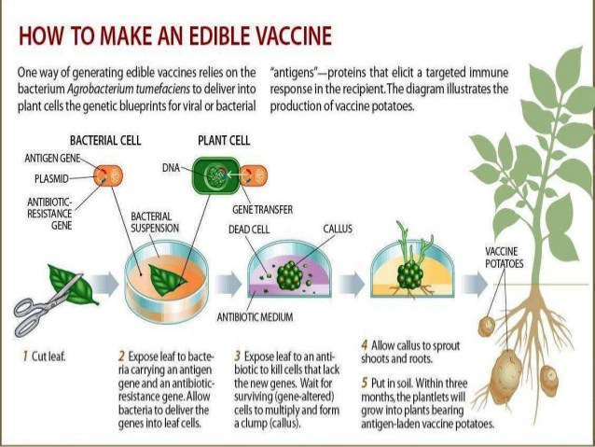

Future
There are several diseases for which there are currently no vaccines, including HIV, malaria and TB. To develop vaccines for these diseases new strategies inducing the cellular and humoral arms of the immune system may need to be employed.
- DNA Vaccines – Early gene therapy attempts discovered immune responses directed against injected DNA and its transcripts. DNA vaccines can contain multiple antigens, are cheap and quick to develop.
- Vectored Vaccines – Several organisms such as bacteria and viruses can infect cells, they can induce an immune response which is similar to that required to control infection. Vaccine antigens can be vectored into host cells by replication deficient viruses such as Adenovirus and modified Vaccinia Ankara, or bacteria such as Salmonella inducing both B- and T-cell responses.
- Reverse Vaccinology – Using modern genome sequencing prospective vaccine candidates can be selected based on predicted immunogenicity

How are vaccines produced?
The production of a vaccine can be divided in the following steps:

1. Generation of the antigen
The first step in order to produce a vaccine is generating the antigen that will trigger the immune response. For this purpose the pathogen’s proteins or DNA need to be grown and harvested using the following mechanisms:
- Viruses are grown on primary cells such as cells from chicken embryos or using fertilised eggs (e.g. influenza vaccine) or cell lines that reproduce repeatedly (e.g. hepatitis A)
- Bacteria are grown in bioreactors which are devices that use a particular growth medium that optimises the production of the antigens
- Recombinant proteins derived from the pathogen can be generated either in yeast, bacteria or cell cultures.

2. Release and isolation of the antigen
The aim of this second step is to release as much virus or bacteria as possible. To achieve this, the antigen will be separated from the cells and isolated from the proteins and other parts of the growth medium that are still present.

3. Purification
In a third step the antigen will need to be purified in order to produce a high purity/quality product.
This will be accomplished using different techniques for protein purification. For this purpose several separation steps will be carried out using the differences in for instance protein size, physico-chemical properties, binding affinity or biological activity.

4. Addition of other components
The fourth step may include the addition of an adjuvant, which is a material that enhances the recipient’s immune response to a supplied antigen. The vaccine is then formulated by adding stabilizers to prolong the storage life or preservatives to allow multi-dose vials to be used safely as needed. Due to potential incompatibilities and interactions between antigens and other ingredients, combination vaccines will be more challenging to develop. Finally, all components that constitute the final vaccine are combined and mixed uniformly in a single vial or syringe.

5. Packaging
Once the vaccine is put in recipient vessel (either a vial or a syringe), it is sealed with sterile stoppers. All the processes described above will have to comply with the standards defined for Good Manufacturing Practices that will involve several quality controls and an adequate infrastructure and separation of activities to avoid cross-contamination, as shown in the diagram below. Finally, the vaccine is labelled and distributed worldwide.
Vaccines are currently produced by gene techniques, i.e. instead of using a virus or bacterium, A single gene (usually a surface glycoprotein of the virus) can be expressed in a foreign host by Cloning. (Expression vectors are used to make large amounts of antigen to be used as a vaccine. Most used vectors for expression are Bacteria: Escherichia coli, Yeasts ,Baculovirus.)• This process induces the vector to produce an antigen, which is then purified.• The purified antigen, when combined with an adjuvant results in a safe and very effective vaccine.• Example: Gardasil, an anti-human papilloma virus vaccine that is very effective in preventing cervical cancer.• The current Hepatitis B vaccine is also this type.
Herd immunity
Use of vaccines to prevent disease in communities is herd immunity, which affords protection by decreasing the number of susceptible people in a community, with time. This basically constitutes mass immunisation. Polio vaccination programmes now target an enormous number of children throughout the world, to eradicate polio, as was done for smallpox earlier.
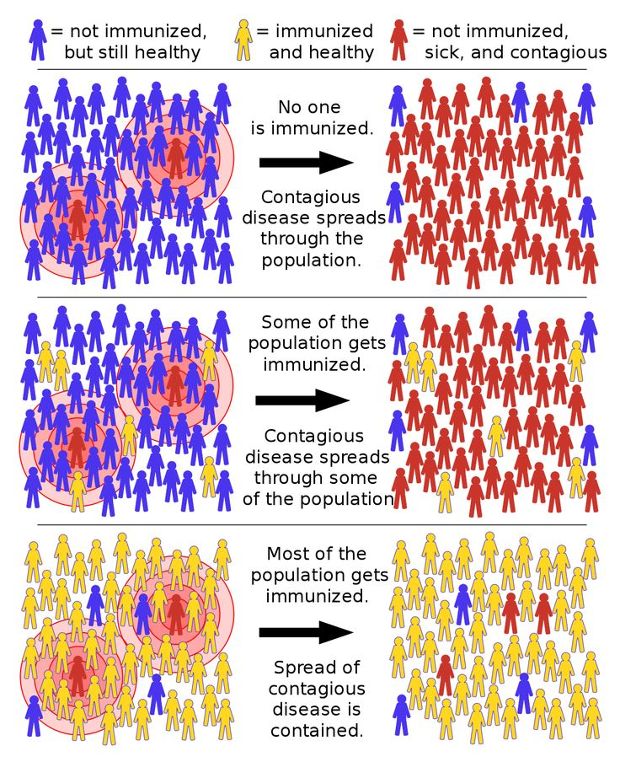
Booster doses
booster dose is an extra administration of a vaccine after an earlier (prime) dose. After initial immunization, a booster injection or booster dose is a re-exposure to the immunizing antigen. It is intended to increase immunity against that antigen back to protective levels, after memory against that antigen has declined through time. For example, tetanus shot boosters are often recommended every 10 years, after which memory cells specific against tetanus have lost their function or undergone apoptosis.
The effectiveness of certain vaccines is life long as for example of smallpox, measles, mumps and rubella. Attenuated vaccines normally afford life long immunity. But in the case of certain others, the effectiveness is short lived and the immune system needs to be re-educated through periodicalbooster doses. The vaccine is administered one or more times, with appropriate time gaps, after the initial vaccination, to boost to the immune system to produce adequate quantities of antibodies against the intended pathogen. Toxoid vaccines require a booster every ten years or so. Boosterdoses are also needed in case of inactivated or acellular vaccines, which are very safe, as they cannot cause the disease.
Multiple vaccines
While most vaccines contain antigens of a single pathogen, there is a practice of multiple vaccines, which combine antigens of more than one pathogen. For example, diphtheria, tetanus and pertussis are administered together as DTP vaccination.
Vaccine administration
Vaccines are administered, as injections (DTP), or dermally (smallpox, anthrax), or orally (polio) or as a nasal spray (influenza virus).
Safety of vaccines
By and large vaccination programmes have proven to be reasonably safe for the human populations. However, at certain times complications may arise mostly due to an incorrect handling of the vaccines and/or vaccination or due to individual metabolic deficiencies. In spite of all that is adverse in vaccination, immunisation is one of the most efficient means of disease prevention, particularly in large sections of the human population. In the case of HIV and epidemic diseases and even cancer, immunisation is probably the only hope.
Vaccines are safe and effective. Because vaccines are given to millions of healthy people — including children — to prevent serious diseases, they’re held to very high safety standards.
How are vaccines tested for safety?
Every licensed and recommended vaccine goes through years of safety testing including:
Testing and evaluation of the vaccine before it’s licensed by the Food and Drug Administration (FDA) and recommended for use by the Centers for Disease Control and Prevention (CDC)
Monitoring the vaccine’s safety after it is recommended for infants, children, or adults
Vaccines are tested before they’re recommended for use
Before a vaccine is ever recommended for use, it’s tested in labs. This process can take several years. FDA uses the information from these tests to decide whether to test the vaccine with people.
During a clinical trial, a vaccine is tested on people who volunteer to get vaccinated. Clinical trials start with 20 to 100 volunteers but eventually include thousands of volunteers. These tests take several years and answer important questions like:
Is the vaccine safe?
What does (amount) works best?
How does the immune system react to it?
Throughout the process, FDA works closely with the company producing the vaccine to evaluate the vaccine’s safety and effectiveness. All safety concerns must be addressed before FDA licenses a vaccine.
Every batch of vaccines is tested for quality and safety
Once a vaccine is approved, it continues to be tested. The company that makes the vaccine tests batches to make sure the vaccine is:
Potent (It works like it’s supposed to)
Pure (Certain ingredients used during production have been removed)
Sterile (It doesn’t have any outside germs)
FDA reviews the results of these tests and inspects the factories where the vaccine is made. This helps make sure the vaccines meet standards for both quality and safety.
Vaccines are monitored after they’re recommended to the public
Once a vaccine is licensed and recommended for use, FDA, CDC, and other federal agencies continue to monitor its safety.
There are many different parts of the national vaccine monitoring system
The United States has one of the most advanced systems in the world for tracking vaccine safety. Each of the systems below supplies a different type of data for researchers to analyze. Together, they help provide a full picture of vaccine safety.
Vaccine Adverse Events Reporting System (VAERS): VAERS is an early warning system managed by CDC and FDA that is designed to find possible vaccine safety issues. Patients, healthcare professionals, vaccine companies, and others can use VAERS to report side effects that happen after a patient received a vaccine. Some side effects might be related to vaccination while others might be a coincidence (happen by chance). VAERS helps track unusual or unexpected patterns of reporting that could mean there’s a possible vaccine safety issue that needs further evaluation.
The Vaccine Safety Datalink (VSD): VSD is collaboration between CDC and several healthcare organizations across the nation. VSD uses databases of medical records to track vaccine safety and do research in large populations. By using medical records instead of self-reports, VSD can quickly study and compare data to find out if reported side effects are linked to a vaccine.
Post-licensure Rapid Immunization Safety Monitoring System (PRISM)External Link: You are leaving vaccines.gov: PRISM is part of the Sentinel Initiative, which is FDA’s national system for monitoring medical products after they’re licensed for use. PRISM focuses on vaccine safety — it uses a database of health insurance claims to identify and evaluate possible safety issues for licensed vaccines.
Clinical Immunization Safety Assessment Project (CISA): CISA is a collaboration between CDC and a national network of vaccine safety experts from medical research centers. CISA does clinical vaccine safety research and — at the request of providers — evaluates complex cases of possible vaccine side effects in specific patients.
Additional research and testing: The Department of Defense (DoD) and U.S. Department of Veterans Affairs (VA) have systems to monitor vaccine safety and do vaccine safety research. The National Institutes of Health (NIH) and the National Vaccine Program Office (NVPO) also support ongoing research on vaccines and vaccine safety.
Immunotherapy
A type of therapy that uses substances to stimulate or suppress the immune system to help the body fight cancer, infection, and other diseases. Some types of immunotherapy only target certain cells of the immune system. Others affect the immune system in a general way. Types of immunotherapy include cytokines, vaccines, bacillus Calmette-Guerin (BCG), and some monoclonal antibodies.

Types of Immunotherapy
Several types of immunotherapy are used to treat cancer. These treatments can either help the immune system attack the cancer directly or stimulate the immune system in a more general way.
Types of immunotherapy that help the immune system act directly against the cancer include:
- Checkpoint inhibitors, which are drugs that help the immune system respond more strongly to a tumor. These drugs work by releasing “brakes” that keep T cells (a type of white blood cell and part of the immune system) from killing cancer cells. These drugs do not target the tumor directly. Instead, they interfere with the ability of cancer cells to avoid immune system attack.
- Adoptive cell transfer, which is a treatment that attempts to boost the natural ability of your T cells to fight cancer. In this treatment, T cells are taken from your tumor. Then those that are most active against your cancer are grown in large batches in the lab.
The process of growing your T cells in the lab can take 2 to 8 weeks. During this time, you may have treatments such as chemotherapy and radiation therapy to reduce your immune cells. After these treatments, the T cells that were grown in the lab will be given back to you via a needle in your vein.
For more information about a specific type of adoptive cell transfer called CAR T-cell therapy, which uses T cells that are changed in the laboratory, see CAR T-Cell Therapy: Engineering Patients' Immune Cells to Treat Their Cancers.
- Monoclonal antibodies, also known as therapeutic antibodies, are immune system proteins produced in the lab. These antibodies are designed to attach to specific targets found on cancer cells. Some monoclonal antibodies mark cancer cells so that they will be better seen and destroyed by the immune system, and these are a type of immunotherapy. Other monoclonal antibodies that are used in cancer treatment do not cause a response from the immune system. Such monoclonal antibodies are considered to be targeted therapy, rather than immunotherapy.
Learn more about targeted therapy.
- Treatment vaccines, which work against cancer by boosting your immune system’s response to cancer cells. Treatment vaccines are different from the ones that help prevent disease.
Types of immunotherapy that enhance the body’s immune response to fight the cancer include:
- Cytokines, which are proteins made by your body’s cells. They play important roles in the body’s normal immune responses and also in the immune system’s ability to respond to cancer. The two main types of cytokines used to treat cancer are calledinterferons and interleukins.
- BCG, which stands for Bacillus Calmette-Guérin, is an immunotherapy that is used to treat bladder cancer. It is a weakened form of the bacteria that causes tuberculosis. When inserted directly into the bladder with a catheter, BCG causes an immune response against cancer cells. It is also being studied in other types of cancer.

Who Receives Immunotherapy
Immunotherapy is not yet as widely used as surgery, chemotherapy, and radiation therapy. However, immunotherapies have been approved to treat people with many types of cancer. To learn about immunotherapies that may be used to treat your cancer, see the PDQ® adult cancer treatment summaries and childhood cancer treatment summaries.
Many other immunotherapies are being studied in clinical trials, which are research studies involving people. To find a study that may be an option for you, visit Find a Clinical Trial.

How Immunotherapy Works against Cancer
One reason that cancer cells thrive is because they are able to hide from your immune system. Certain immunotherapies can mark cancer cells so it is easier for the immune system to find and destroy them. Other immunotherapies boost your immune system to work better against cancer.

Immunotherapy Can Cause Side Effects
Immunotherapy can cause side effects, which affect people in different ways. The side effects you may have and how they make you feel will depend on how healthy you are before treatment, your type of cancer, how advanced it is, the type of therapy you are getting, and the dose. Doctors and nurses cannot know for certain how you will feel during treatment.
The most common side effects are skin reactions at the needle site. These side effects include:
- Pain
- Swelling
- Soreness
- Redness
- Itchiness
- Rash
You may have flu-like symptoms, which include:
- Fever
- Chills
- Weakness
- Dizziness
- Nausea or vomiting
- Muscle or joint aches
- Fatigue
- Headache
- Trouble breathing
- Low or high blood pressure
Other side effects might include:
- Swelling and weight gain from retaining fluid
- Heart palpitations
- Sinus congestion
- Diarrhea
- Risk of infection
Immunotherapies may also cause severe or even fatal allergic reactions. However, these reactions are rare.

How Immunotherapy Is Given
Different forms of immunotherapy may be given in different ways. These include:
- Intravenous (IV)
The immunotherapy goes directly into a vein.
- Oral
The immunotherapy comes in pills or capsules that you swallow.
- Topical
The immunotherapy comes in a cream that you rub onto your skin. This type of immunotherapy can be used for very early skin cancer.
- Intravesical
The immunotherapy goes directly into the bladder.

Where You Go for Your Immunotherapy Treatment
You may receive immunotherapy in a doctor’s office, clinic, or outpatient unit in a hospital. Outpatient means you do not spend the night in the hospital.

How Often You Will Receive Immunotherapy Treatment
How often and how long you receive immunotherapy depends on:
- Your type of cancer and how advanced it is
- The type of immunotherapy you get
- How your body reacts to treatment
You may have treatment every day, week, or month. Some immunotherapies are given in cycles. A cycle is a period of treatment followed by a period of rest. The rest period gives your body a chance to recover, respond to the immunotherapy, and build new healthy cells.

How to Tell Whether Immunotherapy Is Working
You will see your doctor often. He or she will give you physical exams and ask you how you feel. You will have medical tests, such as blood tests and different types of scans. These tests will measure the size of your tumor and look for changes in your blood work.

Stem Cell Transplants in Cancer Treatment
Stem cell transplants are procedures that restore blood-forming stem cells in people who have had theirs destroyed by the very high doses of chemotherapy or radiation therapy that are used to treat certain cancers.
Blood-forming stem cells are important because they grow into different types of blood cells. The main types of blood cells are:
- White blood cells, which are part of your immune system and help your body fight infection
- Red blood cells, which carry oxygen throughout your body
- Platelets, which help the blood clot
You need all three types of blood cells to be healthy.

ON THIS PAGE
- Types of Stem Cell Transplants
- How Stem Cell Transplants Work against Cancer
- Who Receives Stem Cell Transplants
- Stem Cell Transplants Can Cause Side Effects
- How Much Stem Cell Transplants Cost
- What to Expect When Receiving a Stem Cell Transplant
- Special Diet Needs
- Working during Your Stem Cell Transplant

Types of Stem Cell Transplants
In a stem cell transplant, you receive healthy blood-forming stem cells through a needle in your vein. Once they enter your bloodstream, the stem cells travel to the bone marrow, where they take the place of the cells that were destroyed by treatment. The blood-forming stem cells that are used in transplants can come from the bone marrow, bloodstream, or umbilical cord. Transplants can be:
- Autologous, which means the stem cells come from you, the patient
- Allogeneic, which means the stem cells come from someone else. The donor may be a blood relative but can also be someone who is not related.
- Syngeneic, which means the stem cells come from your identical twin, if you have one
To reduce possible side effects and improve the chances that an allogeneic transplant will work, the donor’s blood-forming stem cells must match yours in certain ways. To learn more about how blood-forming stem cells are matched, see Blood-Forming Stem Cell Transplants.

How Stem Cell Transplants Work against Cancer
Stem cell transplants do not usually work against cancer directly. Instead, they help you recover your ability to produce stem cells after treatment with very high doses of radiation therapy, chemotherapy, or both.
However, in multiple myeloma and some types of leukemia, the stem cell transplant may work against cancer directly. This happens because of an effect called graft-versus-tumor that can occur after allogeneic transplants. Graft-versus-tumor occurs when white blood cells from your donor (the graft) attack any cancer cells that remain in your body (the tumor) after high-dose treatments. This effect improves the success of the treatments.

Who Receives Stem Cell Transplants
Stem cell transplants are most often used to help people with leukemia and lymphoma. They may also be used for neuroblastoma and multiple myeloma.
Stem cell transplants for other types of cancer are being studied in clinical trials, which are research studies involving people. To find a study that may be an option for you, seeFind a Clinical Trial.

Stem Cell Transplants Can Cause Side Effects
The high doses of cancer treatment that you have before a stem cell transplant can cause problems such as bleeding and an increased risk of infection. Talk with your doctor or nurse about other side effects that you might have and how serious they might be. For more information about side effects and how to manage them, see the section on side effects.
If you have an allogeneic transplant, you might develop a serious problem called graft-versus-host disease. Graft-versus-host disease can occur when white blood cells from your donor (the graft) recognize cells in your body (the host) as foreign and attack them. This problem can cause damage to your skin, liver, intestines, and many other organs. It can occur a few weeks after the transplant or much later. Graft-versus-host disease can be treated with steroids or other drugs that suppress your immune system.
The closer your donor’s blood-forming stem cells match yours, the less likely you are to have graft-versus-host disease. Your doctor may also try to prevent it by giving you drugs to suppress your immune system.

How Much Stem Cell Transplants Cost
Stem cells transplants are complicated procedures that are very expensive. Most insurance plans cover some of the costs of transplants for certain types of cancer. Talk with your health plan about which services it will pay for. Talking with the business office where you go for treatment may help you understand all the costs involved.
To learn about groups that may be able to provide financial help, go to the National Cancer Institute database, Organizations that Offer Support Services and search "financial assistance." Or call toll-free 1-800-4-CANCER (1-800-422-6237) for information about groups that may be able to help.

What to Expect When Receiving a Stem Cell Transplant

Where You Go for a Stem Cell Transplant
When you need an allogeneic stem cell transplant, you will need to go to a hospital that has a specialized transplant center. The National Marrow Donor Program® maintains alist of transplant centers in the United StatesExit Disclaimer that can help you find a transplant center.
Unless you live near a transplant center, you may need to travel from home for your treatment. You might need to stay in the hospital during your transplant, you may be able to have it as an outpatient, or you may need to be in the hospital only part of the time. When you are not in the hospital, you will need to stay in a hotel or apartment nearby. Many transplant centers can assist with finding nearby housing.

How Long It Takes to Have a Stem Cell Transplant
A stem cell transplant can take a few months to complete. The process begins with treatment of high doses of chemotherapy, radiation therapy, or a combination of the two. This treatment goes on for a week or two. Once you have finished, you will have a few days to rest.
Next, you will receive the blood-forming stem cells. The stem cells will be given to you through an IV catheter. This process is like receiving a blood transfusion. It takes 1 to 5 hours to receive all the stem cells.
After receiving the stem cells, you begin the recovery phase. During this time, you wait for the blood cells you received to start making new blood cells.
Even after your blood counts return to normal, it takes much longer for your immune system to fully recover—several months for autologous transplants and 1 to 2 years for allogeneic or syngeneic transplants.

How Stem Cell Transplants May Affect You
Stem cell transplants affect people in different ways. How you feel depends on:
- The type of transplant that you have
- The doses of treatment you had before the transplant
- How you respond to the high-dose treatments
- Your type of cancer
- How advanced your cancer is
- How healthy you were before the transplant
Since people respond to stem cell transplants in different ways, your doctor or nurses cannot know for sure how the procedure will make you feel.

How to Tell If Your Stem Cell Transplant Worked
Doctors will follow the progress of the new blood cells by checking your blood counts often. As the newly transplanted stem cells produce blood cells, your blood counts will go up.

Special Diet Needs
The high-dose treatments that you have before a stem cell transplant can cause side effects that make it hard to eat, such as mouth sores and nausea. Tell your doctor or nurse if you have trouble eating while you are receiving treatment. You might also find it helpful to speak with a dietitian. For more information about coping with eating problems see the booklet Eating Hints or the section on side effects.

Working during Your Stem Cell Transplant
Whether or not you can work during a stem cell transplant may depend on the type of job you have. The process of a stem cell transplant, with the high-dose treatments, the transplant, and recovery, can take weeks or months. You will be in and out of the hospital during this time. Even when you are not in the hospital, sometimes you will need to stay near it, rather than staying in your own home. So, if your job allows, you may want to arrange to work remotely part-time.
Many employers are required by law to change your work schedule to meet your needs during cancer treatment. Talk with your employer about ways to adjust your work during treatment. You can learn more about these laws by talking with a social worker.

